Table S1 Experimental range and level of the independent variables of selected components for RSM – CCD
Variable Code | Variable | +a | +1 | 0 | -1 | -a
A | Urea | 3.11361 | 2.5 | 1.6 | 0.7 | 0.0863865
B | Cellulose | 1.8409 | 1.5 | 1 | 0.5 | 0.159104
C | MgSO₄ | 0.18409 | 0.15 | 0.1 | 0.05 | 0.0159104

Table S2 Secondary Screening and Selection of Potential Isolates Based on Laccase Activity
Isolates | pH | Enzyme Activity at pH 7 (U/ml) | Enzyme Activity at pH 9 (U/ml)
JA1 | 6 and 7 | 0.015 | 0.005
JA2 | 6 and 7 | 0.011 | 0.023
JA3 | 6 and 7 | 0.073 | 0.063
JA5 | 6 and 7 | 0.086 | 0.075
JA6 | 6 and 7 | 0.098 | 0.078
JA7 | 6 and 7 | 0.011 | 0.001
JB1 | 7 and 9 | 0.156 | 0.240
JB2 | 7 and 9 | 0.080 | 0.042
JB3 | 7 and 9 | 0.015 | 0.166
JB4 | 7 and 9 | 0.009 | 0.012
JB5 | 7 and 9 | 0.007 | 0.080
JB6 | 7 and 9 | 0.153 | 0.226

Table S3a. Quantification of Cypermethrin detoxification by FTIR analysis
Sample | ~3300 cm⁻¹ (O–H/N–H) | ~2090 cm⁻¹ (C≡X) | ~1640 cm⁻¹ (C=C/C=O) | 400–500 cm⁻¹ (Halogen/M–O) | Unique/Notable Peaks | Detoxification Inference
C (Cypermethrin) | 3369.16 | 2091.64 | 1640.20 | 413.59, 746.30 | Strong aromatic ring band | Baseline compound
B | 3367.44 | 2099.32 | 1641.20 | 422.07 | No aromatic ring peak | Possible ring modification
E | 3369.31 | 2099.24 | 1641.84 | 454.03, 435.07 | Shift in halogen band | Bond cleavage, halogen displacement
Se+BE | 3372.89 | - | 1641.20 | 468.17, 439.40, 413.19 | Multiple split peaks | Extensive detoxification & metal interaction

Table S3b. Quantification of Cypermethrin detoxification by GC

Sample | Major cypermethrin signal | Major observed by-products/peaks (RT & approximate area) | Interpretation
Control (Ethyl acetate) | Cypermethrin peaks at RT 25.045 (1,140,603); 25.197 (873,797); 25.290 (838,751); 25.350 (667,939). Total ≈ 3,521,090 | Heneicosane, Eicosane, Dodecane derivatives | Parent present — baseline.
SE+BE | No parent detected (cypermethrin absent) | 2,4-Di-tert-butylphenol (RT ~12.56; area ≈ 563,400), various alkanes (heneicosane, etc.) | Advanced breakdown: oxidative product + hydrocarbons.
B | No parent detected | Dominant long-chain alkanes (several large peaks assigned to heneicosane; large summed area of hydrocarbon peaks) | Parent degraded; chromatogram dominated by matrix hydrocarbons.
E | No parent detected | 2,4-Di-tert-butylphenol (RT ~12.56; area ≈ 1,268,733), hexadecane, dodecane derivatives | High phenolic intermediate signal — strong evidence of oxidative cleavage.

Table S4: Comparative review of bioremediation of cypermethrin
Microorganism / System | Nanoparticle / Immobilization Type | Enzyme Activity / Key Enzyme | Detoxification Efficiency | Last Products of Detoxification | Reference
Bacillus cereus GW-01  Wild-Type | None | Esterase/hydrolase pathway; oxidative stress constrained | 57.76% (soil microcosm, 30 d) | 3-Phenoxybenzoic acid (3-PBA), phenol, benzoic acid, catechol derivatives | (Lei et al., 2027)
B. cereus GW-01  ΔcodY mutant | None (genetic de-repression) | Enhanced hydrolase + stress adaptation (↑SOD, biofilm, hydrophobicity) | 63.69% (soil microcosm, 30 d); 76.16% (liquid, 7 d, 50 mg/L) | Same pathway as WT, but faster clearance of 3-PBA and aromatic intermediates | (Lei et al., 2027)
B. thuringiensis SG4 | None | Esterase cleavage of the ester bond | 83.3% (soil slurry, 15 d) | Phenol, 3-phenoxybenzaldehyde, phthalic acid, 3-phenoxybenzoate, 2-hydroxy-3-phenoxy-benzeneacetonitrile | (Bhatt et al., 2020)
B. thuringiensis SG4 | Sodium alginate beads | Esterase activity retained | 85.3% (liquid, 15 d, 50 mg/L) | Same metabolite profile as free cells (phenol, phthalic acid, 3-PBA derivatives) | (Bhatt et al., 2020)
B. thuringiensis SG4 | Agar discs | Esterase activity retained | 81.0% (liquid, 15 d, 50 mg/L) | Same metabolite profile as above | (Bhatt et al., 2020)
Aspergillus niger YAT | None | Esterase + co-metabolism | 54.83% (liquid, 7 d, 50 mg/L) | 3-Phenoxybenzoic acid → protocatechuic acid → catechol → mineralization | (Huang et al., 2018)
Aspergillus oryzae M-4 | None | Esterase | 26.01% (liquid, 7 d, 50 mg/L) | Aromatic intermediates (3-PBA, phenolic compounds) | (Huang et al., 2018)
Bacillus licheniformis B-1 | None | Esterase | 52.91% (liquid, 7 d, 50 mg/L) | Aromatic intermediates (benzoic acid derivatives) | (Huang et al., 2018)
Proteus mirabilis JB1 | Lac@SeNP | Laccase enzyme | 100 %, liquid, 72h, 1mM | Dodecane, 4,6-dimethyl-, 2,4-Di-tert-butylphenol, Heneicosane | This manuscript

Figure S1: Standard curve for protein quantification using BSA

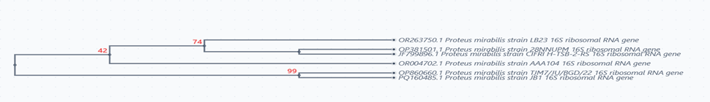

Figure S2: The Phylogenetic tree showing the relationship between isolated Proteus mirabilis JB1 (PQ160485) and other closely related sequences on NCBI GenBank.

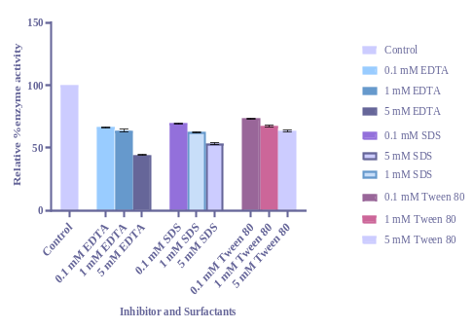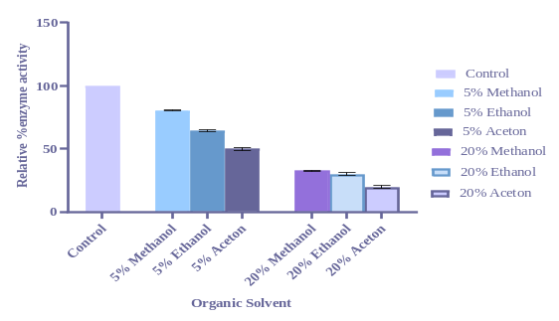
Figure S3: Effect of various inhibitor, surfactants, and organic solvents

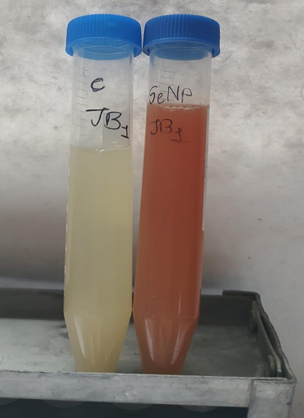
Figure S4: Formation of Lac@SeNp

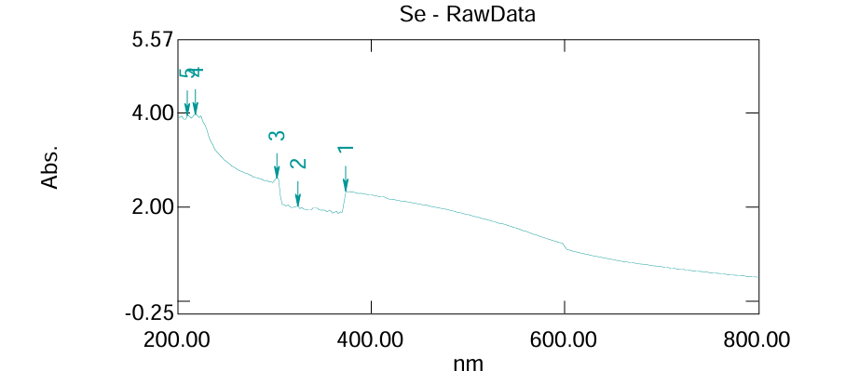
Figure S5: UV spectra of lac@SeNp

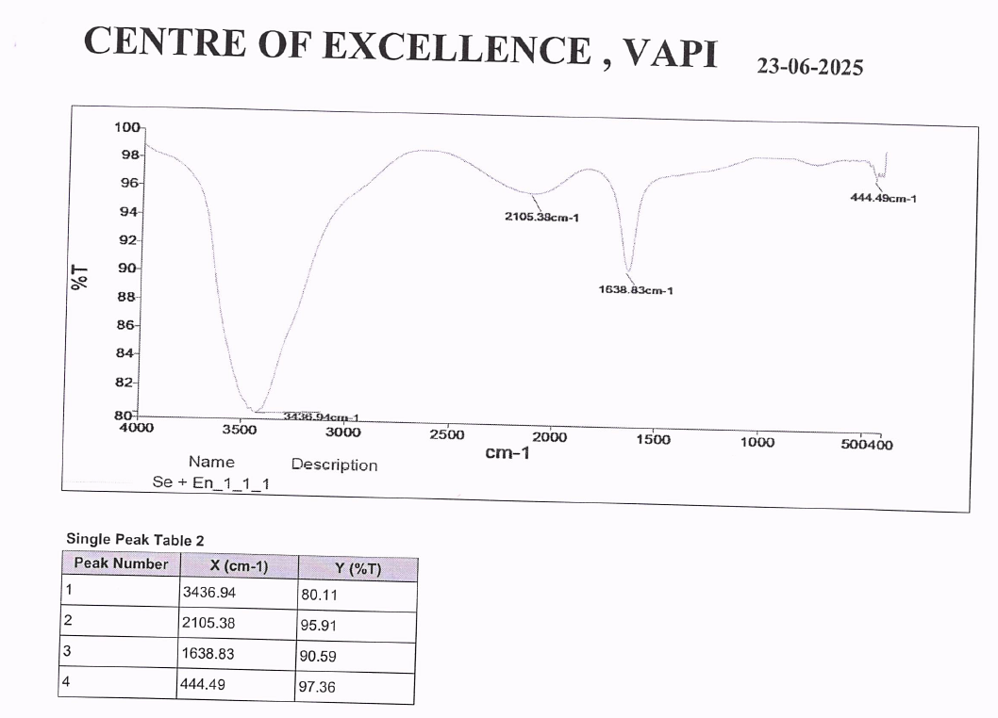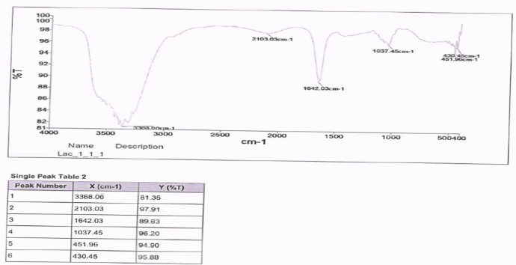
Figure S6: FTIR spectra of lac@SeNp and laccase enzyme

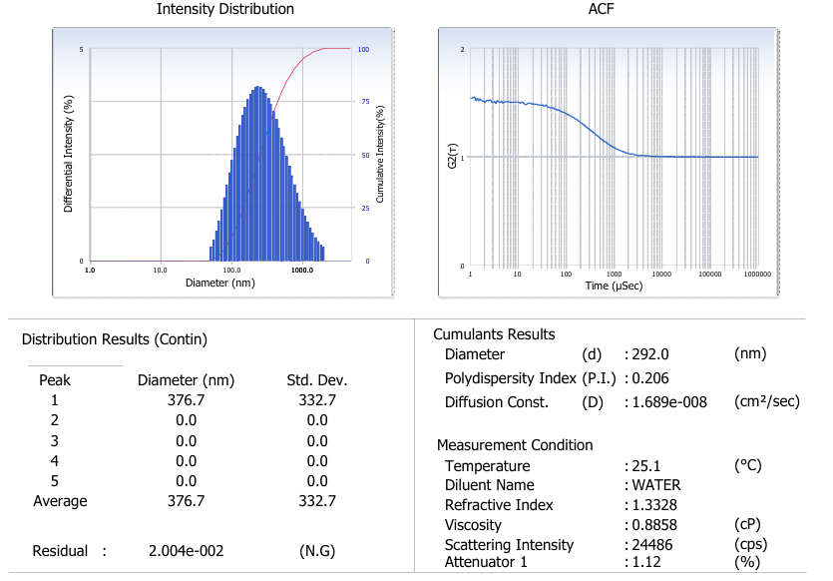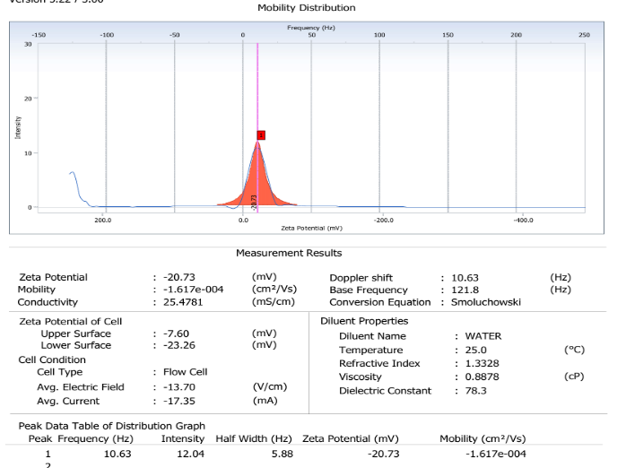
Figure S7: DLS and Zeta potential of Lac@SeNp

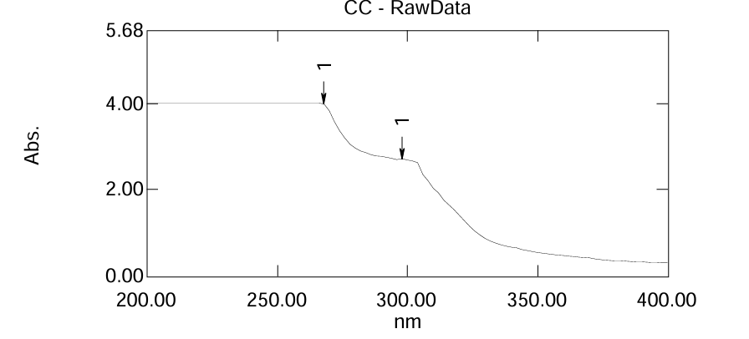
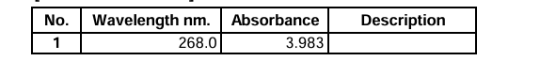
Figure S8: UV spectra of cypermethrin.

Figure S9: Cypermethrin detoxification by bacteria, free enzyme, and immobilized enzyme 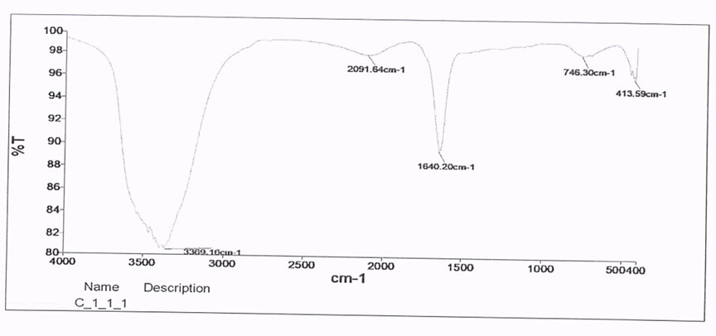
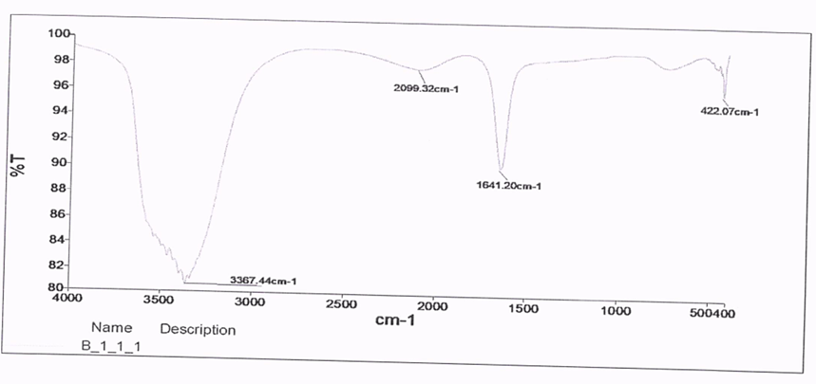
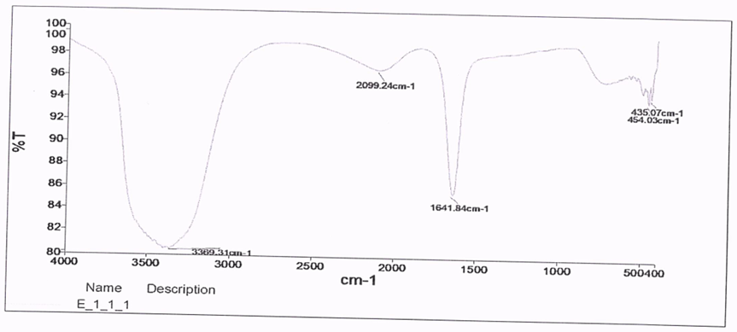
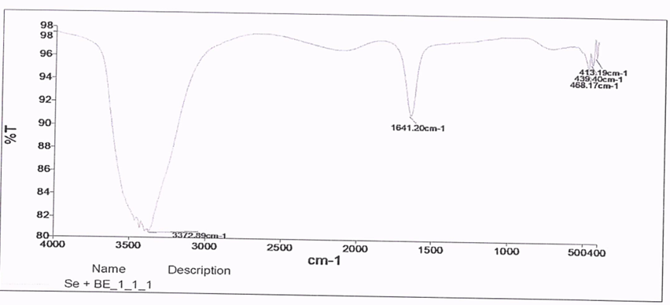
Figure S10: FTIR spectra for Control, B, E, Se+BE

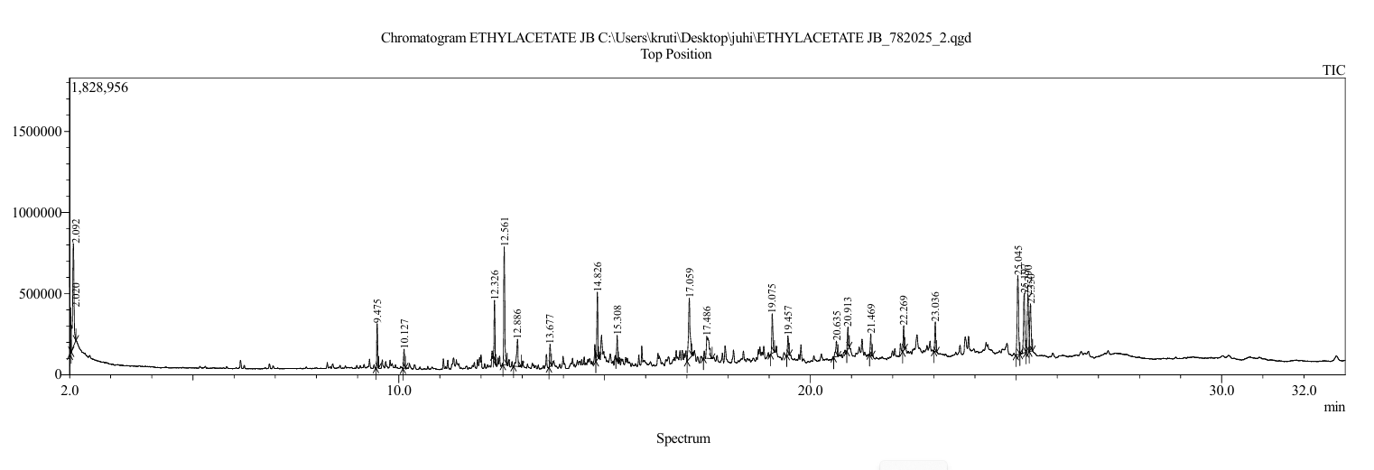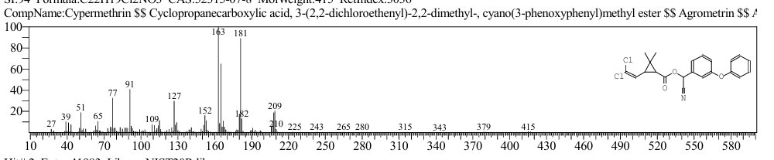
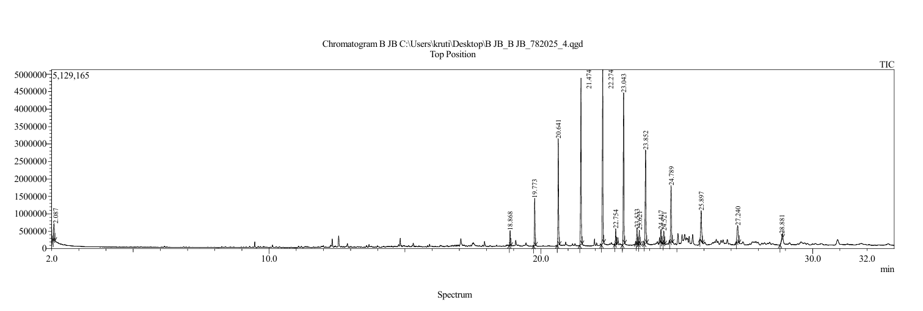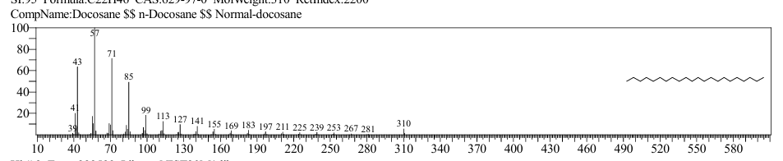
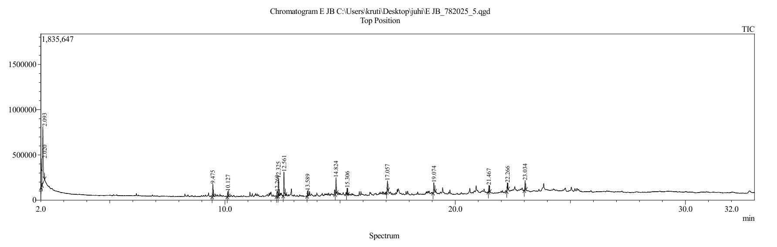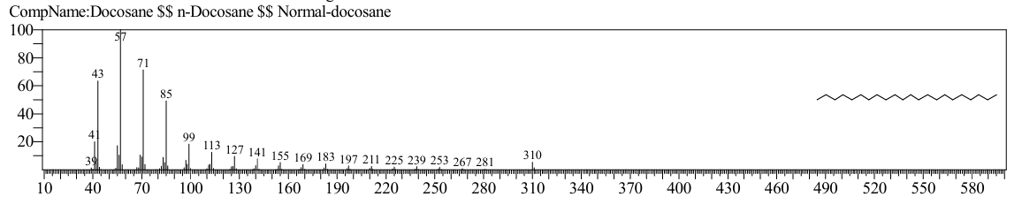
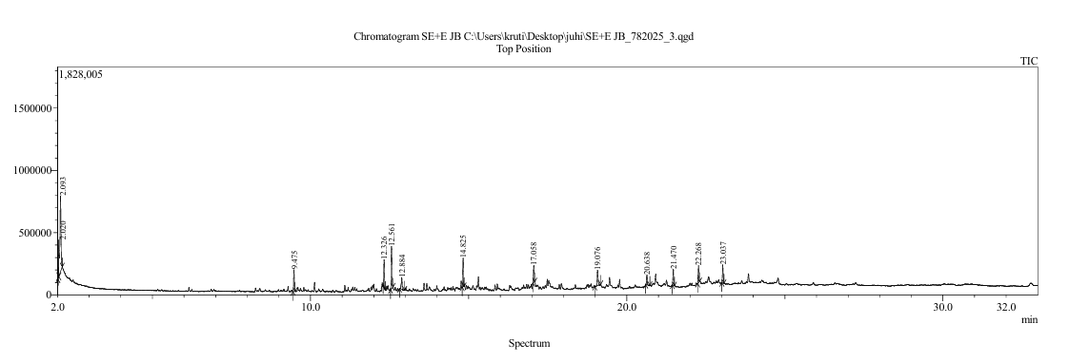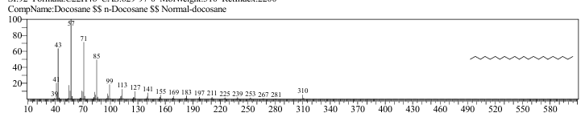
Figure S11 GC chromatogram for Control, B, E, Se+BE

