Appendix 4. Associations between key outcomes: Number of knees with concomitant different types of abnormalities (Venn diagrams a, b; Table A4)

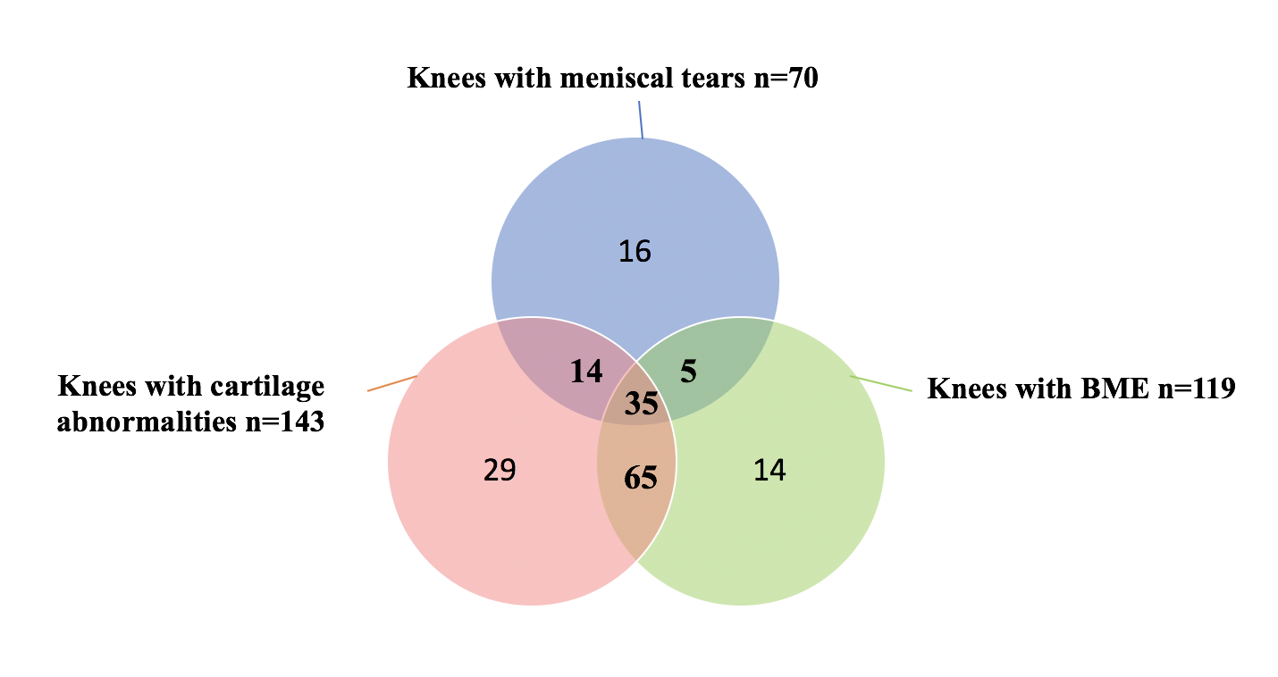
b.
a.

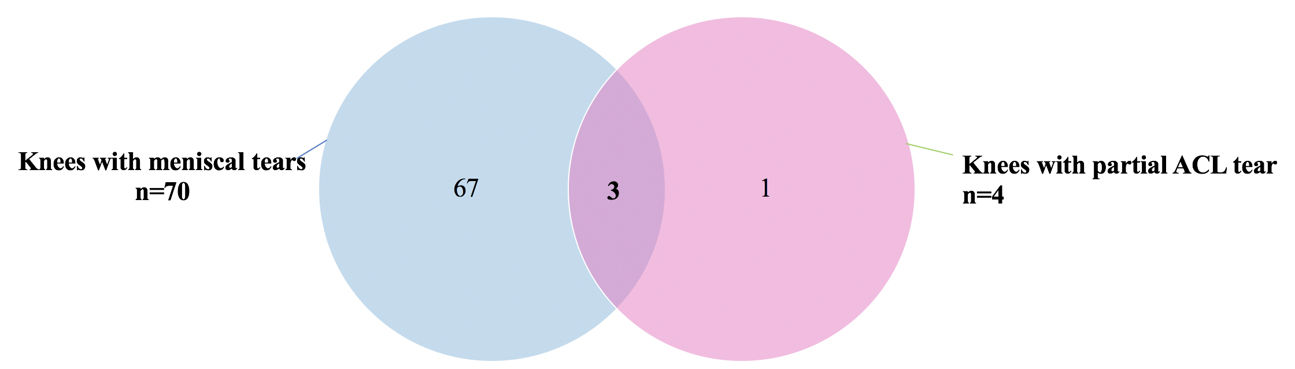

Table A4: Concomitant abnormalities in 230 knees
Types of concomitant abnormalities | Number of concomitant abnormalities
Knees with meniscal tears and cartilage abnormalities (no BME) | 14
Knees with meniscal tears and BME (no cartilage abnormalities) | 5
Knees with cartilage abnormalities and BME (no meniscal tears) | 65
Knees with meniscal tears, cartilage abnormalities and BME | 35
Knees with meniscal tears and ACL rupture | 3
ACL, anterior cruciate ligament; BME, bone marrow oedema.

