Supplementary Material. Score form used for triangular fibrocartilage complex assessment in healthy asymptomatic adolescents with illustrative images from young symptomatic gymnasts that were not included in the present study
A | WRIST POSITIONING
1.1 | Ulnar prestyloid recess position  Axial PD | 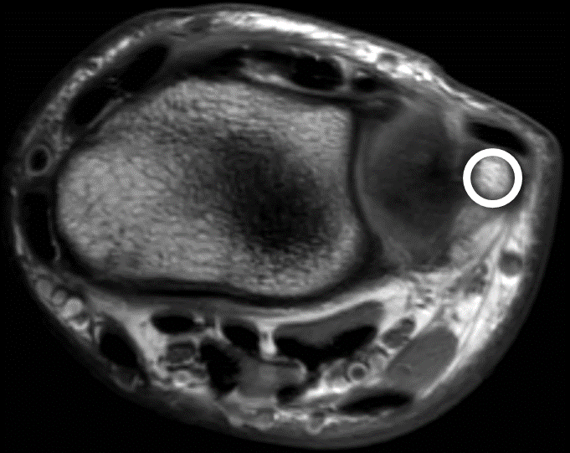  □ Neutral |  | 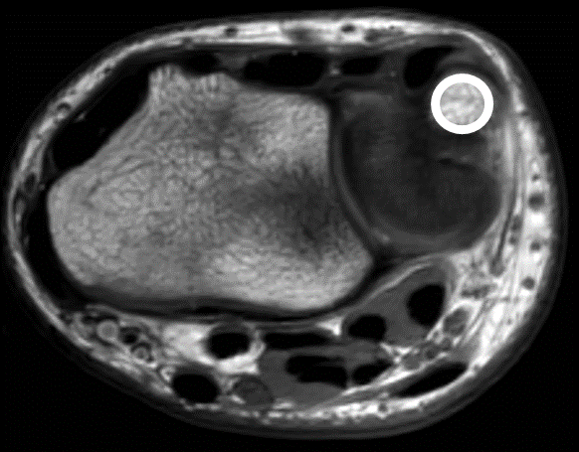  □ Dorsal rotation (supinated) | 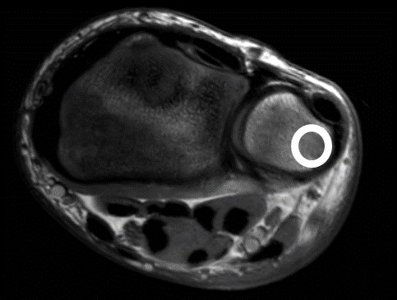  □ Volar rotation (pronated)
B | TRIANGULAR FIBROCARTILAGE (TFC)
1.1 | TFC morphology – On the sagittal slice where the TFC is at its thinnest  Sagittal PD | 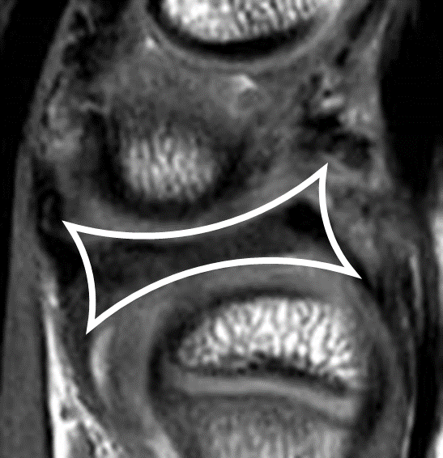  □ Symmetrical biconcave disc |  | 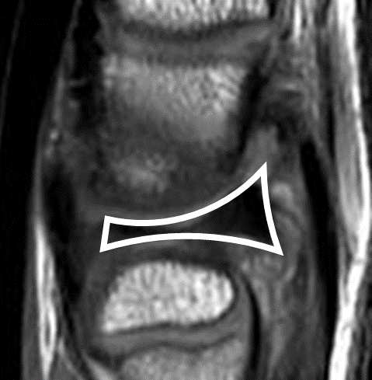  □ Biconcave disc dorsal thicker than volar | 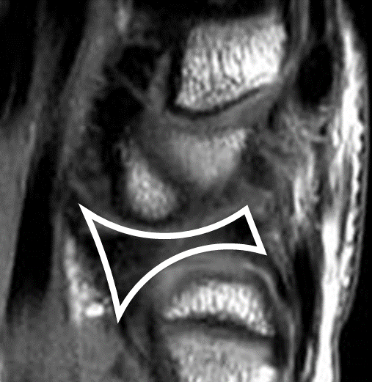  □ Biconcave disc volar thicker than dorsal

1.2 | TFC morphology – On the mid-coronal slice where the TFC is at its thinnest  Coronal PD and PD SPAIR | 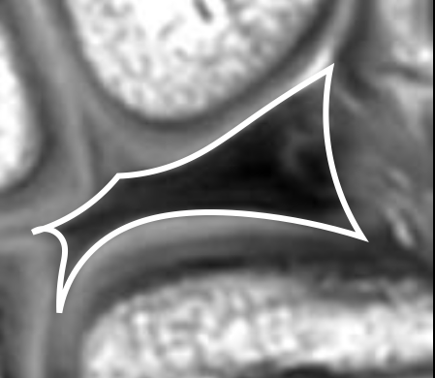  □ Slightly radial tilted asymmetrical bowtie |  | 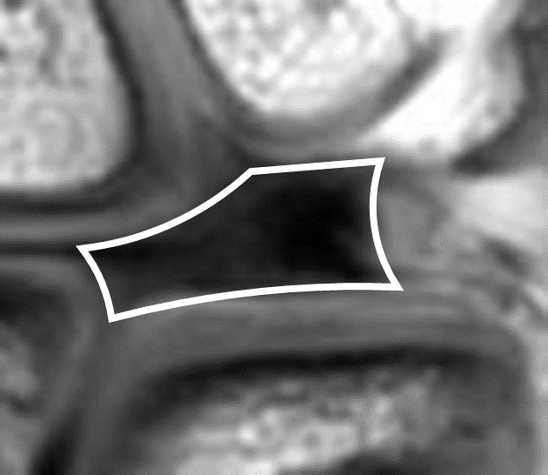  □ Shorter, thicker and more horizontal structure |  | 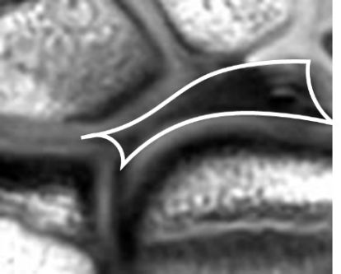  □ Thinner and more stretched structure
1.3 | TFC thickness – On the mid-coronal slice where the TFC is at its thinnest  Coronal PD and PD SPAIR |  | 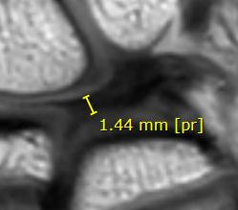  _ . _ _ mm at the thinnest point |  | 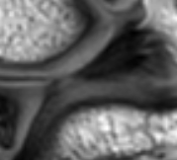0.00 mm when cannot be measured
1.4 | Homogeneity  Coronal PD and PD SPAIR | 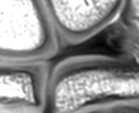  □ Homogeneous hypointens without increased signal | 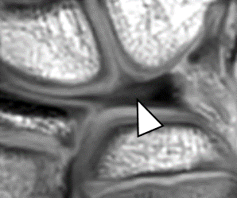  □ Diffuse increased signal not extending to the joint surface |  | 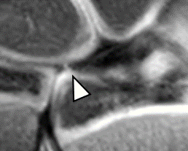  □ Linear vertical increased signal with disruption of the disc |  | 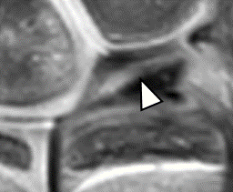  □ Other

C | RADIOULNAR LIGAMENTS (RUL’s)
1.1 | Homogeneity dorsal RUL – sagittal  Sagittal PD | 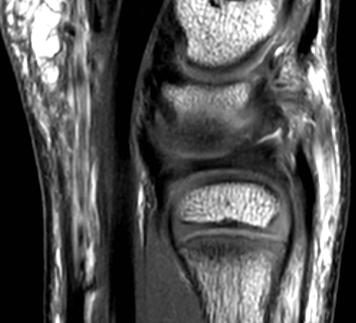  □ Continuous with TFC |  | 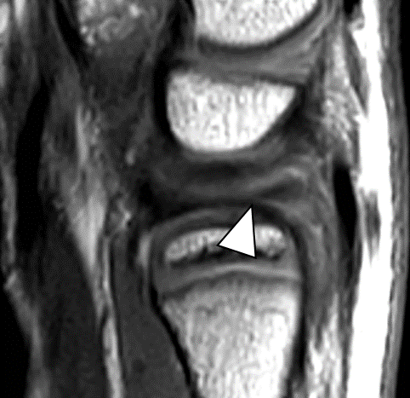  □ Not continuous with TFC |  | □ Not able to assess
1.2 | Homogeneity volair RUL – sagittal  Sagittal PD | 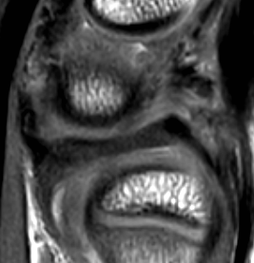  □ Continuous with TFC |  | 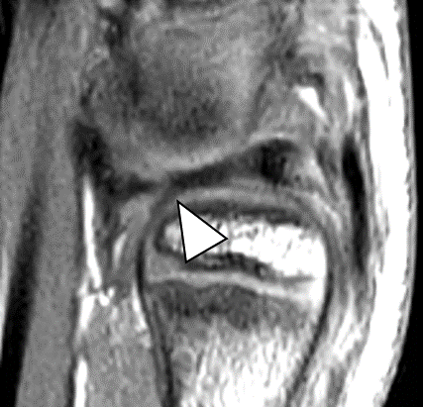  □ Not continuous with TFC |  | □ Not able to assess
1.3 | Fiber continuity dorsal RUL – axial  Axial PD and T2 SPAIR | 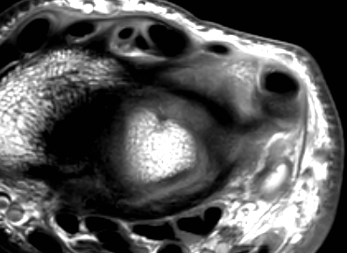  □ Continuous fibers |  | 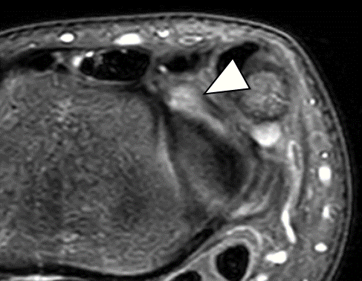  □ Fiber disruption |  | □ Not able to assess
1.4 | Fiber continuity volar RUL – axial  Axial PD and T2 SPAIR | 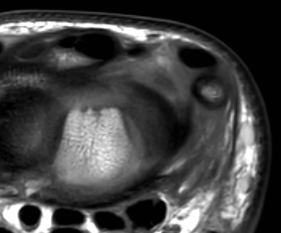  □ Continuous fibers |  | □ Fiber disruption |  | □ Not able to assess
D | PROXIMAL (DEEP) AND DISTAL (SUPERFICIAL) LAMINA
1.1 | Homogeneity proximal lamina  Coronal PD and PD SPAIR / sagittal PD | 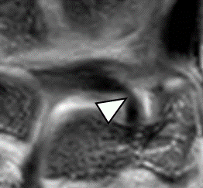  □ Homogeneous hypointens |  | 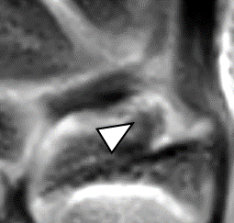  □ Diffuse lamination |  | 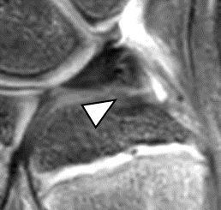  □ Not able to assess

1.2 | Homogeneity distal lamina  Coronal PD and PD SPAIR / sagittal PD | 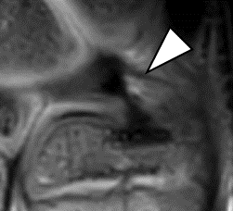  □ Homogeneous hypointens |  |  | 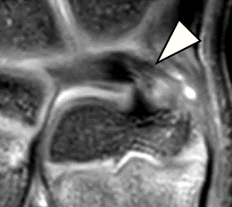  □ Diffuse lamination |  | 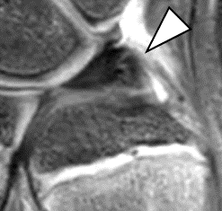  □ Not able to assess
E | LIGAMENTUM SUBCRUENTUM
1 | Visibility  Coronal PD SPAIR |  | 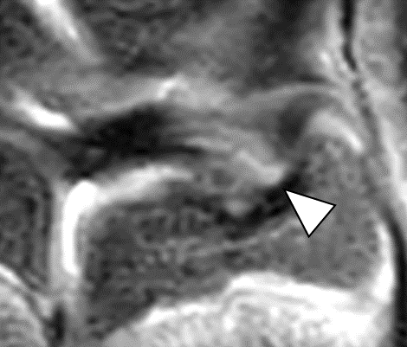□ Hyperintens signal between the proximal and distal lamina |  |  | 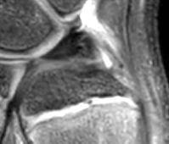  □ Not visible

F | PRESTYLOID RECESS
1 | Visibility  Coronal PD SPAIR | 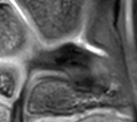  □ Tubular shaped | 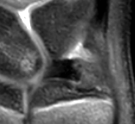  □ Conical shaped |  |  | 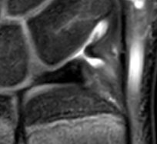  □ Saccular shaped |  | 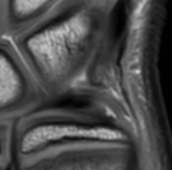  □ Not visible
G | MENISCUS HOMOLOGUE
1 | Visibility  Coronal PD en PD SPAIR | 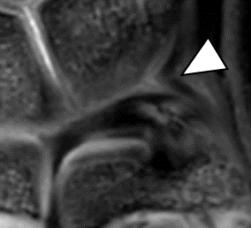  □ Clearly delineated hypointensity |  |  | 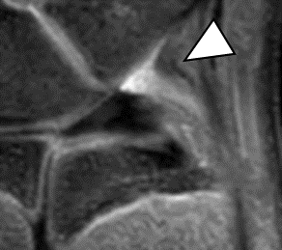  □ Diffuse hypointensity |  | 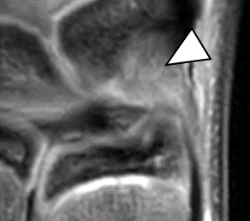  □ Not visible due to diffuse hyperintensity

H | EXTENSOR CARPI ULNARIS (ECU)
1.1 | ECU position in ulnar groove  Axial PD and T2 SPAIR | 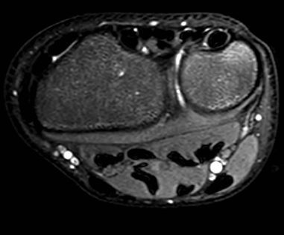  □ Completely within ECU groove |  |  | 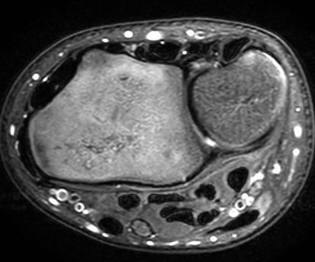  □ Partially within ECU groove |  | 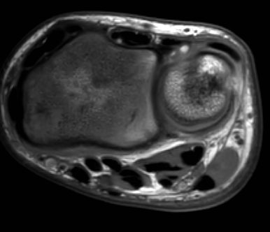  □ Completely outside ECU groove
1.2 | Peritendinous signal intensity – from the ECU groove until distal extensor retinaculum  Axial T2 SPAIR |  | 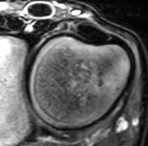  □ Hypointens or intermediate signal |  |  | 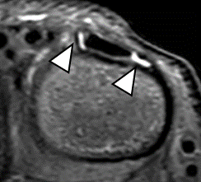  □ Focal increased signal

1.3 | Intratendinous signal intensity – from the ECU groove until distal extensor retinaculum  Axial T2 SPAIR |  |  | □ Homogeneous hypointens | 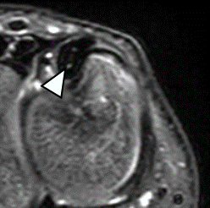  □ Focal or linear increased signal
1.4 | Location increased signal  Axial T2 SPAIR | □ Not applicable | □ Proximal from the styloid process |  | □ At the styloid process level | □ Distal from the styloid process

I | DISTAL RADIOULNAR JOINT (DRUJ)
1.1 | Effusion radioulnar  Coronal PD SPAIR and axial T2 SPAIR | 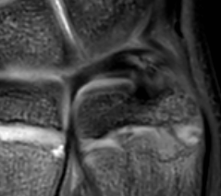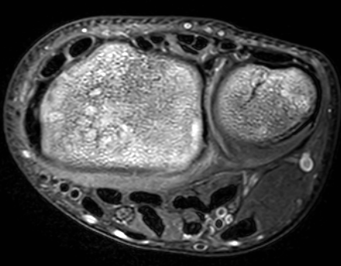  □ Absent |  | 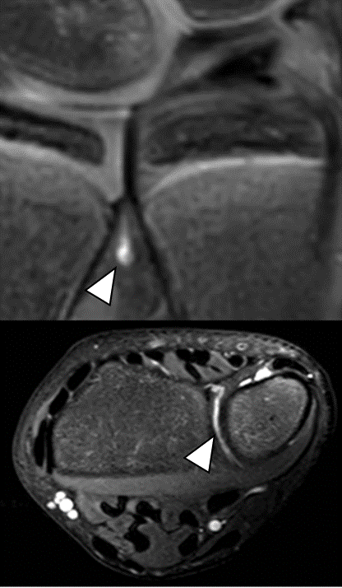  □ Small amount | 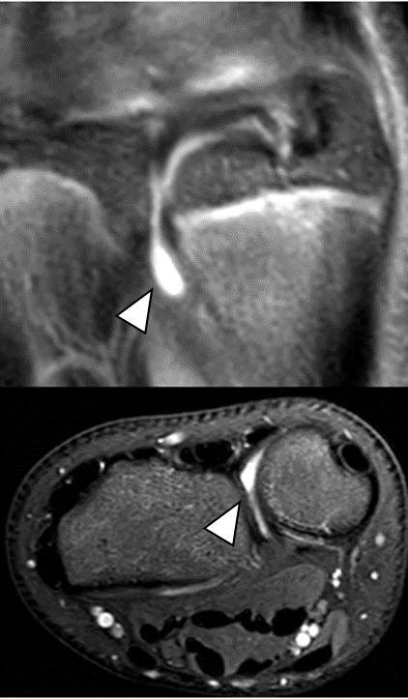  □ Substantial amount

1.2 | Cysts – ulnar sided wrist  Coronal PD SPAIR and axial T2 SPAIR | 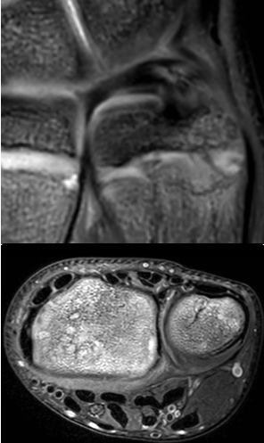  □ Absent |  | 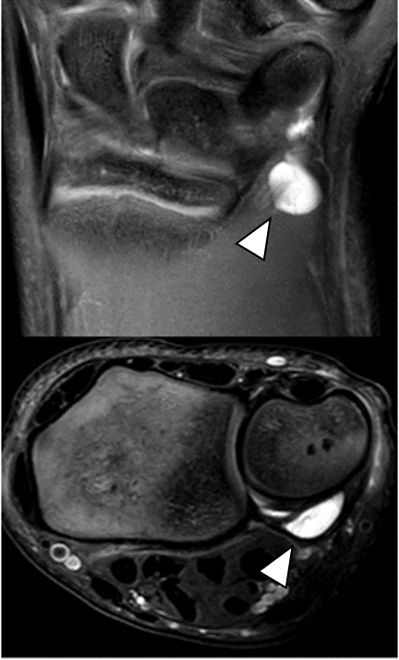  □ Volar | 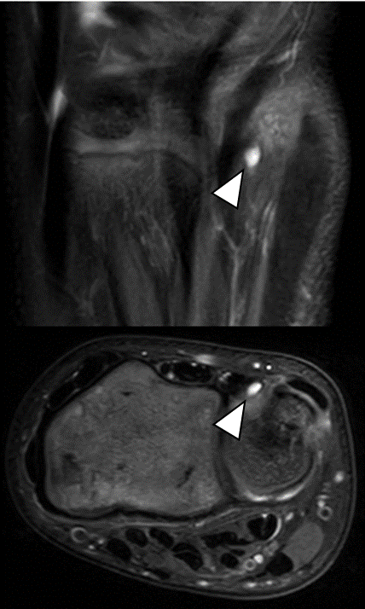  □ Dorsal
J | PISOTRIQUETRAL JOINT (PTJ)
1.1 | PTJ effusion  Coronal PD SPAIR | 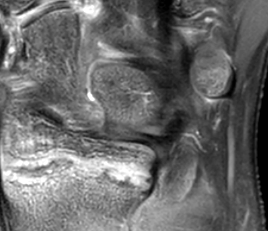  □ Absent |  | 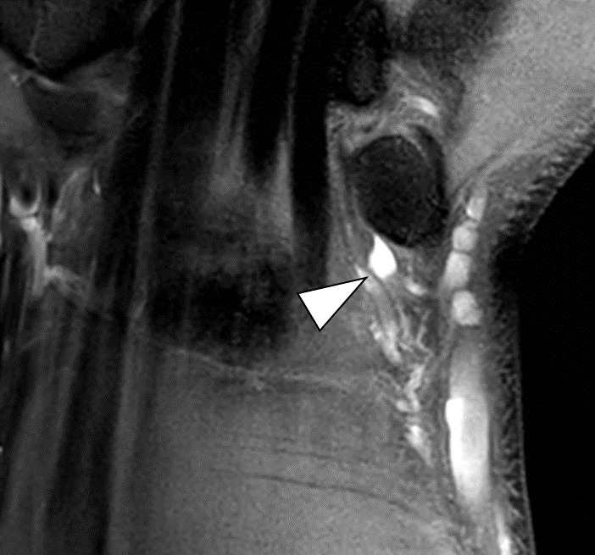  □ Small amount | 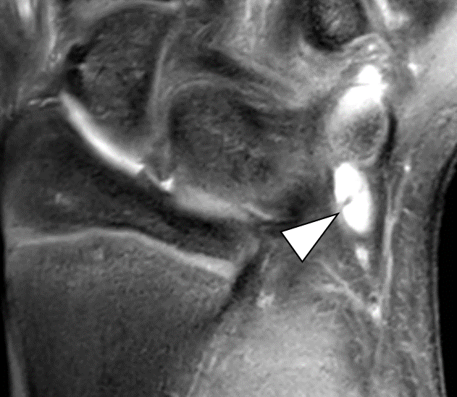  □ Substantial amount

K | OTHER RELEVANT FINDINGS

