SUPPLEMENTARY MATERIAL
APPENDIX A
Table A1 – Difference between WB vs NWB for day 1
 | Navicular plantar displacement | Navicular medial displacement
p-value | *** | ***
MDC | 4.08 | 2.20
Mean_{diff} | 3.91 | 1.70
SD_{diff} | 2.08 | 1.12
p-value: ****= p <0.001, MDC: minimal detectable change in mm. Mean_{diff}: mean of measurements in mm, SD: standard deviation in mm, SD_{diff} :standard deviation in mm

Table A2 – Intraobserver reproducibility of radiological measurements
 |  |  | DAY1 1st round vs 2nd round
 | Plantar position |  | Medial position
 | WBCT | NWBCT | WBCT | NWBCT
p-value | n.s. | n.s. | n.s. | n.s.
Mean | 37.22 | 41.15 | 36.59 | 34.95
SD | 6.47 | 6.82 | 3.69 | 3.19
Mean_{diff} | .05 | .01 | .18 | .12
SD_{diff} | .29 | .17 | 1.30 | 1.53
SEM | .20 | .12 | .92 | .90
MDC | .57 | .33 | 2.54 | 2.99
ICC | 1.000(.999;1.000) | 1.000(1.000;1.000) | .967(.918;.987) | .946(.864;.979)
 |  |  | DAY 1 vs DAY 2
 | Plantar position |  | Medial position
 | WBCT | NWBCT | WBCT | NWBCT
p-value | n.s. | n.s. | n.s. | n.s.
Mean | 37.17 | 41.34 | 36.68 | 35.01
SD | 6.44 | 6.72 | 3.52 | 3.22
Mean_{diff} | 0.16 | 0.37 | 0.18 | 0.12
SD_{diff} | 1.13 | 0.94 | 1.30 | 1.53
SEM | 0.80 | 0.66 | 0.92 | 1.08
MDC | 2.21 | 1.84 | 2.54 | 2.99
ICC | .933(.981;997) | .995(.986;998) | .967(.918;.987) | .946(.864;.979)
p-value: n.s.= p > .05 (non-significant), Mean: mean of measurements in mm, SD: standard deviation in mm, Mean_{diff}: mean difference of measurements in mm, SD_{diff} : difference of standard deviation in mm, SEM: standard error of the mean, MDC: minimal detectable change, ICC: Intraclass correlation coefficient

Table A3 – Interobserver reproducibility of radiological measurements
 | Navicular plantar position
 | DAY1 |  | DAY 2
 | WBCT | NWBCT | WBCT | NWBCT
p-value | n.s. | n.s. | n.s. | n.s.
Mean | 37.34 | 41.27 | 37.08 | 41.65
SD | 6.33 | 6.74 | 6.31 | 6.55
Mean_{diff} | .18 | .23 | .02 | .25
SD_{diff} | .76 | .71 | .94 | .71
SEM | .54 | .50 | .67 | .50
MDC | 1.48 | 1.39 | 1.85 | 1.40
ICC | .996(.991;.999) | .997(.993;.999) | .997(.993;.999) | .997(.993;.999)
 | Navicular medial position
 | DAY1 |  | DAY 2
 | WBCT | NWBCT | WBCT | NWBCT
p-value | ** | * | n.s. | n.s.
Mean | 36.36 | 34.83 | 36.41 | 34.84
SD | 3.42 | 3.43 | 3.58 | 3.04
Mean_{diff} | .81 | .47 | .35 | .22
SD_{diff} | 1.02 | 0.92 | 1.19 | 1.41
SEM | .72 | .65 | .84 | 1.00
MDC | 2.00 | 1.81 | 2.33 | 2.77
ICC | .978(.943;.991) | .982(.954;.993) | .972(.930;.989) | .946(.864;.979)
p-value: *= p ≤0.05, **= p ≤.01 , n.s.= p > .05 (non-significant), Mean: mean of measurements in mm, SD: standard deviation in mm, Mean_{diff}: mean difference of measurements in mm, SD_{diff} : difference of standard deviation in mm, SEM: standard error of the mean, MDC: minimal detectable change, ICC: Intraclass correlation coefficient

Table A4 – Inter- and intraobserver reproducibility for clinical FPI measurements
 | DAY1 vs DAY2 | DAY 1
 | Intraobserver | Interobserver
p-value | n.s. | *
Mean | 4.45 | 4.27
SD | 2.67 | 2.71
Mean_{diff} | .70 | 1.10
SD_{diff} | 1.81 | 1.92
SEM | 1.36 | 1.28
MDC | 3.55 | 3.76
ICC | .875(.684;.950) | .875(.683;.950)
p-value: *=p≤0.05, n.s.= p > .05 (non-significant), Mean: mean of measurements in mm, SD: standard deviation in mm, Mean_{diff}: mean difference of measurements in mm, SD_{diff} : difference of standard deviation in mm, SEM: standard error of the mean, MDC: minimal detectable change, ICC: Intraclass correlation coefficient

APPENDIX B – RADIOLOGICAL INTRAOBSERVER MEASUREMENTS
Figure B1 – Bland-Altman plot of intraobserver measurements of WB plantar position
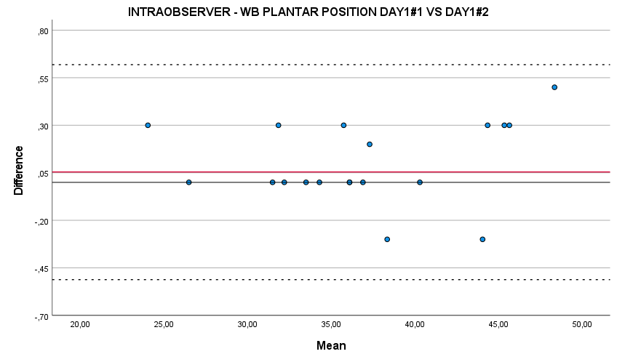
Figure B2 – Bland-Altman plot of intraobserver measurements of NWB plantar position
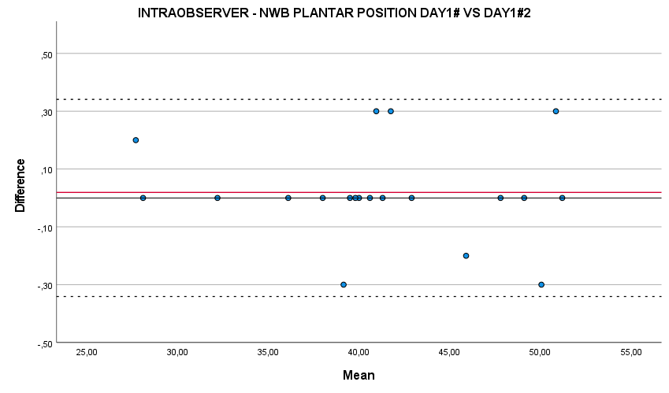
Figure B3 – Bland-Altman plot of intraobserver measurements of WB medial position
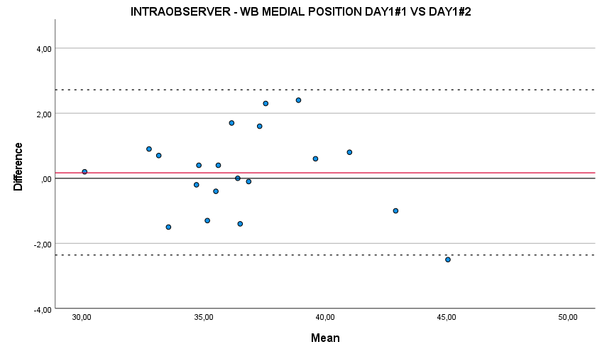

Figure B4 – Bland-Altman plot of intraobserver measurements of NWB medial position
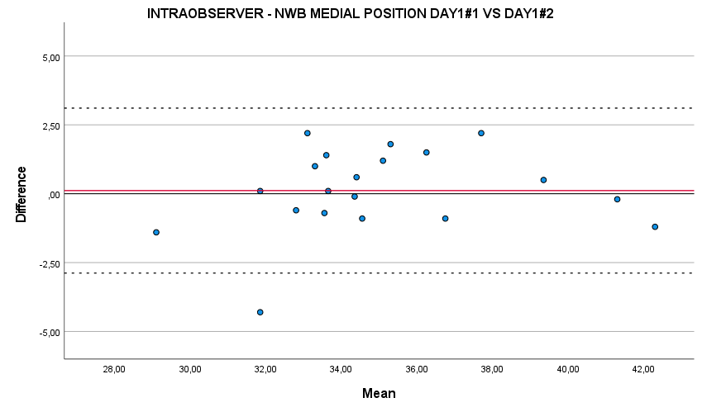

APPENDIX C – RADIOLOGICAL INTEROBSERVER MEASUREMENTS

Figure C1 – Bland-Altman plot of interobserver measurements of WB plantar position day 1

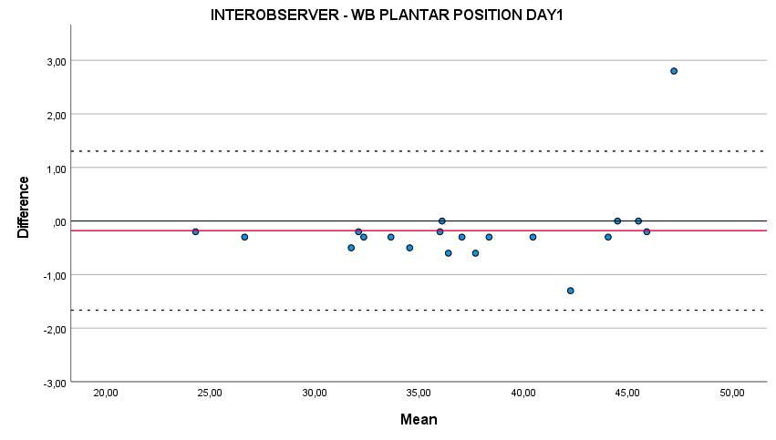

Figure C2 – Bland-Altman plot of interobserver measurements of WB plantar position day 2

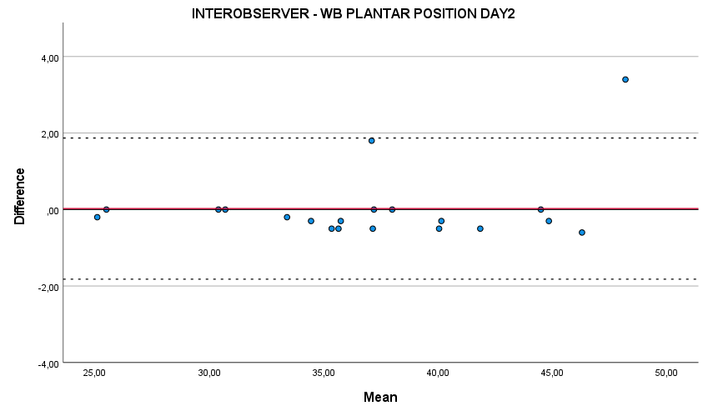

Figure C3 – Bland-Altman plot of interobserver measurements of NWB plantar position day 1

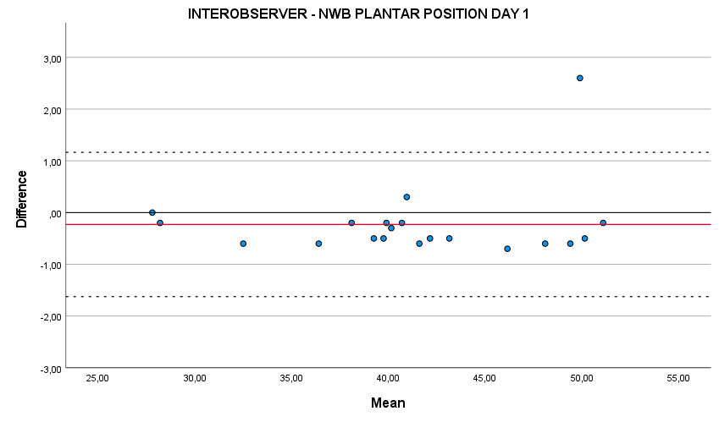

Figure C4 – Bland-Altman plot of interobserver measurements of NWB plantar position day 2

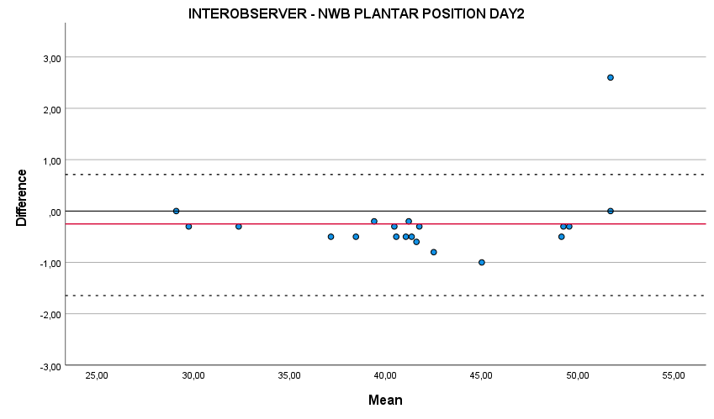

Figure C5 – Bland-Altman plot of interobserver measurements of WB medial position day 1

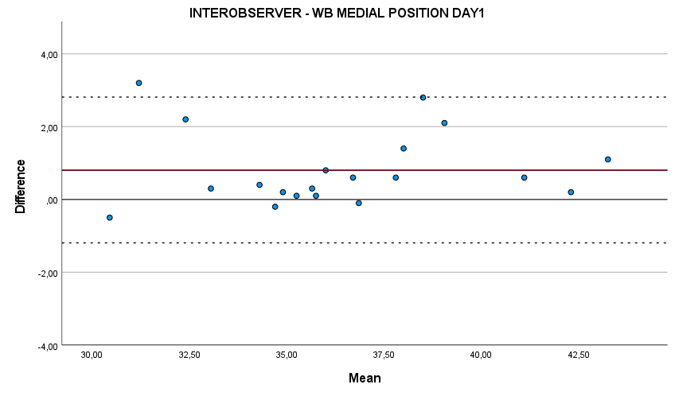

Figure C6 – Bland-Altman plot of interobserver measurements of WB medial position day 2

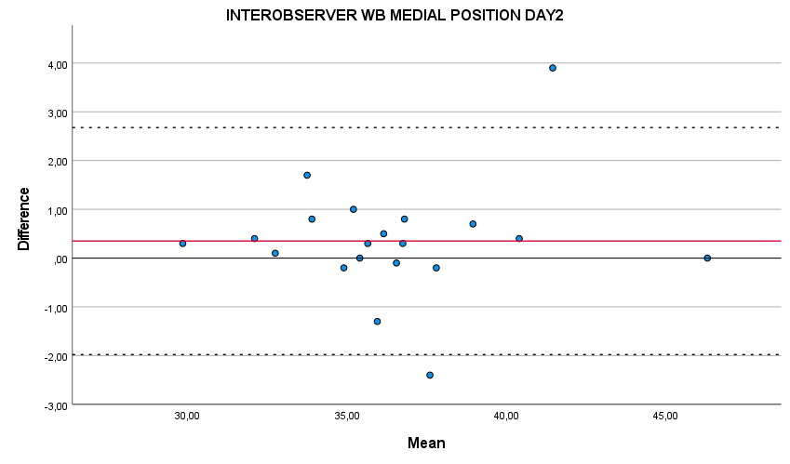

Figure C7 – Bland-Altman plot of interobserver measurements of NWB medial position day 1

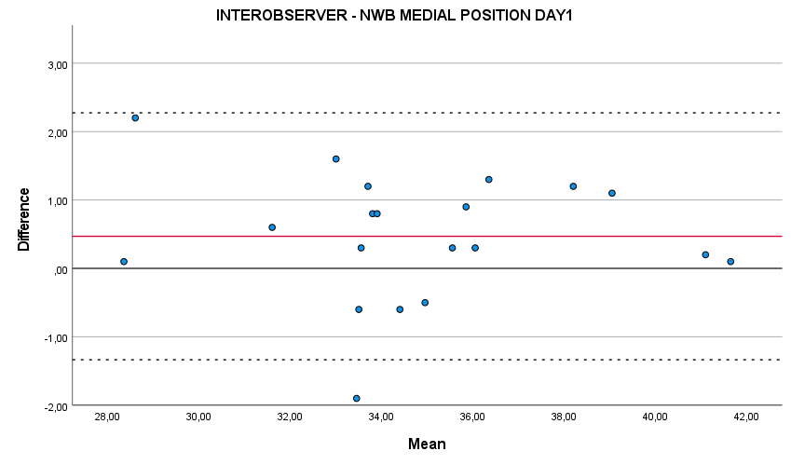

Figure C8 – Bland-Altman plot of interobserver measurements of NWB medial displacement day 2
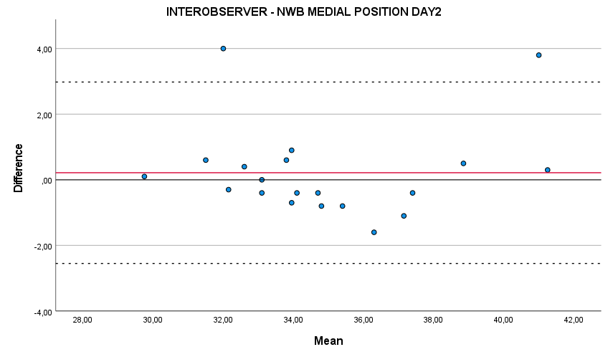
APPENDIX D – DELTA VALUES BETWEEN WB AND NWB POSITION

Figure D1 - Bland-Altman plot of interobserver measurements of plantar displacement delta values between WB and NWB position, between day 1 vs day 2

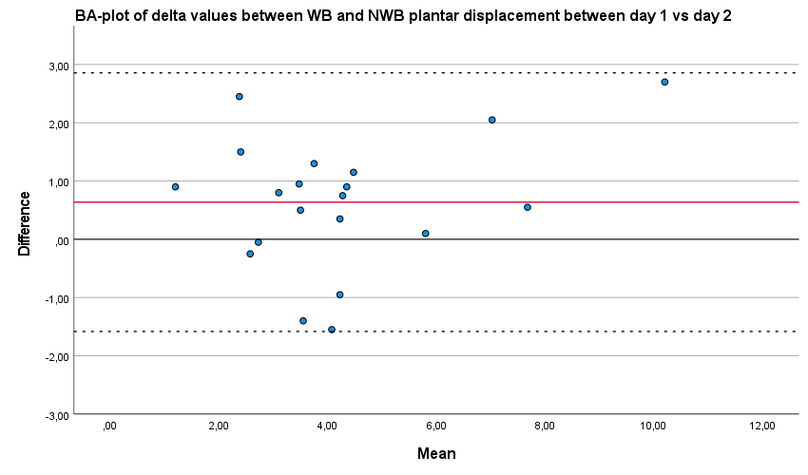
Figure D2 - Bland-Altman plot of interobserver measurements of medial displacement delta values between WB and NWB position, between day 1 vs day 2

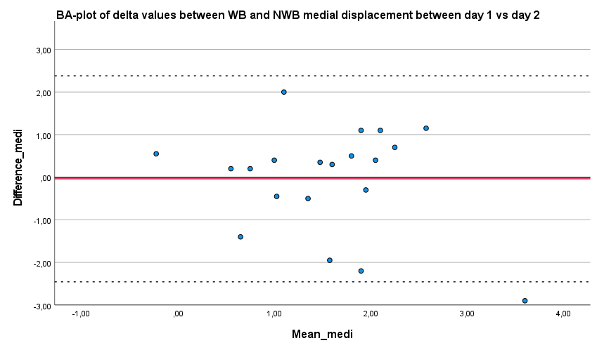
APPENDIX E – CLINICAL FPI MEASUREMENTS

Figure E1 – Bland-Altman plot of intraobserver measurements of total score of clinical FPI measurements day 1 to day 2

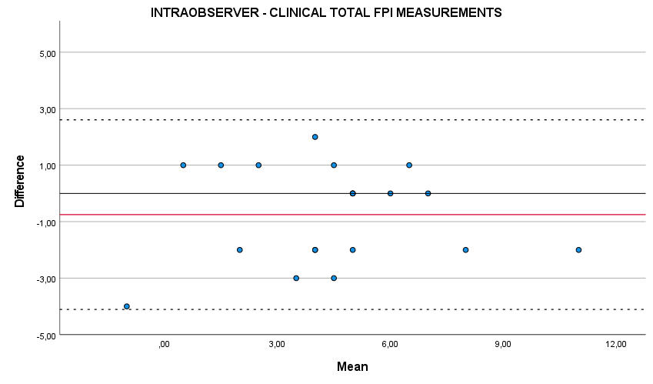

Figure E2– Bland-Altman plot of interobserver measurements of total score of clinical FPI measurements day 1
