Supplementary Material
Fig. S1
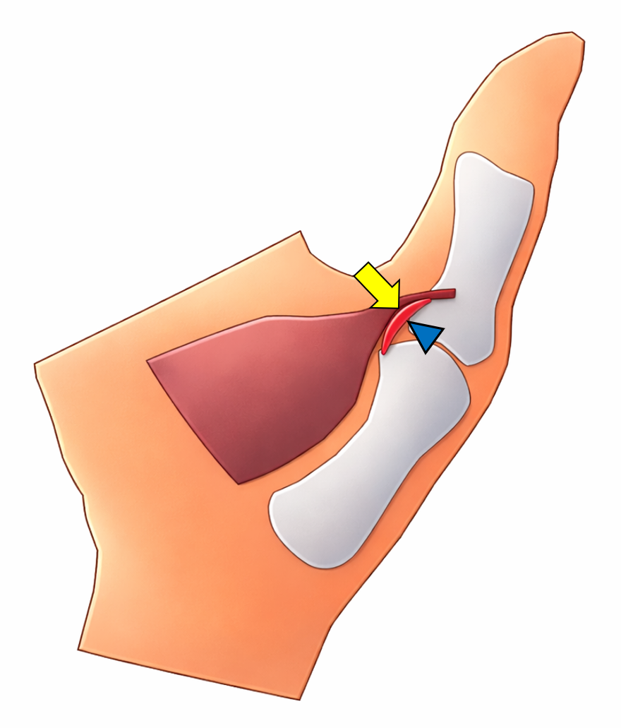

Fig. S1. Schematic illustration of the normal anatomy of the ulnar collateral ligament of the thumb. At the first metacarpophalangeal joint, the intact ulnar collateral ligament (blue arrowhead) is located deep to the aponeurosis of the adductor pollicis muscle (yellow arrow).

Fig. S2

Fig. S2. Coronal fat-saturated PD-weighted MR image of the thumb showing the normal anatomy of the ulnar collateral ligament. At the first metacarpophalangeal joint, the ulnar collateral ligament (red dotted area) lies deep to the aponeurosis of the adductor pollicis muscle (yellow dotted line).

Fig. S3

Fig. S3. Longitudinal ultrasound image of the thumb at the first metacarpophalangeal joint demonstrating an intact ulnar collateral ligament (red dotted area).

Fig. S4

Fig. S4. Schematic illustration of a Stener lesion of the thumb. The ulnar collateral ligament (blue arrowhead) is ruptured, and its distal end is displaced superficial to the aponeurosis of the adductor pollicis muscle. Note that the torn ligament is typically thickened.

