Supplementary Material

The Impact of Revascularization on Myocardial Blood Flow as Assessed by Positron Emission Tomography

European Journal of Nuclear Medicine and Molecular Imaging

Robert M. Bober, MD^{1,2}, Richard V. Milani, MD^{1,2}, Ahmet A. Oktay, MD¹, Fahad Javed, MD¹, Nichole M. Polin, MD^{1,2}, Daniel P. Morin, MD^{1,2}

¹John Ochsner Heart and Vascular Institute, Department of Cardiovascular Diseases, New Orleans, LA

² Ochsner Clinical School, Queensland University School of Medicine, New Orleans, LA

Address for correspondence:
Robert M. Bober, MD
rbober@ochsner.org

Online Resource Figure 1
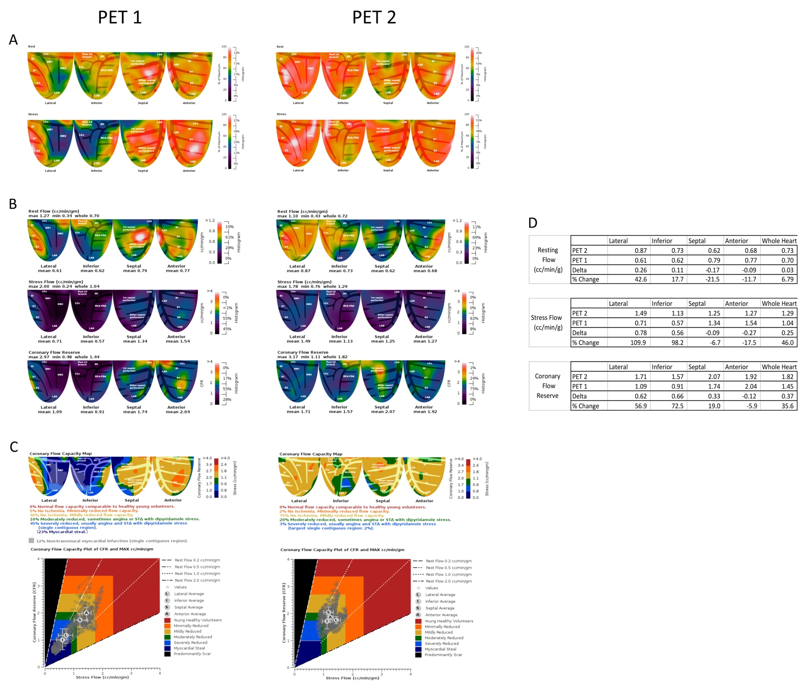
This supplemental figure is a representative case from the study. PET 1 was performed for symptoms of angina and PET 2 was performed 71 days after PCI of the LCX and RCA. (A) Demonstrates a large, severe stress induced relative perfusion defect in the lateral and inferior quadrants comprising 34% of the myocardium. These defects are significant as they represent >10% of the myocardium. There are no significant stress induced perfusion abnormalities in the septal or anterior quadrants. (B) Absolute flow and CFR before and after revascularization with quadrant averages, minimums and maximums. (C) PET 1 coronary flow capacity maps demonstrate severe reduction in CFC in both the lateral and inferior quadrants comprising a total of 45% of the myocardium. As the lateral and inferior walls had significant perfusion abnormalities and were revascularized, they are considered “SevereAbn/+Revasc” whereas the septal and anterior walls are considered “Norm/-Revasc”. After revascularization, severe reduction in flow capacity significantly decreased from 45% to 3% of the myocardium. (D) As a result of revascularization to the lateral and inferior quadrants, rMBF increased 43% and 18% respectively, sMBF increased 110% and 98% respectively and CFR increased 57% and 73% respectively. On a patient level analysis, this patient’s whole heart sMBF increased 46% and rMBF increased 6.8% resulting in an increase in CFR by 36%. On a regional level analysis, this patient contributed 2 “SevereAbn/+Revasc” quadrants and 2 “Norm/-Revasc” quadrants of the total 200 patient quadrants evaluated. This case is an example of “completely concordant” as the patient had revascularization only to territories with perfusion abnormalities and/or reduced flow capacity.

Online Figure 2

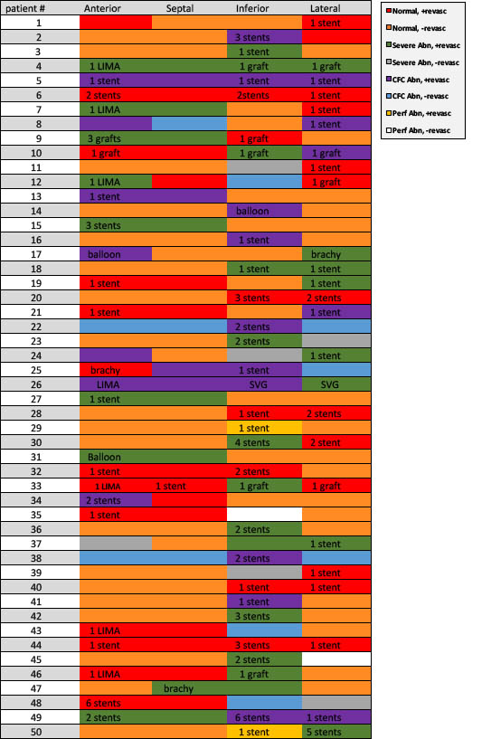

Summary of the quadrant types and revascularization performed in each patient.

Supplemental Table 1
Regional-level analysis comparing PCI vs. CABG

 |  | SevereAbn/+Revasc | CFCAbn/+Revasc | Norm/+Revasc
PCI | ΔrMBF*  [IQR] | 0.05  [-0.01-0.14]  p=0.256  n=24 | 0.10  [-0.05-0.42]  p=0.86  n=22 | -0.07  [-0.17-0.21]  p=0.716  n=34
PCI | ΔsMBF*  [IQR] | 0.52†  [0.32-0.78]  p<0.001  n=24 | 0.35‡  [0.14-0.52]  P<0.001  n=22 | 0.05§  [-0.31-0.29]  p=0.889  n=34
CABG | ΔrMBF*  [IQR] | 0.32  [0.02-0.40]  p=0.038  n=13 | 0.14  [0.12-0.23]  P=0.137  n=4 | 0.12  [0.07-0.29]  p=0.256  n=10
CABG | ΔsMBF*  [IQR] | 0.50†  [0.31-0.58]  p=0.004  n=13 | 0.35‡  [0.34-0.43]  P=0.093  n=4 | 0.04§  [-0.32-0.18]  p=0.756  n=10
* = indicates change between PET1 and PET2 in cc/min/g
†,‡, §= ΔsMBF between PCI and CABG regions; p= 0.790, 0.627, 0.644 respectively

Supplemental Table 2
Risk Factors in Patient Concordant Categories

Risk Factor | Completely Concordant Patients (n=26) | Mixed Concordant  Patients (n=12) | Completely Discordant Patients (n=12) | P value
CAD | 20 (76.9%) | 9 (75.0%) | 11 (91.7%) | 0.879
Hypertension | 25 (96.2%) | 11 (91.7%) | 11 (91.7%) | 0.992
Hyperlipidemia | 22 (84.6%) | 12 (100%) | 12 (100%) | 0.352
Diabetes Mellitus | 15 (57.7%) | 6 (50.0%) | 9 (75.0%) | 0.816
Tobacco use | 4 (15.4%) | 4 (33.0%) | 3 (25.0%) | 0.828
Prior PCI | 14 (53.8) | 6 (50.0%) | 5 (41.7%) | 0.990
Prior CABG | (9) 34.6% | 1 (8.3%) | 3 (25%) | 0.540
CAD, coronary artery disease; PCI, percutaneous coronary intervention; CABG, coronary artery bypass graft

Supplemental Table 3
Regression Analysis Identifying Predictors of Improvement in Whole Heart Stress MBF After Revascularization
 | Change in Stress MBF
 | Univariable Analysis |  | Multivariable Analysis 1 |  | Multivariable Analysis 2 |  | Multivariable Analysis 3
 | β | P Value | β | P Value | β | P Value | β | P Value
Risk factors
Age | -0.155 | 0.283
Gender | 0.029 | 0.840
Body Mass Index | -0.205 | 0.154* | -1.281 | 0.111 | -1.419 | 0.071 | -1.209 | 0.110
Diabetes Mellitus | -0.318 | 0.024* | -18.191 | 0.053 | -17.277 | 0.058 | -13.707 | 0.121
Hypertension | 0.096 | 0.509
Hyperlipidemia | -0.270 | 0.058* | -23.027 | 0.175 | -23.698 | 0.150 | -16.984 | 0.288
Tobacco use | 0.074 | 0.610
History of PCI | -1.76 | 0.223
History of CABG | -2.47 | 0.083* | -13.434 | 0.193 | -13.843 | 0.167 | -15.817 | 0.102
Medication Use
Statins | -0.011 | 0.939
Platelet inhibition | -0.092 | 0.525
Beta Blockers | 0.06 | 0.680
Ca channel blockers | -0.039 | 0.788
ACE/ARB | 0.081 | 0.575
PET scan findings
Severe PA | 0.242 | 0.09* |  |  | 17.187 | 0.050* | 5.445 | 0.579
Severely reduced CFC | 0.443 | 0.001* |  |  |  |  | 25.338 | 0.032*
PCI, percutaneous coronary intervention; CABG, coronary artery bypass graft; ACE, angiotensin converting enzyme; ARB, angiotensin receptor blocker; PA, perfusion abnormality; CFC, coronary flow capacity
*Significant coefficients for P<0.20 (univariable analysis) or P<0.05 (multivariable analysis).

Supplemental Table 4
Regression Analysis to Determine Which PET Flow Metric Predicts Any Improvement in sMBF After Revascularization
 | Univariable analysis |  | Multivariable Analysis
PET Metric | β | P Value | β | P Value
Severely reduced CFC | 0.77 | <0.001 | 0.948 | 0.004
Baseline sMBF | -32.66 | 0.01 | 24.15 | 0.221
Baseline CFR | -31.21 | 0.007 | -16.84 | 0.162
CFC, coronary flow capacity; sMBF, stress myocardial blood flow; CFR, coronary flow reserve

Supplemental Table 5
Regression Analysis to Determine Which PET Flow Metric Predicts Improvement >20% in sMBF After Revascularization
 | Univariable analysis |  | Multivariable Analysis
PET Metric | β | P Value | β | P Value
Severely reduced CFC | 0.010 | 0.001 | 0.015 | 0.004
Baseline sMBF | -0.348 | 0.063 | 0.428 | 0.161
Baseline CFR | -0.268 | 0.123 | -0.069 | 0.706
CFC, coronary flow capacity; sMBF, stress myocardial blood flow; CFR, coronary flow reserve

