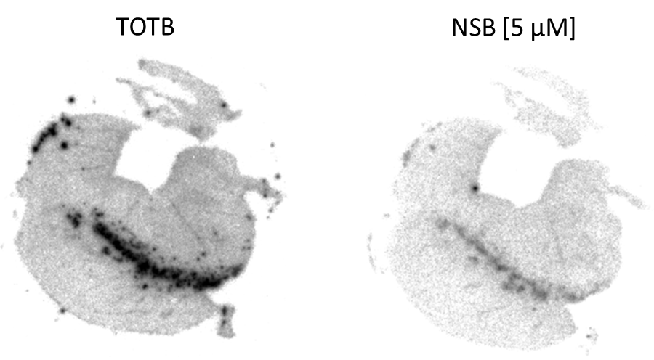
Supplement Figure 1: Assessment of specific binding of [¹⁸F]PI-2620 (7) to the pars compacta of human brain sections of the substantia nigra. Non-specific binding (NSB) was determined by addition of 5 µM unlabeled PI-2620.

