Supplementary material and methods 1
Radiochemistry
Scheme S1. Synthesis of ¹⁸F-FPIA. Reaction conditions: a) ¹⁸F-fluoride, K₂₂₂, KHCO₃, DMSO, 120 °C, 25 min; b) NaOH, then HCl.

Automated radiosynthesis of ¹⁸F-FPIA using the GE FASTlab™ platform.
An aqueous solution of ¹⁸F-fluoride in oxygen-18 enriched water (2 – 3 mL) was transferred from the cyclotron target to the hot-cell containing the FASTlab module with a sweep of argon gas. The ¹⁸F-fluoride was trapped on a Waters Sep-Pak QMA-carbonate light cartridge and eluted into the reactor with a solution (700 uL) containing MeCN (550 uL), H₂O (150 uL), Kryptofix K₂₂₂ (10.1 mg) and KHCO₃ (1.7 mg). The ¹⁸F-fluoride was dried by evaporation in vacuo (120 °C, -1000mBar) and a low flow of nitrogen (200 mBar) for 8 min. To the reactor containing dry ¹⁸F-fluoride was added 1 (5 - 7 mg) in anhydrous DMSO (500 µL) and heated at 120 °C for 15 min to produce ¹⁸F-2. After cooling to 60 °C, a solution of NaOH (1 mL, 2M) was added to the reactor and heated to 50 °C for 15 min to produce ¹⁸F-FPIA. The reactor was cooled and to the reactor containing crude reaction mixture was added HCl_{(aq)} (1 mL, 2M). The contents of the reactor were transferred to an off-board bottle containing sodium phosphate buffer (17 mL, 58 mM) and phosphoric acid (500 µL, 1M) to achieve a final pH of 2.4 for semi-preparative HPLC purification. The HPLC injection loop (10 mL) was filled and ¹⁸F-FPIA was purified using an Agilent Eclipse XDB-C18 5µm, 250 × 9.4 mm column with a mobile phase containing 15% EtOH and 85% sodium dihydrogen phosphate buffer (58 mM, pH 4.5) at a flow rate of 4 mL/min. A radioactive peak corresponding to ¹⁸F-FPIA eluted at ca. 12 min, which was cut for 1 min into a sterile vial and formulated in water for injection (5 mL) to give a final buffered formulation pH 4.5 – 5.0. The final formulation was filtered through a PALL Acrodisc 0.2 μm sterile filter into a final sterile vial (Figure S1).

 | Manifold position
¹⁸O water collection | 1
QMA eluent | 2
QMA-carb SPE | 4-5
¹⁸F-inlet | 6
Reaction vessel | 7,8,25
FPIA precursor (1) | 12
NaOH | 14
HCl | 16
Water | 15
HPLC dilution vial | 9
HPLC loop | 10
Product vial | Off cassette

Figure S1. Schematic representations of the GE FASTLab™ cassette with HPLC purification.

Table S1. ¹⁸F-FPIA product description
 | Criteria
Appearance  pH  Chemical purityª  Kryptofix 222  Stable FPIA  FPIA precursor (1)  Hydroxypivalic acid  Unknown impurities  Residual solvents  Acetonitrile  DMSO  Ethanol  Radionuclide identity  Radiochemical purity  Radiochemical stability  Sterility  Endotoxinª | Clear, colourless, practically free from particles  4.5 – 7.0  ≤ 2.2 mg  ≤ 30 μg  ≤ 12 μg  ≤ 4.1 mg  ≤ 50 mg  3 – 10%  105 – 115 min  ≥ 95 %  ≥ 95 %^{b}  Sterile  ≤175 EU
ª in total administered dose
^{b} at end of shelf-life

Supplementary Results 1

A

B  ¹⁸F-FPIA Parent  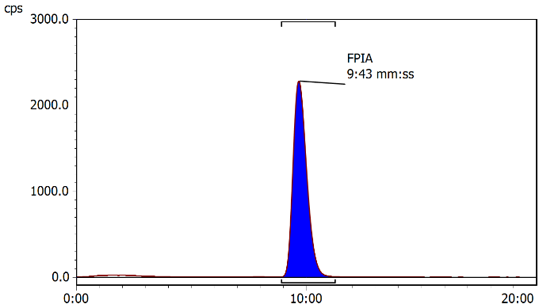 | C  Pivaloylcarnitine  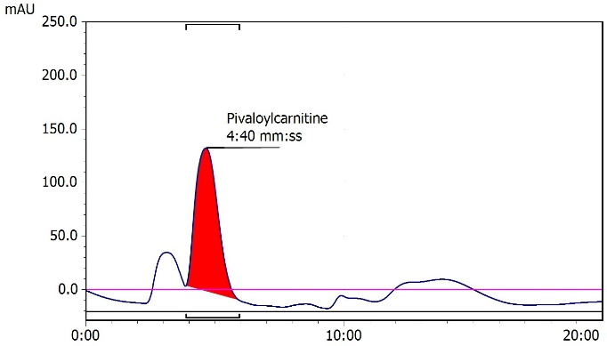
D
Radioactive metabolites in urine
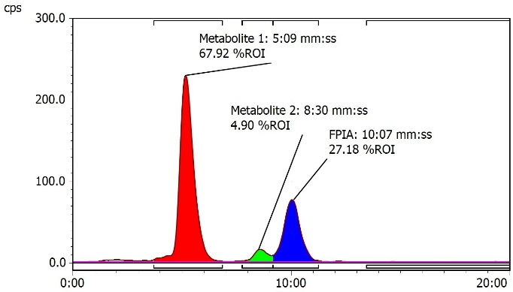
Fig S2. A) Putative mechanism for the in vivo synthesis of ¹⁸F-FPIA-carnitine based on a published mechanism for the in vivo metabolic fate of pivalic acid via activation by coenzyme A (11). B) Radio-HPLC chromatogram showing ¹⁸F-FPIA parent radiotracer, t_{R} = 09:43 min:sec. C) UV-HPLC chromatogram of pivaloylcarnitine obtained from a commercial supplier, t_{R} = 04:40 min:sec, λ = 210 nm. D) Representative radio-HPLC chromatogram showing a main radioactive metabolite (t_{R} = 05:09 min:sec) in urine post PET scan. There is a 20 – 30 sec delay between the UV detector and γ-detector on the HPLC system used.

