False Positive PSMA PET for Tumor Remnants in the Irradiated Prostate and other Interpretation Pitfalls in a Prospective Multi-Center Trial

SUPPLEMENTAL MATERIAL

Supplemental Table 1. PET/CT and PET/MRI Imaging Parameters. Abbreviations: ADT, androgen deprivation therapy; SD, standard deviation.
 |  | PET/CT (N=443) |  |  | PET/MRI (N=192)
Parameter |  | N | (%) |  | N | (%)
Injected activity (mCi) | Median (SD) | 5.1 | (0.9) |  | 5.4 | (1.3)
Uptake time (hh:mm) | Median (SD) | 01:01 | (00:08) |  | 01:14 | (00:15)
Furosemide given |  | 394 | 89 |  | 192 | 100
Contrast given |  | 422 | 95 |  | 188 | 98
PET under ADT |  | 60 | 14 |  | 17 | 9

Supplemental Table 2. [⁶⁸Ga]Ga-PSMA-11 PET/CT and PET/MRI False Negative Findings. Findings are illustrated in Supplemental Figure 2A (CT) and B (MRI). miTNM stage in accordance with PROMISE [8]. Abbreviations: FN, false negative; Tr, prostate bed; N1, pelvic nodes; M1, extrapelvic.
Case No | PSA (ng/mL) | Time from initial therapy (years) | Subregion | N false readers | CT/MRI | Visual PET uptake (SUV_{max}) | Validation triggered by | Details
CT FN 1 | 0.3 | 8 | Tr | 3 | no lesion | no (2.2) | clinical suspicion | adjacent bladder/urine uptake
CT FN 2 | 5.1 | 3 | Tr (Left seminal vesicle) | 2 | no lesion | intermediate (7.2) | PET local read | adjacent bladder/urine uptake
CT FN 3 | 0.2 | 5 | Tr | 2 | no lesion | intermediate (5.5) | PET local read | adjacent rectum uptake
CT FN 4 | 0.2 | 2 | N1 (mesorectal) | 3 | round shaped 5 mm node | no (1.7) | CT local read | small metastasis
CT FN 5 | 2.4 | 7 | Tr (Left seminal vesicle) | 2 | no lesion | intermediate (3.3) | PET local read | small metastasis
CT FN 6 | 2.7 | 14 | M1c (lung) | 2 | 13 mm | no (2.4) | CT local read | partial volume, respiratory movement
MRI FN 1 | 2.9 | 1 | Tr | 3 | thickening of bladder wall | no (1.8) | MRI local read | adjacent bladder/urine uptake
MRI FN 2 | 4.3 | 8 | M1a (retroperitoneal) | 3 | no lesion | low (4.5) | PET local read | small metastasis

Supplemental Figure 1. [⁶⁸Ga]Ga-PSMA-11 PET/CT (A) and PET/MRI (B) False Positive (FP) Findings.
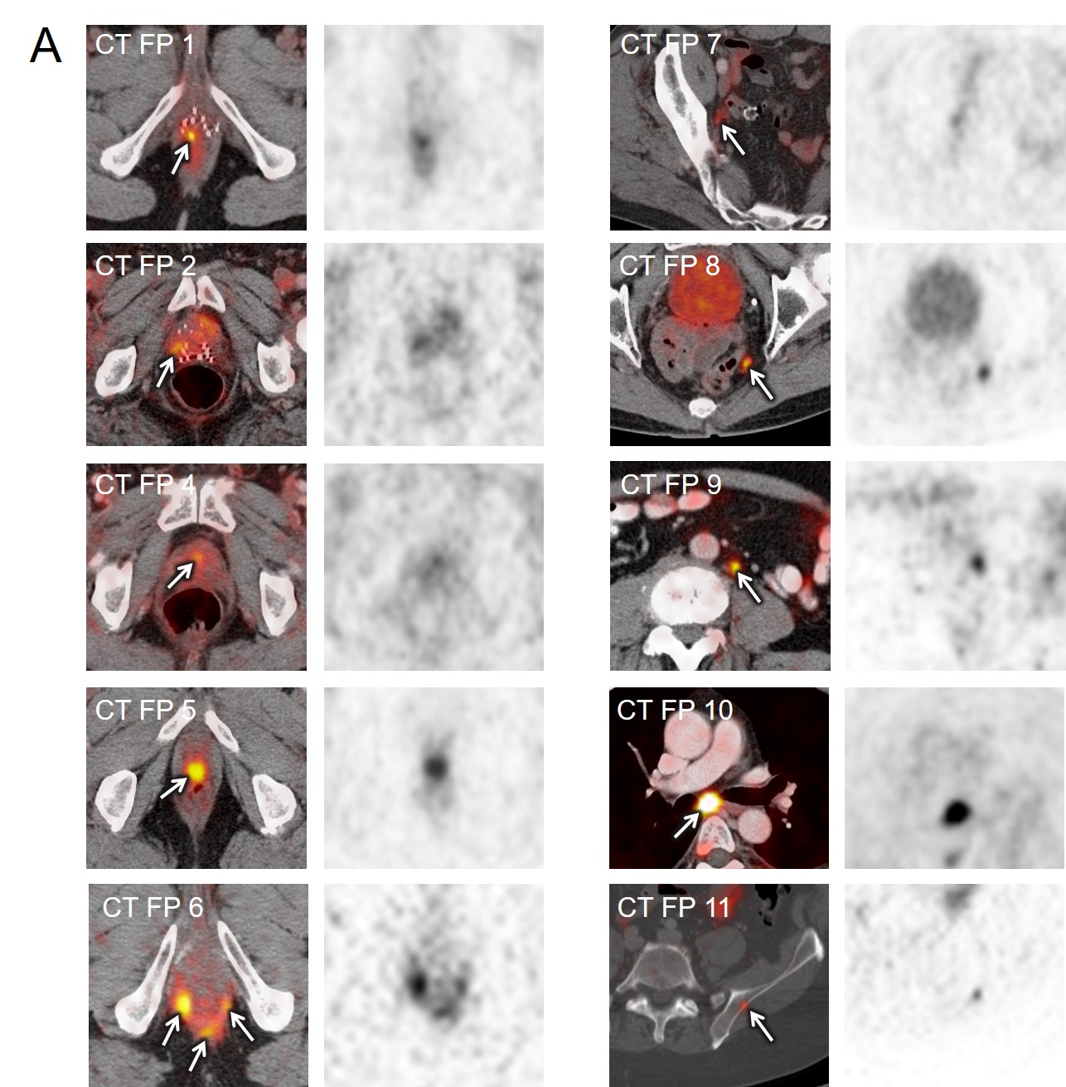
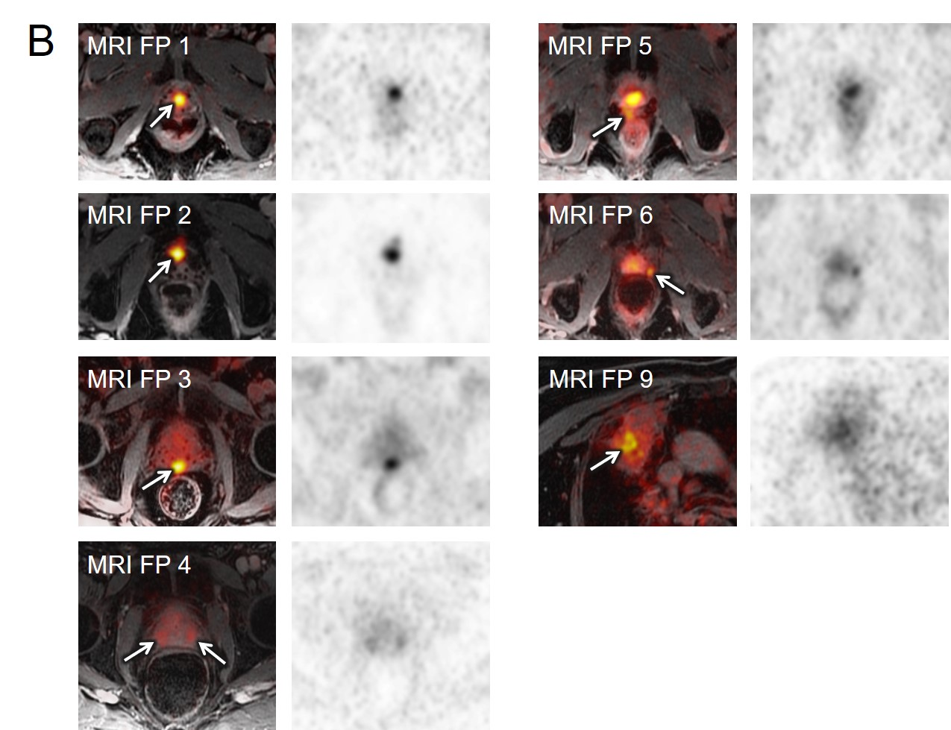

Supplemental Figure 2. [⁶⁸Ga]Ga-PSMA-11 PET/CT (A) and PET/MRI (B) False Negative (FN) Findings.
