Supplementary material

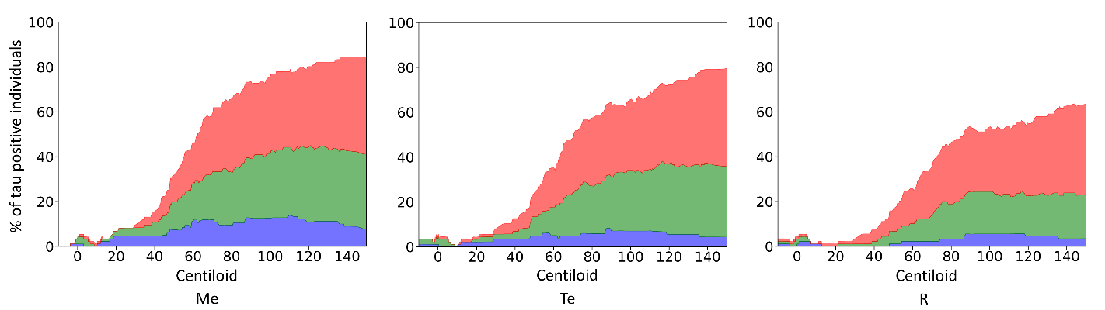
Online Resource 1 Prevalence of tau positive subjects as a function of centiloid excluding subjects in the peri-threshold.
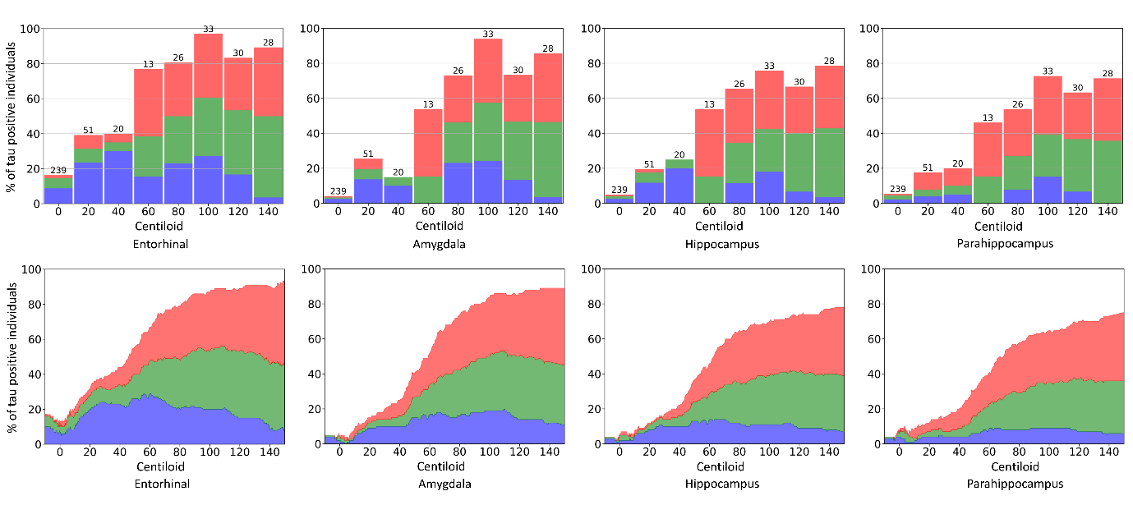
Online Resource 2 Prevalence of tau positive subjects as a function of centiloid in the 4 subregions of Me.
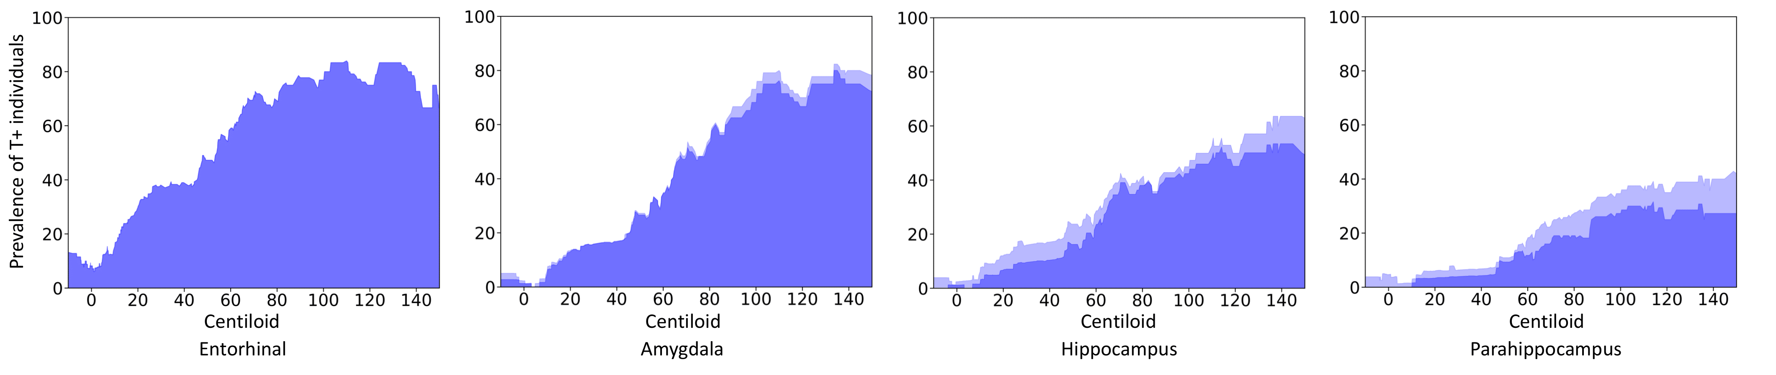
Online Resource 3 Prevalence (percentage) of high tau CU subjects among the cognitively unimpaired in the 4 subregions of Me. No peri-threshold were available for the entorhinal cortex
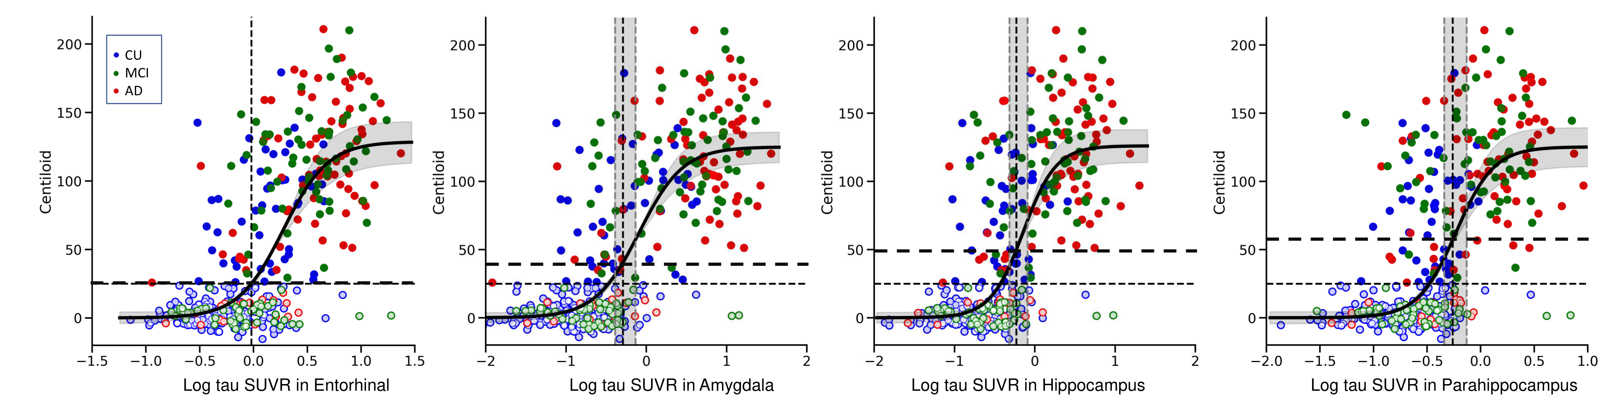
Online Resource 4 From left to right, scatter plots of Centiloid versus the log tau SUVR in the entorhinal cortex (left), amygdala, hippocampus and parahippocamus ROI in 3 different color-coded clinical diagnostic groups, with light colours used to identify A- subjects. Thresholds are displayed in fine dash vertical and horizontal lines. Peri-thresholds are in grey shadow and a sigmoid curve has been fitted to the whole population. The thick dash horizontal line shows the CL value at which tau SUVR reaches the threshold for elevated tau. No peri-threshold were available for the entorhinal cortex

