Supplementary Figure 1: Case example of a patient with decrease of inflammatory uptake between early imaging and late imaging

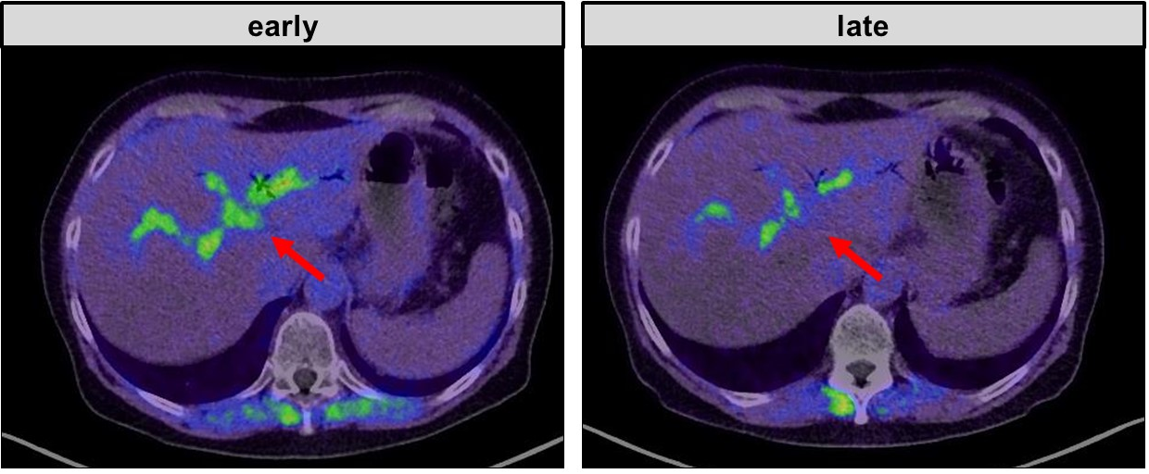

This is a case example of a 62-y/o patient with suspected cholangitis. FAPI-46 PET was performed for re-staging after resection of pancreatic cancer and de-novo peritoneal involvement. FAPI-46 PET revealed aerobilia and surrounding uptake (red arrow), which decreased from early to late imaging (SUVmax 6.2 vs 4.8)

