Figure S2 - VT parametric mapping solved with 2TCM1K and variational bayes regression before and after XBD173 administration in a representative subject.
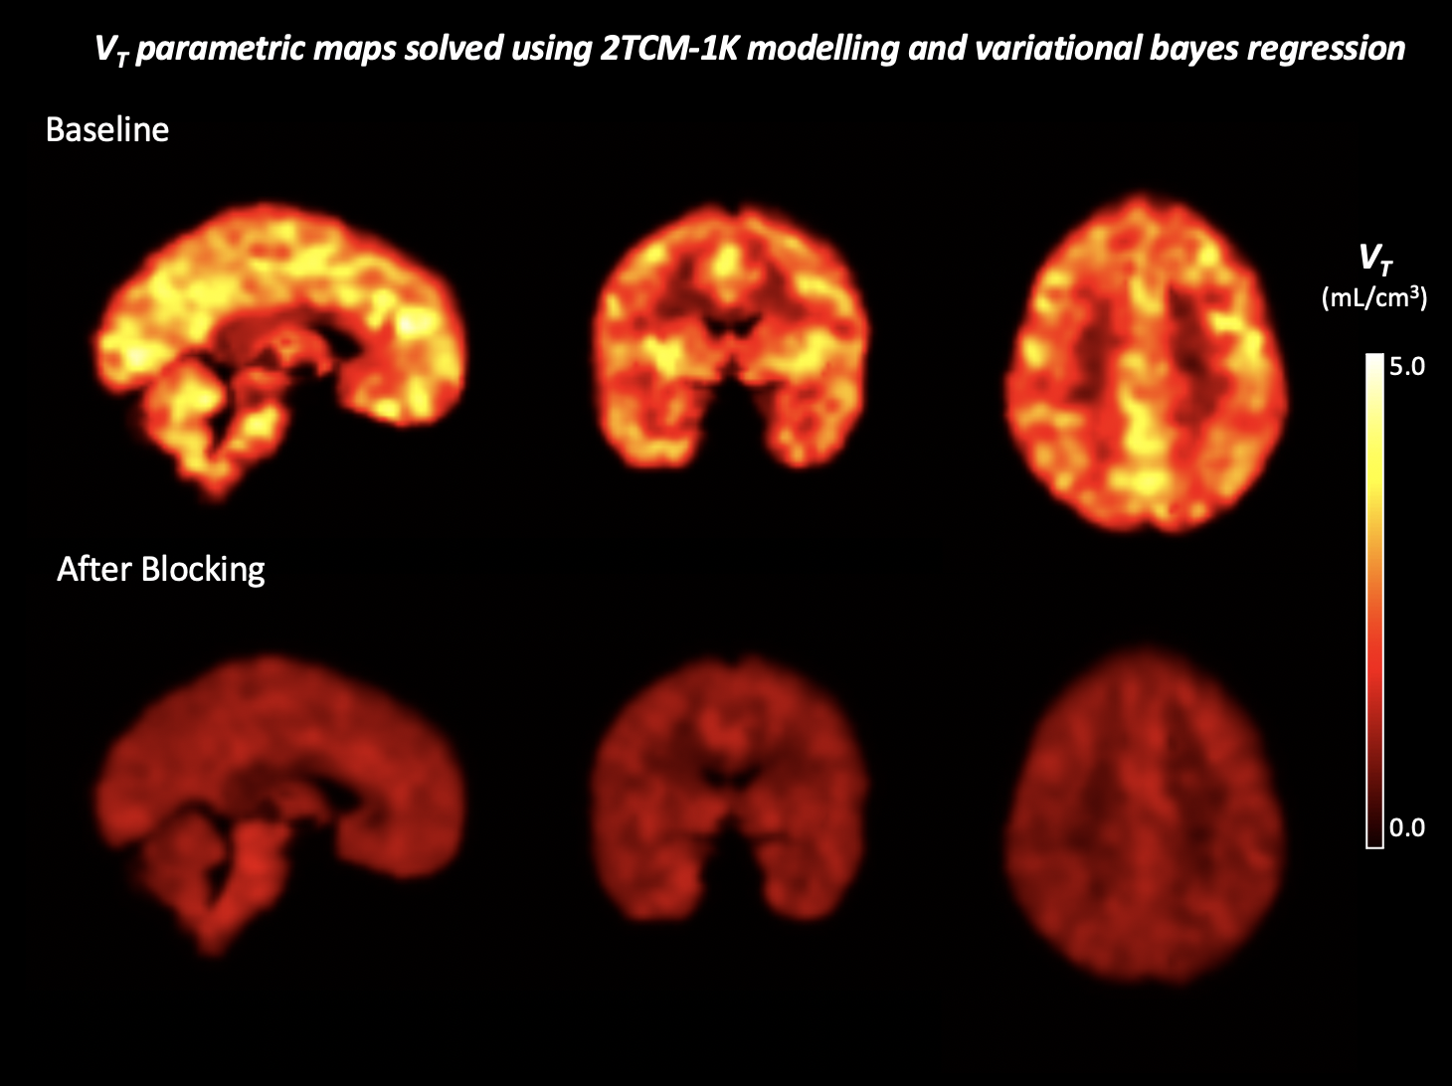
Ref: https://doi.org/10.1016/j.neuroimage.2017.02.009

