Supplemental Figure 1: Illustration of box plots and individual DVR and SUVr data points of patients with progressive supranuclear palsy (PSP) and healthy controls (HC) in representative brain regions for different dynamic and static [¹⁸F]PI-2620 imaging windows. DVR = distribution volume ratio; SUVr = standardized uptake value ratio; GPi = globus pallidus internus; SN = substantia nigra; DLPFC = dorsolateral prefrontal cortex; DN = dentate nucleus

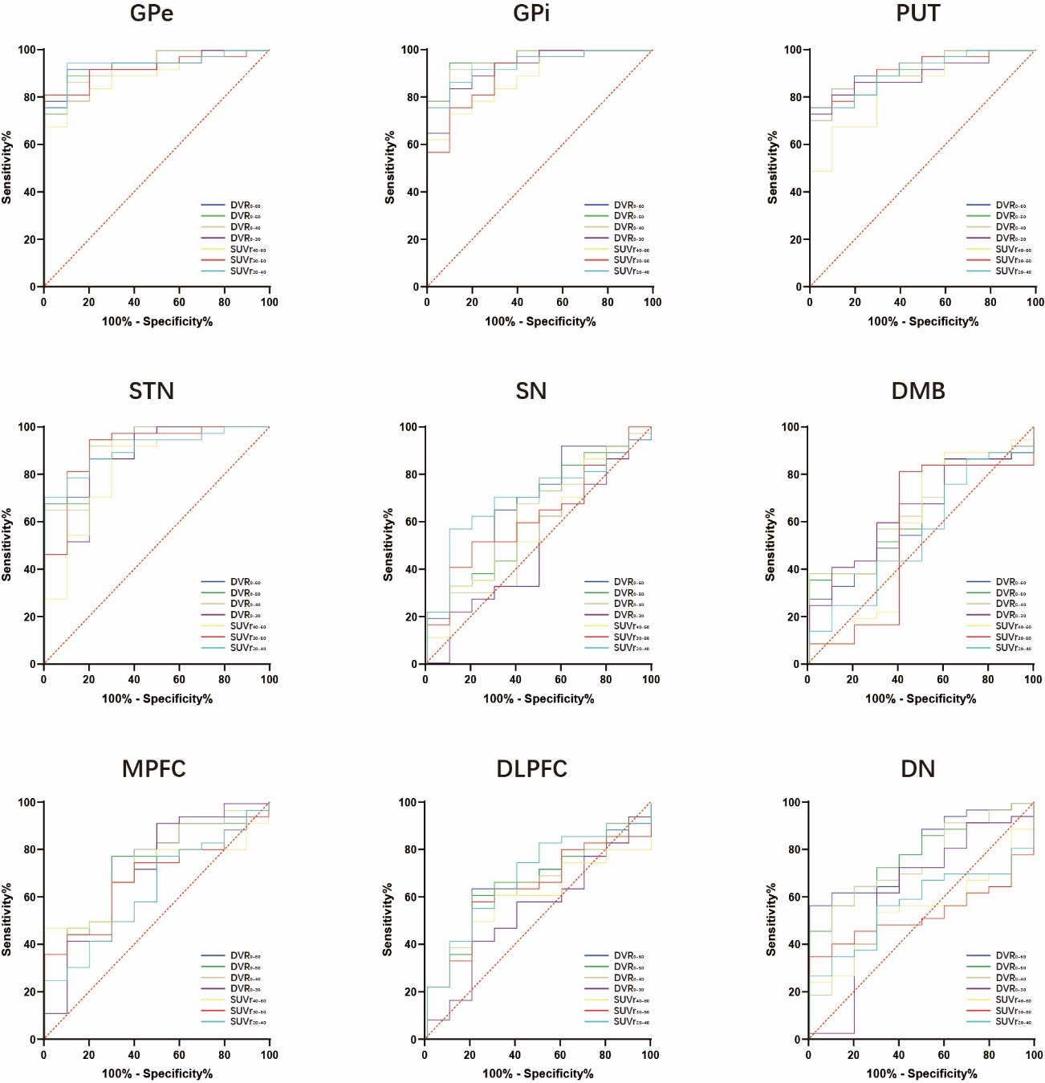
Supplemental Figure 2: Illustration of receiver operating curves (ROC) in all brain regions for different dynamic and static [¹⁸F]PI-2620 imaging windows. DVR = distribution volume ratio; SUVr = standardized uptake value ratio; GPe = globus pallidus externus; GPi = globus pallidus internus; PUT = putamen; STN = subthalamic nucleus; SN = substantia nigra; DMB = dorsal midbrain; MPFC = medial prefrontal cortex; DLPFC = dorsolateral prefrontal cortex; DN = dentate nucleus

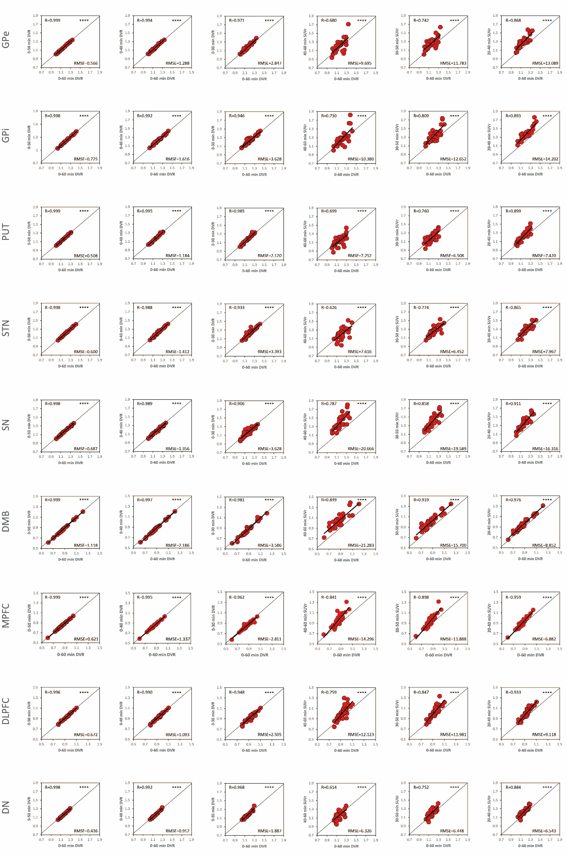
Supplemental Figure 3: Agreement between different truncated dynamic and static [¹⁸F]PI-2620 imaging windows with 0-60 distribution volume ratios (DVR) for all brain regions. SUVr = standardized uptake value ratio; GPe = globus pallidus externus; GPi = globus pallidus internus; PUT = putamen; STN = subthalamic nucleus; SN = substantia nigra; DMB = dorsal midbrain; MPFC = medial prefrontal cortex; DLPFC = dorsolateral prefrontal cortex; DN = dentate nucleus; RMSE = root-mean-square-error; R = Pearson’s correlation coefficient

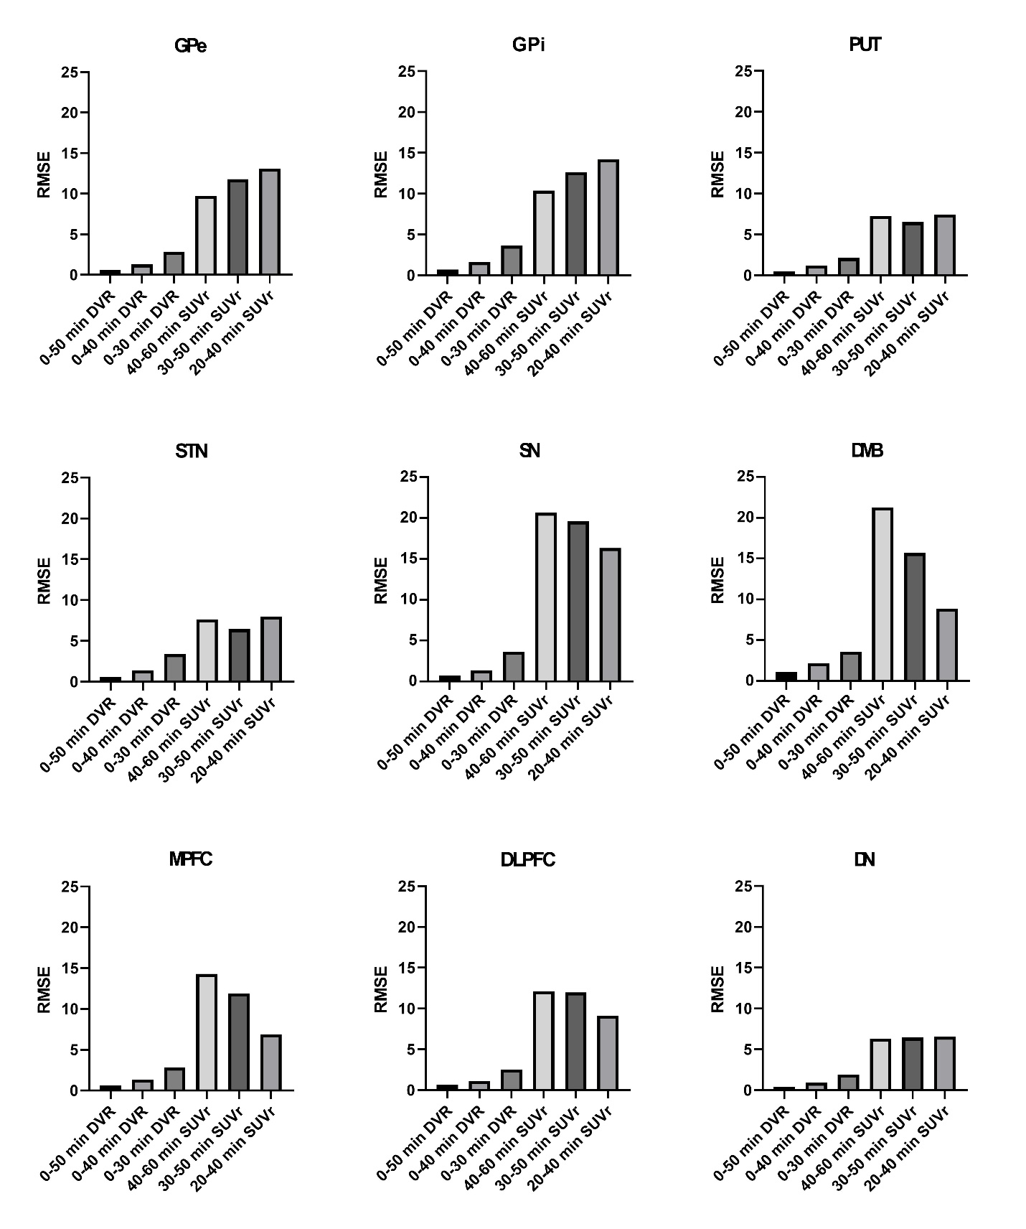
Supplemental Figure 4: Illustration of root-mean-square-errors (RMSE) in all brain regions for different dynamic and static [¹⁸F]PI-2620 imaging windows. DVR = distribution volume ratio; SUVr = standardized uptake value ratio; GPe = globus pallidus externus; GPi = globus pallidus internus; PUT = putamen; STN = subthalamic nucleus; SN = substantia nigra; DMB = dorsal midbrain; MPFC = medial prefrontal cortex; DLPFC = dorsolateral prefrontal cortex; DN = dentate nucleus; RMSE = root-mean-square-error

