SUPPLEMENTARY INFORMATION
Supplemental Fig. 1 Diagram summarizing the PET/CT datasets used in the analysis and the data split performed for the deep learning model development and testing
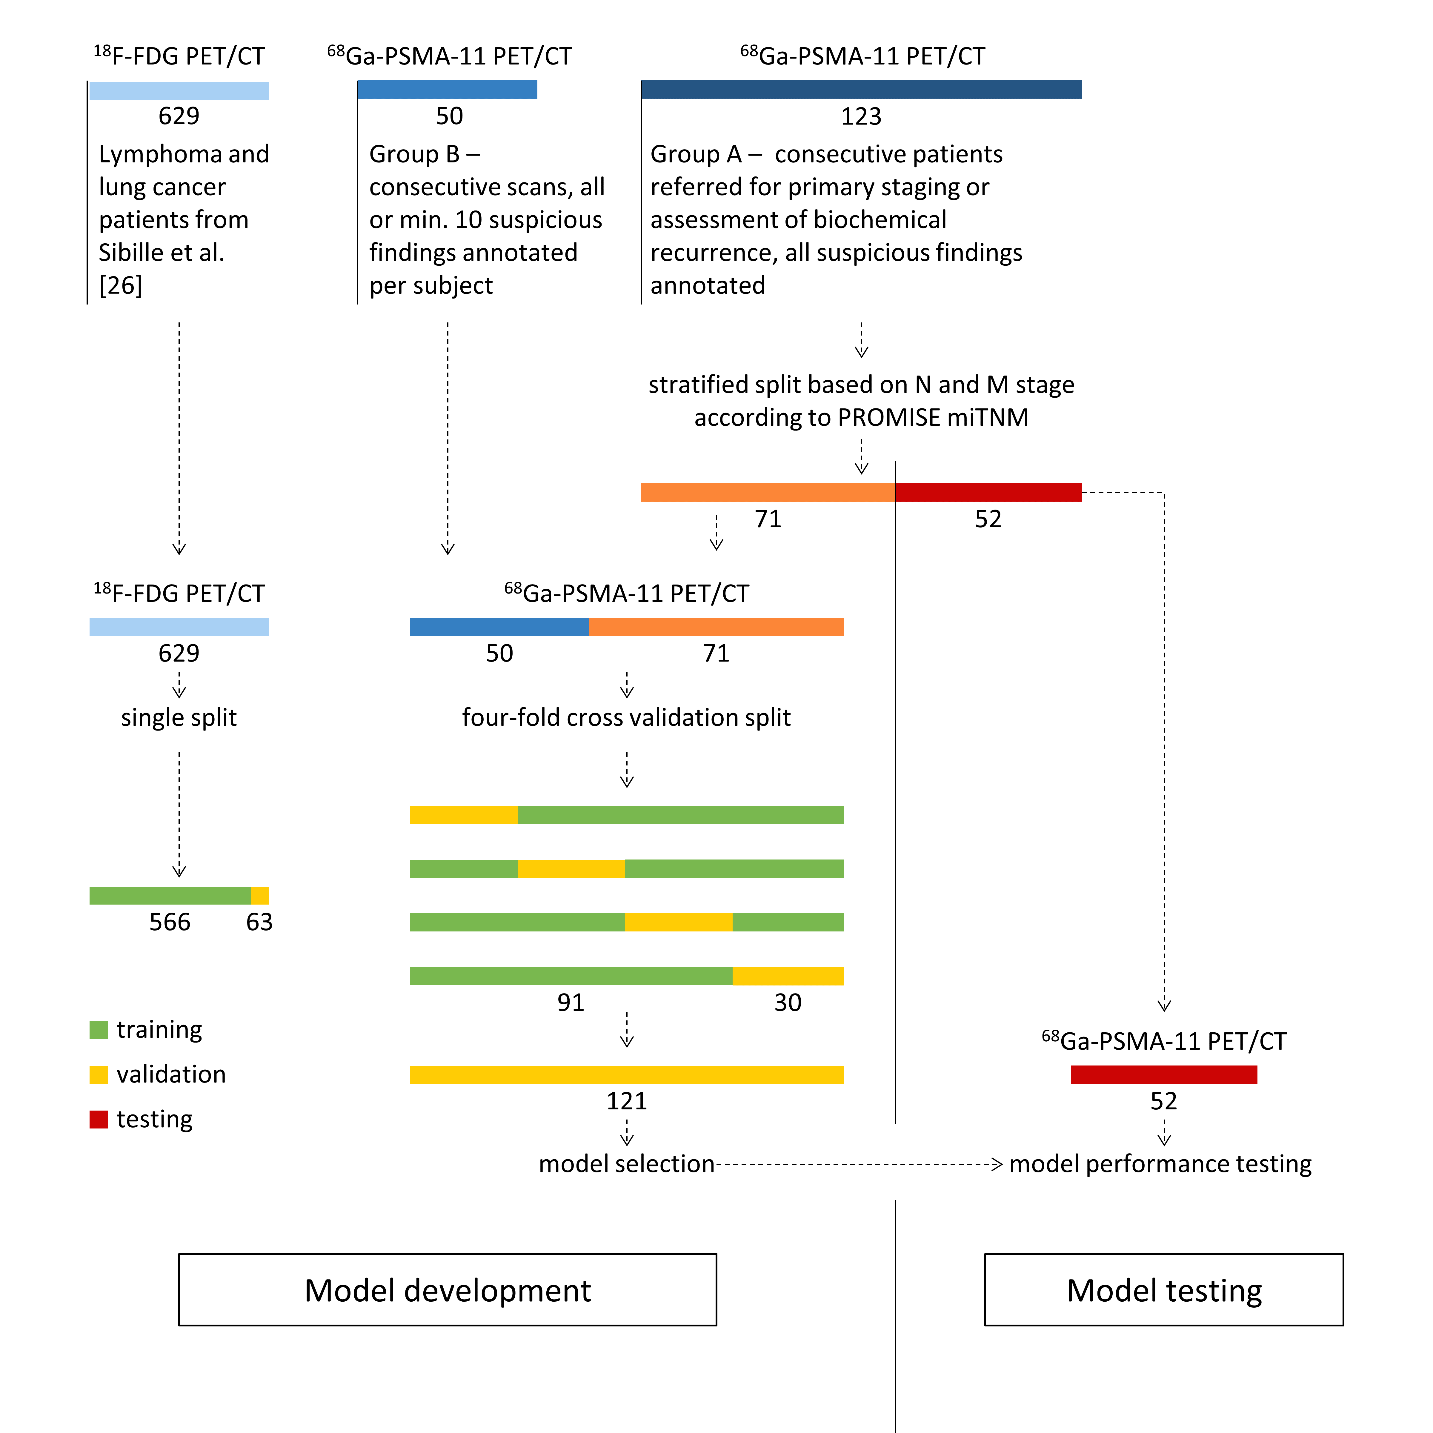

Supplemental Table 1: Summary of the findings annotated by an expert reader in ⁶⁸Ga-PSMA-11 PET/CT images using semi-automated segmentation methods, reported by anatomical location label assigned, in descending order of occurrence.
 | Number of findings | Number of suspicious findings (%)
Total | 5577 | 1057 (19)
Anatomical location
abdomen, liver | 1875 | 22 (1)
abdomen, small intestine | 870 | 8 (1)
abdomen, kidney | 357 | 0 (0)
neck, submandibular gland | 334 | 0 (0)
neck, parotid gland | 310 | 0 (0)
abdomen, spleen | 277 | 0 (0)
abdomen, lymph nodes, iliacal | 164 | 159 (97)
neck, sublingual gland | 149 | 0 (0)
abdomen, bladder | 146 | 0 (0)
abdomen, lymph nodes, para-aortic | 134 | 133 (99)
abdomen, bones, pelvis | 123 | 121 (98)
thorax, bones, spine | 109 | 109 (100)
abdomen, bones, spine | 86 | 77 (90)
thorax, lymph nodes | 79 | 75 (95)
thorax, bones, ribs | 72 | 72 (100)
neck, glottis | 50 | 0 (0)
abdomen, bones, sacrum | 50 | 47 (94)
abdomen, ureter | 38 | 1 (3)
abdomen, prostate | 30 | 30 (100)
abdomen, lymph nodes, presacral | 29 | 28 (97)
neck, tonsils | 27 | 0 (0)
lower limb, bones, femur | 23 | 22 (96)
thorax, bones, scapula | 23 | 23 (100)
neck, bones, spine | 20 | 19 (95)
cranium, nose | 17 | 0 (0)
thorax, bones, sternum | 17 | 17 (100)
abdomen, lymph nodes, obturator | 15 | 15 (100)
neck, thyroid | 15 | 0 (0)
neck, cervical lymph nodes | 13 | 11 (85)
upper limb, bones, humerus | 12 | 12 (100)
abdomen, lymph nodes, inguinal | 10 | 9 (90)
thorax, lung | 10 | 9 (90)
cranium, mouth, teeth | 9 | 0 (0)
abdomen, colon | 8 | 0 (0)
abdomen, lymph nodes, inguinal / femoral | 8 | 8 (100)
thorax, oesophagus | 7 | 0 (0)
thorax, bones, clavicle | 6 | 6 (100)
thorax, skin | 5 | 5 (100)
abdomen, ganglia | 5 | 1 (20)
abdomen, rectum | 4 | 2 (50)
cranium, skull | 4 | 3 (75)
thorax, ganglia | 4 | 1 (25)
cranium, mouth, palate | 4 | 0 (0)
lower limb, lymph nodes, femoral | 3 | 3 (100)
cranium, mouth, floor of mouth | 3 | 0 (0)
abdomen, skin | 3 | 2 (67)
cranium, eye | 3 | 0 (0)
abdomen, lymph nodes, mesenterial | 3 | 2 (67)
abdomen, lymph nodes, peri-hepatic | 2 | 1 (50)
thorax, mediastinum, hilum | 2 | 0 (0)
abdomen, penis | 2 | 0 (0)
abdomen, testis | 2 | 0 (0)
abdomen, adrenal gland | 1 | 1 (100)
neck, accessory sinuses, maxillary sinus | 1 | 0 (0)
thorax, pleura | 1 | 1 (100)
abdomen, stomach, cardia / fundus / body | 1 | 0 (0)
abdomen, lymph nodes, peri-splenic | 1 | 1 (100)
neck, bones, clavicle | 1 | 1 (100)

Supplemental Table 2 Summary of the N and M stage assigned based on expert reader annotation of PSMA-ligand PET/CT images according to the PROMISE miTNM framework, for subjects in group A.
 | Development (group A) | Test
Total | 71 | 52
Stage
miN0M0 | 8 | 6
miN1M0 | 11 | 8
miN2M0 | 5 | 3
miN0M1a | 2 | 1
miN1M1a | 3 | 3
miN2M1a | 7 | 5
miN0M1b/u | 11 | 8
miN1M1b/u | 7 | 4
miN2M1b/u | 1 | 1
miN0M1b/o | 3 | 2
miN1M1b/o | 1 | 1
miN2M1b/o | 2 | 1
miN0M1b/d | 5 | 4
miN1M1b/d | 1 | 1
miN2M1b/d | 2 | 2
miN0M1c | 1 | 1
miN2M1c | 1 | 1

