Supplementary material

Table S1. Mean values of quantitative ¹⁸F-FDG PET/MRI parameters in both malignant and benign breast lesions with corresponding significance levels according to independent t-test analysis.

Parameter | Malignant lesions |  | Benign lesions |  | p value
 | Mean | St. dev | Mean | St. dev
Size (mm) | 28.50 | 17.09 | 19.68 | 12.56 | 0.035
ADCmean (mm²/sec) | 0.92 | 0.24 | 1.42 | 0.23 | < 0.0001
ADCmean_cbp (mm²/sec) | 1.95 | 0.30 | 1.99 | 0.35 | 0.580
PF (ml/100 ml/min) | 67.05 | 35.72 | 56.37 | 34.72 | 0.231
VD (ml/100 ml) | 75.30 | 40.92 | 89.94 | 39.40 | 0.153
MTT (sec) | 77.17 | 25.06 | 118.90 | 38.44 | < 0.0001
SUVmax | 6.22 | 4.29 | 3.09 | 3.55 | 0.003
SUVmean ibp | 1.01 | 0.40 | 0.99 | 0.32 | 0.810
SUVmean cbp | 0.94 | 0.39 | 1.10 | 0.41 | 0.096

Note: ADCmean = apparent diffusion coefficient of breast lesions; ADCmean_cbp = ADCmean of the contralateral breast parenchyma; PF = plasma flow; VD = volume distribution; MTT = mean transit time; SUV = standardised uptake value; St. dev = standard deviation; SUVmean_ibp = standardised uptake value of the ipsilateral breast parenchyma; SUVmean_cbp =
standardised uptake value of the contralateral breast parenchyma. In bold, significant p values (≤ 0.05).

Table S2. Results of the intraclass correlation coefficient analysis for intra- and inter-observer reproducibility of quantitative ¹⁸F-FDG PET/MRI parameter measurements.

 | Intra-observer |  | Inter-observer
Parameter | ICC | 95% CI | ICC | 95% CI
Size | 0.901 | 0.829 – 0.943 | 0.893 | 0.815 – 0.939
ADCmean | 0.960 | 0.924 – 0.979 | 0.890 | 0.793 – 0.940
ADCmean_cbp | 0.722 | 0.545 – 0.837 | 0.562 | 0.331 – 0.730
PF | 0.882 | 0.797 – 0.933 | 0.875 | 0.786 – 0.929
VD | 0.880 | 0.795 – 0.931 | 0.878 | 0.791 – 0.930
MTT | 0.870 | 0.779 – 0.925 | 0.863 | 0.767 – 0.921
SUVmax | 0.999 | 0.998 – 0.999 | 0.995 | 0.991 – 0.997
SUVmean | 0.852 | 0.748 – 0.915 | 0.832 | 0.702 – 0.906
SUVmin | 0.604 | 0.376 – 0.762 | 0.625 | 0.413 – 0.774
SUVmean_ibp | 0.640 | -010 – 0.860 | 0.671 | 0.067 – 0.868
SUVmean_cbp | 0.754 | 0.146 – 0.907 | 0.753 | 0.162 – 0.906

Note: ICC = intraclass correlation coefficient; ADCmean = apparent diffusion coefficient of breast lesions; ADCmean_cbp = ADCmean of the contralateral breast parenchyma; PF = plasma flow; VD = volume distribution; MTT = mean transit time; SUV = standardised uptake value; SUVmean_ibp = standardised uptake value of the ipsilateral breast parenchyma; SUVmean_cbp =
standardised uptake value of the contralateral breast parenchyma.

Table S3. Distribution of BI-RADS descriptors, ADC and PET scores in benign and malignant breast lesions.
BI-RADS Descriptor | Malignant lesions (n = 101) | Benign lesions (n = 19)
FGT
A | 6 (6%) | 1 (5%)
B | 48 (47%) | 9 (47%)
C | 44 (44%) | 6 ( 32%)
D | 3 (3%) | 3 (16%)
BPE
BPE level
Minimal | 62 (61%) | 5 (26%)
Mild | 25 (25%) | 11 (58%)
Moderate | 8 (8%) | 2 (11%)
Marked | 6 (6%) | 1 (5%)
BPE simmetry
Symmetric | 61 (60%) | 13 (68%)
Asymmetric | 27 (27%) | 4 (21%)
Lesion type
Focus | 0 (0%) | 0 (0%)
Mass | 74 (73%) | 15 (79%)
Non-mass | 6 (6%) | 2 (10.5%)
Mass/Non-mass | 21 (21%) | 2 (10.5%)
Mass | Malignant lesions  (n = 95) | Benign lesions  (n = 17)
Shape
Oval | 28 (29%) | 8 (47%)
Round | 19 (20%) | 1 (6%)
Irregular | 48 (51%) | 8 (47%)
Margin
Circumscribed | 11 (12%) | 13 (76%)
Irregular | 59 (62%) | 4 (24%)
Spiculated | 25 (26%) | 0 (0%)
Internal characteristics
Homogeneous | 7 (7%) | 4 (23%)
Heterogeneous | 54 (57%) | 9 (53)
Rim enhancement | 34 (36%) | 2 (12%)
Dark internal septations | 0 (0%) | 2 (12%)
Non-mass enhancement | Malignant lesions  (n = 27) | Benign lesions  (n = 4)
Distribution
Focal | 0 (0%) | 1 (25%)
Linear | 5 (19%) | 0 (0%)
Segmental | 7 (26%) | 1 (25%)
Regional | 4 (14%) | 2 (50%)
Multiple regions | 5 (19%) | 0 (0%)
Diffuse | 6 (22%) | 0 (0%)
Internal enhancement patterns
Homogeneous | 3 (11%) | 0 (0%)
Heterogeneous | 15 (56%) | 3 (75%)
Clumped | 9 (33%) | 1 (25%)
Clustered ring | 0 (0%) | 0 (0%)
ADCmean values | Malignant lesions  (n = 101) | Benign lesions  (n = 19)
< 1.3 x10⁻³ mm²/s | 96 (95%) | 5 (26%)
> 1.3 x10⁻³ mm²/s | 5 (5%) | 14 (74%)
¹⁸F-FDG uptake | Malignant lesions  (n = 101) | Benign lesions  (n = 19)
Higher than the background activity | 101 (100%) | 14 (74%)
Equal/lower than the background activity | 0 (0%) | 5 ( 26%)

Note: FGT = fibroglandular tissue; BPE = background parenchymal enhancement; ¹⁸F-FDG = ¹⁸F-fluoro-2-deoxy-d-glucose; ADCmean = apparent diffusion coefficient of breast lesions.

Figure S1.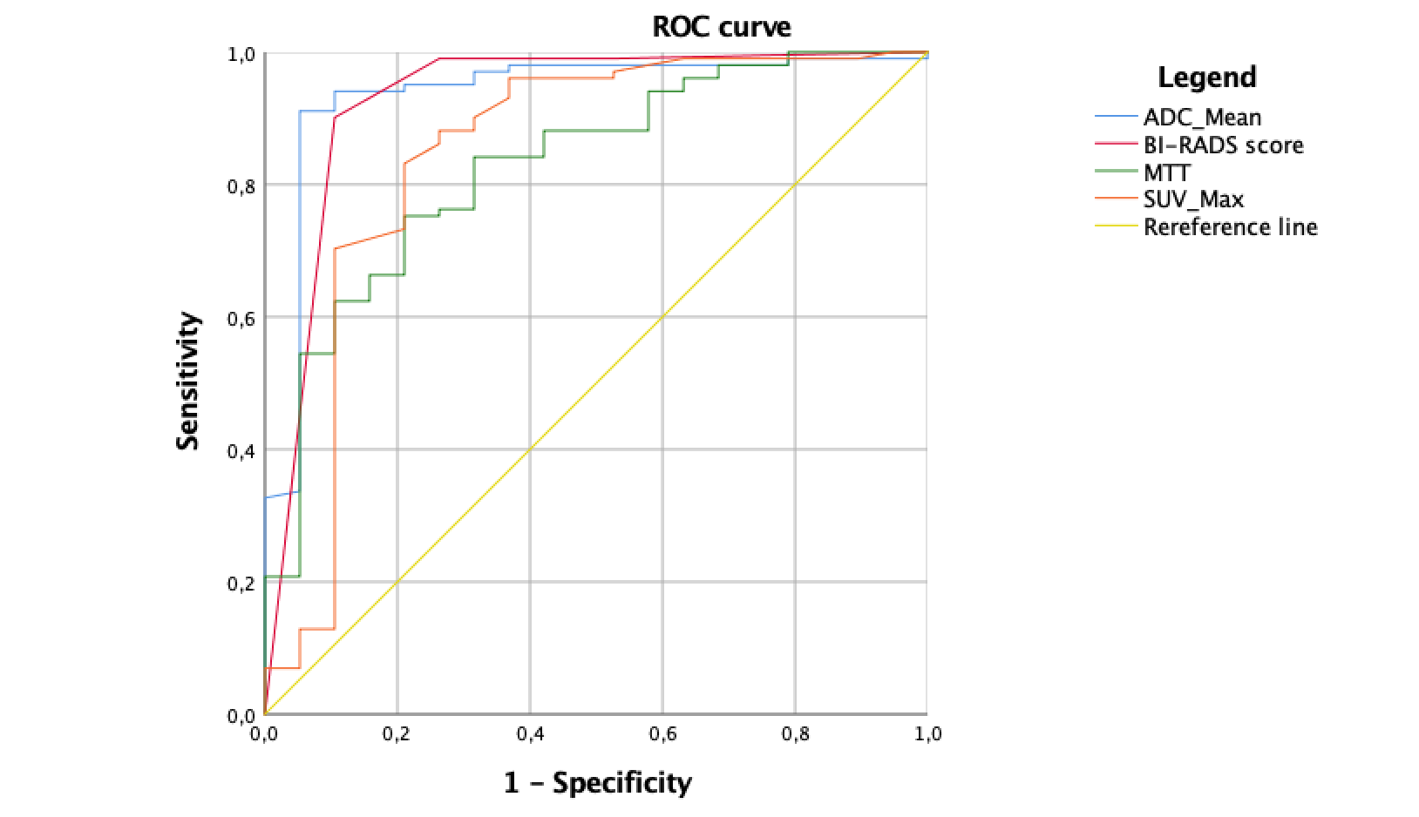

Figure S4. ROC curve analysis of BI-RADS scores (AUC = 0.929, 95% CI: 0.843-1.000) along with quantitative parameters significantly different between benign and malignant breast lesions, namely ADCmean (AUC = 0.937, 95% CI: 0.867-1.00), MTT (AUC = 0.829, 95% CI: 0.730-0.927) and SUVmax (AUC = 0.845, 95% CI: 0.721-0.970). ADCmean = apparent diffusion coefficient of breast lesions; MTT = mean transit time; SUV = standardised uptake value.

Table S5. Accuracy metrics of BI-RADS assessment, ADC and PET alone as well as combined clinical evaluation and best radiomics model.
 | Sensitivity | Specificity | PLR | NLR | AUC
BI-RADS | 100 | 78.85 | 4.75 | 0.00 | 0.967
ADCmean | 95.05 | 73.68 | 3.61 | 0.97 | 0.917
PET | 100 | 26.32 | 1.36 | 0.00 | 0.883
Combined clinical evaluation | 100 | 73.68 | 3.8 | 0.00 | 0.958
Best radiomics model | 95.3 | 94.3 | 16.72 | 0.05 | 0.983

Note: ADCmean = apparent diffusion coefficient of breast lesion; PLR = positive likelihood ratio; NLR = negative likelihood ratio; AUC = area under the curve.

