Supplementary information
Targeted alpha therapy using astatine (²¹¹At)-labeled PSMA1,5 and 6: a preclinical evaluation as a new novel compound

Tadashi Watabe^{1,2}, Kazuko Kaneda-Nakashima^{2,3}, Yoshifumi Shirakami², Yuichiro Kadonaga², Kazuhiro Ooe^{1,2}, Yang Wang⁴, Hiromitsu Haba⁴, Atsushi Toyoshima², Jens Cardinale⁵, Frederik L. Giesel⁵, Noriyuki Tomiyama^{2,6}, Koichi Fukase⁷
¹Department of Nuclear Medicine and Tracer Kinetics, Graduate School of Medicine, Osaka University
²Institute for Radiation Sciences, Osaka University
³Core for Medicine and Science Collaborative Research and Education, Project Research Center for Fundamental Sciences, Graduate School of Science, Osaka University
⁴Nishina Center for Accelerator-Based Science, RIKEN
⁵Department of Nuclear Medicine, Dusseldorf University
⁶Department of Radiology, Graduate School of Medicine, Osaka University
⁷Department of Chemistry, Graduate School of Science, Osaka University

Corresponding and first author:
Tadashi Watabe (Assistant Professor)
2-2 Yamadaoka, Suita, Osaka 565-0871, Japan
Tel: +81-6-6879-3461
Fax: +81-6-6879-3469
E-mail: watabe@tracer.med.osaka-u.ac.jp
ORCID: 0000-0001-8658-2395
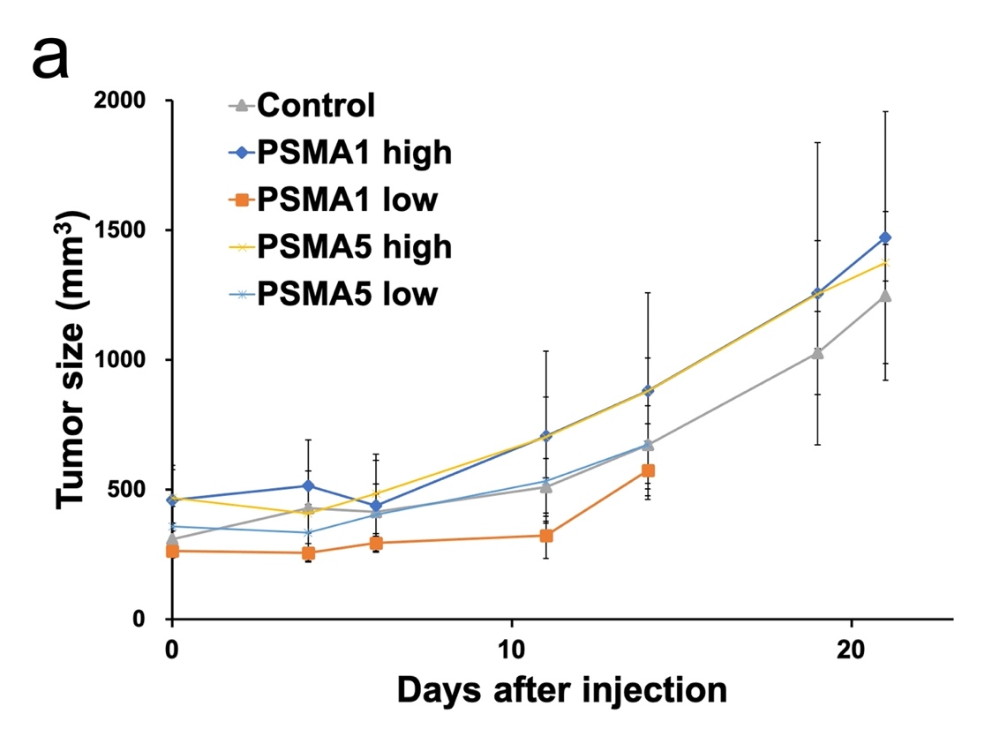
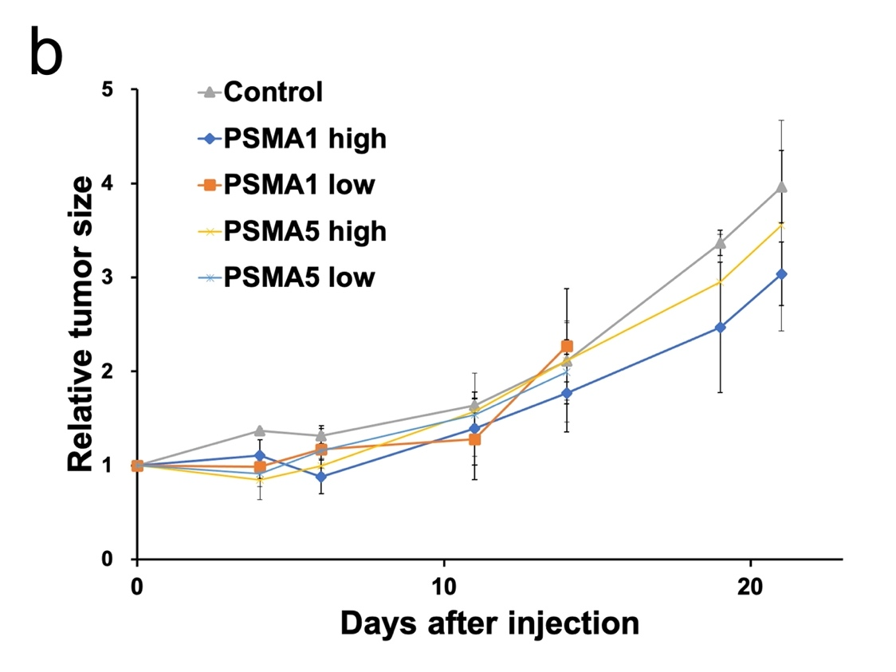
Supplementary Fig. S1. Tumor growth curve after the single administration of non-radiolabeled PSMA1, PSMA5, and control (saline): (a) actual tumor size and (b) relative tumor size. High and low correspond to the peptide dose of 10 MBq and 1 MBq of [²¹¹At]PSMA1 and [²¹¹At]PSMA5, respectively.

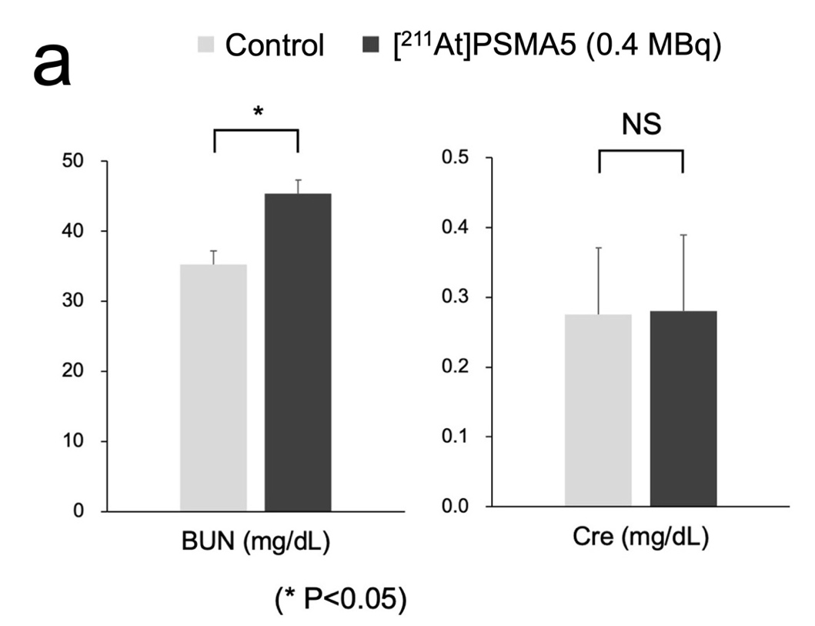
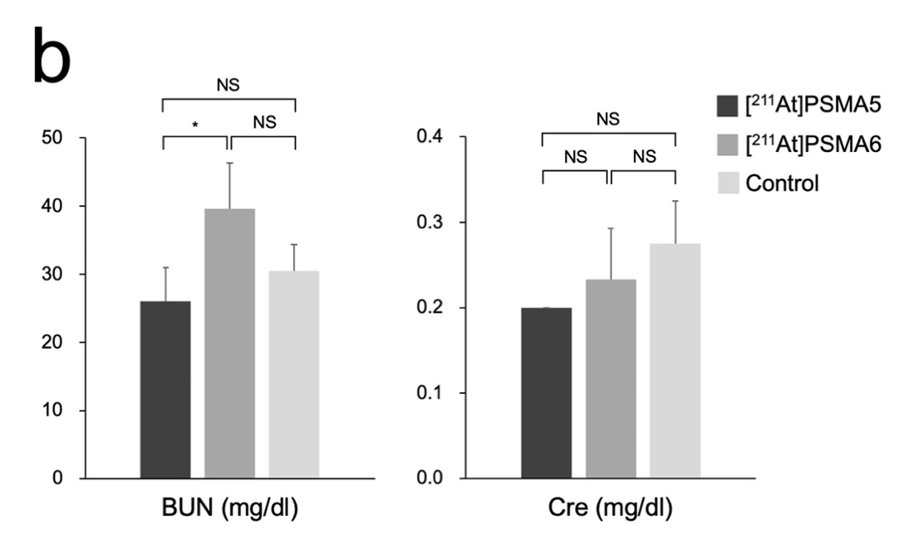
Supplementary Fig. S2. Evaluation of renal function using blood sample (a) 3 weeks after the administration of [²¹¹At]PSMA5 (0.4 MBq) in NOD/SCID mice and (b) 8 weeks after the administration of [²¹¹At]PSMA5 (0.4 MBq) and [²¹¹At]PSMA6 (0.4 MBq) in ICR mice (*p < 0.05; NS, not significant).

- Materials
Structures of precursor molecules for ²¹¹At labeling, PSMA-1, PSMA-5 and PSMA-6, are shown in Supplemental Figure 1
PSMA-1
PSMA-5 PSMA-6
Supplemental Fig. S3. Chemical structures of precursor molecules

Chemical names of the precursors are as follows.
PSMA-1:
(((S)-5-((R)-2-(4-((4-(((R)-5-(2-(2-(4-boronophenyl)acetamido)acetamido)-5-carboxypentyl)amino)-4-oxobutanamido)methyl)benzamido)-3-(naphthalen-2-yl)propanamido)-1-carboxypentyl)carbamoyl)-L-glutamic acid
PSMA-2:(((S)-5-((R)-2-(4-(((R)-2-((R)-2-(4-(((R)-5-(2-(2-(4-boronophenyl)acetamido)acetamido)-5-carboxypentyl)amino)-4-oxobutanamido)-4-carboxybutanamido)-4-carboxybutanamido)methyl)benzamido)-3-(naphthalen-2-yl)propanamido)-1-carboxypentyl)carbamoyl)-L-glutamic acid

PSMA-5:
(((S)-5-((R)-2-(4-(((R)-2-((R)-2-(2-(4-boronophenyl)acetamido)-4-carboxybutanamido)-4-carboxybutanamido)methyl)benzamido)-3-(naphthalen-2-yl)propanamido)-1-carboxypentyl)carbamoyl)-L-glutamic acid

PSMA-6:
(((S)-5-((R)-2-(4-(((S)-2-((S)-2-(2-(4-boronophenyl)acetamido)-4-carboxybutanamido)-4-carboxybutanamido)methyl)benzamido)-3-(naphthalen-2-yl)propanamido)-1-carboxypentyl)carbamoyl)-L-glutamic acid

HPLC profiles of the precursors

Conditions:
HPLC system: Shimadzu LC-20
Column: C18 MSII, 150 x 4.6 mm
Temperature: 30°C
Detector: UV 226 nm
Injection volume: 50 µL
Sample concentration: 1 µg/mL
Solvent: A) 5mmol/L Tetrabuthylammonium phosphate, pH7.5
B) Acetonitrile
Time solvent A solvent B
Gradient: 0 - 5 min 70% 30%
5 - 30 min 70% to 20% 30% to 80%

Chromatograms:

Supplemental Fig. S4. HPLC analysis of precursors.

Radio-TLC:

Crude products Purified products

²¹¹At-PSMA-1 (RCY: 84.8%) ²¹¹At-PSMA-1 (RCY: 98.0%)
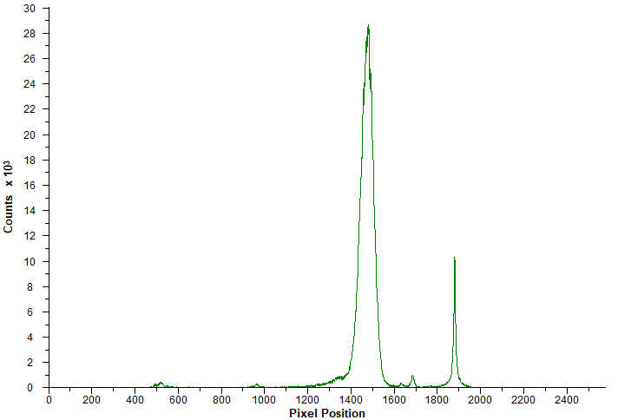
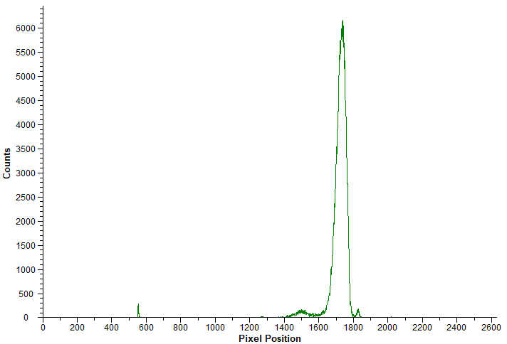

²¹¹At-PSMA-5 (RCY: 78.6%) ²¹¹At-PSMA-5 (RCY: 99.8%)
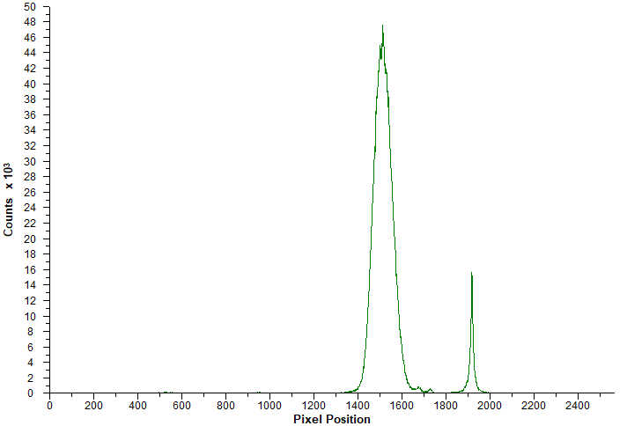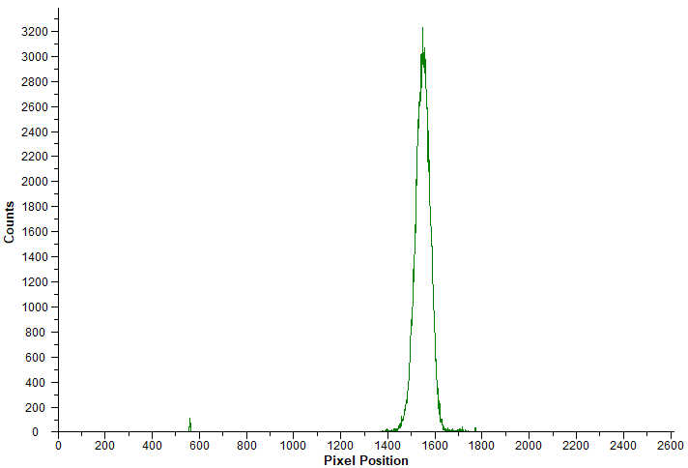

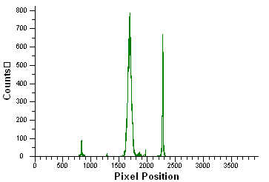
²¹¹At-PSMA-6 (RCY: 72.8%) ²¹¹At-PSMA-6 (RCY: 72.8%)
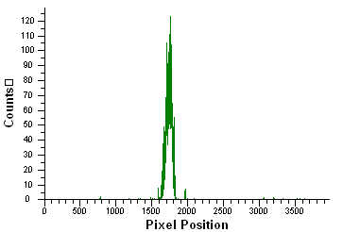

Supplemental Fig. S5. Radio-TLC analysis of precursors.

Day | 10 | 14 | 21 | 24 | 28 | 31 | 38 | 45 | 52
[²¹¹At]PSMA5 No. 1 | (±) | 30 (1+) | 30 (1+) | (±) | (±) | (-) | (-) | (±) | (±)
[²¹¹At]PSMA5 No. 2 | 30 (1+) | (±) | (±) | (-) | (-) | (-) | (-) | (-) | (-)
[²¹¹At]PSMA5 No. 3 |  | (±) | 30 (1+) | (-) | (-) | (-) | 30 (1+) | (-) | (-)
[²¹¹At]PSMA6 No. 1 | (±) | (-) | (-) | (±) | (±) | (-) | (-) | (-) | (-)
[²¹¹At]PSMA6 No. 2 | (±) | (±) | 30 (1+) | 100 (2+) | (-) | (±) | 30 (1+) | 30 (1+) | (±)
[²¹¹At]PSMA6 No. 3 | (±) | (±) | (±) | (±) | (-) | 30 (1+) | (-) | (±) | (±)
Control No. 1 | 30 (1+) | (±) | (-) | (-) | (-) | 30 (1+) | 30 (1+) | (-) | (-)
Control No. 2 | (±) | 30 (1+) | (±) | (±) | (-) | (-) | 30 (1+) | 30 (1+) | (-)
Control No. 3 |  | (±) | (±) | (±) | (-) | (-) | (-) | 30 (1+) | (-)
Control No. 4 |  | (±) | (±) | (±) | (±) | (±) | (±) | 30 (1+) | (±)
Supplementary Table S1. Results of urine tests of protein (mg/dl) until 8 weeks after the administration of [²¹¹At]PSMA5 (0.4 MBq) and [²¹¹At]PSMA6 (0.4 MBq) in ICR mice.

