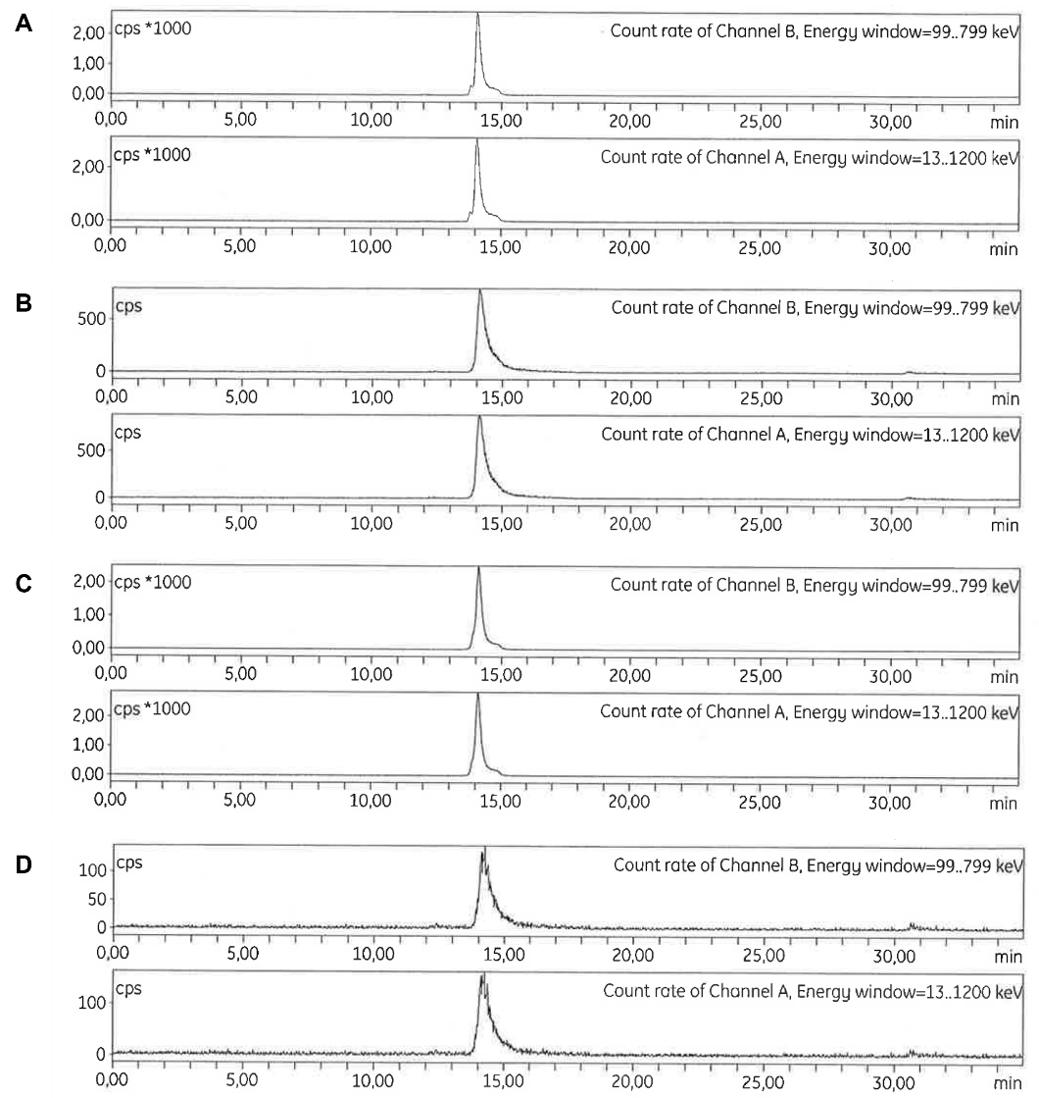
SUPPLEMENTARY FIGURE 1. All exendin analogues show uniform, radioactively labelled products. HPLC profile of radiolabelled exendin-4 (A), exendin-4-Pen (B), exendin(9-39) (C), and exendin(9-39)-Pen (D).
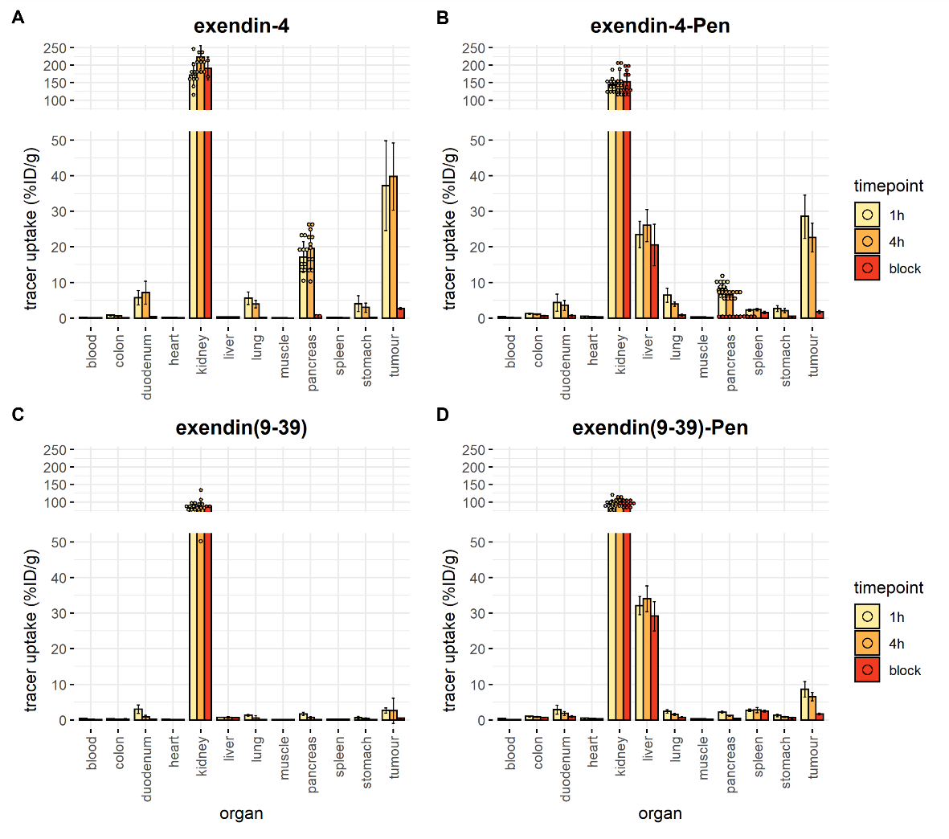
SUPPLEMENTARY FIGURE 2. In vivo biodistribution, overview per exendin variant. Balb/c nude mice with subcutaneous INS-1 tumours were injected with 20 pmol of the corresponding compound. For the blocking condition, a 100x excess of either unlabelled exendin-4 (for exendin-4 and exendin-4-Pen groups) or unlabelled exendin(9-39) (for exendin(9-39) and exendin (9-39)-Pen groups) was administered together with the labelled compound. Blocking condition was only measured at 4h. A) overview for exendin-4 B) overview for exendin-4-Pen C) overview for exendin(9-39) D) overview for exendin(9-39)-Pen.
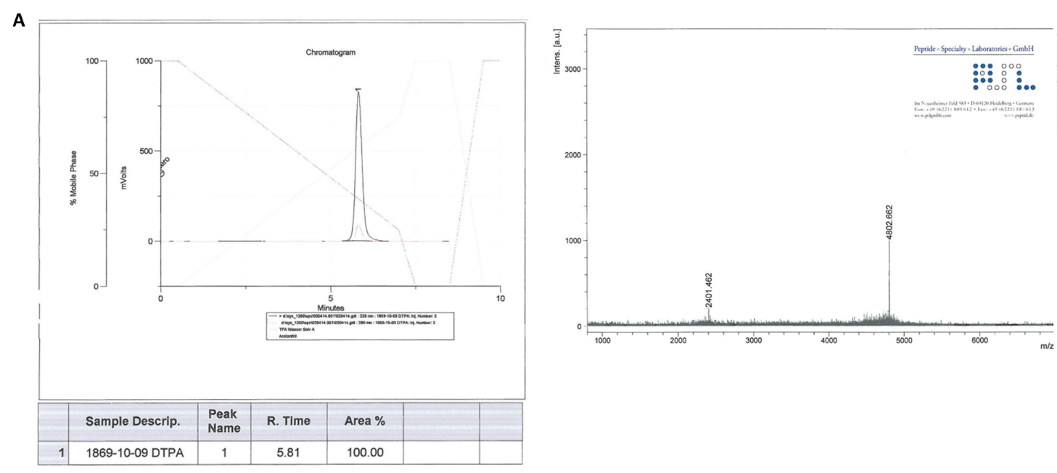

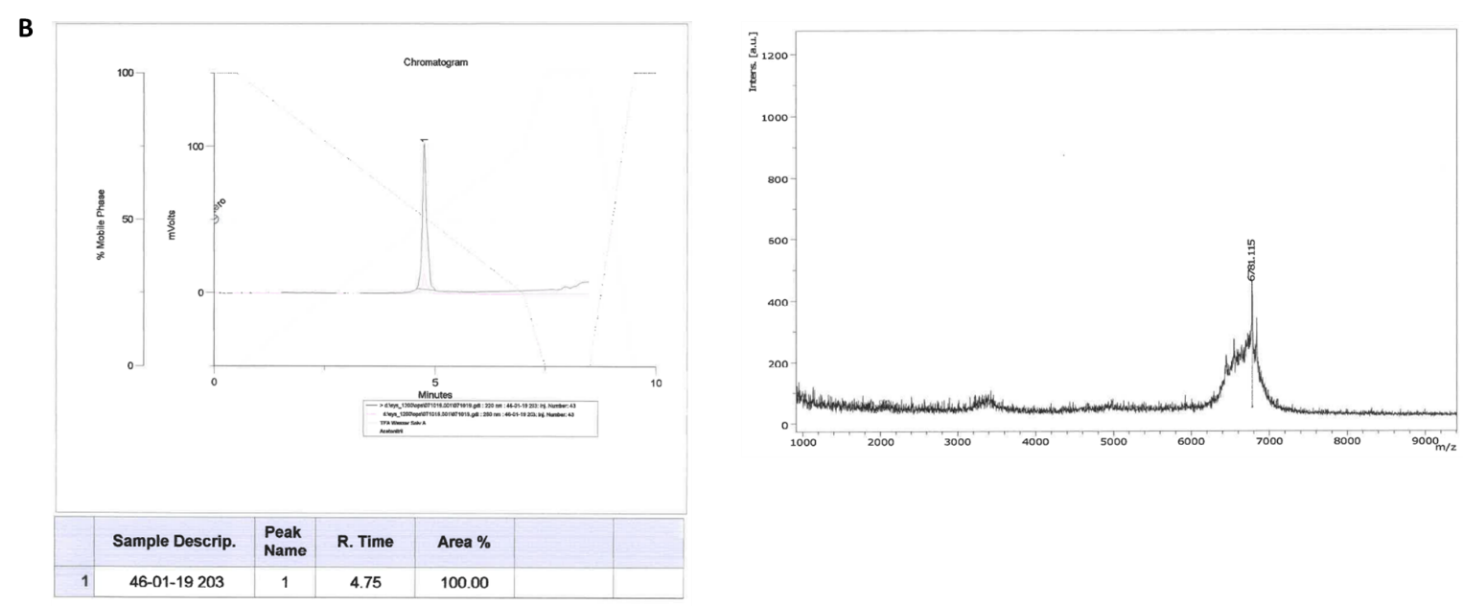
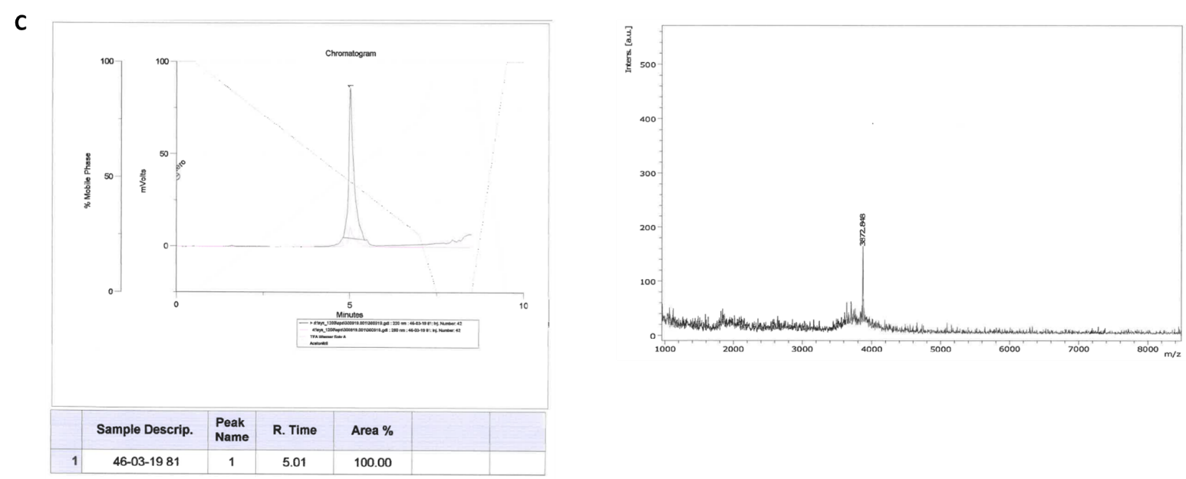
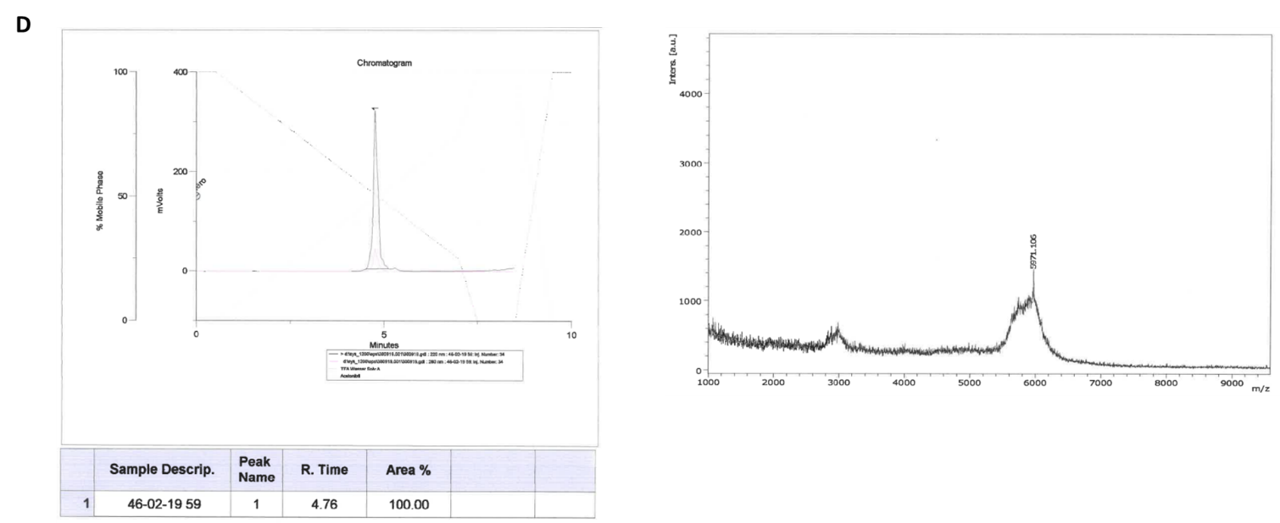
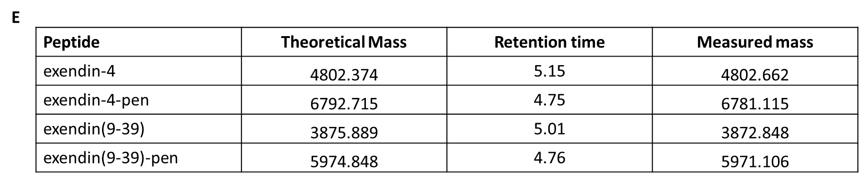
SUPPLEMENTRAY FIGURE 3. HPLC-MS profiles of A) exendin-4-DTPA, B) exendin-4-Pen-DTPA, C) exendin(9-39), D) exendin(9-39)-DTPA. E) masses and retention times of all four peptides (including a C-terminal DTPA moiety, which in the case of exendin-4-DTPA is attached to an Ahx linker)

