Supplementary information

Tracer synthesis and quality control
BI 754111 (5 mg, 20 mg/mL) was diluted to 5 mg/mL with 0.9% NaCl and the pH of the solution adjusted to 8.9–9.1 with 0.1 M Na₂CO₃ after which the solution was added to benzyl isothiocyanate-DFO (DFO-Bz-NCS) (3 equivalents in dimethyl sulfoxide [DMSO], 100 nmol, 20 µL of 5 mM) and reacted for 30 min at 37°C. DFO-Bz-NCS-BI754111 was purified on a pyrogen-free PD10 column to remove unreacted chelator using 25 mM NaOAc/240 mM Trehalose/0.67 mM Methionine/0.04% w/v Tween-20 pH 5.5 as eluent. This purified DFO-Bz-NCS-BI754111 was then labeled with Zr-89. To this end, the required amount of ⁸⁹Zr in 1 M oxalic acid (Perkin Elmer, Boston, MA, USA) was supplemented to 0.2 mL with 1 M oxalic acid, followed by the addition of 90 µL 2 M Na₂CO₃ to neutralize the solution. Hereafter, 1 mL 0.5 M Hepes was added, followed by 0.71 mL DFO-Bz-NCS-BI 754111 (~2.3 mg). After labeling (60 min), [⁸⁹Zr]Zr-DFO-Bz-NCS-BI 754111 was purified on a pyrogen free PD10 column and eluted in 25 mM NaOAc/240 mM Trehalose / 0.67 mM Methionine/0.04% w/v Tween-20 pH 5.5. Chemical modifications to generate [⁸⁹Zr]Zr-DFO-Bz-NCS- BI 754111 had no impact on BI 754111 binding affinity to lymphocyte-activation gene 3 (LAG-3) as was demonstrated by Surface Plasma Resonance based assays (data not shown).
The product was formulated to arrive at an injection dose of 37 MBq – 4 mg – 20 mL [⁸⁹Zr]Zr-BI 754111. The pH of the product was 5.49 ± 0.02. The mean radiochemical purity as assessed by spin filter was 99.3% ± 0.5%. To this end, 4 µL of product was diluted with 96 µL eluent (5% DMSO and 95% 50 mM NaOAc + 200 mM sucrose buffer) and applied on a microcon-30 centrifugal filter unit (Ultracel YM-30, regenerated cellulose, 30 kDa cut-off, Merck Millipore, Burlington, MA, USA). The solution was spun down for 7 min at 14,000 rpm (Eppendorf 5430). The filter was washed twice with 100 µL eluent and spun down at 14,000 rpm for 7 min after each wash step. The filtrate contained free ⁸⁹Zr/⁸⁹Zr-DFO, while the radiolabeled mAb was left on the filter. The mean radiochemical purity was 99.7 ± 0.6% and the mean protein integrity was 98.9% ± 0.2% as determined by size exclusion high-performance liquid chromatography using a superdex 200 10/30 GL increase size exclusion column (GE healthcare Life sciences, Piscataway, NJ, USA) including a guard column using a mixture of 0.05 M sodium phosphate, 0.15 M sodium chloride (pH 6.8), and 0.01 M NaN₃ as the eluent at a flow rate of 0.75 mL/min. The mean immune reactive fraction as assessed by a LAG-3 binding assay was 78.6% ± 4.1%. Sterility of each [⁸⁹Zr]Zr-BI 754111 batch was assured by performing a media fill immediately after final filter sterilization of each batch. These procedures resulted in a sterile final product with endotoxin levels <0.2 EU/mL.

Supplementary Table 1.1. Intended patient distribution across dose groups in pharmacokinetic model development
Dose (mg) | n
4 | 4
20 | 9
80 | 9
200 | 9
400 | 9
600 | 9

Supplementary Table 1.2. Population pharmacokinetic model parameters
Parameter | Value | Units
Fixed effect parameters
Cl | 0.0122 | L/h
Vc | 3.40 | L
Vp | 2.25 | L
Q | 0.0353 | L/h
Clsaturable | 0.0489 | L/h
C50 | 216 | ug/L
Between subject variability
ω2 | Cl | 0.149
ω2 | Vc | 0.0473
Residual error
Proportional (CV) | 10.0E+00 | %
Cl clearance, CV coefficient of variation, Q intercompartmental clearance, Vc central volume of distribution, Vp peripheral volume of distribution

Supplementary Table 2.1. Organ-to-plasma ratios of [⁸⁹Zr]Zr-BI 754111
Organ | Dose | Time p.i. (h) | n | Mean | SD | Organ | Dose | Time p.i. (h) | n | Mean | SD
Bone marrow | 4 | 2 | 3 | 0.12 | 0.02 | Liver | 4 | 2 | 3 | 0.25 | 0.03
Bone marrow | 4 | 96 | 6 | 0.84 | 0.69 |  | 4 | 96 | 6 | 2.42 | 1.82
Bone marrow | 4 | 144 | 6 | 1.36 | 0.67 |  | 4 | 144 | 6 | 4.30 | 2.09
Bone marrow | 44 | 96 | 3 | 0.30 | 0.11 |  | 44 | 96 | 3 | 0.79 | 0.31
Bone marrow | 44 | 144 | 2 | 0.35 | 0.07 |  | 44 | 144 | 2 | 1.26 | 0.93
Bone marrow | 604 | 96 | 3 | 0.16 | 0.04 |  | 604 | 96 | 3 | 0.45 | 0.02
Bone marrow | 604 | 144 | 3 | 0.18 | 0.02 |  | 604 | 144 | 3 | 0.57 | 0.03
Brain | 4 | 2 | 3 | 0.03 | 0.00 | Lung | 4 | 2 | 3 | 0.08 | 0.00
Brain | 4 | 96 | 6 | 0.06 | 0.02 |  | 4 | 96 | 6 | 0.23 | 0.12
Brain | 4 | 144 | 6 | 0.08 | 0.05 |  | 4 | 144 | 6 | 0.36 | 0.16
Brain | 44 | 96 | 3 | 0.05 | 0.02 |  | 44 | 96 | 3 | 0.11 | 0.02
Brain | 44 | 144 | 2 | 0.05 | 0.03 |  | 44 | 144 | 2 | 0.12 | 0.01
Brain | 604 | 96 | 3 | 0.04 | 0.01 |  | 604 | 96 | 3 | 0.13 | 0.00
Brain | 604 | 144 | 3 | 0.05 | 0.02 |  | 604 | 144 | 3 | 0.15 | 0.01
Kidney | 4 | 2 | 3 | 0.12 | 0.02 | Spleen | 4 | 2 | 3 | 0.31 | 0.17
Kidney | 4 | 96 | 6 | 0.82 | 0.46 |  | 4 | 96 | 6 | 11.22 | 11.82
Kidney | 4 | 144 | 6 | 1.33 | 0.47 |  | 4 | 144 | 6 | 19.93 | 14.89
Kidney | 44 | 96 | 3 | 0.38 | 0.10 |  | 44 | 96 | 3 | 0.92 | 0.21
Kidney | 44 | 144 | 2 | 0.44 | 0.20 |  | 44 | 144 | 2 | 1.55 | 0.82
Kidney | 604 | 96 | 3 | 0.28 | 0.03 |  | 604 | 96 | 3 | 0.41 | 0.16
Kidney | 604 | 144 | 3 | 0.32 | 0.05 |  | 604 | 144 | 3 | 0.47 | 0.21
p.i. post-injection, SD standard deviation

Supplementary Table 2.2. Organ SUVmean uptake of [⁸⁹Zr]Zr-BI 754111
Organ | Dose | Time p.i. (h) | n | Mean | SD | Organ | Dose | Time p.i. (h) | n | Mean | SD
Bone  marrow | 4 | 2 | 3 | 2.73 | 0.06 | Liver | 4 | 2 | 3 | 5.73 | 0.20
Bone  marrow | 4 | 96 | 6 | 2.71 | 0.76 | Liver | 4 | 96 | 6 | 7.48 | 1.99
Bone  marrow | 4 | 144 | 6 | 2.59 | 0.73 | Liver | 4 | 144 | 6 | 8.00 | 1.87
Bone  marrow | 44 | 96 | 3 | 2.20 | 0.47 | Liver | 44 | 96 | 3 | 5.81 | 1.91
Bone  marrow | 44 | 144 | 2 | 2.32 | 0.58 | Liver | 44 | 144 | 2 | 7.30 | 2.50
Bone  marrow | 604 | 96 | 3 | 1.80 | 0.24 | Liver | 604 | 96 | 3 | 5.25 | 0.75
Bone  marrow | 604 | 144 | 3 | 1.67 | 0.04 | Liver | 604 | 144 | 3 | 5.43 | 0.82
Brain | 4 | 2 | 3 | 0.60 | 0.10 | Lung | 4 | 2 | 3 | 1.88 | 0.33
Brain | 4 | 96 | 6 | 0.24 | 0.11 | Lung | 4 | 96 | 6 | 0.77 | 0.30
Brain | 4 | 144 | 6 | 0.17 | 0.10 | Lung | 4 | 144 | 6 | 0.68 | 0.16
Brain | 44 | 96 | 3 | 0.34 | 0.09 | Lung | 44 | 96 | 3 | 0.81 | 0.23
Brain | 44 | 144 | 2 | 0.30 | 0.04 | Lung | 44 | 144 | 2 | 0.82 | 0.41
Brain | 604 | 96 | 3 | 0.48 | 0.18 | Lung | 604 | 96 | 3 | 1.52 | 0.28
Brain | 604 | 144 | 3 | 0.46 | 0.21 | Lung | 604 | 144 | 3 | 1.43 | 0.25
Kidney | 4 | 2 | 3 | 2.73 | 0.12 | Spleen | 4 | 2 | 3 | 6.84 | 3.15
Kidney | 4 | 96 | 6 | 2.73 | 0.70 | Spleen | 4 | 96 | 6 | 32.33 | 15.37
Kidney | 4 | 144 | 6 | 2.58 | 0.48 | Spleen | 4 | 144 | 6 | 36.12 | 15.84
Kidney | 44 | 96 | 3 | 2.84 | 0.52 | Spleen | 44 | 96 | 3 | 7.12 | 2.51
Kidney | 44 | 144 | 2 | 2.76 | 0.01 | Spleen | 44 | 144 | 2 | 9.54 | 0.78
Kidney | 604 | 96 | 3 | 3.23 | 0.15 | Spleen | 604 | 96 | 3 | 4.65 | 1.26
Kidney | 604 | 144 | 3 | 3.01 | 0.09 | Spleen | 604 | 144 | 3 | 4.30 | 1.23
p.i. post-injection, SD standard deviation, SUV standardized uptake value
Supplementary Table 3. Net irreversible uptake (K_{i}) of [⁸⁹Zr]Zr-BI 754111 presented as µL g⁻¹ min⁻¹ with SD in organs at different mass doses. Baseline K_{i} values, based on Patlak analysis of monoclonal antibodies in organs without target expression, are adapted from Jauw et al. for comparison (1)
Tissue | 4 mg mass dose  K_{i} ± SD | 40 mg mass dose  K_{i} ± SD | 604 mg mass dose  K_{i} ± SD | Baseline  K_{i} median (IQR) (1)
Bone marrow | 1.95 ± 0.84 | 0.58 ± 0.13 | 0.27 ± 0.12 | NA
Brain | 0.05 ± 0.06 | 0.01 ± 0.030 | 0.07 ± 0.04 | NA
Kidney | 1.65 ± 0.58 | 0.46 ± 0.06 | 0.47 ± 0.13 | 0.7 (0.4–1.3)
Liver | 6.57 ± 2.00 | 2.30 ± 0.81 | 1.24 ± 0.16 | 1.1 (0.8–2.1)
Lung | 0.41 ± 0.22 | 0.14 ± 0.09 | 0.23 ± 0.03 | 0.2 (0.1–0.3)
Spleen | 30.06 ± 11.17 | 2.91 ± 0.79 | 0.67 ± 0.39 | 0.5 (0.3–0.7)
IQR interquartile range, K_{i} net irreversible uptake component, NA not available, SD standard deviation

Supplementary Table 4. Treatment-emergent AEs by system organ class, preferred term, and maximum CTCAE grade for all included patients (n = 8)
System organ class | Total number (percentage) of patients
Preferred term | All grades | Grade 1 | Grade 2 | Grade 3
 | n (%) | n (%) | n (%) | n (%)
Number of patients | 8 (100.0) | 8 (100.0) | 8 (100.0) | 8 (100.0)
Total with AEs | 7 (87.5) | 2 (25.0) | 2 (25.0) | 3 (37.5)
General disorders and administration site conditions | 5 (62.5) | 1 (12.5) | 1 (12.5) | 3 (37.5)
Pyrexia | 1 (12.5) | 0 | 0 | 1 (12.5)
Fatigue | 2 (25.0) | 1 (12.5) | 1 (12.5) | 0
Malaise | 2 (25.0) | 0 | 0 | 2 (25.0)
Gastrointestinal disorders | 2 (25.0) | 0 | 2 (25.0) | 0
Diarrhea | 1 (12.5) | 0 | 1 (12.5) | 0
Food poisoning | 1 (12.5) | 0 | 1 (12.5) | 0
Gastric hemorrhage | 1 (12.5) | 0 | 1 (12.5) | 0
Musculoskeletal and connective tissue disorders | 2 (25.0) | 1 (12.5) | 0 | 1 (12.5)
Arthralgia | 1 (12.5) | 0 | 0 | 1 (12.5)
Musculoskeletal pain | 1 (12.5) | 0 | 0 | 1 (12.5)
Myalgia | 1 (12.5) | 0 | 0 | 1 (12.5)
Osteoarthritis | 1 (12.5) | 0 | 0 | 1 (12.5)
Pain in extremity | 1 (12.5) | 1 (12.5) | 0 | 0
Respiratory, thoracic, and mediastinal disorders | 2 (25.0) | 1 (12.5) | 0 | 1 (12.5)
Chronic obstructive pulmonary disease | 1 (12.5) | 0 | 0 | 1 (12.5)
Dyspnea | 1 (12.5) | 1 (12.5) | 0 | 0
Pharyngeal hemorrhage | 1 (12.5) | 1 (12.5) | 0 | 0
Skin and subcutaneous tissue disorders | 2 (25.0) | 0 | 1 (12.5) | 1 (12.5)
Dry skin | 1 (12.5) | 0 | 1 (12.5) | 0
Rash macular | 1 (12.5) | 0 | 0 | 1 (12.5)
Neoplasms benign, malignant, and unspecified (including cysts and polyps) | 2 (25.0) | 0 | 0 | 2 (25.0)
Metastases to bone | 1 (12.5) | 0 | 0 | 1 (12.5)
Metastases to central nervous system | 1 (12.5) | 0 | 0 | 1 (12.5)
AEs adverse events, CTCAE Common Terminology Criteria for Adverse Events

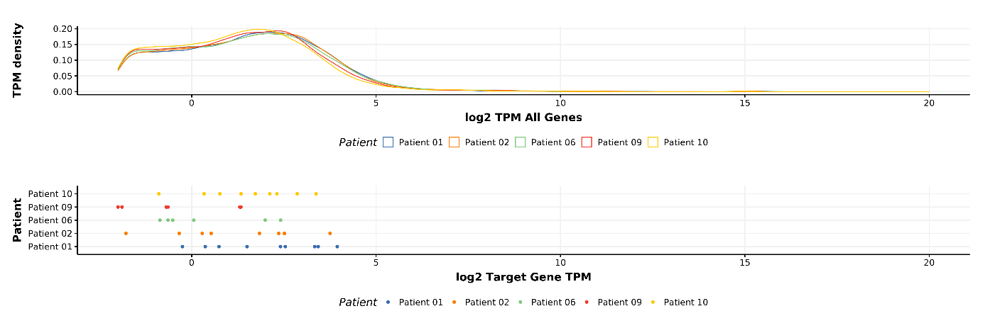
Supplementary Fig. 1 RNA check gene frequencies. Comparative analysis of overall log2 TPM gene expression density (top) against the expression of our selected set of 15 genes per patient (bottom). As can be observed, the gene expression for the set of genes investigated does not lie on the extreme borders of the overall TPM distribution of the samples. Furthermore, the expression distribution of all investigated patient samples resembles each other, particularly pointing out that there is technical consistency across samples. TPM transcript per million
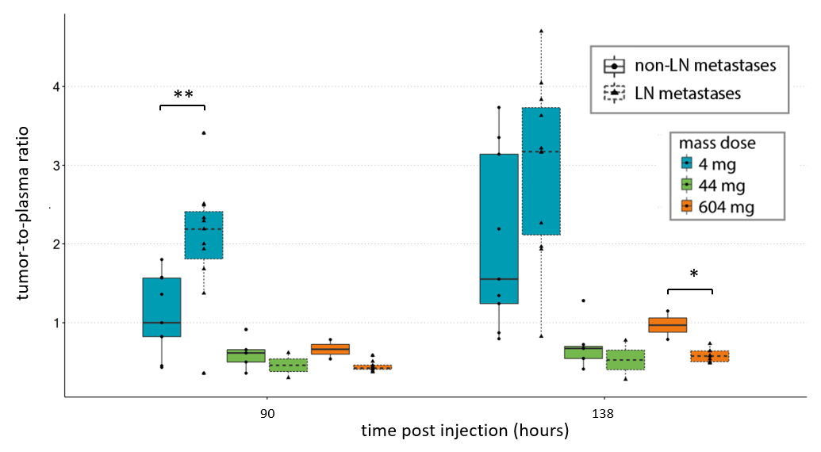Supplementary Fig. 2 [⁸⁹Zr]Zr-BI 754111 tumor-to-plasma ratios for LN metastases versus non-LN metastases (i.e., solid tumors). LN metastases have a slightly higher tumor-to-plasma ratio at 90 h p.i. only for the 4 mg dose, but are not significantly different from non-LN metastases at 138 h p.i.. Non-LN metastases include soft tissue, bone, and lung metastases. Kruskall-Wallis with post-hoc Wilcoxon rank-sum tests (two-sided) with Bonferroni correction were performed (**, p < 0.01; *, p < 0.05, n for non-LN vs. LN metastases: at 4 mg mass dose n = 11 vs. n = 9, at the 44 mg mass dose n = 7 vs. n = 2, and at the 604 mg mass dose n = 2 vs. n = 9). LN lymph node, p.i. post-injection
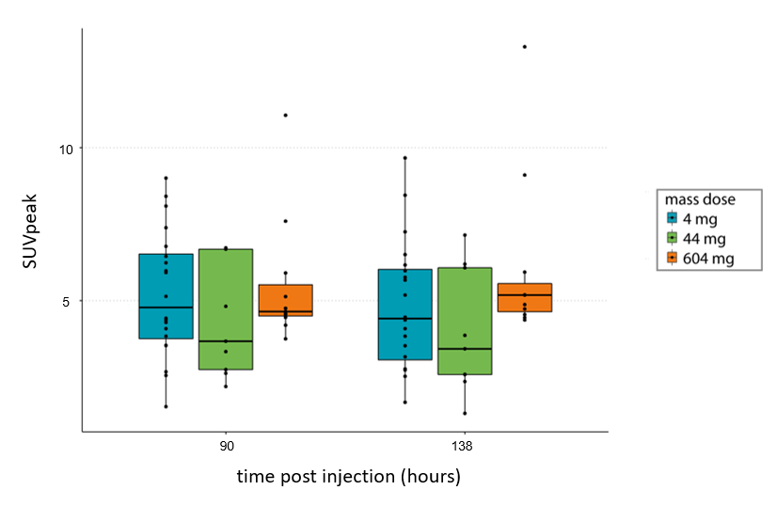
Supplementary Fig. 3 SUVpeak tumor uptake of [⁸⁹Zr]Zr-BI 754111. Tumor uptake of [⁸⁹Zr]Zr-BI 754111, expressed as SUVpeak, did not differ between the 4 mg mass dose compared to the 44 mg and 604 mg mass doses (Kruskal-Wallis tests were performed, for the 4 mg dose n = 20, for the 44 mg mass dose n = 9, and for the 604 mg mass dose n = 11, p > 0.05). SUV standardized uptake value

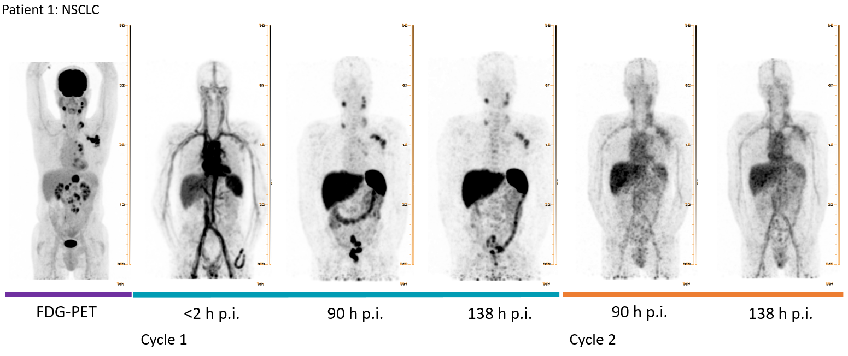
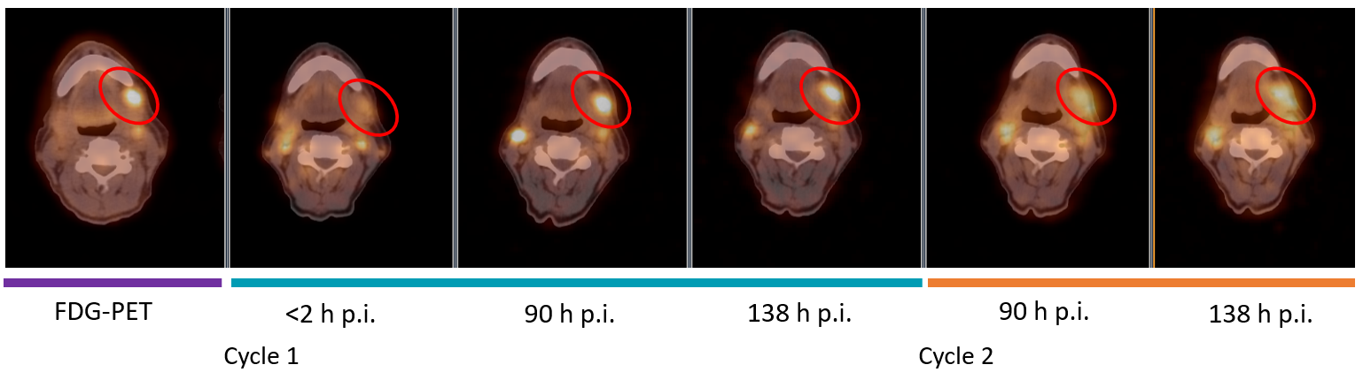
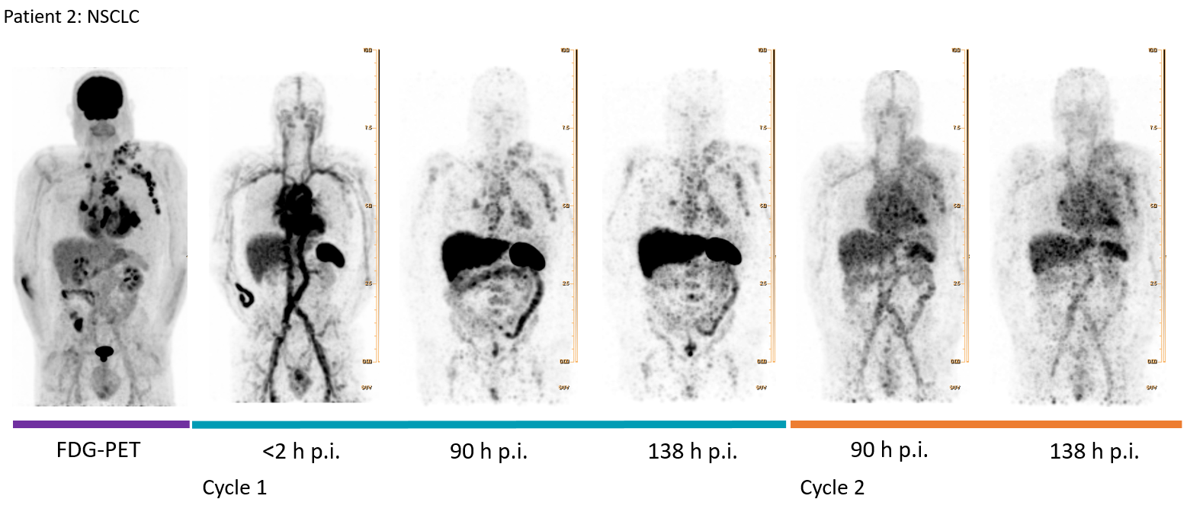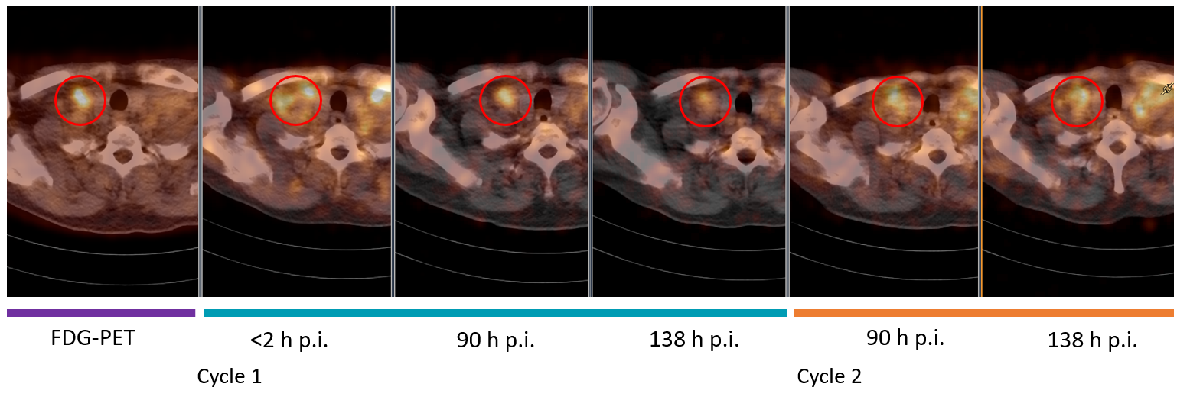
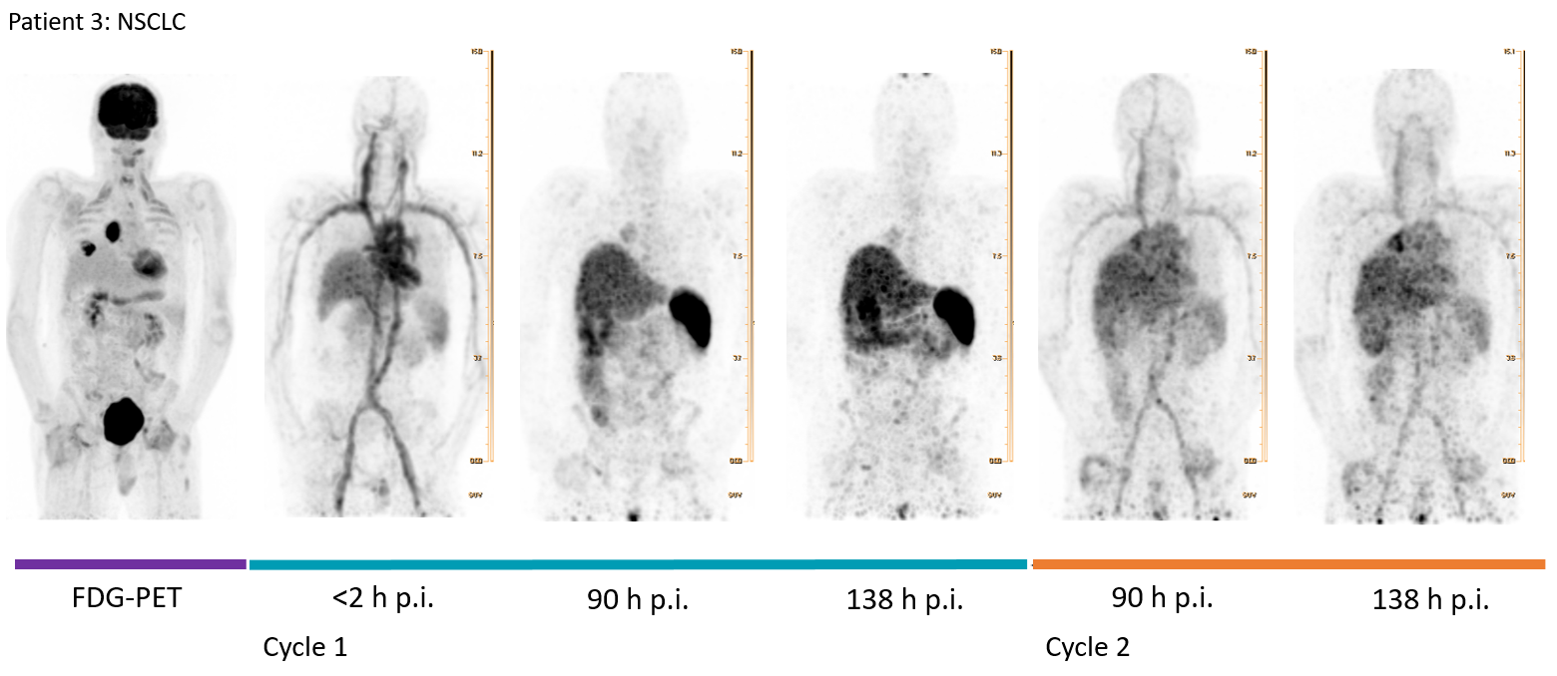
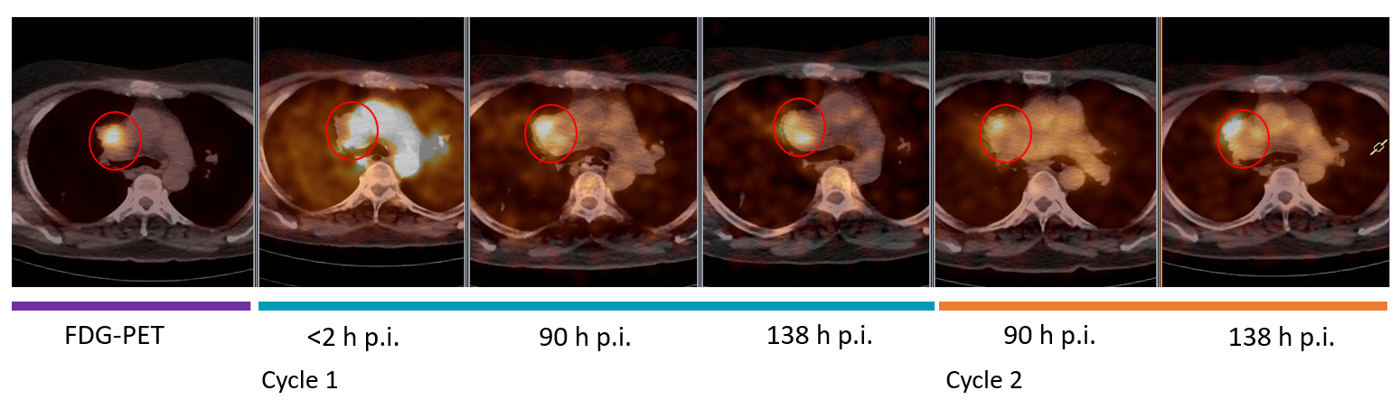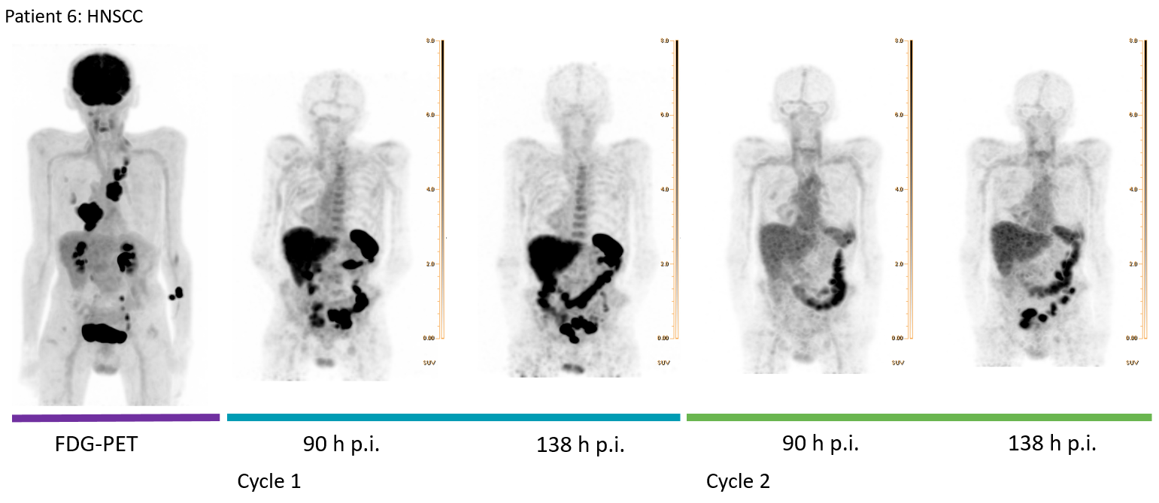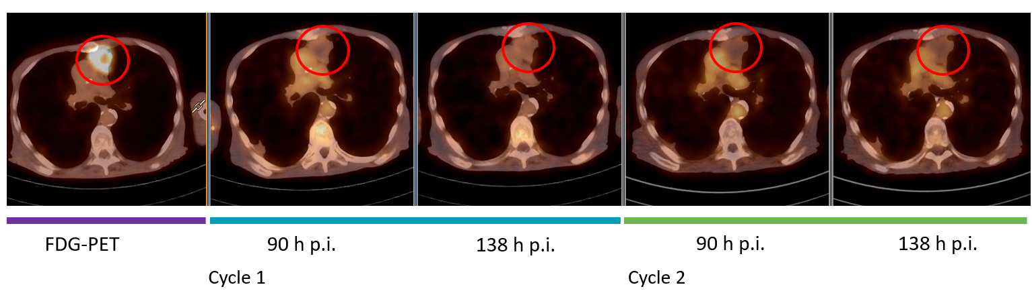
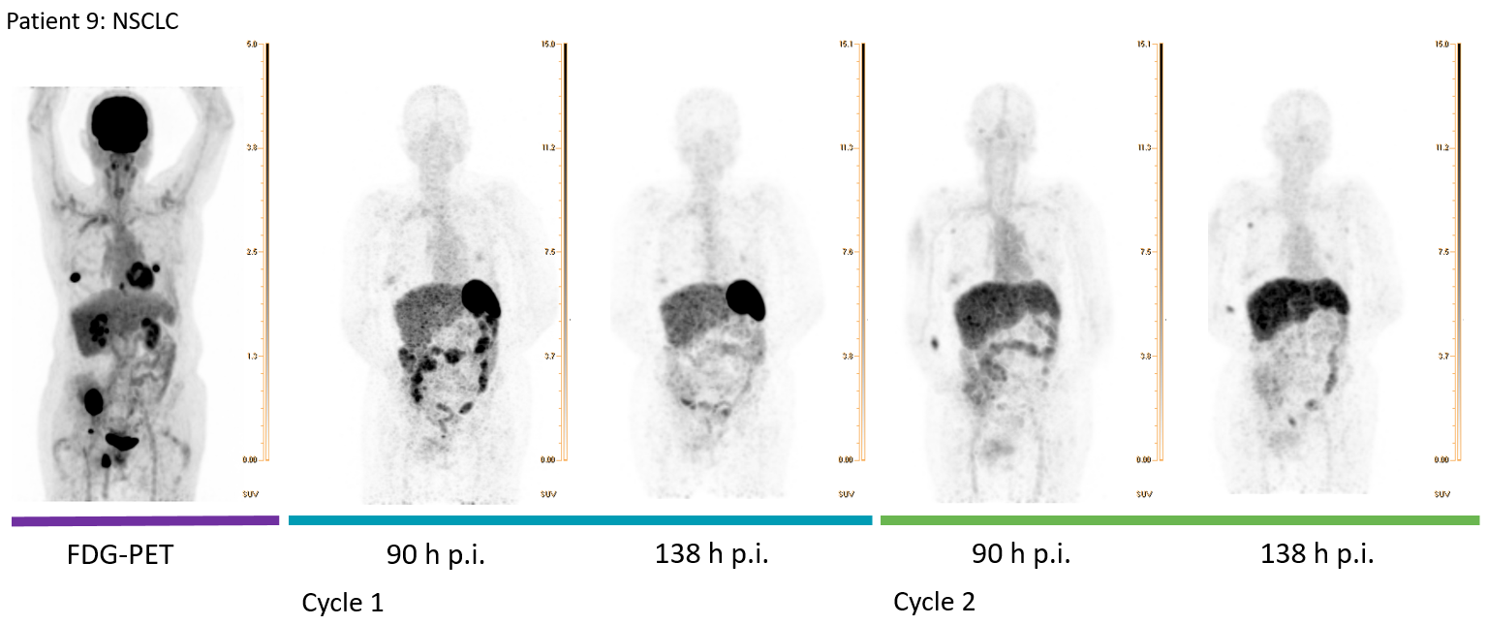 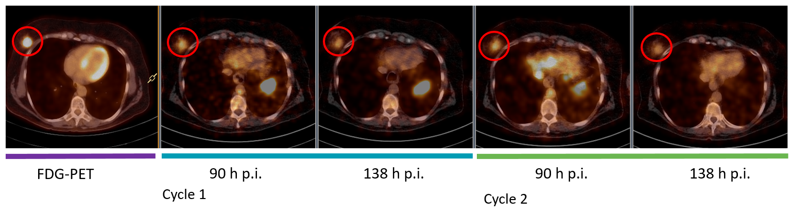 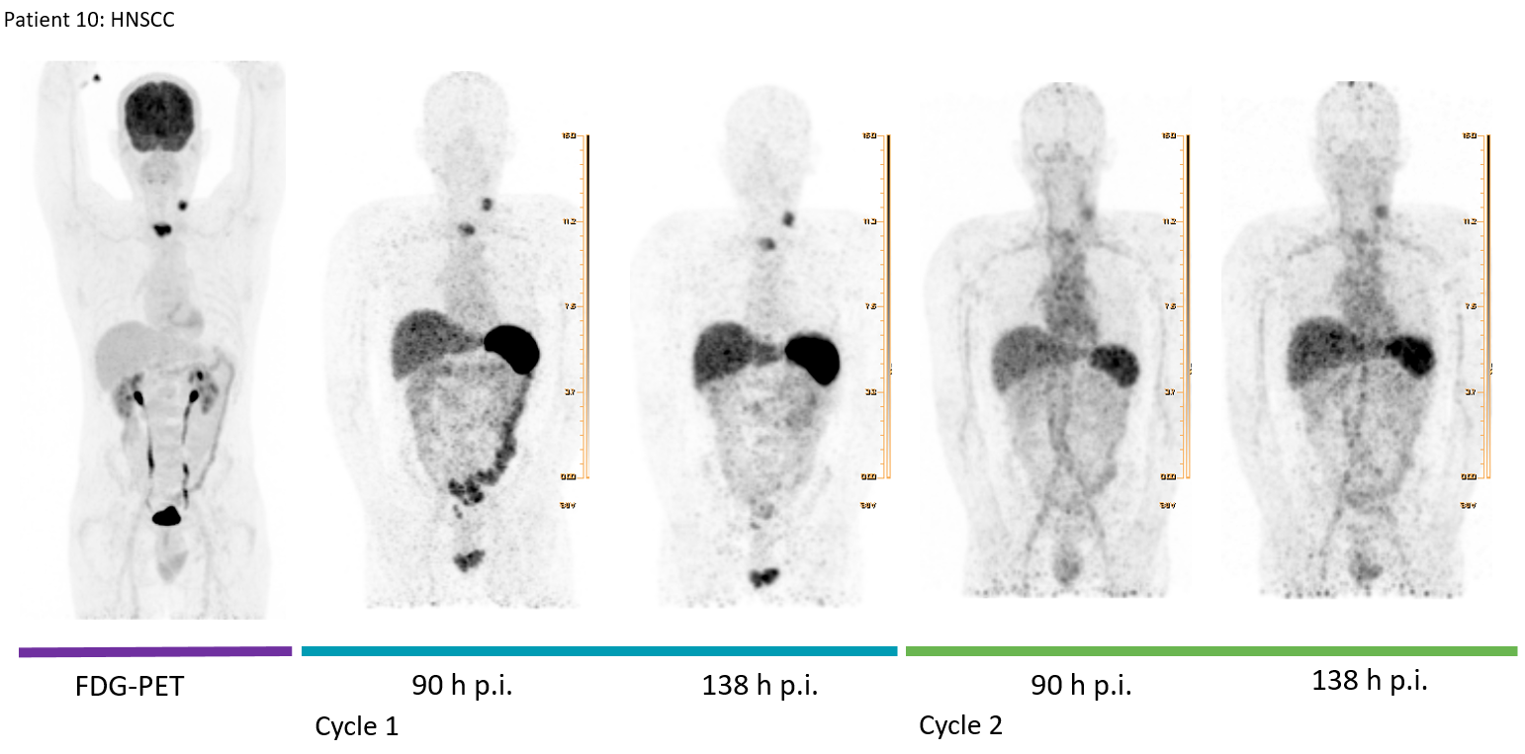 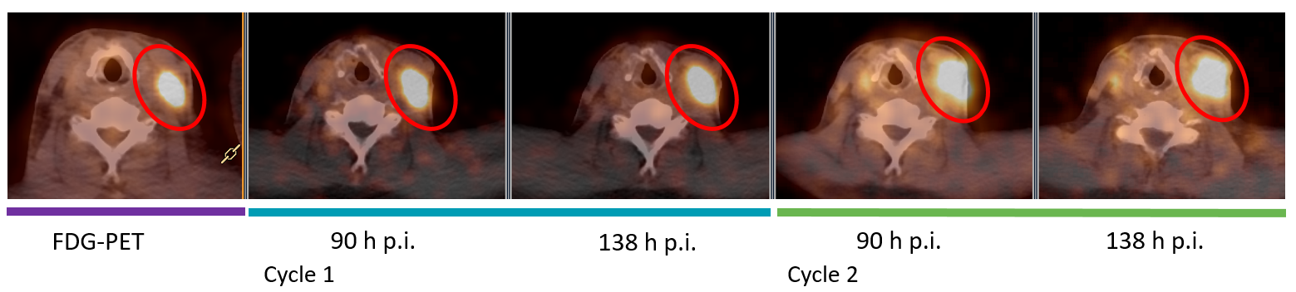Supplementary Fig. 4 MIP images of each scan and detailed axial PET-CT fusion images of one tumor lesion per patient. A red circle indicates a tumor lesion.

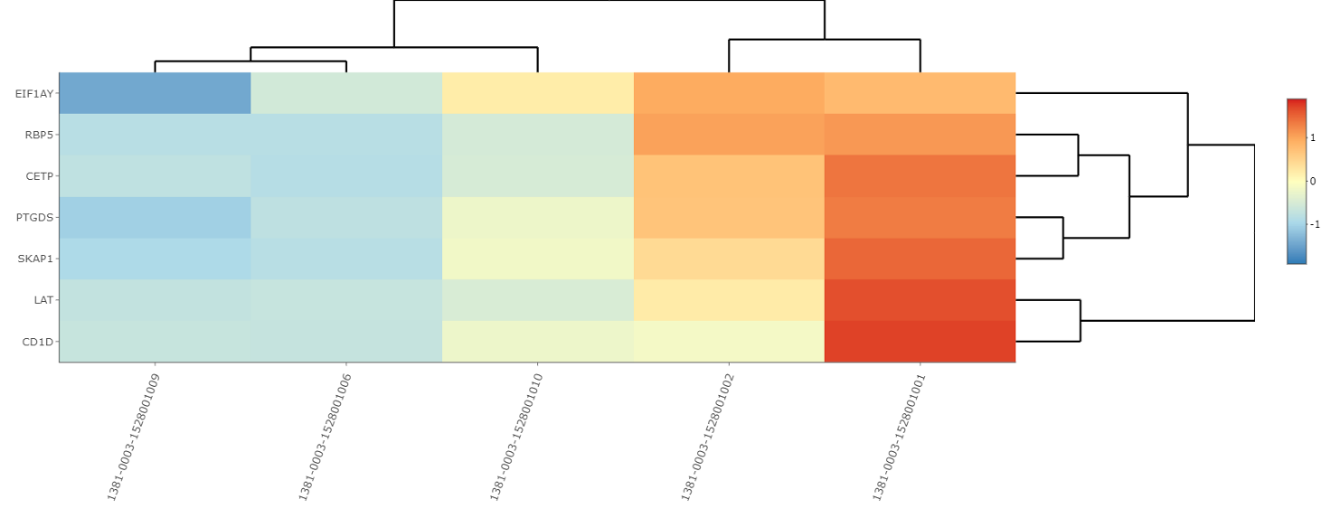
Supplementary Fig. 5 TLS signature. Heatmap for the TLS signature computed using the GSVA algorithm and based on the signature described in Cabrita et al. (2). GSVA gene set variation analysis, TLS tertiary lymphoid structure
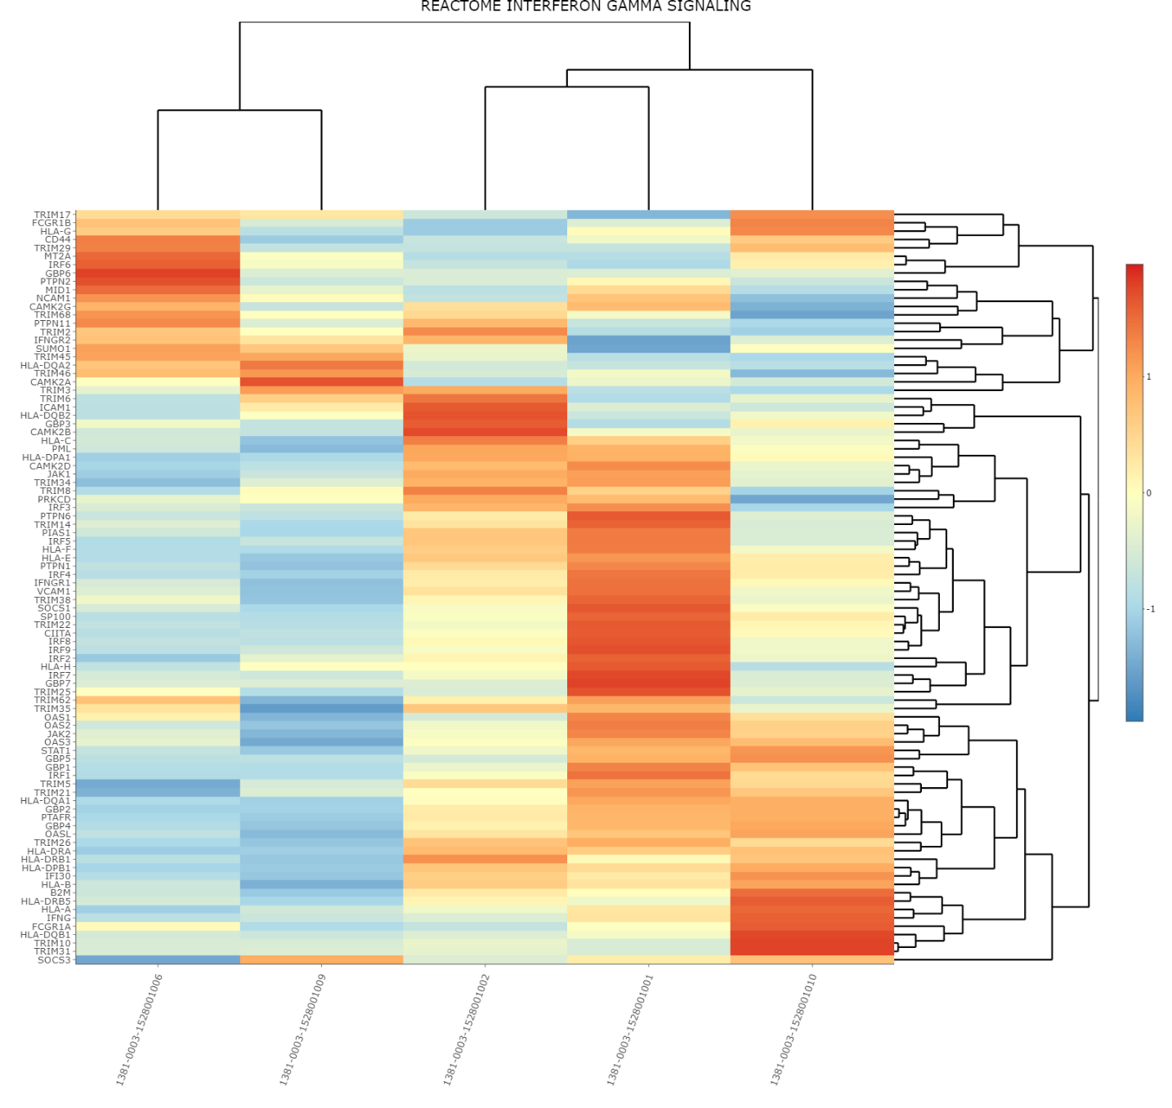
Supplementary Fig. 6 IFN-gamma signature. Heatmap for IFN-gamma signature values for all 5 patients computed using the GSVA algorithm using the Hallmark IFN-Gamma Response Signature (3). GSVA gene set variation analysis, IFN interferon
References
1. Jauw YWS, O'Donoghue JA, Zijlstra JM, Hoekstra OS, Menke-van der Houven van Oordt CW, Morschhauser F, et al. (89)Zr-immuno-PET: toward a noninvasive clinical tool to measure target engagement of therapeutic antibodies in vivo. J Nucl Med 2019;60:1825-32.
2. Cabrita R, Lauss M, Sanna A, Donia M, Skaarup Larsen M, Mitra S, et al. Tertiary lymphoid structures improve immunotherapy and survival in melanoma. Nature 2020;577:561-5.
3. Liberzon A, Birger C, Thorvaldsdottir H, Ghandi M, Mesirov JP, Tamayo P. The Molecular Signatures Database (MSigDB) hallmark gene set collection. Cell Syst 2015;1:417-25.

