Supplementary Material

Table 1: Patients` characteristics (sex, height, weight, BMI, age and applied activity) of 108 included patients receiving [⁶⁸Ga]Ga-DOTA-TOC PET/CT are outlined. Additionally primary tumour location, tumour stage and treatment are given.

Sex | Height  [cm] | Weight  [kg] | BMI  [kg/m²] | Age  [years] | Activity [MBq] | Primary tumour location | Tumour stage | Treatment
Male: 67  Female: 41 | 172 (148-184) | 75.5 (39-122) | 25.8±5.6 | 64±15 | 152.2±9.2 | Gastrointestinal: 74  (Stomach/Ileum/Colon)  Pancreas: 20  Paraganglioma: 5  Lung: 3  Testicular: 1  Medullary thyroid cancer: 2  Unknown: 3 | Metastases: 99  No metastases: 9 | No treatment: 11  Somatostatin analogue : 97  (e.g. lanreotide)  PRRT: 4  (Pancreas: 2; Ileum: 2)

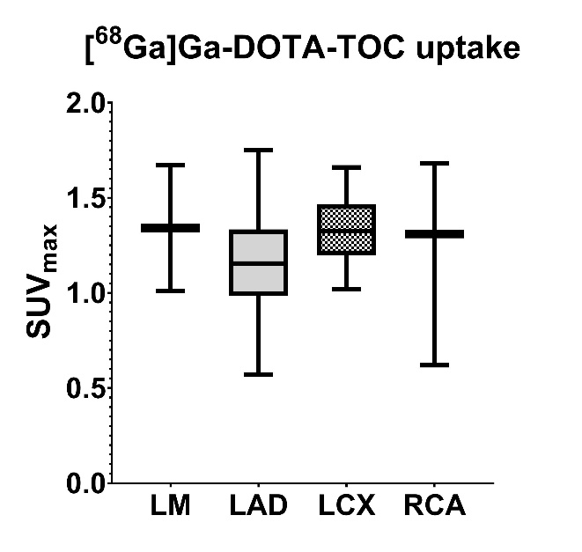
Figure 1 SUV_{max} in calcified coronary artery plaques per affected vessel.
LM: left main; LAD: left anterior descending, RCX: left circumflex artery; RCA: right coronary artery
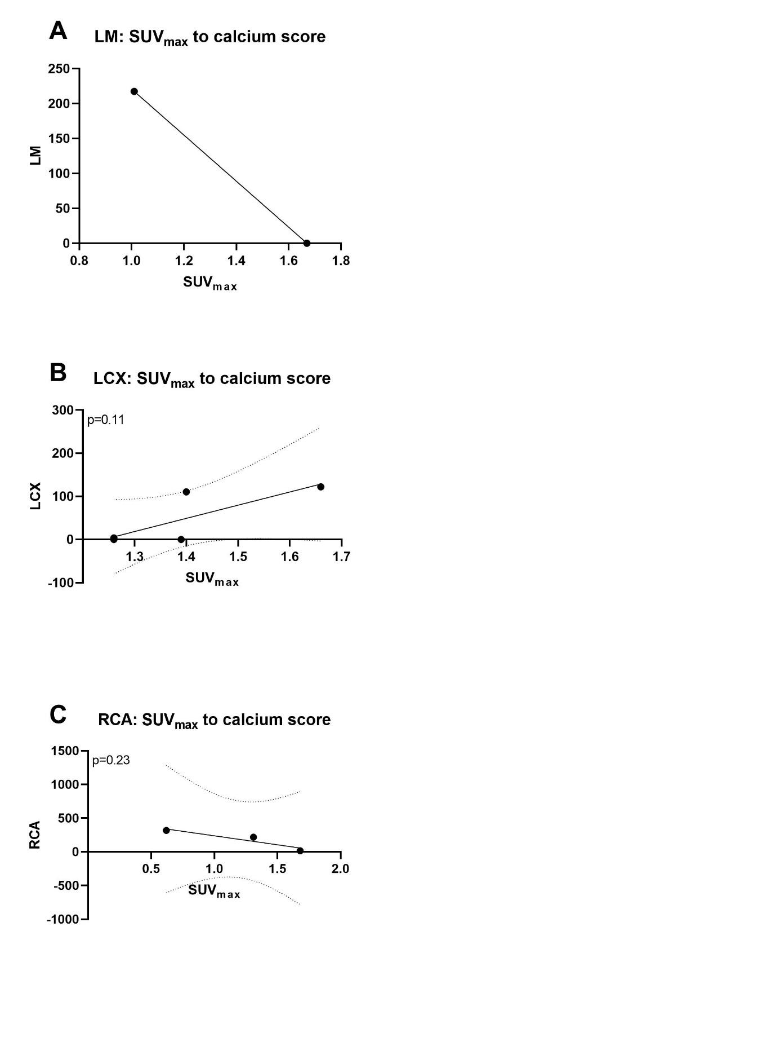
Figure 2 Linear correlation of Calcium Score and SUV_{max}
Indicated are the linear regression models (best fit and standard deviations) of LM (A), LCX (B) and RCA (C) Calcium Score to SUV_{max} ; p-values are given.

