Supplement
Time-activity curves
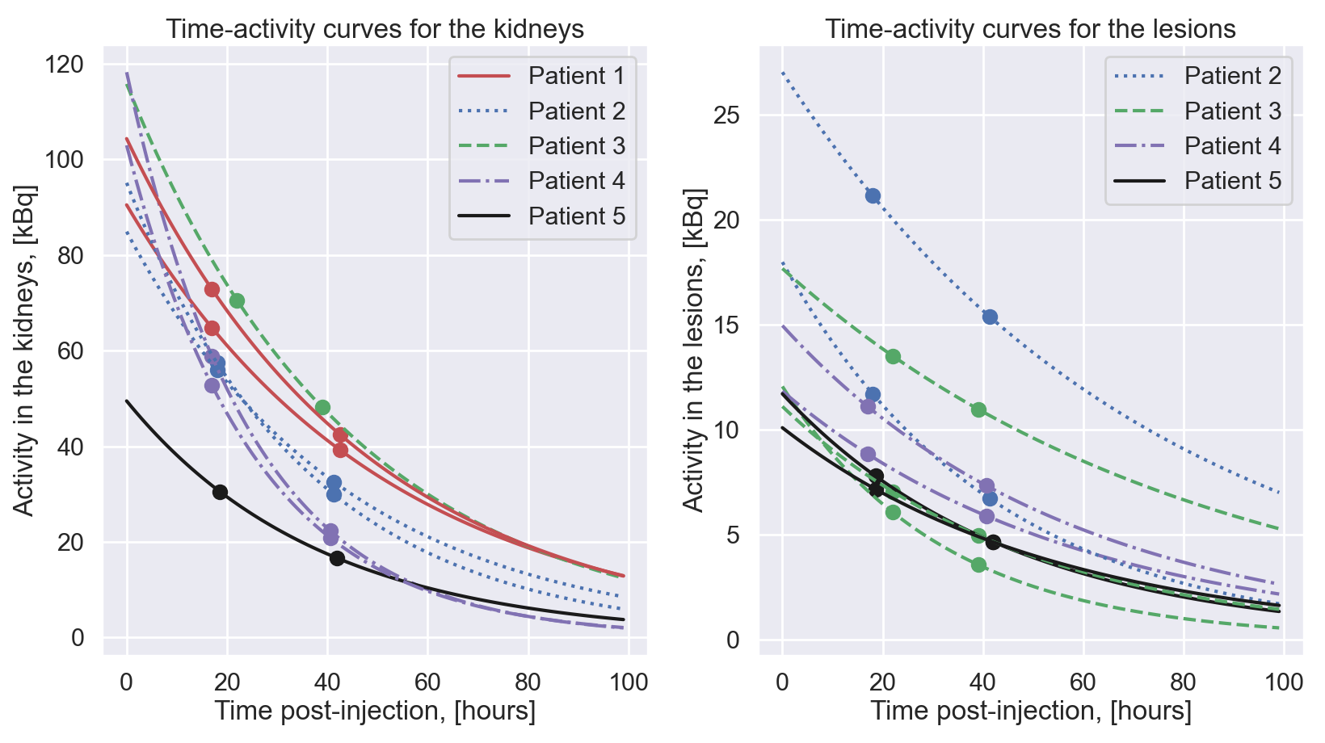
Figure A1: Time-activity curves for the analyzed kidneys (left) and lesions (right) for all patients. The two data points (shown with dots) used to generate the mono-exponential fits are also shown.

