Supplementary Table 1. Normal Tissue Complication Probability (NTCP) analysis (n=209).
Dosimetry method | Odds Ratio | 95% CI | p-value
MRI or CT  (Anatomic method) | 1.03 | 0.90, 1.18 | 0.634
[^{99m}Tc]TcMAA SPECT | 0.93 | 0.83, 1.05 | 0.239
[^{99m}Tc] = technetium-99m; CI = confidence interval; CT = computerized tomography; MAA = macroaggregated albumin; MRI = magnetic resonance imaging; SPECT = single-photon emission computed tomography; Note: Logistic regression of bilirubin >3 times upper limit of normal in absence of disease progression versus absorbed dose to perfused volume normal tissue. Odds ratio for absorbed dose corresponds to a 10 Gy increase in absorbed dose.

Supplementary Table 2. Multivariate modelling of Normal Tissue Complication Probability (NTCP) and ≥grade 3 hyperbilirubinemia.
Dosimetry method | Parameter | Odds Ratio | 95% CI | p-value
Total perfused normal tissue
Anatomic | Absorbed dose (Gy) | 1.11 | 0.94, 1.29 | 0.214
Anatomic | Baseline bilirubin  <1.0 mg/dL vs. ≥1.0 mg/dL | 0.23 | 0.06, 0.94 | 0.041
Anatomic | PVT [^{99m}Tc]TcMAA targeting  No PVT targeting vs. PVT targeting  No PVT vs. PVT targeting | 8.85  1.64 | 0.86, 91.60  0.18, 14.80 | 0.048
Total perfused normal tissue
[^{99m}Tc]TcMAA SPECT | Absorbed dose (Gy) | 0.94 | 0.83, 1.06 | 0.312
[^{99m}Tc]TcMAA SPECT | Baseline bilirubin  <1.0 mg/dL vs. ≥1.0 mg/dL | 0.31 | 0.08, 1.16 | 0.083
[^{99m}Tc] = technetium-99m; CI = confidence interval; CT = computerized tomography; MAA = macroaggregated albumin; MRI = magnetic resonance imaging; SPECT = single-photon emission computed tomography; Note: Logistic regression of bilirubin >3 times upper limit of normal in absence of disease progression versus absorbed dose to normal tissue. Odds ratio for absorbed dose corresponds to a 10 Gy increase in absorbed dose.
Supplementary Table 3. Bland-Altman analysis of agreement and Pearson’s correlation coefficient of pre-treatment [^{99m}Tc]TcMAA SPECT (anatomic method) and post-treatment ⁹⁰Y PET/CT.
Volume of interest | Bias (95% limits of agreement), Gy | Pearson’s Correlation Coefficient
Total perfused normal tissue | -4.7 (-48.0, 38.6) | 0.71
Whole liver normal tissue | -1.9 (-29.9, 26.2) | 0.72
Total perfused tumor | 11.5 (-227.0, 250.0) | 0.80

Supplementary Figure 1. Scatter plot of pre- and post-treatment absorbed doses to total perfused normal tissue. Pearson’s correlation coefficient was 0.71.
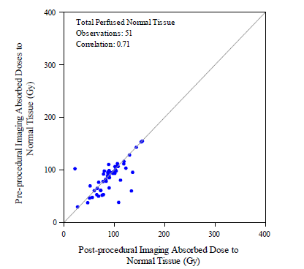

Figure 4.

Supplementary Figure 2. Scatter plot of pre- and post-treatment absorbed doses to total perfused tumor. Pearson’s correlation coefficient was 0.80.
