Supplementary Materials

Huashan Parkinsonian PET Imaging (HPPI) inclusion criteria
The inclusion criteria for healthy subjects were: (1) no previous history of neurological or psychiatric illness; (2) no prior exposure to neuroleptic agents or drug addiction; (3) normal neurological or MRI examination; (4) no previous use of drugs with DAT blocking components. The inclusion criteria for subjects with normal DAT imaging were: (1) visited the Movement Disorders Clinic with Parkinson-related complains; (2) parkinsonism was considered clinically at the first visit, and finally was diagnosed as essential tremor, depression or anxiety; (3) DAT PET imaging was determined as normal based on visual assessment by at least two experienced neuroimaging experts from the PET Center and the semi-quantitative value was within the normal range.

Detailed Cycle GAN Model
Model
A 3D CycleGAN was developed to make the image-to-image translation between two domains, DAT PET imaging and DAT SPECT imaging. The CycleGAN model includes two generators (G_{PS} - PET to SPECT- and G_{SP} – SPECT to PET) and two associated adversarial discriminators (D_{P} and D_{S}).
Each one of the discriminators encourages its corresponding generator to synthesize images similar to the original ones by minimizing an adversarial loss function. The latter is defined, for PET to SPECT translation, as:
$L_{adv}(G_{PS}, D_{S}, P, S)=E_{S\sim p_{data}\left(S\right)}[\log{D_{S}(S)]+E_{P\sim p_{data}(P)}[\log{(1-D_{S}(G_{PS}\left(P\right))] } }$, (1)
Where P and S are the sampled elements from each probability distribution of PET and SPECT images respectively, G_{PS} is the generator that translates PET to SPECT images and D_{S} the discriminator that distinguishes between real and synthetic SPECT. A similar adversarial loss for SPECT to PET translation, $L_{adv}(G_{SP}, D_{P}, S, P)$, is used.
The synthesized SPECT images are then translated back to the original PET domain, with the G_{SP} (and vice-versa for the synthetic PET images). The cycle consistency loss, $L_{cyc}\left(G_{PS}, G_{SP}\right),$ helps ensure that the translated images are similar to the real ones:
$L_{cyc}\left(G_{PS}, G_{SP}\right)=E_{P\sim p_{data}\left(P\right)}\left[∥G_{SP}\left(G_{PS}\left(P\right)\right)-P∥\right]+E_{S\sim p_{data}\left(S\right)}\left[∥G_{PS}\left(G_{SP}\left(S\right)\right)-S∥\right]$.
The PET scan is inputted into the G_{SP} and vice-versa (SPECT to the G_{PS}) and the output image is compared to the real PET (and SPECT) image, through the identity loss:
$L_{id}\left(G_{PS}, G_{SP}\right)=E_{P\sim p_{data}\left(P\right)}\left[∥G_{SP}(P)-P∥\right]+E_{S\sim p_{data}\left(S\right)}\left[∥G_{PS}(S)-S∥\right]$.
The final and total cycleGAN loss is:
$L\left(G_{PS}, G_{SP}, D_{P}, D_{S}\right)=α_{1}{[L}_{adv}\left(G_{PS}, D_{S}, P, S\right)+L_{adv}\left(G_{SP}, D_{P}, S, P\right)]+α_{2}L_{cyc}\left(G_{PS}, G_{SP}\right)+α_{3}L_{id}\left(G_{PS}, G_{SP}\right)$,
where α₁, α₂, α₃ weight the importance of each loss.
Our generator network consists of an encoder consisting of three downsampling blocks and six residual blocks with residual connections, and a decoder consisting of two upsampling blocks, and a final convolution layer and hyperbolic tangent activation function. The dowsampling blocks include a 3D convolutional layer, instance normalization and a RELU activation function. The upsampling blocks have a 3D transposed convolution layer, followed by instance normalization layer and a RELU activation.
Synthetic Images processing
After generation of synthetic SPECT images we applied the SPM brain mask in the MNI space and a Gaussian filter of 1.7 FWHM to smooth the images with a grid-like texture.
The mean images of real PET, real SPECT and synthetic SPECT test datasets are shown in Supplementary Figure 1.
In Supplementary Figure 2, two examples of synthetic SPECT images are displayed to illustrate the grid-like texture of the synthetic SPECT images before application of Gaussian filter.
In Supplementary Figure 3, an example of a synthetic image with artifacts is shown.
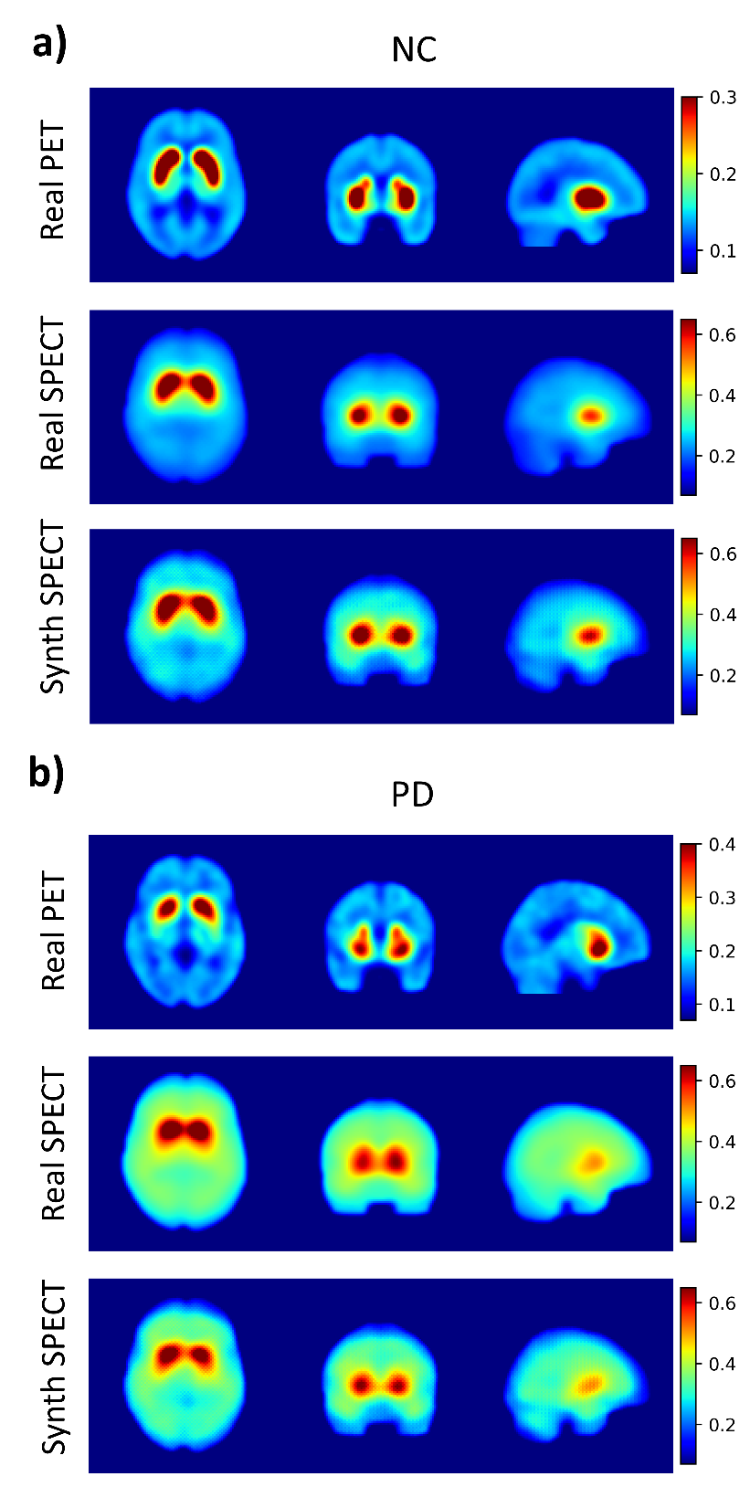
Supplementary Figure 1. Mean images of real PET (upper row), real SPECT (middle row) and synthetic SPECT (bottom row) test datasets from (a) normal controls and (b) Parkinson’s disease. NC: Normal controls; PD: Parkinson disease.
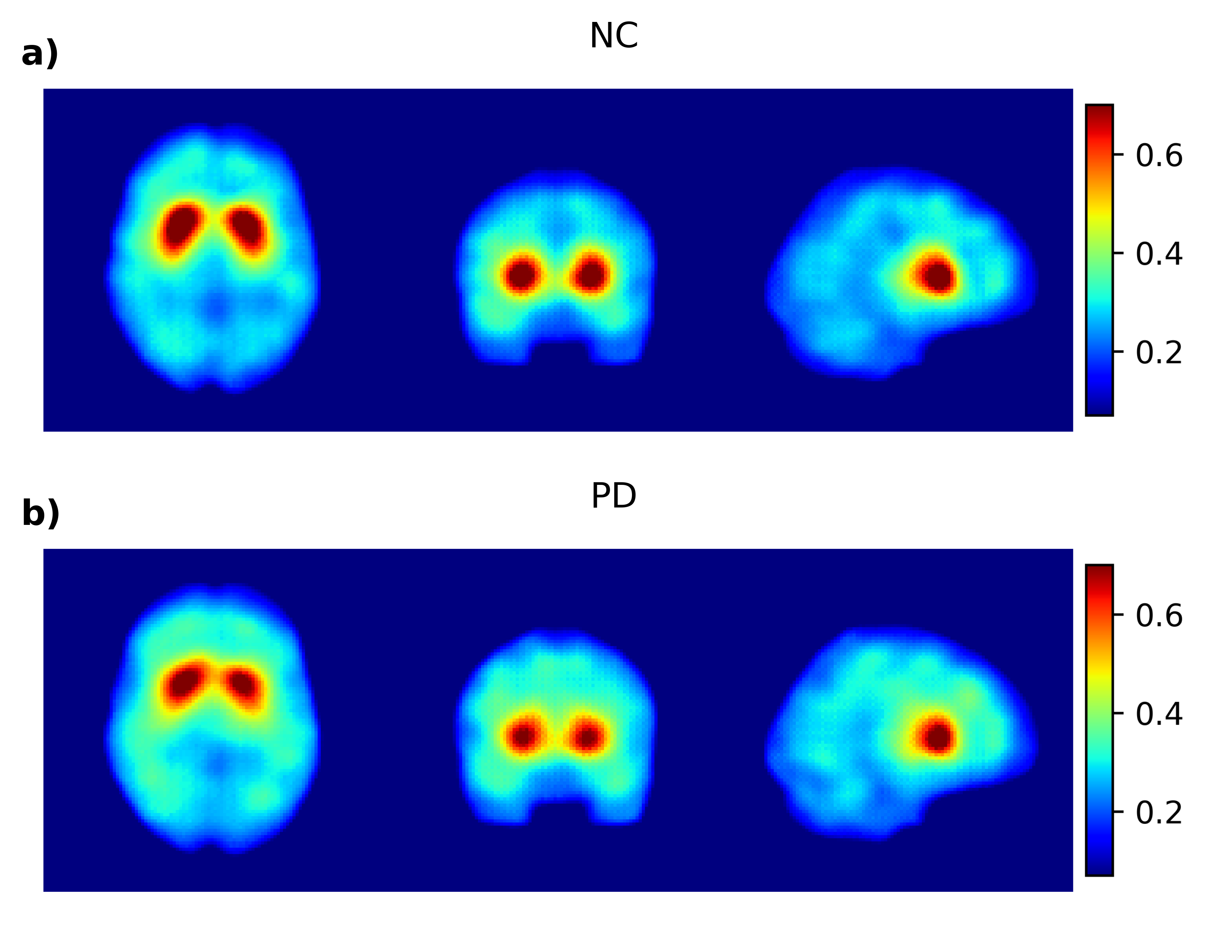
Supplementary Figure 2. Synthetic SPECT images of a) NC and b) PD without Gaussian filter applied. NC: Normal controls; PD: Parkinson disease.
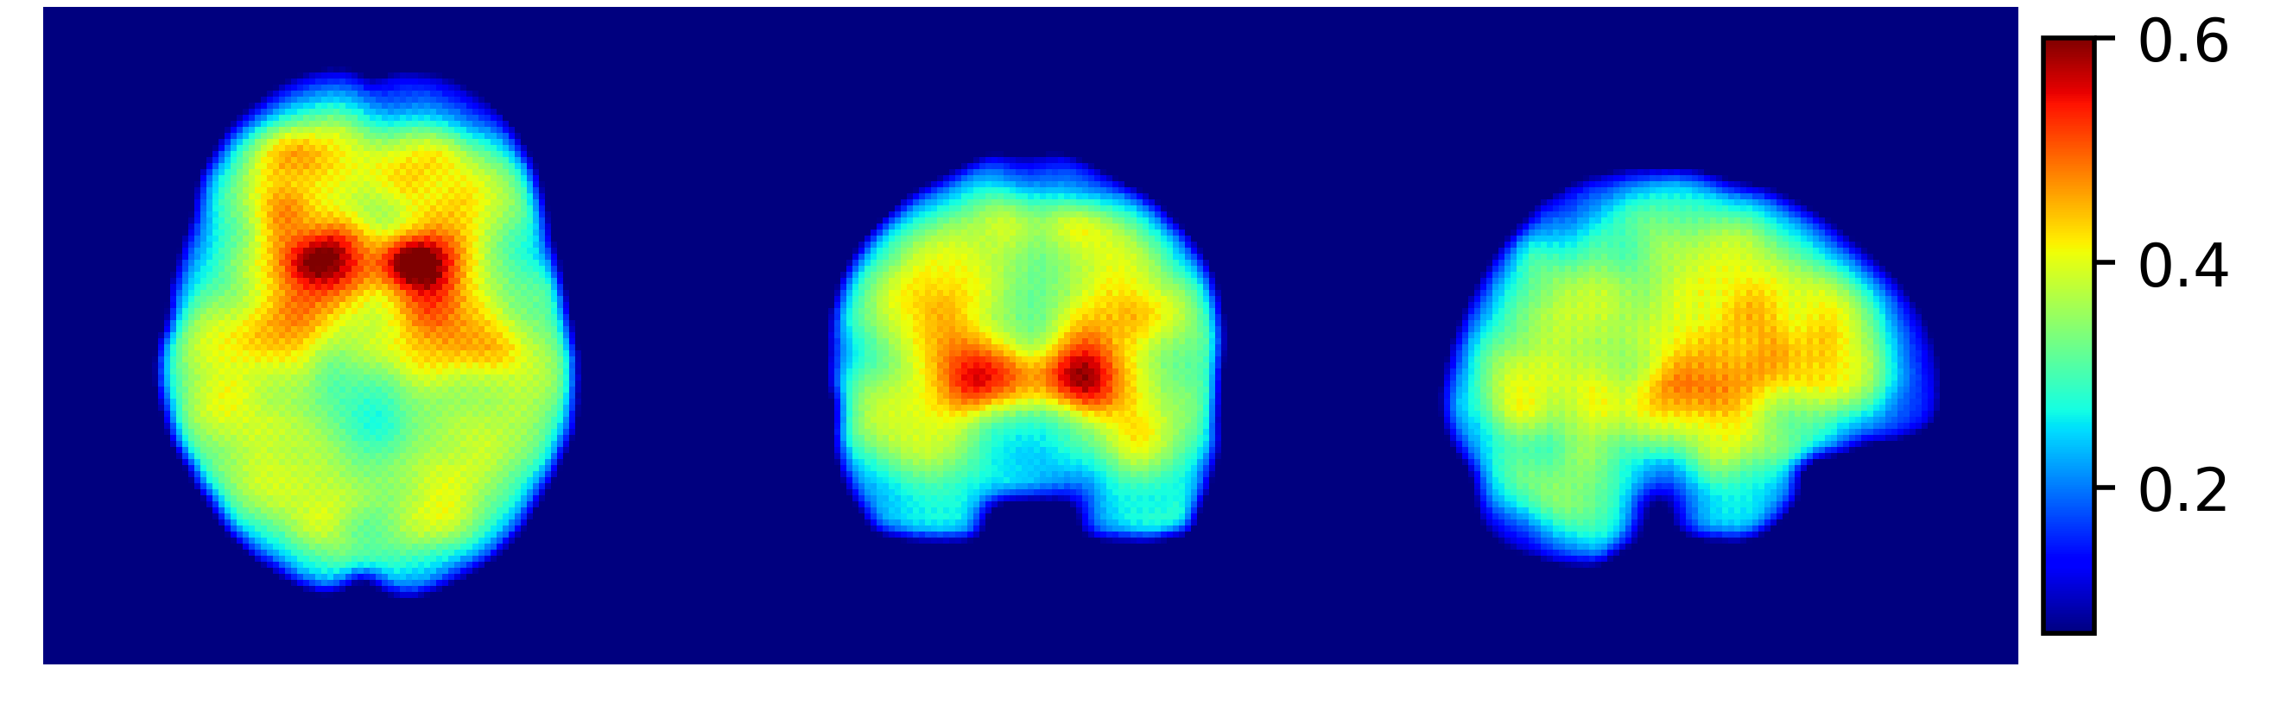
Supplementary Figure 2. Example of Synthetic SPECT image with artifacts.

Blind Visual Assessment of individual readers
In Supplementary Table 1, the scores of each individual reader are presented in the 4 criteria analyzed: synthetic Appearance, level of noise, presence of artifacts and confidence in diagnosis. Scores of both real and synthetic SPECT datasets are presented and compared.
Reader | Criteria | Real SPECT  (Median ± IQR) | Synthetic SPECT  (Median ± IQR) | P-value
#1 | Synthetic Appearance | 2.0 ± 1.75 | 2.0 ± 0.0 | 0.912
#1 | Level of Noise | 2.0 ± 0.75 | 2.0 ± 0.75 | 0.8534
#1 | Presence of Artifacts | 1.0 ± 0.0 | 1.0 ± 0.0 | 0.73936
#1 | Confidence in Diagnosis | 2.5 ± 1.0 | 2.0 ± 0.75 | 0.1051
#2 | Synthetic Appearance | 1.5 ± 1.0 | 1.0 ± 0.0 | 0.3527
#2 | Level of Noise | 1.0 ± 0.0 | 1.0 ± 0.0 | 1.0
#2 | Presence of Artifacts | 1.0 ± 0.75 | 1.0 ± 0.75 | 0.9705
#2 | Confidence in Diagnosis | 2.0 ± 0.75 | 2.0 ± 1.5 | 0.8534
#3 | Synthetic Appearance | 2.0 ± 0.0 | 2.0 ± 0.0 | 1.0
#3 | Level of Noise | 1.0 ± 0.0 | 1.0 ± 0.0 | 1.0
#3 | Presence of Artifacts | 2.0 ± 0.0 | 2.0 ± 0.0 | 1.0
#3 | Confidence in Diagnosis | 3.0 ± 0.75 | 3.0 ± 0.75 | 1.0
#4 | Synthetic Appearance | 3.0 ± 2.0 | 1.0 ± 1.5 | 0.27986
#4 | Level of Noise | 2.0 ± 0.75 | 2.0 ± 1.0 | 0.4359
#4 | Presence of Artifacts | 3.0 ± 2.0 | 1.5 ± 1.75 | 0.4359
#4 | Confidence in Diagnosis | 3.0 ± 1.0 | 2.0 ± 1.5 | 0.21756
Supplementary Table 1. Synthetic Appearance, level of noise, presence of artifacts and confidence in diagnosis scores per dataset (Real and Synthetic SPECT images) of each individual reader. Values are presented as median score of all images ± interquartile range (IQR). P-values of the differences between Real and Synthetic SPECT datasets are also presented as obtained by Mann-Whitney U test.

PPMI Sponsor and funding Partners
PPMI is sponsored and partially funded by The Michael J. Fox Foundation for Parkinson’s Research (MJFF). Other funding partners include a consortium of industry players, non-profit organizations and private individuals.

Funding Partners
1. 4D Pharma
2. AbbVie Inc.
3. AcureX Therapeutics
4. Allergan
5. Amathus Therapeutics
6. Aligning Science Across Parkinson’s (ASAP)
7. Avid Radiopharmaceuticals
8. Bial Biotech
9. Biogen
10. BioLegend
11. BlueRock Therapeutics
12. Bristol Myers Squibb
13. Calico Life Sciences LLC
14. Celgene Corporation
15. DaCapo Brainscience
16. Denali Therapeutics
17. The Edmond J. Safra Foundation
18. Eli Lilly and Company
19. Gain Therapeutics
20. GE Healthcare
21. GlaxoSmithKline
22. Golub Capital
23. Handl Therapeutics
24. Insitro
25. Janssen Pharmaceuticals
26. Lundbeck
27. Merck & Co., Inc.
28. Meso Scale Diagnostics, LLC
29. Neurocrine Biosciences
30. Pfizer Inc.
31. Piramal Imaging
32. Prevail Therapeutics
33. F. Hoffmann-La Roche Ltd and its affiliated company Genentech Inc.
34. Sanofi Genzyme
35. Servier
36. Takeda Pharmaceutical Company
37. Teva Neuroscience, Inc.
38. UCB
39. Vanqua Bio
40. Verily Life Sciences
41. Voyager Therapeutics, Inc.
42. Yumanity Therapeutics, Inc.

