Supporting Information:
Towards the Clinical Translation of a Silver Sulfide Nanoparticle Contrast Agent: Large Scale Production with a Highly Parallelized Microfluidic Chip
Katherine J. Mossburg^{1,2}*, Sarah J. Shepherd¹*, Diego Barragan^{2,3}, Nathaniel H. O^{2,4,5}, Emily K. Berkow^{2,6}, Portia S. N. Maidment², Derick N. Rosario Berrios^{2,7}, Jessica C. Hsu^{1,2┼}, Michael J. Siedlik⁸, Sagar Yadavali⁸, Michael J. Mitchell^{1,9}, David Issadore^{1,10,11}**, David P. Cormode^{1,2,9}**

¹Department of Bioengineering, University of Pennsylvania, Philadelphia, PA, USA
²Department of Radiology, University of Pennsylvania, Philadelphia, PA, USA
³Department of Biology, University of Pennsylvania, Philadelphia, PA, USA
⁴Department of Pharmaceutical Sciences, St. Joseph’s University, Philadelphia, PA, USA
⁵Department of Physics, St. Joseph’s University, Philadelphia, PA, USA
⁶Department of Chemistry, University of Pennsylvania, Philadelphia, PA, USA
⁷Biochemistry and Molecular Biophysics Graduate Group, University of Pennsylvania, Philadelphia, PA, USA
⁸InfiniFluidics, Inc, Philadelphia, PA, USA
⁹ Cardiovascular Institute, Perelman School of Medicine, University of Pennsylvania, PA, USA
¹⁰ Department of Electrical and Systems Engineering, University of Pennsylvania, PA, USA
¹¹ Department of Chemical and Biomolecular Engineering, University of Pennsylvania, PA, USA

┼This author’s current affiliation is the Departments of Radiology and Medical Physics, University of Wisconsin-Madison, Madison, WI, USA.
*These authors contributed equally to this work.
**Corresponding authors.
Emails: issadore@seas.upenn.edu; david.cormode@pennmedicine.upenn.edu

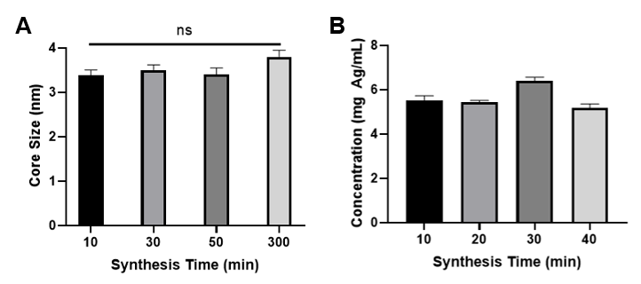
Figure S1. Ag₂S-NP A) product size as evaluated by TEM and B) concentration as evaluated by ICP measured over time during synthesis by a 1X SSMS chip.
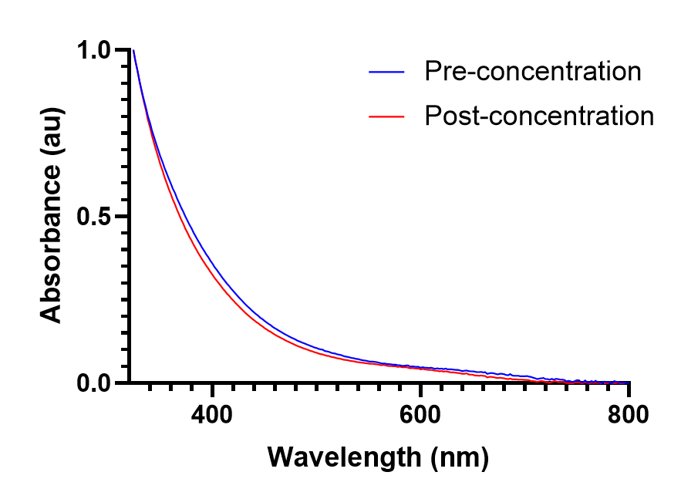
Figure S2. UV-visible absorption spectra of Ag2S-NP immediately after synthesis (pre-concentration) and after concentration and washing using molecular weight cut off tubes (post-concentration).

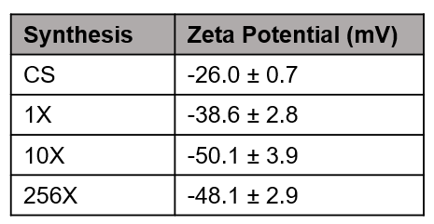
Figure S3. Table of zeta potential values for each Ag₂S-NP synthetic condition.
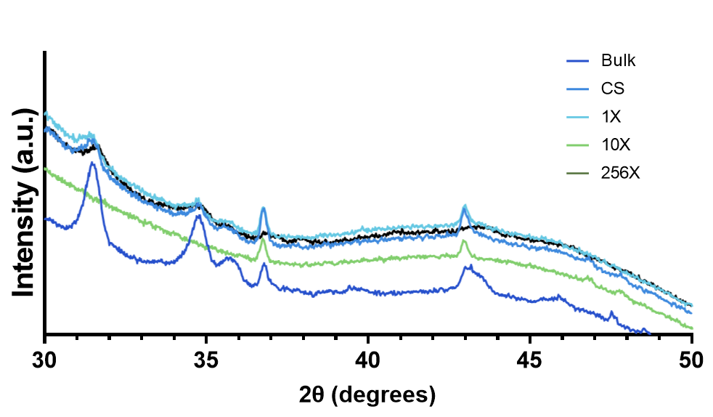
Figure S4. X-ray diffraction patterns of Ag₂S-NP from each synthesis method.
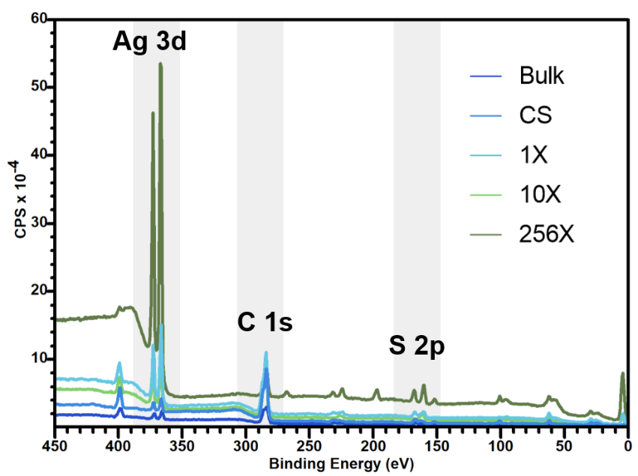
Figure S5. Survey XPS spectra of each type of Ag₂S-NP.
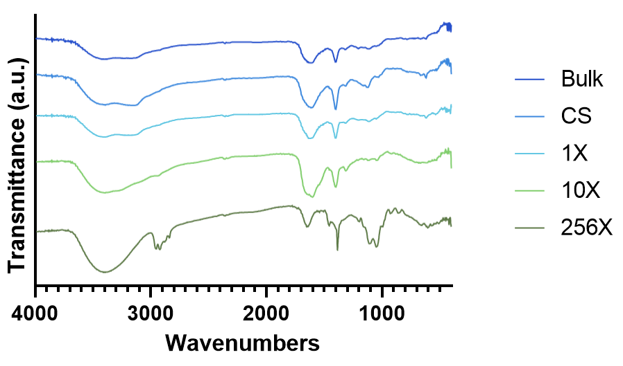
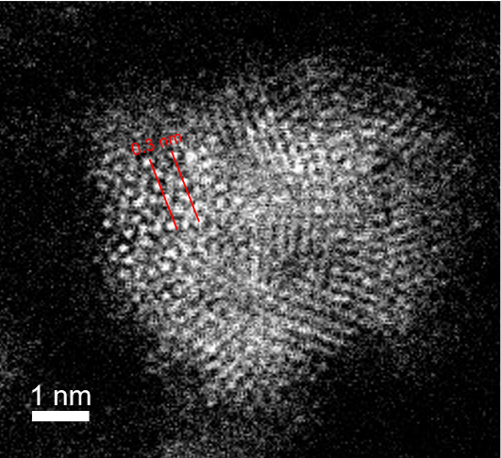
Figure S6. FT-IR spectra of each synthesis method of Ag₂S-NP.

Figure S7. HR-TEM micrograph of representative CS-Ag₂S-NP, showing 0.3 nm lattice fringe distance.

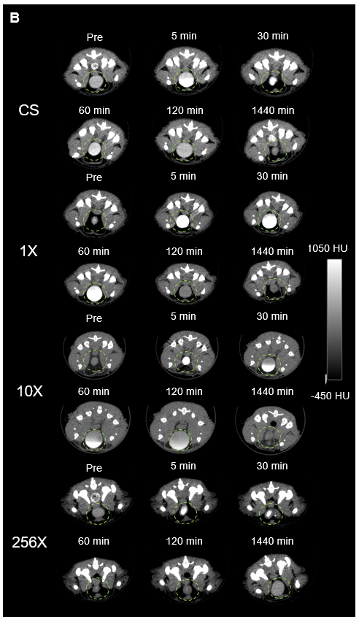
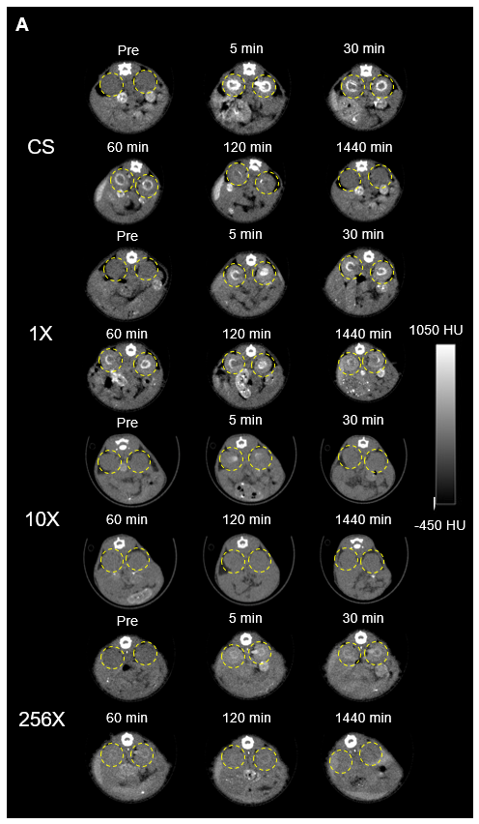
Figure S8. Representative µCT images showing Ag₂S-NP being renally cleared through A) the kidneys (yellow circle) and B) the bladder (green circle).
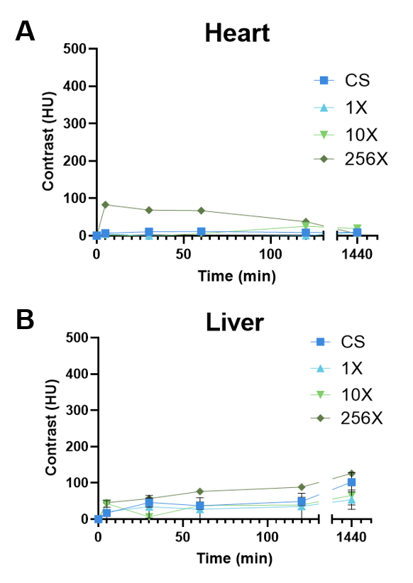
Figure S9. Quantification of CT attenuation in the A) heart and B) liver at each time point. n=5 per group. Data is presented as mean ± SEM.
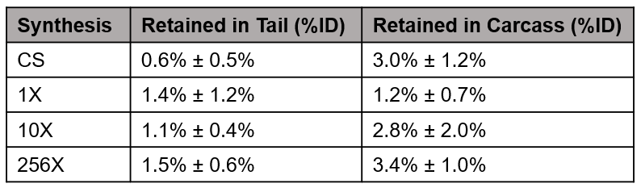
Figure S10. Silver content retained by the carcass and the tail of mice injected with Ag₂SNP.

