Supplementary Information

Selective PET imaging of CXCR4 using the Al¹⁸F-labeled antagonist LY2510924

Muriel Aline Spahn¹, Tom Van Loy², Sofie Celen³, Michel Koole³, Christophe M. Deroose³, Christopher Cawthorne³, Wim Vanduffel⁴, Dominique Schols², Guy Bormans¹ and Frederik Cleeren^{1*}

¹Radiopharmaceutical Research, Department of Pharmaceutical and Pharmacological Sciences, KU Leuven; Leuven, Belgium
²KU Leuven, Department of Microbiology, Immunology and Transplantation, Rega Institute for Medical Research, Molecular Structural and Translational Virology Research Group, B-3000 Leuven, Belgium
³Nuclear Medicine and Molecular Imaging, Department of Imaging and Pathology, KU Leuven; Leuven, Belgium
⁴Laboratory for Neuro- and Psychophysiology, KU Leuven Medical School, Leuven, Belgium

*Corresponding author: E-mail: frederik.cleeren@kuleuven.be

LC-HRMS of AlF NOTA-SC
The construct’s mass was analyzed using a Dionex Ultimate 3000 UPLC system (Thermo Fisher Scientific, Sunnyvale, USA), which was coupled in sequence to a UV detector, a three-inch thick NaI (Tl) radioactivity detector, and an ultra-high resolution time-of-flight mass spectrometer (MaXis Impact, Bruker, Bremen, Germany) set in ‘positive mode’ with electron spray ionization. A gradient elution was performed on a 38.5 °C warmed Waters Acquity UPLC BEH C18 column (1.7 μm 2.1 x 50 mm) at a flow rate of 0.6 mL/min, using Milli-Q water (solvent A), and acetonitrile (solvent B), both containing 0.1% formic acid. The multistep gradient included the following steps: 0–2 min: 95% A; 2–8 min: from 95% to 5% A; 8–10 min: 5% A; 10–12 min: 95% to 5% A. The run was monitored with UV detection at 220 nm and the average neutral molecular ion mass was calculated using the Compass Isotope Pattern software (Version 3.2, Bruker Daltonik, Bremen, Germany). The deconvolution of the measured mass data was performed with the DataAnalysis software program (Bruker Daltonik).
Radio-HPLC of [¹⁸F]AlF-NOTA-SC for quality control and in vitro stability assessment
The radioHPLC system was equipped with a degasser (Alltech Elite On-line degassing system, Grace Davison Discovery Sciences, Lokeren, Belgium), a pump (LaChrom Elite L-2130, Hitachi, Tokyo, Japan) coupled to an UV detector (L-2400, Hitachi, Tokyo, Japan), as well as to a three inch thick NaI(Tl) based radioactivity detector (GABI Star module, Elysia Raytest Angleur, Belgium). The radiochemical purity (RCP) was assessed using a Hamilton PRP-1 (1.5 µm, 4.1 × 150 mm) column (Hamilton, Bonaduz, Graubünden, Switzerland) with a gradient composed of MilliQ water (solvent A) and acetonitrile (solvent B), both containing 0.1% trifluoroacetic acid, at a flow rate of 0.75 mL/min. The gradient steps over a 30-min period were: 0–5 min, 95% A, 5 – 10 min 95% to 70% A, 10-15 min 70% to 60% A, 15–25 min 60% to 5% A, 25–30 min 5% to 95% A.
In vitro stability was assessed by incubating the radiotracer for 2 h at 37°C in human serum (H4522 human male AB plasma, USA origin, sterile-filtered, Sigma Aldrich) and for 4.5 h at room temperature in formulation buffer composed of PBS supplemented with 0.58% sodium ascorbate. The identity of the radiotracer was confirmed with a reference injection. The resulting UV chromatogram of [^{nat}F]AlF-NOTA-SC and the radiochromatogram of [¹⁸F]AlF-NOTA-SC, along with the in vitro stability results, have been included (Figure S.1). The in vitro stability of the radiotracer demonstrated an intactness of over 99% in both formulation buffer and human serum.
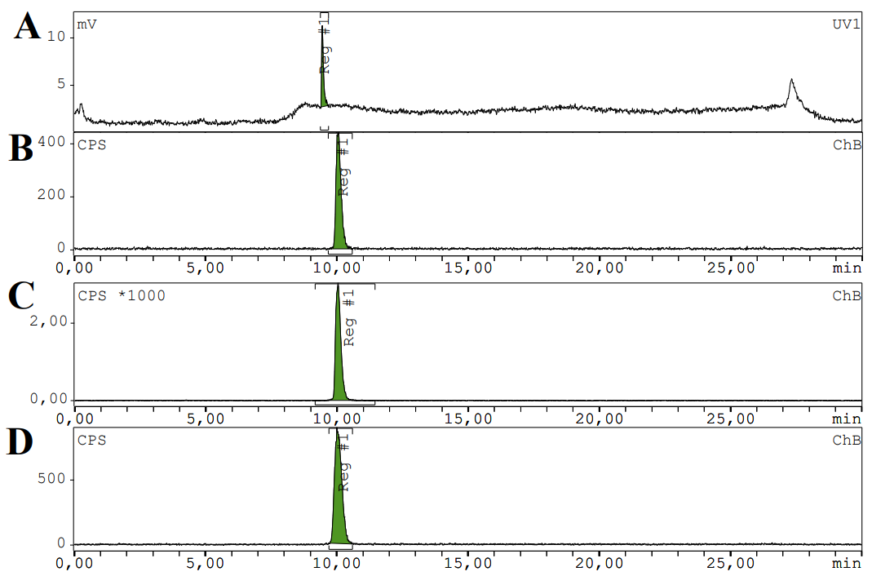
Figure S1: Chromatographic analysis of [^{nat}F]AlF-NOTA-SC and [¹⁸F]AlF-NOTA-SC (A) UV (220 nm) chromatogram of [^{nat}F]AlF-NOTA-SC. (B) Radiochromatogram of [¹⁸F]AlF-NOTA-SC. The in vitro stability of [¹⁸F]AlF-NOTA-SC in (C) formulation buffer and (D) human serum.
In vitro affinity assessment
The affinity binding curves (Figure S. 2) demonstrate that [^{nat}F]AlF-NOTA-SC exhibits a higher affinity for hCXCR4 compared to mCXCR4. Reference compounds AMD3100 and AMD11070 showed affinities towards hCXCR4 of 28.3±5.4 nM and 2.7±4.0 nM, respectively, and for mCXCR4 of 81.89±62.61 nM and 4.88±1.13 nM, respectively.

Figure S.2: IC₅₀ binding curve of [^{nat}F]AlF-NOTA-SC on human (A) and mouse (B) CXCR4. The values are expressed as mean±SD (n = 4).
In vitro radioligand binding assay on U87.MG and U87 cells overexpressing ACKR3 and CCR5
The in vitro cell binding assay on U87.MG, U87.CD4.ACKR3 and U87.CD4.CCR5 cells showed uptake percentages of 1.55±0.40%, 0.95±0.09% and 1.19±0.19%, respectively (Figure S. 3), and blocking using VUF11207 (ACKR3 agonist) or Maraviroc (CCR5 antagonist) did not block or change the uptake.
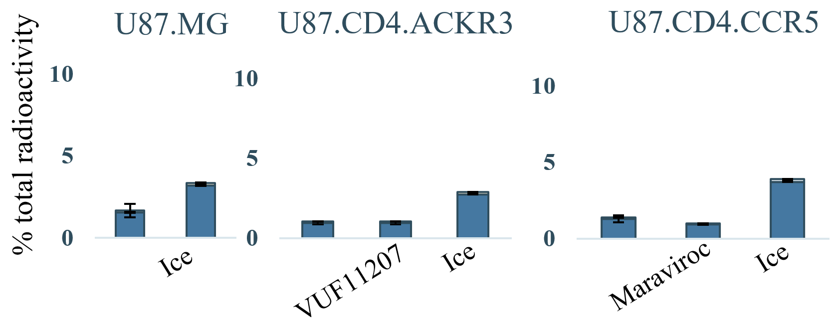
Figure S.3: Radioligand binding assay of [¹⁸F]AlF-NOTA-SC on U87.MG and U87 cells overexpressing ACKR3 and CCR5. The light blue bar represents the internalized fraction, and the dark blue bar represents the membrane-bound fraction. The values are expressed as mean±SD (n = 3).
In vivo radiometabolite and plasma protein binding profile in mice and rhesus macaque
The same HPLC machine setup as described above for Quality Control assessment was utilized. Radiometabolites were quantified using a Waters XTerra RP C18 (5 µm, 4.6x250 mm) column (W21611A Waters Corporation) with a gradient composed of 50 mM NaOAc (pH 5.5, solvent A), and acetonitrile (solvent B), both containing 0.1% trifluoroacetic acid, at a flow rate of 0.8 mL/min. The gradient elution program over 25 min consisted of: 0–5 min, 95% A, 5–10 min 95% to 70% A, 10-15 min 70% to 60% A, 15–20 min 60% to 5% A, 20-25 min 5% to 95% A.
The plasma protein binding capacity was determined by dividing the activity residing in the plasma with the one in the precipitated plasma proteins. The plasma was collected by centrifuging the blood sample for 10min at 2333 x g and the plasma proteins were precipitated by adding acetonitrile to the plasma fraction.
In mice, the fraction of the parent [¹⁸F]AlF-NOTA-SC was determined to be 96.98±1.01% at 10 min p.i., (n = 4) (Figure S.4A) and 94.02±1.89% at 75 min p.i., (n = 4) (Figure S.4B). In urine, the fraction of parent radiotracer at 75 min p.i. was 95.38±1.47% (n = 4) (Figure S.4C). Plasma protein binding was 16.4±3.6% at 10 min p.i., (n = 4) and 13.61±2.33% at 75 min p.i. (n = 4).
In the non-human primate the plasma stability of [¹⁸F]AlF-NOTA-SC was 63.47% at 10 min p.i. (n = 1) (Figure S.5A), and urine stability was 57.60% at 180 min p.i., (n = 1) (Figure S.5B). Plasma protein binding was 16.10% at 10 min p.i., (n = 1), 14.89% at 30 min p.i., (n = 1) and 15.39% at 60 min p.i., (n = 1), respectively.
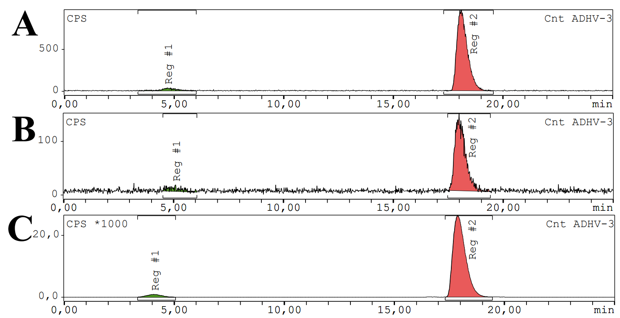
Figure S.4: In vivo radiometabolite analysis of [¹⁸F]AlF-NOTA-SC in mouse plasma at 10 min p.i.(A) and 75 min p.i. (B) and in mouse urine at 75 min p.i. (C)
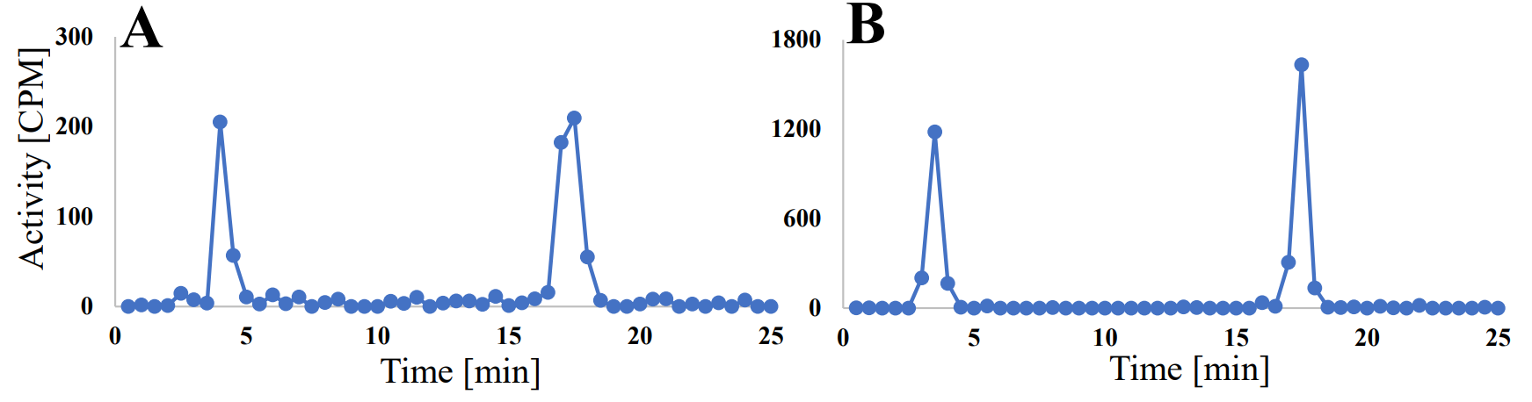
Figure S.5: In vivo radiometabolite analysis of [¹⁸F]AlF-NOTA-SC in non-human primate plasma at 10 min p.i. (A) and urine at 180 min p.i. (B)
Time activity curve of bone in naïve mice
The bone-TAC in naïve mice (Figure S. 6) peaked at 4.5 min p.i. (1.18±0.15 g/mL, n = 4) and gradually decreased over time (0.73±0.09 g/mL at 57.5 min p.i., n = 4).
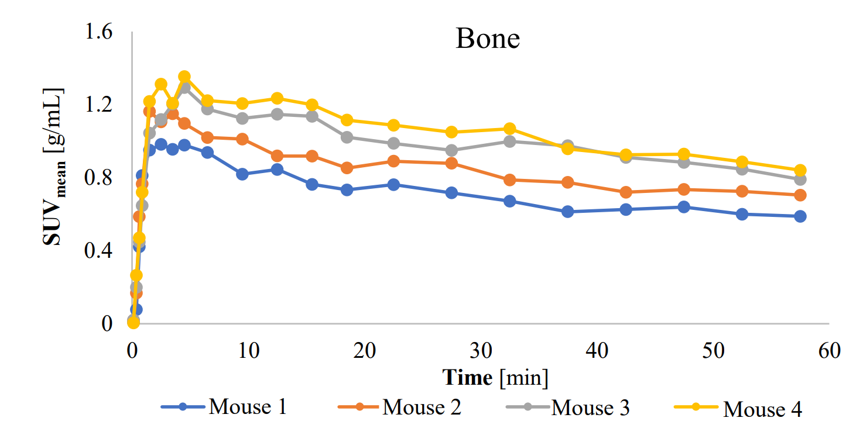
Figure S.6: Bone TAC of naïve mice injected with [¹⁸F]AlF-NOTA-SC
Ex vivo biodistribution data of systemic MM.1S model
The ex vivo biodistribution of [¹⁸F]AlF-NOTA-SC in the systemic MM.1S model (Figure S.7) revealed radiotracer uptake in various organs, with a strong predominance of bone, reflecting the typical pattern observed in multiple myeloma.
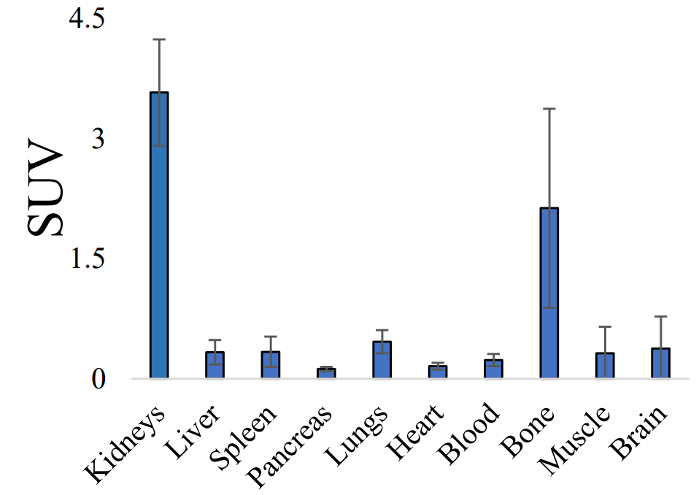
Figure S.7: Ex vivo biodistribution profile of the systemic MM.1S model at 75 min p.i. of [¹⁸F]AlF-NOTA-SC (n = 3). The values are expressed as mean±SD (n = 3).
Flow cytometry analysis of CXCR4 expression on MM.1S cells
The expression of CXCR4 receptors on the cell membrane of MM.1S cells was assessed following methods similar to those described by D’huys [61]. Briefly, MM.1S cells were washed with PBS containing 2% FBS (Thermo Fisher Scientific) and incubated on ice for 30 min with PE-labeled anti-CXCR4 mAb clone 12G5 (BD Biosciences, San Diego, CA, USA), PE-labeled anti-CXCR4 mAb clone 1D9 (BD Biosciences, San Diego, CA, USA , #551510), PerCP-Cy5.5-labeled anti-CXCR4 mAb clone 12G5 (BD Biosciences, San Diego, CA, USA, #560670), APC-labeled anti-CXCR4 mAb clone 12G5 (BD Biosciences, San Diego, CA, USA, #555976) or BV421-labeled anti-CXCR4 mAb clone 12G5 (BD Biosciences, San Diego, CA, USA, #566282), respectively. The fluorescently labeled negative controls included PE-labeled IgG2a (BD Biosciences, San Diego, CA, USA, #555574), rat PE-labeled IgG2a (BD Biosciences, San Diego, CA, USA, #554689), PerCP-Cy5.5-labeled IgG2a (BD Biosciences, San Diego, CA, USA, #552577), APC-labeled mouse IgG2a (BD Biosciences, San Diego, CA, USA, #555576) and BV421-labeled IgG2a (BD Biosciences, San Diego, CA, USA, #563464). Subsequently, the cells were washed with PBS and fixed with 1% paraformaldehyde for analysis using the FACSCalibur flow cytometer (BD Biosciences) and FlowJo software. Flow cytometry results (Figure S. 8) indicate a strong CXCR4 expression.
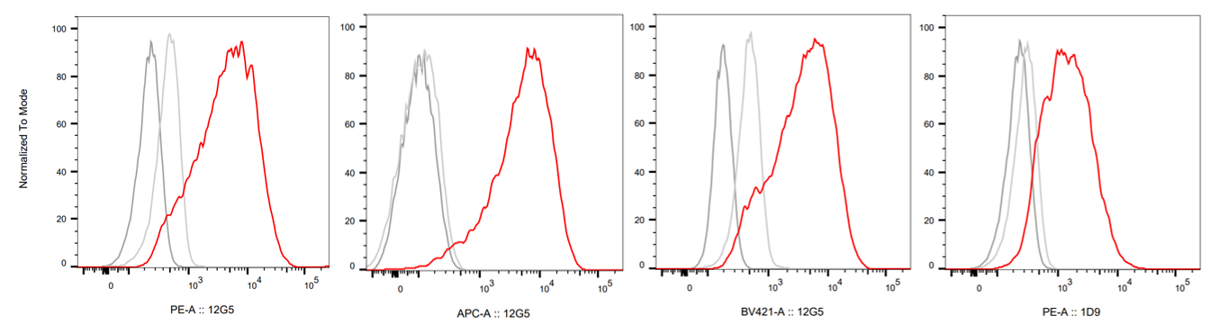
Figure S.8: Flow cytometry analysis of CXCR4 expression on MM.1S cells

