The Molar Dose of FAPI Administered Impacts on the FAP-targeted PET Imaging and Therapy in Mouse Syngeneic Tumor Models
Luoxia Liu¹, Yifan Shi¹, Shujie He¹, Jingfei Yang¹, Shuang Song¹, Dongdong Wang¹, Ziqiang Wang¹, Huimin Zhou¹, Xiaoyun Deng¹, Sijuan Zou¹, Yuankai Zhu¹, Bo Yu^{1*}, Xiaohua Zhu^{1*}
1. Department of Nuclear Medicine, Tongji Hospital, Tongji Medical College, Huazhong University of Science and Technology, 1095 Jiefang Ave, Wuhan 430030, China

Corresponding authors：
Xiaohua Zhu, evazhu@vip.sina.com
Bo Yu, yuboxf@hotmail.com

Supplementary Materials and Methods
Radiolabeling
For radiolabeling of [⁶⁸Ga]Ga-NOTAGA-FAPI-04 and [⁶⁸Ga]Ga-DOTAGA-FAPI-04, 20 μg (24 nmol) of the NOTAGA-FAPI-04 or 20 μg (21 nmol) of the DOTAGA-FAPI-04 were mixed with 0.2 mL of 5 M acetate buffer (pH = 4) and 2 ml the eluent from a ⁶⁸Ge-⁶⁸Ga generator with 0.05 M HCl, followed by incubation at 100°C for 15 min. After cooling to room temperature, the reaction mixture was diluted with 10 mL of water. Then, the purification steps were identical to those for the radiolabeling of [⁶⁸Ga]Ga-FAPI-04.
For radiolabeling of [¹⁸F]AlF-NOTA-FAPI-04, [¹⁸F]F－ was trapped onto a QMA cartridge and eluted by 200 μL of saline. To 150 μL of elute, 20 μL of 1 M acetate buffer (pH = 4), 6.5 μL of 2 mM AlCl₃, and 80 μg (104 nmol) of NOTA-FAPI-04 precursor were added and heated at 105°C for 15 min. The mixture was cooled to room temperature, diluted with 10 mL of water, and trapped to a C18 light cartridge (preconditioned as above mentioned). The C18 light cartridge was washed with 30 mL of water. Then, the subsequent steps were identical to those for the radiolabeling of [⁶⁸Ga]Ga-FAPI-04.
Cell Culture and Cell Line-Derived Xenograft Models
4T1, U87MG, Huh7, Hepa1-6, PC3, and MC38 cells were cultured at 37°C with 5% CO₂ in RPMI 1640 or DMEM medium supplemented with 10% fetal bovine serum and 100 U/mL penicillin‒streptomycin. All animal experiments were approved by The Ethical Committee of Tongji Hospital, Tongji Medical College, Huazhong University of Science and Technology. To establish subcutaneous xenografts, Balb/c mice aged 6 to 8 weeks were subcutaneously implanted with 1 × 10⁵ 4T1 cells in 100 μL of saline in the right flank for 4T1 xenografts. For Huh7 and PC3 xenografts, 2 × 10⁶ Huh7 cells and 2 × 10⁶ PC3 cells were subcutaneously administered to 6-to-8-week-old Balb/c nude mice, respectively. For Hepa1-6 and MC38 xenografts, 3 × 10⁶ Hepa1-6 cells and 4 × 10⁵ MC38 cells were administered as above to C57/BL6 mice, respectively.
Docking
The molecular structure of FAPI-04 was constructed using ChemDraw and Chem3D software with energy minimization. The PDB formats of the human FAP protein (hFAP) and murine FAP protein (muFAP) were downloaded from the RCSB PDB protein data bank (ID: 1Z68) and the Universal Protein Knowledgebase (ID: P97321, AlphaFold predicted structure), respectively. PyMOL software was used to remove any repeated protein chains and ligand molecules. Dehydration, hydrogenation, energy minimization, and PDBQT format transformation of the proteins and FAPI-04 were performed using AutoDock Tools 1.5.7. The docking grid box encompassed the entire protein structures. AutoDock was run 100 times using the Lamarckian Genetic Algorithm. The model with the lowest binding energy was selected as the best binding configuration. PyMOL software was used to visualize the docking results.
Immunofluorescence and Immunohistochemical Staining
4T1 and U87MG cells were seeded into a 24-well plate and incubated overnight. The cells were fixed with precooled methanol and blocked with 5% bovine serum albumin (BSA). The cells were then incubated with a primary antibody against FAP (ABclonal, A23789, 1:200) overnight. Coralite488-conjugated secondary antibodies (Proteintech, SA00013-2, 1:1000) were used for fluorescence imaging.
Paraffin-embedded, rehydrated, and antigen-retrieved slides were blocked with 5% BSA. Primary antibodies against Ki-67 (Proteintech, 28074-1-AP, 1:400), FAP (Affinity, AF0739, 1:500), and CD31 (Proteintech, 28083-1-AP, 1:2000) were added for incubation overnight. The secondary antibody was applied, and then positive staining was visualized with a DAB coloration kit. Semiquantitative analysis was performed using ImageJ software.
Bioinformatics Analysis
The FAP transcript levels in various tumors in TCGA database were analyzed via the GEPIA web server. The FAP transcript levels in murine organs and cells were analyzed via the Mouse Cell Atlas Database and Tabula-Muris Database, two single-cell RNA normal mouse organ sequencing databases[11, 12].

Supplementary Table S2. pH of reaction mixture and final radio product of [⁶⁸Ga]Ga-FAPI-04, [⁶⁸Ga]Ga-DOTAGA-FAPI-04, [⁶⁸Ga]Ga-NOTAGA-FAPI-04, and [¹⁸F]AlF-NOTA-FAPI-04.
Radio pharmaceuticals | Reaction mixture | Product pre QMA adsorption | Product post QMA adsorption | Radiopharmaceutical after filter and dilution
[⁶⁸Ga]Ga-FAPI-04 | 4.0 | 5.4 | 6.5 | 7.4
[⁶⁸Ga]Ga-DOTAGA-FAPI-04 | 3.5 | 5.4 | 5.8 | -
[⁶⁸Ga]Ga-NOTAGA-FAPI-04 | 4.0 | 5.4 | 6.5 | -
[¹⁸F]AlF-NOTA-FAPI-04 | 3.8 | 5.8 | 6.4 | 7.4

Supplementary Table S3. Adsorption efficacy of QMA in [⁶⁸Ga]Ga-FAPI-04, [⁶⁸Ga]Ga-DOTAGA-FAPI-04, [⁶⁸Ga]Ga-NOTAGA-FAPI-04, [¹⁸F]AlF-NOTA-FAPI-04, and [¹⁷⁷Lu]Lu-FAPI-04.
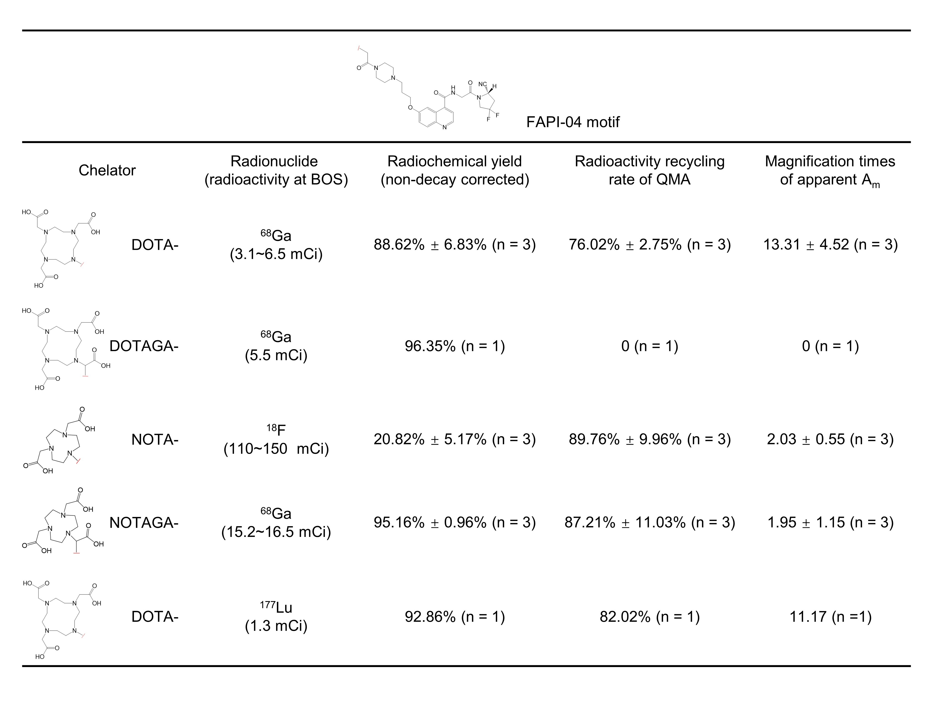

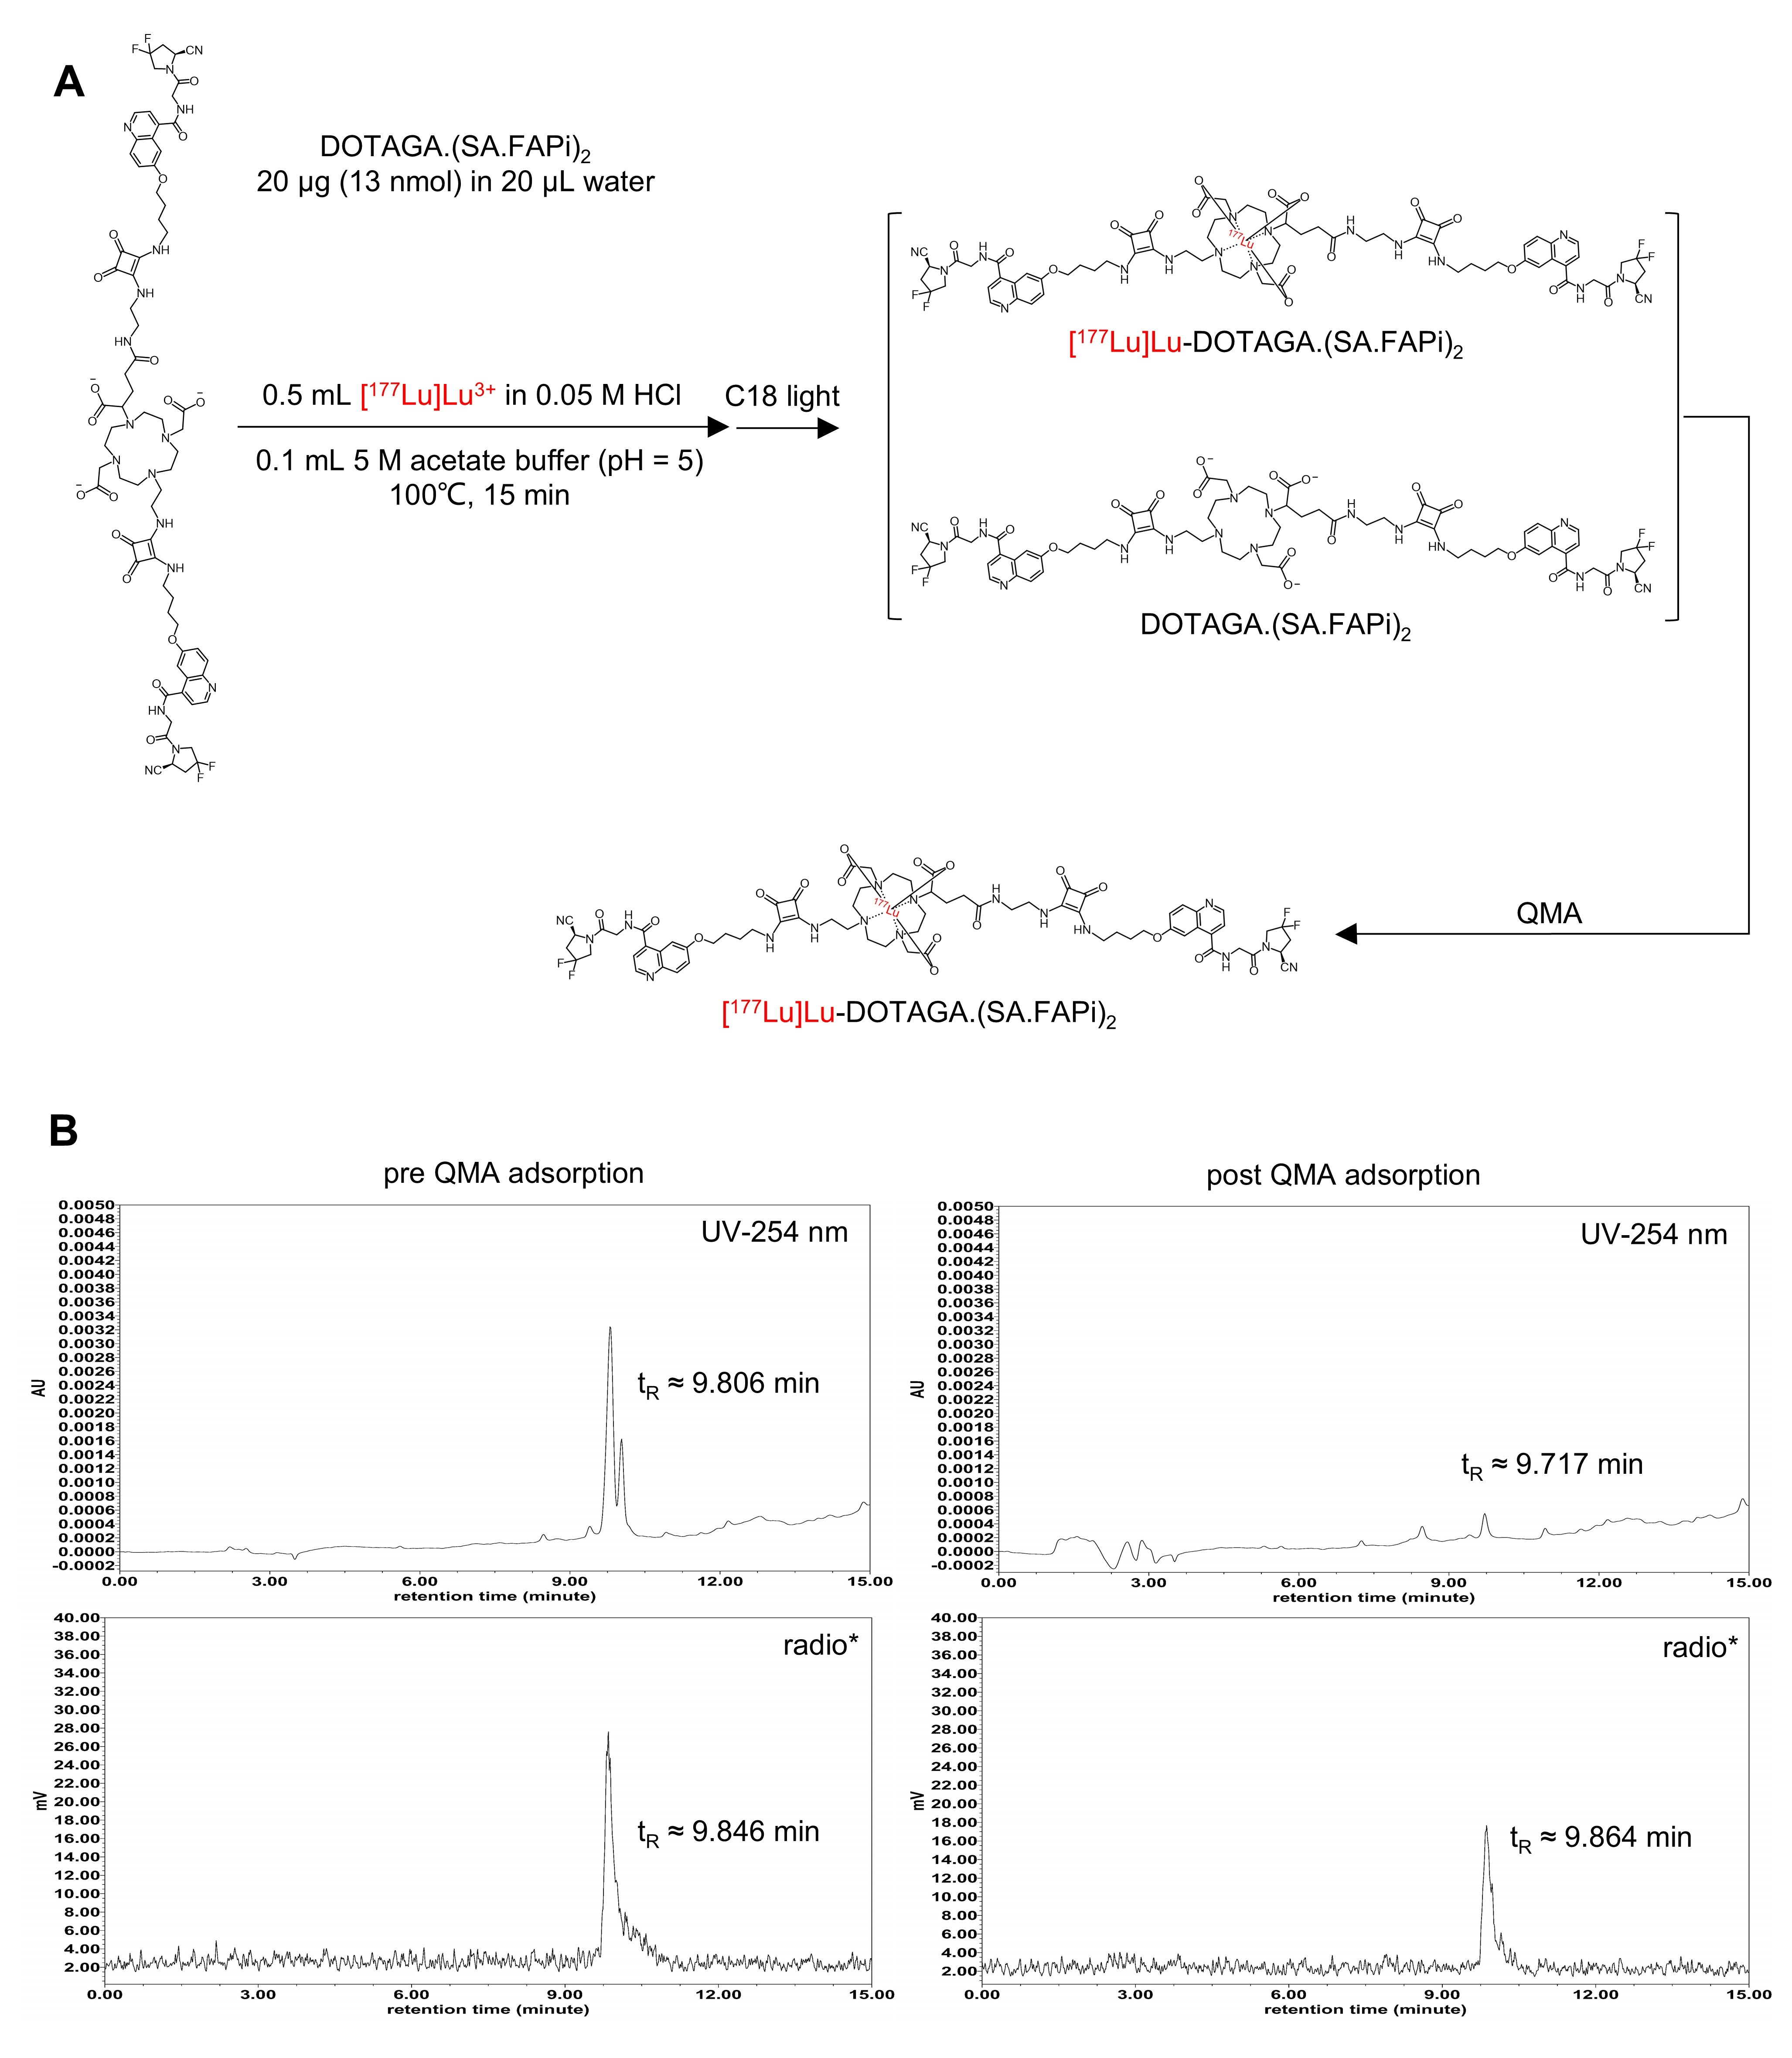
Supplementary Fig. S1. (A) Radiolabeling scheme of [¹⁷⁷Lu]Lu-DOTAGA.(SA.FAPi)₂. (B) Comparison of the ultraviolet absorption peaks and radioactivity of [¹⁷⁷Lu]Lu-DOTAGA.(SA.FAPi)₂ with and without QMA adsorption. * There was 25-min delay of loading time of sample post QMA adsorption. HPLC method: Waters e2695 radio-HPLC; Symmetry C18 column, 5.0 μm, 4.6 mm × 250 mm; 0~15 min 80%/20% water/acetonitrile to 60%/40% water/acetonitrile, with 0.1% trifluoroacetic acid; flow rate, 1 mL/min; λ = 254 nm; and column temperature 35℃).

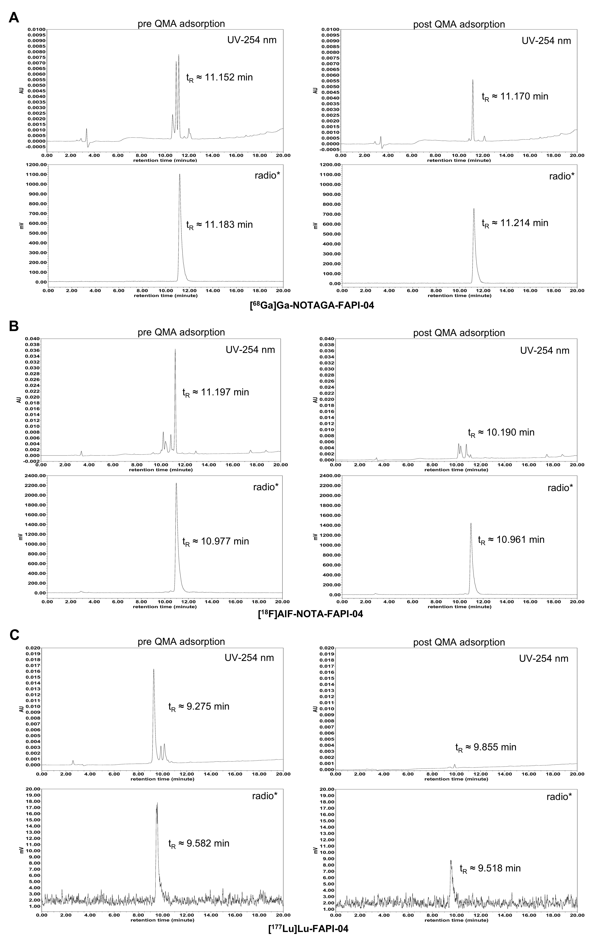
Supplementary Fig. S2. Comparison of the ultraviolet absorption peaks and radioactivity of [⁶⁸Ga]Ga-NOTAGA-FAPI-04 (A), [¹⁸F]AlF-NOTA-FAPI-04 (B), and [¹⁷⁷Lu]Lu-FAPI-04 (C) with and without QMA adsorption. * There was 25-min delay of loading time of sample post QMA adsorption. HPLC method: Waters e2695 radio-HPLC; Symmetry C18 column, 5.0 μm, 4.6 mm × 250 mm; 0~2 min 95%/5% water/acetonitrile, 2~17 min 95%/5% water/acetonitrile to 65%/35% water/acetonitrile, 17~20 min 65%/35% water/acetonitrile, with 0.1% trifluoroacetic acid; flow rate, 1 mL/min; λ = 254 nm; and column temperature 35℃)

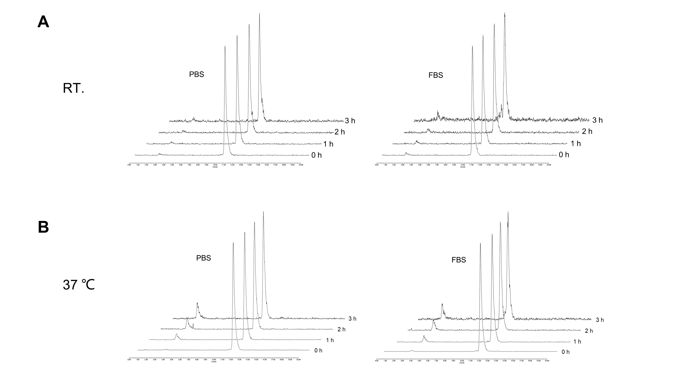
Supplementary Fig. S3. (A and B) Stability of ⁶⁸Ga-FAPI-04 with high apparent A_{m}.

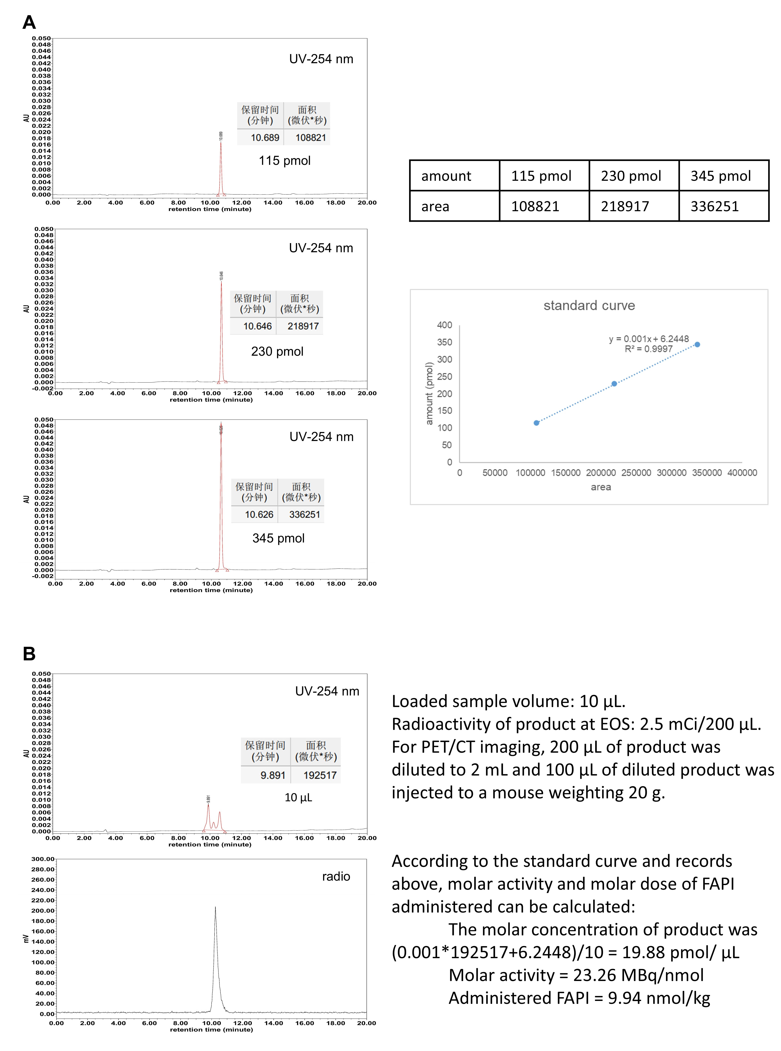
Supplementary Fig. S4. (A) HPLC standard curve of FAPI-04. (B) Calculation process of A_{m} of [⁶⁸Ga]Ga-FAPI-04 sample to be measured by HPLC external standard method and administered molar dose of FAPI-04 to every mouse.

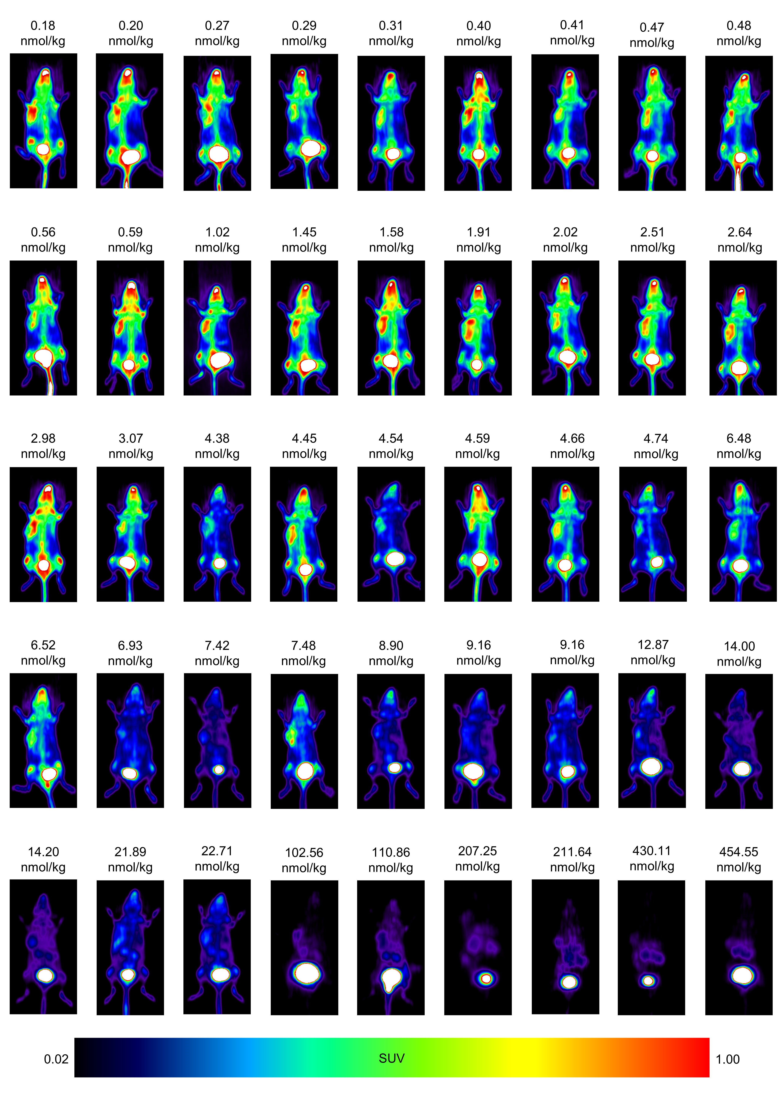
Supplementary Fig. S5. MIP of [⁶⁸Ga]Ga-FAPI-04 PET images of all 4T1 tumor-bearing mice included in Sigmoidal model simulation.

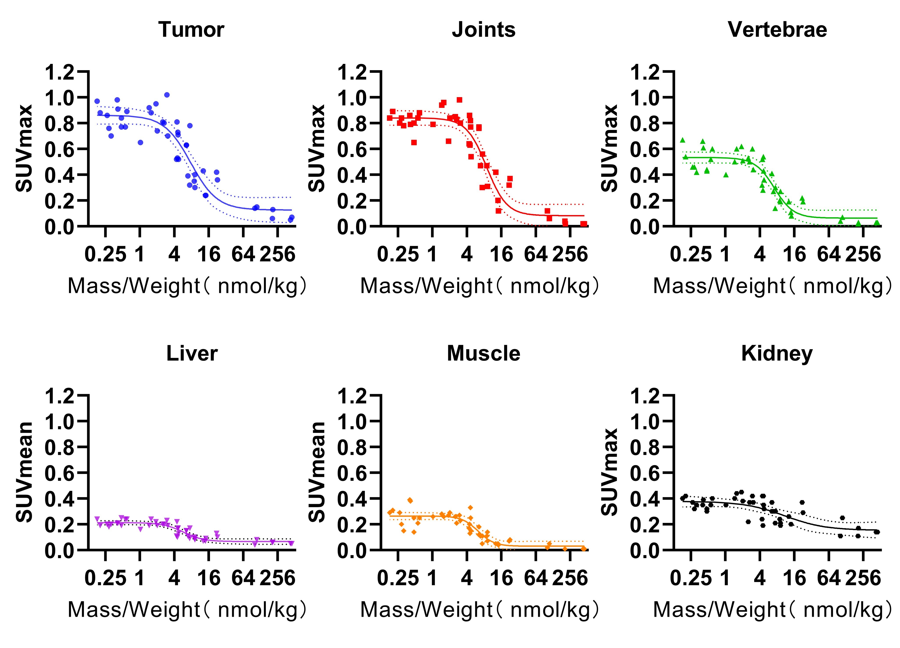
Supplementary Fig. S6. Sigmoidal curves of tumors and organs of [⁶⁸Ga]Ga-FAPI-04 PET imaging.
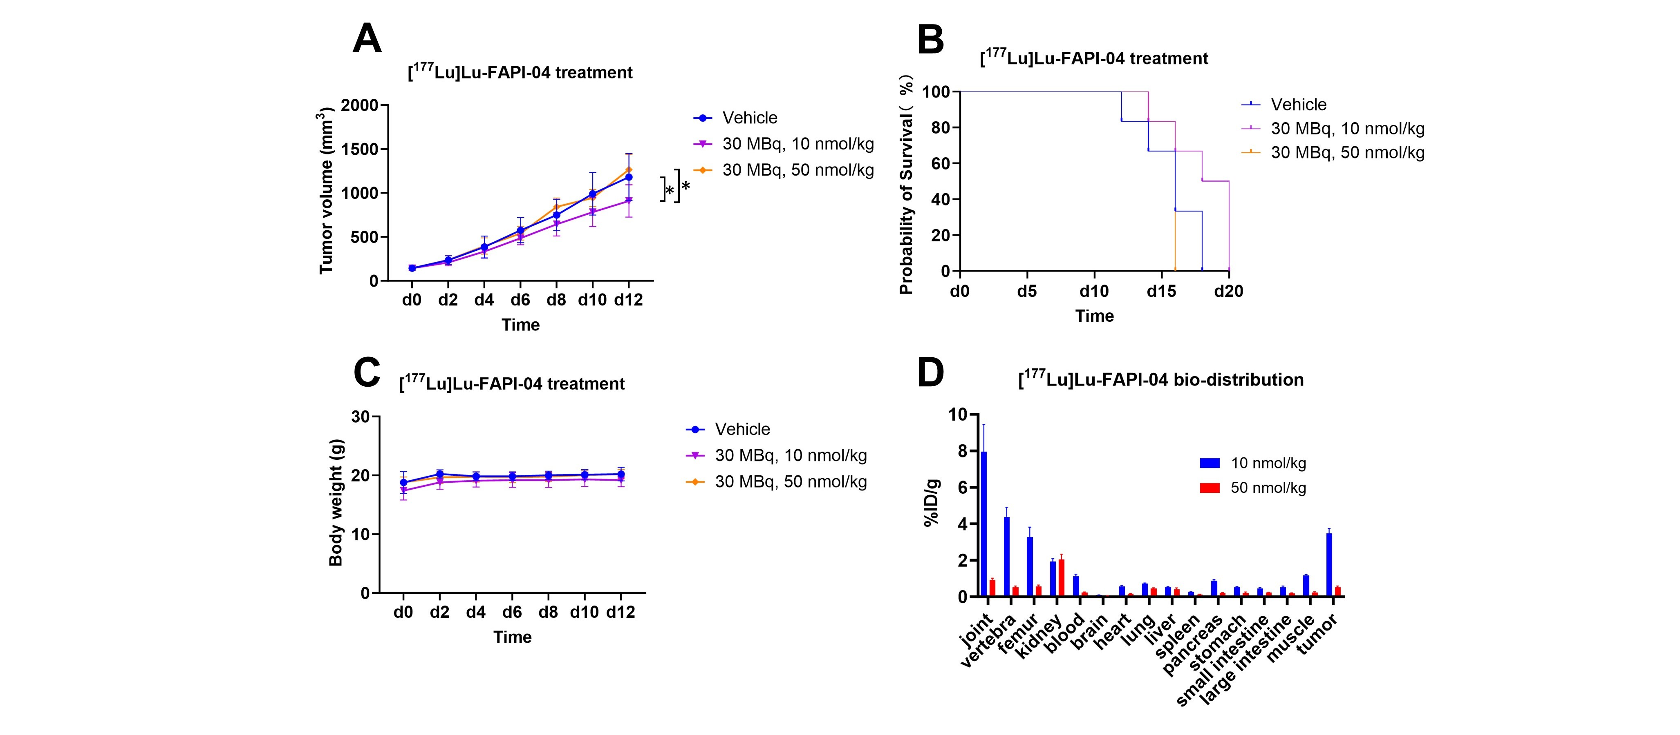
Supplementary Fig. S7. Treatment with [¹⁷⁷Lu]Lu-FAPI-04 with the same radioactivity dose but different molar doses of FAPI-04. (A) Changes in the tumor volumes of the mice after treatment (n = 6 for each group). *p < 0.05. (B) Survival analysis of the mice after treatment (n = 6 for each group). (C) Changes in the mouse body weights after treatment (n = 6 for each group). (D) Biodistribution of [¹⁷⁷Lu]Lu-FAPI-04 with different moles of FAPI-04 in mice (n = 3 for each group).

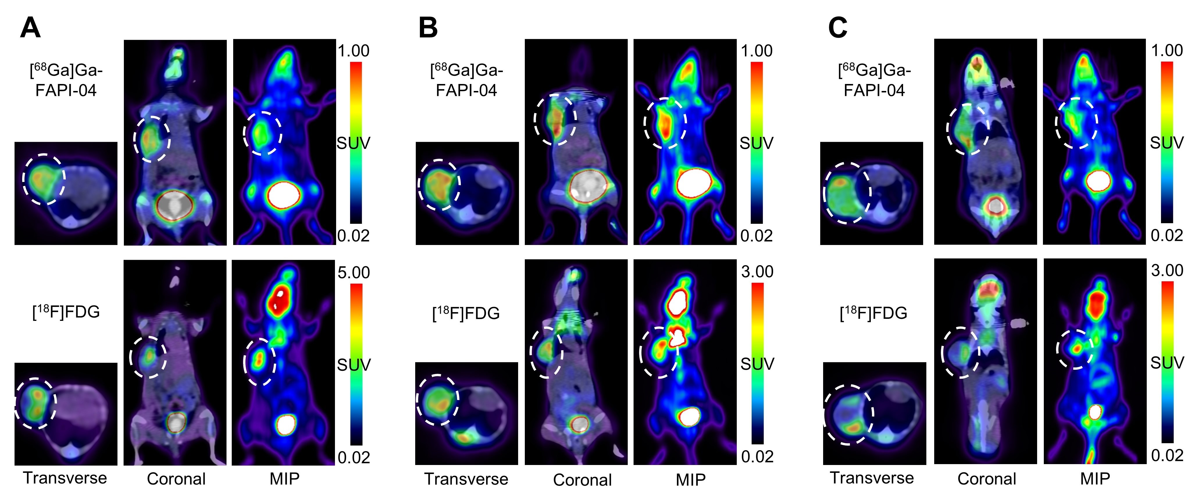
Supplementary Fig. S8. Unmatched spatial distribution of FAPI and FDG in 4T1 tumors. (A – C) [⁶⁸Ga]Ga-FAPI-04 and [¹⁸F]FDG PET/CT imaging at adjacent days (administered FAPI-04 ≈ 4.6 nmol/kg).

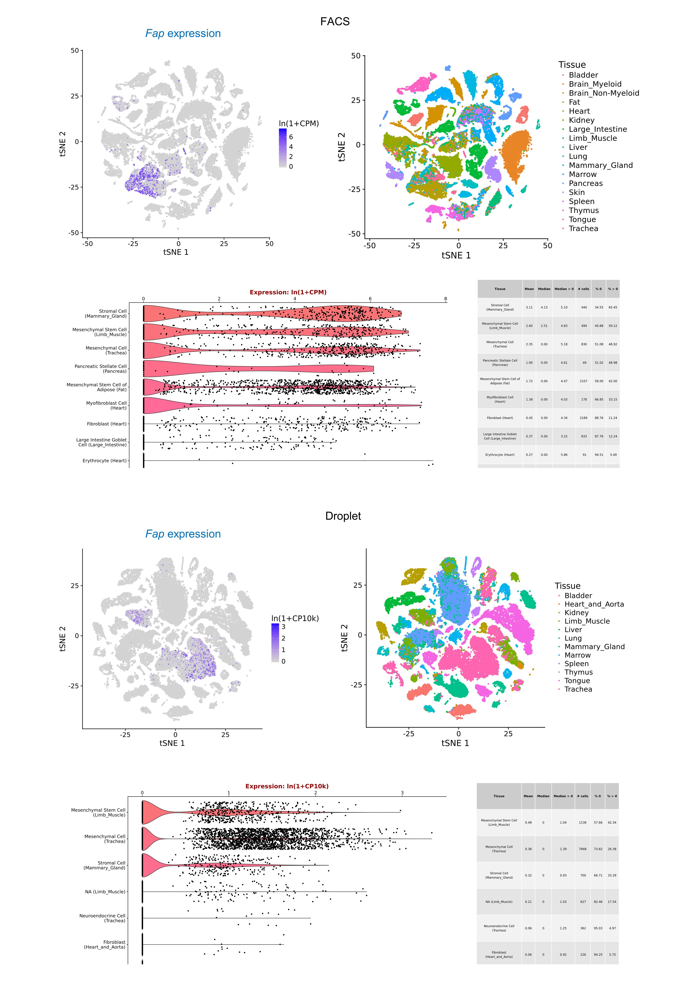
Supplementary Fig. S9. Physiological expression of FAP in Tabula-Muris single-cell RNA sequencing database.

