Multimodal Neuroimaging Insights into the Neurobiology of Healthy Aging Across the Lifespan
European Journal of Nuclear Medicine and Molecular Imaging

Laust Vind Knudsen¹, Tanja Maria Michel^{1†}, Ziba Ahangarani Farahani², Manouchehr Seyedi Vafaee^{1,2}
†Shared first author

Author affiliations:
¹ Department of Psychiatry, University of Southern Denmark, 5000 Odense C, Denmark
² Department of Nuclear Medicine, Odense University Hospital, 5000 Odense C, Denmark
Correspondence to:
Manouchehr Seyedi Vafaee
University of Southern Denmark, J.B. Winsløws vej 18, 5000 Odense C, Denmark
E-mail: mvafaee@health.sdu.dk
Online Resource 11. Results from the ASL analysis
O
R

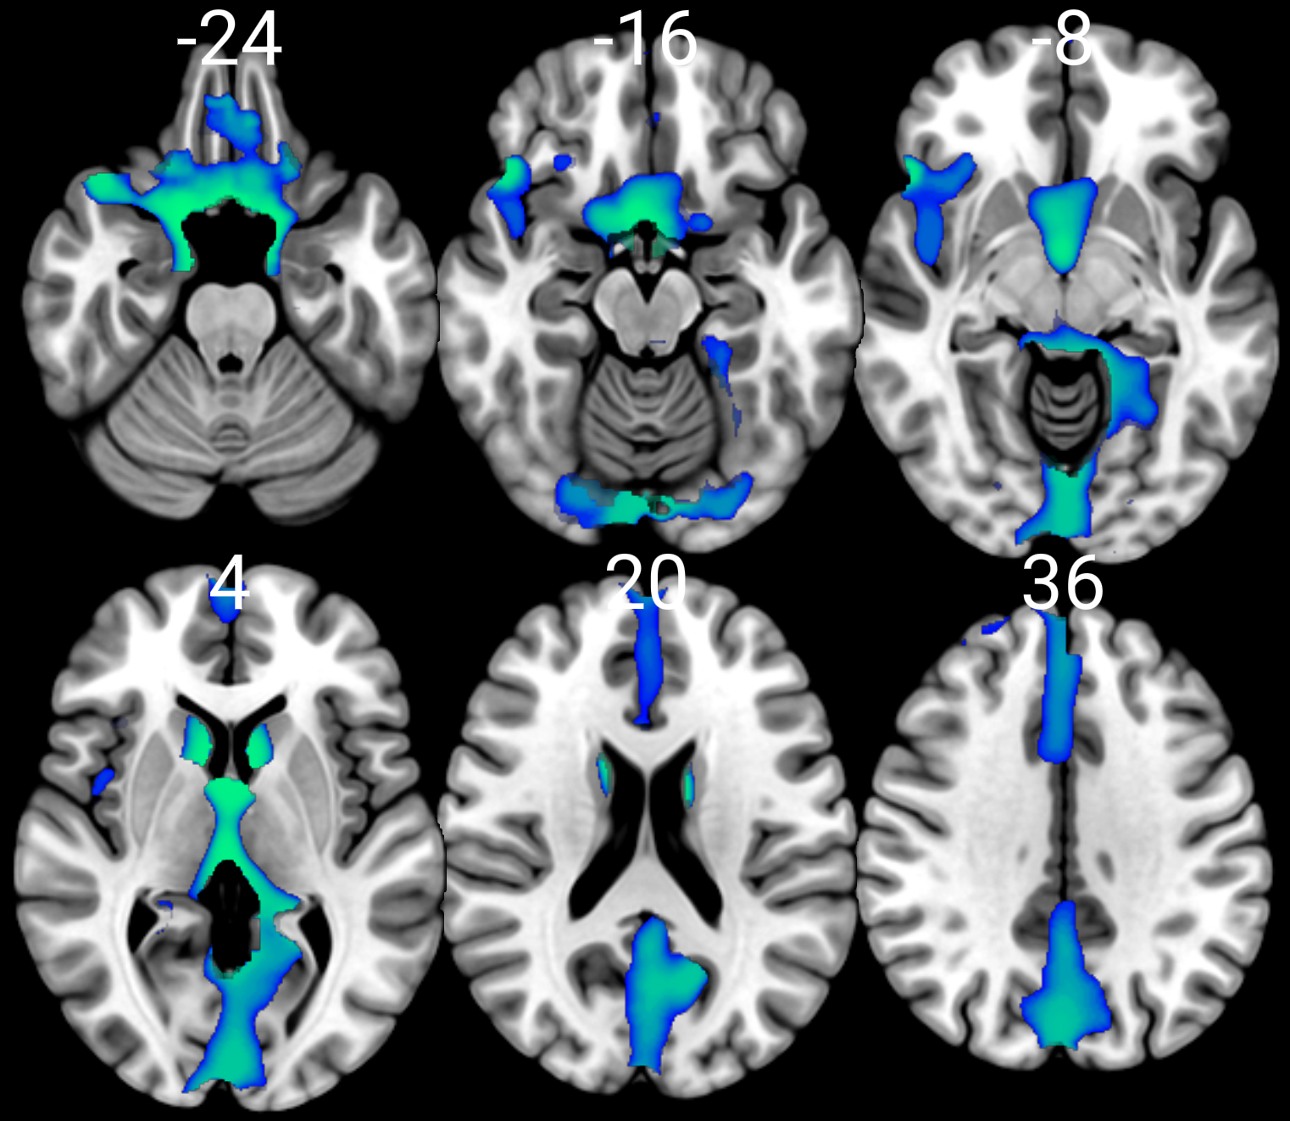
FSO
FIO
I
CA
TPS
PH

FF
FSM
C
L
FS
AC
MC

T

H
PRE
CU
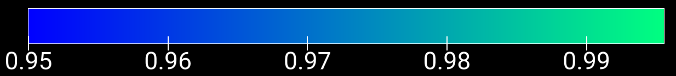

The axial slices display statistically significant maps from the arterial spin labeling analysis, adjusted for gender and corrected for multiple comparisons, overlaid on the MNI152 image. Areas where cerebral blood flow decreases with advancing age are highlighted in blue-green. Temporal Pole superior = TPS. Frontal superior orbital = FSO. Frontal inferior orbital = FIO. Rectus = R. Parahippocampal = PH. Fusiform = FF. Lingual = L. Insula = I. Caudate = CA. Calcarine fissure = C. Frontal superior medial = FSM. Thalamus = T. Hippocampus = H. Anterior Cingulate = AC. Precuneus = PRE. Cuneus = CU. Frontal superior = FS. Cingulate mid = MC.

