EJNMMI - Supplementary Material

Biodistribution and dosimetry of [¹⁷⁷Lu]Lu-SibuDAB in patients with metastatic castration-resistant prostate cancer

Philipp Ritt^{1,2*}, René Fernández³, Cristian Soza-Ried^{3,4}, Heinz Nicolai^{3,5}, Horacio Amaral^{3,6}, Korbinian Krieger^{7,8}, Ana Katrina Mapanao⁷, Amanda Rotger¹, Konstantin Zhernosekov¹, Roger Schibli^{7,8}, Cristina Müller^{7,8}, Vasko Kramer^{3,6}

¹ ITM Oncologics GmbH, 85748 Munich, Germany
² Friedrich-Alexander-Universität Erlangen-Nürnberg, Chair for Clinical Nuclear Medicine, 91054 Erlangen, Germany
³ Center for Nuclear Medicine & PET/CT Positronmed, 7501068 Providencia, Santiago, Chile
⁴ Facultad de Medicina Veterinaria y Agronomía, Instituto de Ciencias Naturales, Universidad de las Américas, Santiago, Chile
⁵ Departamento de Urología, Universidad de Chile, Hospital San Borja Arriarán, Santiago, Chile
⁶ Positronpharma SA, 7501068 Providencia, Santiago, Chile
⁷ Center for Radiopharmaceutical Sciences, PSI Center for Life Sciences, 5232 Villigen-PSI, Switzerland
⁸ Department of Chemistry and Applied Biosciences, ETH Zurich, 8093 Zurich, Switzerland

*Corresponding author:
Dr. Philipp Ritt
ITM Oncologics GmbH,
Lichtenbergstrasse 1, 85748 Garching/Munich, Germany
Germany
Email: philipp.ritt@itm-radiopharma.com

EXTENDED MATERIALS AND METHODS
1. Recruitment
A total of 17 patients diagnosed with advanced, metastatic prostate adenocarcinoma, resistant to androgen deprivation therapy (ADT) and presenting progression or a contraindication to conventional treatments were enrolled into this study. Patients were selected according to inclusion and exclusion criteria by the medical team and co-investigators of the Hospital Clínico San Borja Arriarán of the University of Chile and referring hospitals within the greater area of Santiago de Chile.

2. Inclusion criteria
Patients diagnosed with metastatic, castration-resistant prostate adenocarcinoma who met following criteria were enrolled in the study:
- Evidence of metastatic disease confirmed by PET/CT with [¹⁸F]fluorine prostate specific membrane antigen (PSMA)-1007;
- Rising level of prostate-specific antigen according to the Prostate Cancer Working Group 3 criteria [1]: 2 consecutive elevations above a reference level of 2 ng/mL despite having testosterone less than 20 ng/mL;
- No remaining approved treatment options according to protocol and cannot receive other treatments, either due to contraindications, lack of access or availability or (including economic limitations);
- Signed informed consent;
- Biochemical parameters (haematological, liver and kidney values) appropriate for treatment;
- Leukocyte count ≥ 2.5 x 10⁹/L;
- Platelet count ≥ 75 x 10⁹/L;
- Haemoglobin: > 9 g/dL in the absence of red blood cell transfusions at least 2 weeks prior to Day 1 of Cycle 1 of the treatment. Patients who have been transfused must have a safety examination prior to treatment. Use of erythropoietin was allowed up to 4 weeks prior to Day 1 of Cycle 1;
- Creatinine clearance ≥ 30 mL/min/1.73 m² or creatinine value not greater than 2 times the upper reference value;
- Liver enzymes at a value no greater than 5 times the upper limit of normality;
- Performance status score Eastern cooperative oncology group (ECOG) [2]: 0‒3;
- Survival estimate: > 6 months;
- Consent to use at least one barrier method if they had sexual intercourse.

3. Exclusion criteria
Potential patients who met any of the following criteria were excluded from participating in the study:
- Not signing the informed consent form;
- Not meeting the inclusion criteria;
- Risk of spinal cord compression;
- Risk of imminent pathological fracture.

During the screening period, patients were referred to a medical interview with the principal investigator, a nuclear medicine specialist, who was responsible for confirming the patient's eligibility according to the inclusion and exclusion criteria in the protocol. If the patient met all inclusion and exclusion criteria and decided to participate, the patient was enrolled in the study after he signed the informed consent form.

4. Radiochemistry
SibuDAB also known as (S)-Ibu-DAB-PSMA was developed at the Center for Radiopharmaceutical Sciences at Paul Scherrer Institute, Switzerland [3]. GMP-grade SibuDAB was manufactured by Diverchim CDMO (Roissy-en-France, France) and the lutetium-177 (no-carrier added, [¹⁷⁷Lu]LuCl₃ in HCl 0.04 M) was obtained from Isotope Technologies GmbH (Garching, Germany). [¹⁷⁷Lu]Lu-SibuDAB was synthesized on an automated radiosynthesis module (Gaia V2 and Luna, Elysia-Raytest, Straubenhardt,Germany) using cassettes and reagent kits for ¹⁷⁷Lu-labeling (Advanced biochemical compounds ABX, Radeberg, Germany).
Briefly, 80, 200 or 400 µg Sibu-DAB were dissolved in 1.0 mL ascorbate buffer pH = 4.5 (0.2 g ascorbic acid and 0.8 g sodium ascorbate in 10 mL ultrapure water), added to 6.0‒7.0 GBq lutetium-177 and heated to 90°C for 25 min. The reaction was diluted with 9.0 mL formulation buffer (5% (v/v) ethanol in 50 mg/mL sodium ascorbate in water for injection) and passed through a 0.22 µm sterile filter (Merck Millipore, Millex-GV SLGV033R).
Quality control was carried out with an aliquot of the final product by radio-thin layer chromatography (miniGITA, Elysia-Raytest, Straubenhardt, Germany; silica 60 F254; solvent a: 0.1 M citrate buffer, solvent b: 1.0 M ammonium acetate buffer pH 4.5/methanol 1:1) and radio-high pressure liquid chromatography (Elysia-Raytest, Straubenhardt, Germany; column: Phenomenex Luna C18, 250x4.6 mm, flow: 1.5 mL/min, wave length 220 nm, solvent A: 0.1% trifluoroacetic acid (TFA) in MilliQ water, solvent B: 0.1% TFA in acetonitrile, gradient: 0‒0.5 min, 25% B; 0.5-13.0 min to 50% B; 13.0‒15.0 min 85% B; 15.0‒20.0 min 25% B). A radiochemical yield of ≥ 95%, a radiochemical purity ≥ 99% and < 1% free ¹⁷⁷Lu were obtained.

5. Pretherapeutic PET/CT using [¹⁸F]PSMA-1007
Tumour-associated PSMA-positivity was confirmed by a pre-therapeutic PET/CT imaging 60 min post injection of 222‒296 MBq [¹⁸F]PSMA-1007 on a Siemens Biograph mCT 20. All patients received water as an oral contrast agent. Briefly, a diagnostic CT scan was performed 60–70 s after the intravenous injection of iodinated contrast agent. Subsequently, scans were acquired in 3D-mode with an acquisition time of 1.5 min/bed position. Emission data was corrected for scatter and attenuation and reconstructed iteratively with the manufacturer’s implementation of an ordered subset expectation maximation algorithm (2 iterations and 21 subsets) with post-reconstruction Gaussian filtering (full width at half maximum = 4 mm) [4]. For retrospective analysis, total tumour uptake on PET was determined, according to Unterrainer et al [5]. In brief, total tumour uptake was semi-automatically determined on a dedicated workstation (Affinity 3.0.5, Hermes Medical Solutions, Stockholm, Sweden) as follows: In the software, all regions with higher uptake than SUV=4.0 were automatically included in one volume of interest. Subsequently, all non-malignant regions were manually excluded from this volume and its mean uptake (in SUV normalized by body weight, SUV_{Mean-bw}) and volume were displayed. The total tumour uptake was then derived by multiplying the mean uptake (in units of SUV) with the volume (in units of mL).

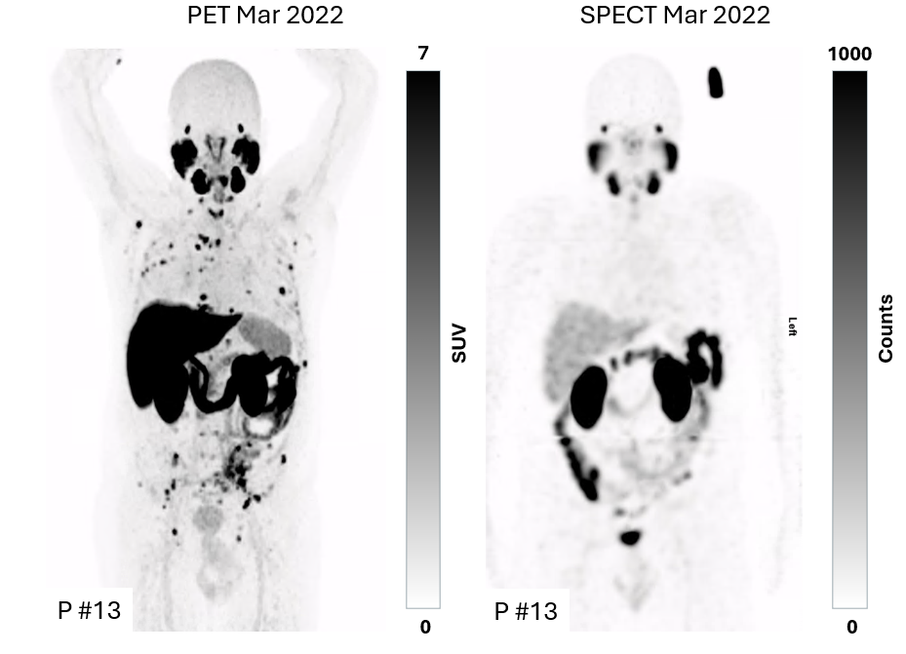
Supplemental Fig. 1 Maximum-intensity projections of PET (left) and SPECT (right) images of [¹⁷⁷Lu]Lu-SibuDAB patient #13 at 60 min. and 24h. p.i.,respectively. In this patient, tumour lesions could not be clearly distinguished from background in the SPECT/CT and were, thus, omitted for tumour dosimetry evaluation.

References

1. Scher HI, Morris MJ, Stadler WM, Higano C, Basch E, Fizazi K, et al. Trial design and objectives for castration-resistant prostate cancer: updated recommendations from the prostate cancer clinical trials working group 3. J Clin Oncol. 2016;34:1402-18. doi:10.1200/JCO.2015.64.2702.
2. Oken MM, Creech RH, Tormey DC, Horton J, Davis TE, McFadden ET, et al. Toxicity and response criteria of the Eastern Cooperative Oncology Group. Am J Clin Oncol. 1982;5:649-55.
3. Borgna F, Deberle LM, Busslinger SD, Tschan VJ, Walde LM, Becker AE, et al. Preclinical investigations to explore the difference between the diastereomers [¹⁷⁷Lu]Lu-SibuDAB and [¹⁷⁷Lu]Lu-RibuDAB toward prostate cancer therapy. Mol Pharm. 2022;19:2105-14. doi:10.1021/acs.molpharmaceut.1c00994.
4. Giesel FL, Knorr K, Spohn F, Will L, Maurer T, Flechsig P, et al. Detection efficacy of ¹⁸F-PSMA-1007 PET/CT in 251 patients with biochemical recurrence of prostate cancer after radical prostatectomy. J Nucl Med. 2019;60:362-8. doi:10.2967/jnumed.118.212233.
5. Unterrainer LM, Beyer L, Zacherl MJ, Gildehaus FJ, Todica A, Kunte SC, et al. Total tumor volume on ¹⁸F-PSMA-1007 PET as additional imaging biomarker in mCRPC patients undergoing PSMA-targeted alpha therapy with ²²⁵Ac-PSMA-I&T. Biomedicines. 2022;10. doi:10.3390/biomedicines10050946.

