Supplementary Tables
Supp. Materials Table 1 Distribution of all DMI training, validation and testing set per site.
Site (Location) | Training | Validation | Testing
1 (Asia) | 8 | 0 | 0
2 (Asia) | 6 | 2 | 7
3 (USA) | 22 | 3 | 2
4 (USA) | 0 | 0 | 1
5 (USA) | 29 | 7 | 5
6 (USA) | 87 | 11 | 11
7 (USA) | 87 | 2 | 7
8 (USA) | 1 | 0 | 0
10 (Europe) | 0 | 1 | 0
11 (Europe) | 69 | 7 | 27
Total | 309 | 33 | 60

Supp. Materials Table 2 Distribution of all DMI training, validation and testing set per tracer.
Radiotracer | Training | Validation | Testing
¹⁸F FDG | 232 | 19 | 15
¹⁸F PSMA | 15 | 4 | 15
⁶⁸Ga PSMA | 18 | 4 | 15
⁶⁸Ga DOTATATE | 30 | 3 | 15
⁶⁸Ga RM2 | 7 | 2 | 0
¹⁸F Fluciclovine | 5 | 1 | 0
¹⁸F FDOPA | 1 | 0 | 0
¹⁸F FES | 1 | 0 | 0
Total | 309 | 33 | 60

Supp. Materials Table 3 FDG training datasets. The beta values chosen for the target QCFX images of three levels of PDL (H: high, M: Medium, L: Low) together with the beta values of the input QCHD images. All the datasets are full duration.
Source site | Target beta (QCFX) |  |  | Input beta (QCHD)
 | H | M | L | H | M | L
1 | 250 | 550 | 1050 | 200, 350, 500 | 200, 350, 500, 750 | 350, 500, 750
2 | 150 | 350 | 850 | 200, 350, 500 | 200, 350, 500, 750 | 350, 500, 750
3 | 250 | 500 | 1000 | 200, 350, 500 | 200, 350, 500, 750 | 350, 500, 750
4 | 250 | 550 | 1050 | 200, 350, 500, 550 | 200, 350, 500, 550, 750 | 350, 500, 550, 750
5 | 500 | 700 | 1000 | 500, 700, 1000 | 500, 700, 1000 | 500, 700, 1000
6 | 325 | 450 | 700 | 325, 450, 700 | 325, 450, 700 | 325, 450, 700
Average | 287.5 | 516.7 | 941.7

Supp. Materials Table 4 Non-FDG training datasets. The beta values chosen for the target QCFX images of three levels of PDL (H: high, M: Medium, L: Low) together with the beta values of the input QCHD images. All the datasets are full duration. The values in parentheses reflect that beta values varied per tracers.
Source site | Target beta (QCFX) |  |  | Input beta (QCHD)
 | H | M | L | All models
2 | 250 | 350 | 500 | 550, 425, 350, 300,250
3 | (350)  (350)  (700) | (800)  (650)  (1000) | (1000)  (800)  (1300) | (1000, 850, 650, 450, 350)  (1000, 850, 650, 450, 350)  (1300, 1150, 1000, 850, 700)
4 | (700)  (250) | (1000)  (450) | (1300)  (850) | (1300, 1150, 1000, 850, 700)  (850, 600, 450, 325, 250)
6 | (350)  (250) | (700)  (450) | (1000)  (600) | (1000, 850, 700, 500, 350)  (850, 600, 450, 325, 250)
7 | 250 | 400 | 550 | 700, 550, 400, 325, 250
8 | (350)  (250) | (700)  (500) | (1000)  (700) | (1000, 850, 700, 500, 350)  (850, 700, 500, 350, 250)

Supp. Materials Table 5. Number of patch pairs per dataset including data augmentation.
Dataset | Clinical Data  (FDG) | Clinical Data  (non-FDG) | Phantom Data | Total
Training Set | 9834 | 4929 | 773 | 15536
Validation Set | 690 | 599 | 0 | 1331

Supp. Materials Table 6. DLToF Model Hyperparameters
Hyper Parameter | Value
Number of resolution levels | 4
Skip connections | 4
Number of kernels at 1st layer | 64
Kernel size | 3×3×3
Batch size | 8
Number of epochs | 100
Dropout factor | 0.2
SUV threshold | 20
Learning rate | 0.001
Optimisation algorithm | Adam
Loss function | MSE
# training parameters | 42,944,832

Supp. Materials Table 7. Statistical significance analysis between lesion SUV_{max} of target ToF BSREM and different methods using a two-tail t-test with two sample of unequal variances (Welch t-test). If p-value > 0.05 it means the two group’s means are not significantly different.

Radiotracer | Methods | p-value
¹⁸F-FDG (n=38) | Non-ToF BSREM | 0.000
¹⁸F-FDG (n=38) | DLToF-L | 0.002
¹⁸F-FDG (n=38) | DLToF-M | 0.063
¹⁸F-FDG (n=38) | DLToF-H | 0.640
¹⁸F-PSMA (n=35) | Non-ToF BSREM | 0.000
¹⁸F-PSMA (n=35) | DLToF-L | 0.000
¹⁸F-PSMA (n=35) | DLToF-M | 0.061
¹⁸F-PSMA (n=35) | DLToF-H | 0.725
⁶⁸Ga-PSMA (n=23) | Non-ToF BSREM | 0.083
⁶⁸Ga-PSMA (n=23) | DLToF-L | 0.252
⁶⁸Ga-PSMA (n=23) | DLToF-M | 0.472
⁶⁸Ga-PSMA (n=23) | DLToF-H | 0.828
⁶⁸Ga-DOTATATE (n=32) | Non-ToF BSREM | 0.082
⁶⁸Ga-DOTATATE (n=32) | DLToF-L | 0.034
⁶⁸Ga-DOTATATE (n=32) | DLToF-M | 0.186
⁶⁸Ga-DOTATATE (n=32) | DLToF-H | 0.539

Supp. Materials Table 8. Quantitative performance of the DL-ToF models evaluated on 60 testing exams (15 exams per 4 radiotracers), for lesion SUV_{max}, lung SUV_{mean} and liver SUV_{mean} as NRMSE(%) from ToF BSREM.
Radiotracer | Methods | Lesion SUV_{max} (%) | Liver SUV_{mean} (%) | Lung SUV_{mean} (%)
¹⁸F-FDG (n=38) | Non-ToF BSREM | 17.5 | 0.4 | 3.0
¹⁸F-FDG (n=38) | DLToF-L | 13.8 | 0.2 | 2.1
¹⁸F-FDG (n=38) | DLToF-M | 6.8 | 0.3 | 2.5
¹⁸F-FDG (n=38) | DLToF-H | 4.5 | 0.3 | 2.1
¹⁸F-PSMA (n=35) | Non-ToF BSREM | 19.3 | 0.2 | 1.4
¹⁸F-PSMA (n=35) | DLToF-L | 14.6 | 0.2 | 1.1
¹⁸F-PSMA (n=35) | DLToF-M | 7.9 | 0.2 | 0.9
¹⁸F-PSMA (n=35) | DLToF-H | 6.0 | 0.2 | 1.0
⁶⁸Ga-PSMA (n=23) | Non-ToF BSREM | 13.3 | 0.0 | 1.0
⁶⁸Ga-PSMA (n=23) | DLToF-L | 7.1 | 0.1 | 1.4
⁶⁸Ga-PSMA (n=23) | DLToF-M | 3.7 | 0.0 | 1.0
⁶⁸Ga-PSMA (n=23) | DLToF-H | 2.6 | 0.0 | 0.9
⁶⁸Ga-DOTATATE (n=32) | Non-ToF BSREM | 9.1 | 0.1 | 2.4
⁶⁸Ga-DOTATATE (n=32) | DLToF-L | 12.8 | 0.1 | 1.7
⁶⁸Ga-DOTATATE (n=32) | DLToF-M | 6.3 | 0.1 | 1.8
⁶⁸Ga-DOTATATE (n=32) | DLToF-H | 2.8 | 0.1 | 2.1

Supp. Materials Table 9. Bonferroni corrected p-value results for the clinical reader scores compared to ToF BSREM scores.
Tracer | Method | Low-contrast Lesion Detectability | Diagnostic Confidence | Image  Quality
¹⁸F-FDG | Non-ToF BSREM | 0.097 | 1.000 | <0.001
¹⁸F-FDG | DLToF-L | 0.003 | 1.000 | <0.001
¹⁸F-FDG | DLToF-M | 1.000 | 1.000 | <0.001
¹⁸F-FDG | DLToF-H | 1.000 | 1.000 | 1.000
¹⁸F-PSMA | Non-ToF BSREM | <0.001 | <0.001 | <0.001
¹⁸F-PSMA | DLToF-L | <0.001 | <0.001 | <0.001
¹⁸F-PSMA | DLToF-M | 0.004 | 1.000 | <0.001
¹⁸F-PSMA | DLToF-H | 1.000 | 1.000 | 1.000
⁶⁸Ga-PSMA | Non-ToF BSREM | <0.001 | <0.001 | <0.001
⁶⁸Ga-PSMA | DLToF-L | 0.008 | 0.320 | <0.001
⁶⁸Ga-PSMA | DLToF-M | 1.000 | 1.000 | <0.001
⁶⁸Ga-PSMA | DLToF-H | 1.000 | 1.000 | <0.001
⁶⁸Ga-DOTATATE | Non-ToF BSREM | 1.000 | 1.000 | <0.001
⁶⁸Ga-DOTATATE | DLToF-L | 1.000 | 1.000 | <0.001
⁶⁸Ga-DOTATATE | DLToF-M | 1.000 | 0.166 | <0.001
⁶⁸Ga-DOTATATE | DLToF-H | 1.000 | 0.214 | 1.000

Supp. Materials Table 10 Bonferroni corrected p-value results for the clinical reader scores compared to non-ToF BSREM scores.
Tracer | Method | Low-contrast Lesion Detectability | Diagnostic Confidence | Image  Quality
¹⁸F-FDG | DLToF-L | 1.000 | 1.000 | <0.001
¹⁸F-FDG | DLToF-M | 0.018 | 0.048 | 0.842
¹⁸F-FDG | DLToF-H | 0.477 | 1.000 | <0.001
¹⁸F-PSMA | DLToF-L | 1.000 | 1.000 | 0.030
¹⁸F-PSMA | DLToF-M | <0.001 | <0.001 | 1.000
¹⁸F-PSMA | DLToF-H | <0.001 | <0.001 | <0.001
⁶⁸Ga-PSMA | DLToF-L | 0.050 | 0.554 | 0.016
⁶⁸Ga-PSMA | DLToF-M | <0.001 | <0.001 | 1.000
⁶⁸Ga-PSMA | DLToF-H | <0.001 | 0.015 | <0.001
⁶⁸Ga-DOTATATE | DLToF-L | 1.000 | 1.000 | <0.001
⁶⁸Ga-DOTATATE | DLToF-M | 1.000 | 0.387 | 1.000
⁶⁸Ga-DOTATATE | DLToF-H | 0.728 | 1.000 | 0.004
Supp. Materials Table 11 Quantitative performance of the DL-ToF multi-tracer (MT) and DL-ToF FDG-only single-tracer (ST) models evaluated on 15 ¹⁸F-FDG testing exams, for lesion SUV_{max}, lung SUV_{mean} and liver SUV_{mean} as a percentage difference from ToF BSREM.
Methods | Lesion SUV_{max}(%) | Liver SUV_{mean}(%) | Lung SUV_{mean}(%)
Non-ToF BSREM | -38.9 ± 15.5 | 4.6 ± 4.3 | 7.7 ± 13.9
DLToF-L (MT) | -37.0 ± 16.0 | 2.0 ± 4.3 | 3.8 ± 13.0
DLToF-M (MT) | -21.9 ± 17.4 | 3.9 ± 4.2 | 4.1 ± 13.9
DLToF-H (MT) | -5.9 ± 24.3 | 3.5 ± 3.8 | 4.1 ± 13.4
DLToF-L (ST) | -41.2 ± 14.5 | 3.3 ± 12.1 | 2.9 ± 4.1
DLToF-M (ST) | -26.8 ± 16.3 | 3.8 ± 4.1 | 3.3 ± 12.0
DLToF-H (ST) | -10.3 ± 20.3 | 4.7 ± 11.7 | 3.0 ± 3.9

Supplementary Figures

Supp Materials Figure 1 The proportion of different radiotracers in the clinical exams used for training of the DLToF models.

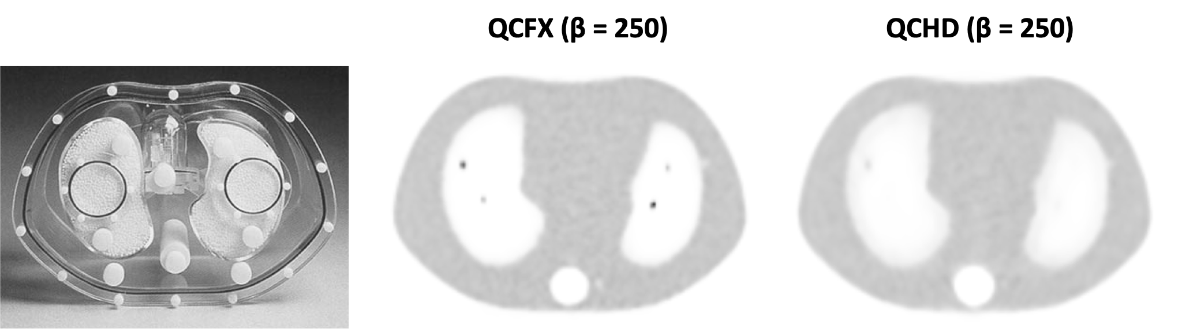
Supp Materials Figure 2 The anthropomorphic torso phantom photograph and its PET images reconstructed with (QCFX) and without (QCHD) ToF BSREM algorithm in a DMI PET/CT scanner. The beta is the regularisation parameter used for the reconstructions.

Supp Materials Figure 3 The architecture of the 3D UNET convolutional network, with residual and skip connections, used in DLToF models.

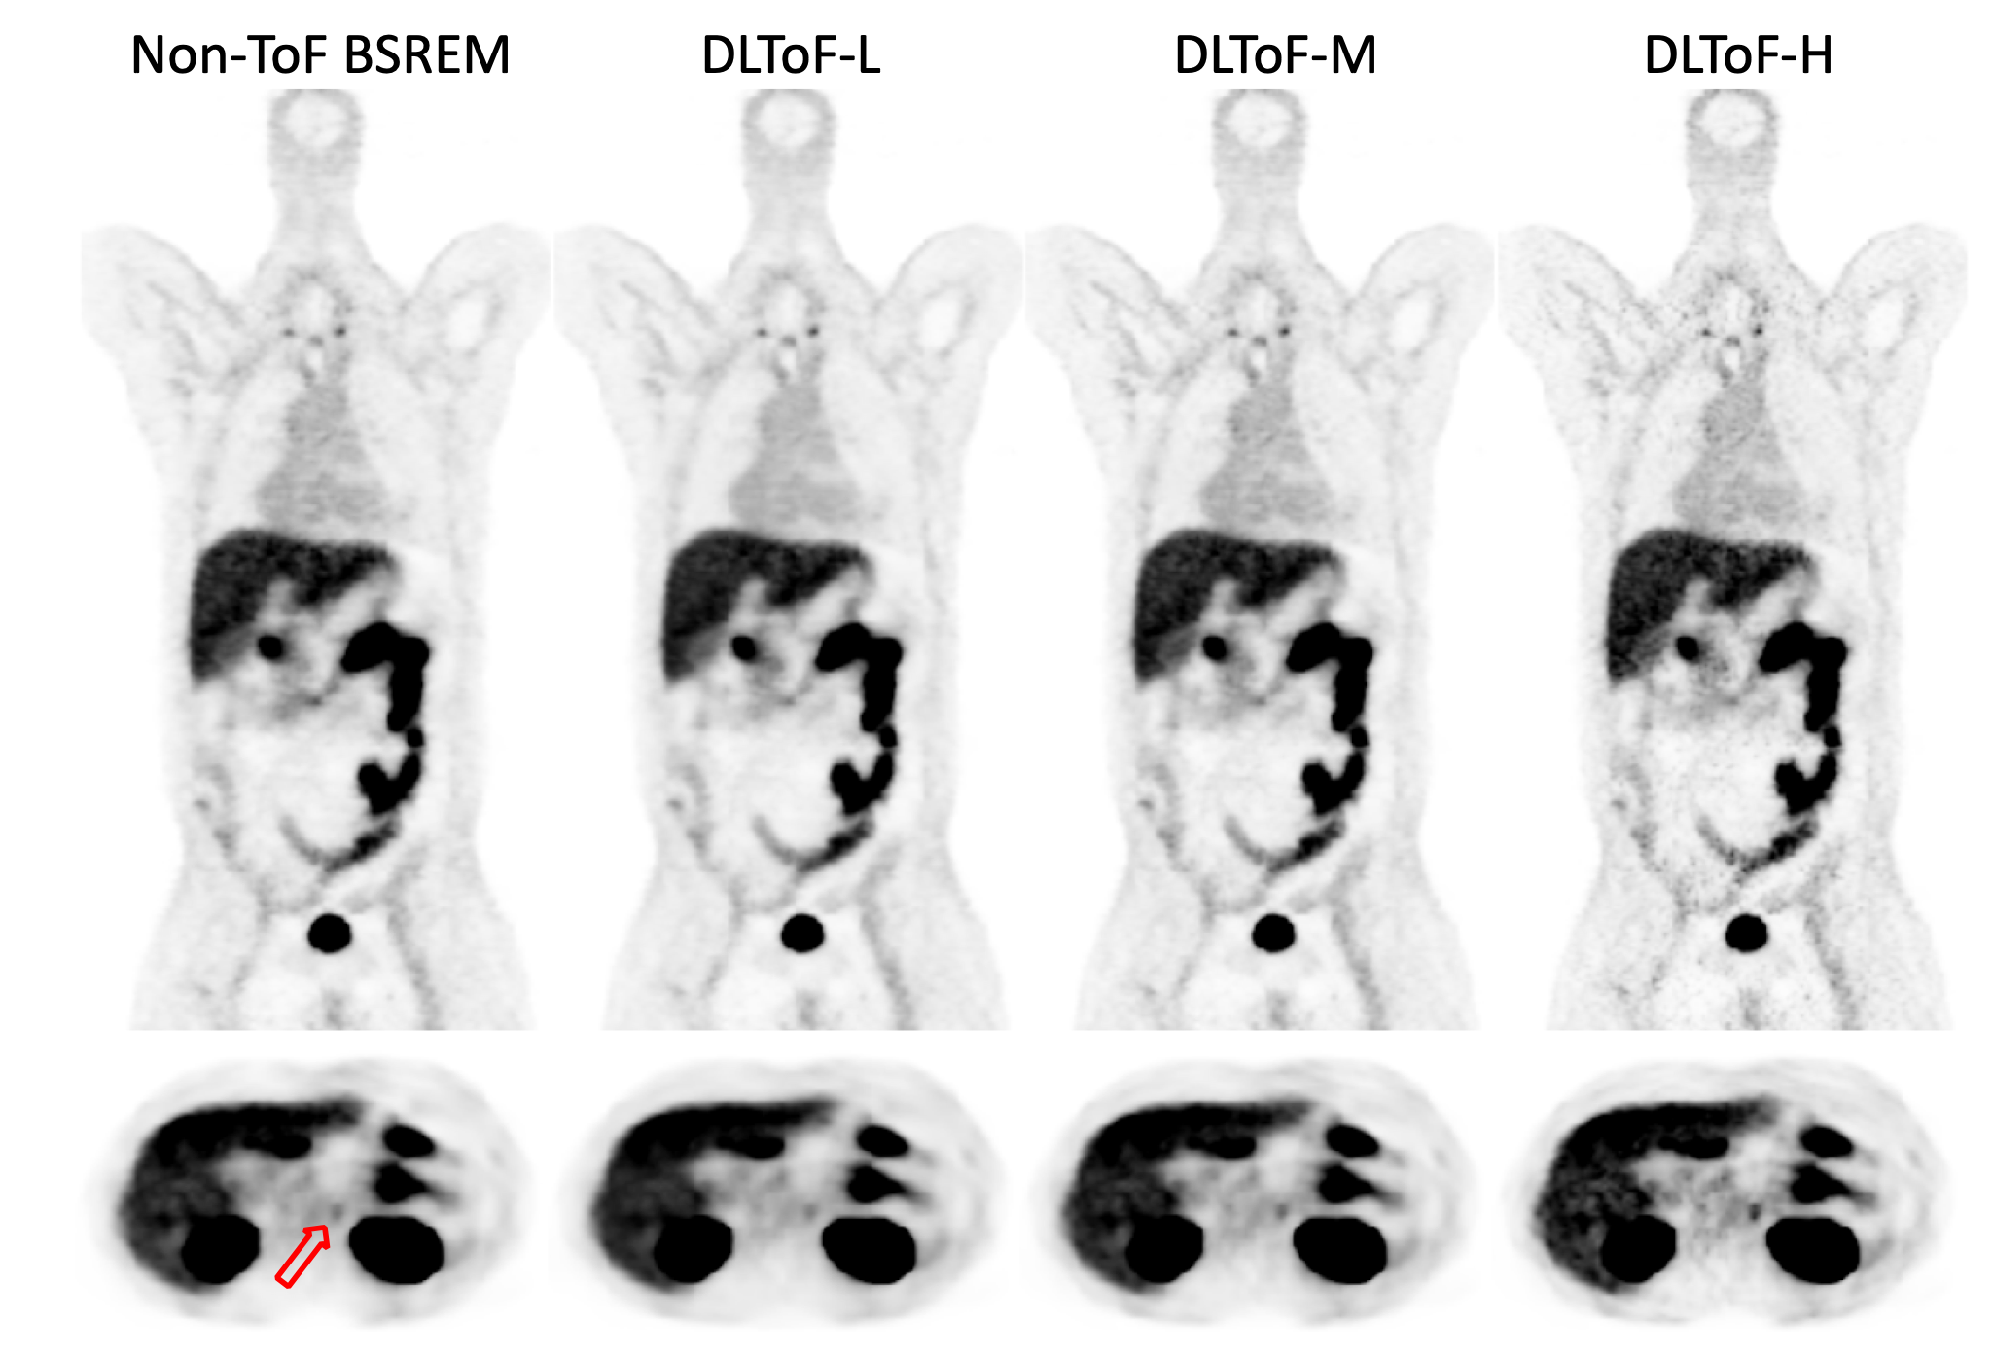
Supp Materials Figure 4 DL-ToF enhancement of a representative ⁶⁸Ga-PSMA test subject with a BMI of 21.8 kg/m² with an injected activity of 162 MBq scanned on a GE OMNI Legend PET/CT scanner. Display window: 0-5 SUV.

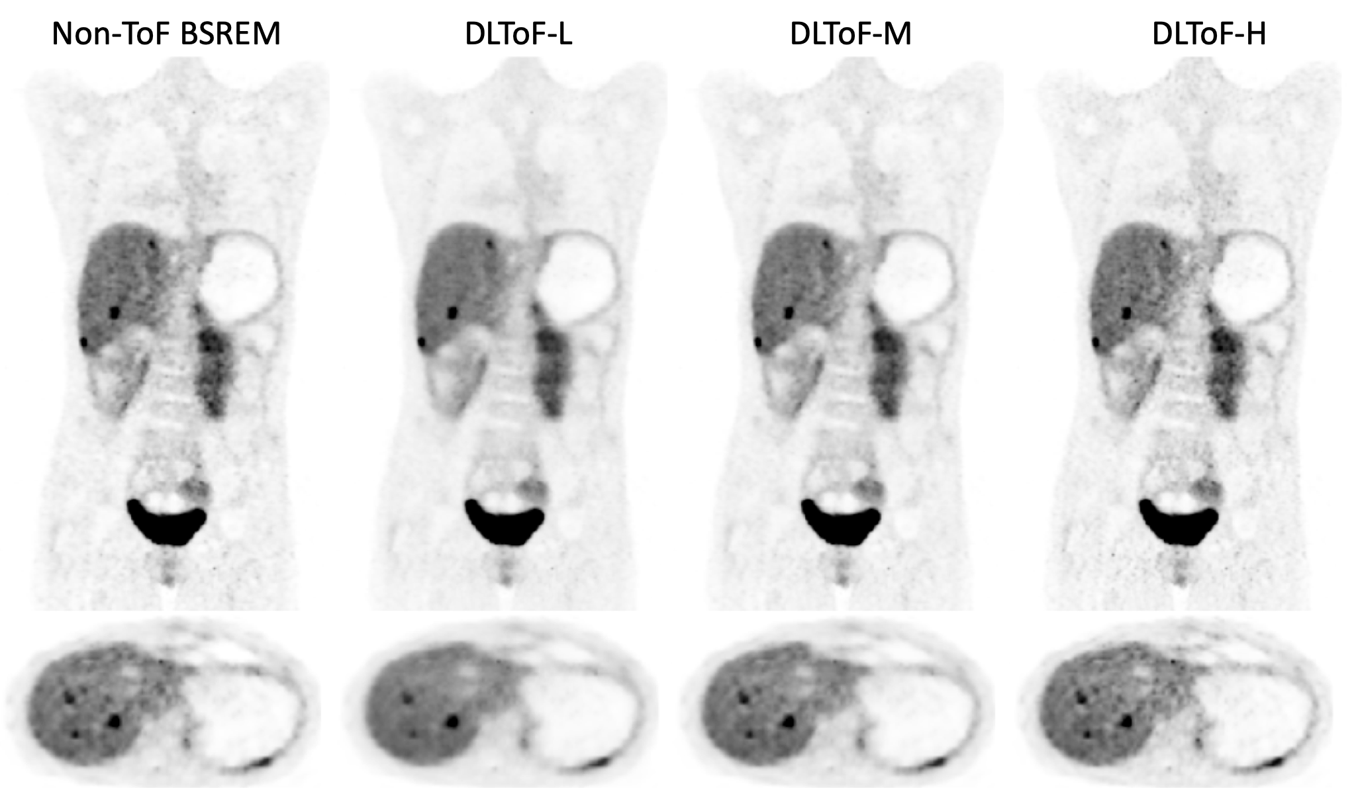
Supp Materials Figure 5 DL-ToF enhancement of a representative ⁶⁸Ga-DOTATATE test subject with a BMI of 18.4 kg/m² with an injected activity of 192.4 MBq scanned on a GE Omni Legend PET/CT scanner. Display window: 0-5 SUV.
Supp Materials Figure 6 Comparison of DLToF-M FDG-only single-tracer (ST) and multi-tracer (MT) versions for a representative ¹⁸F-FDG test subject scanned on a GE DMI PET/CT scanner. Display window: 0-5 SUV.

Supp Materials Figure 7 Comparison of DLToF-M FDG-only single-tracer (ST) and multi-tracer (MT) versions for a representative ¹⁸F-PSMA test subject scanned on a GE DMI PET/CT scanner. Display window: 0-5 SUV.

Supp Materials Figure 8 Comparison of DLToF-M FDG-only single-tracer (ST) and multi-tracer (MT) versions for a representative ⁶⁸Ga-PSMA test subject scanned on a GE DMI PET/CT scanner. Display window: 0-5 SUV.

Supp Materials Figure 9 Comparison of DLToF-M FDG-only single-tracer (ST) and multi-tracer (MT) versions for a representative ⁶⁸Ga-DOTATATE test subject scanned on a GE DMI PET/CT scanner. Display window: 0-5 SUV.

Supp Materials Figure 10 Blinded clinical reader study on a subset of 6 DMI ¹⁸F-FDG exams comparing DLToF FDG-only single-tracer (ST) and multi-tracer (MT) versions. The scores were done by our most experienced reader (KMB).

