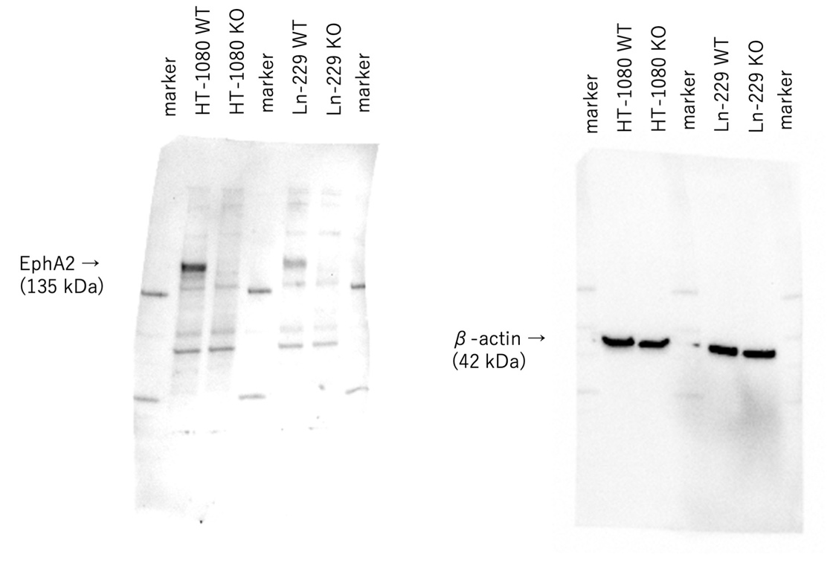
Supplementary Fig. 1. The full uncropped images of western blotting analysis for EphA2 in HT-1080 WT and HT-1080 EphA2-KO cells.

