Supplementary Material
Table 1: Confusion matrix for Total-Body (TB) and short-axial field-of-view (SAFOV) PET/CT. Positive and negative results from both tests as well as from the composite reference standard (CRS) for N-staging of the enrolled patients with NSCLC.
CRS | TB PET/CT |  | SAFOV PET/CT
 | positive | negative | positive | negative
positive | 49 | 8 | 44 | 13
negative | 11 | 632 | 17 | 626

Table 2: Maximum standardized uptake value (SUV_{max}), tumor-to-background ratio (TBR), metabolic tumor volume (MTV) and total lesion glycolysis (TLG) thresholds for Total-Body (TB) and short-axial field-of-view (SAFOV) PET/CT.
 | TB |  |  |  | SAFOV
 | Threshold | Sensitivity |  | Specificity | Threshold | Sensitivity |  | Specificity
SUV_{max} | 3.0 |  | 81% | 84% | 3.0 |  | 90% | 85%
TBR | 1.2 |  | 96% | 84% | 1.7 |  | 84% | 83%
MTV (ml) | 0.5 |  | 81% | 95% | 1.0 |  | 84% | 86%
TLG (ml) | 1.0 |  | 91% | 81% | 3.0 |  | 84% | 91%

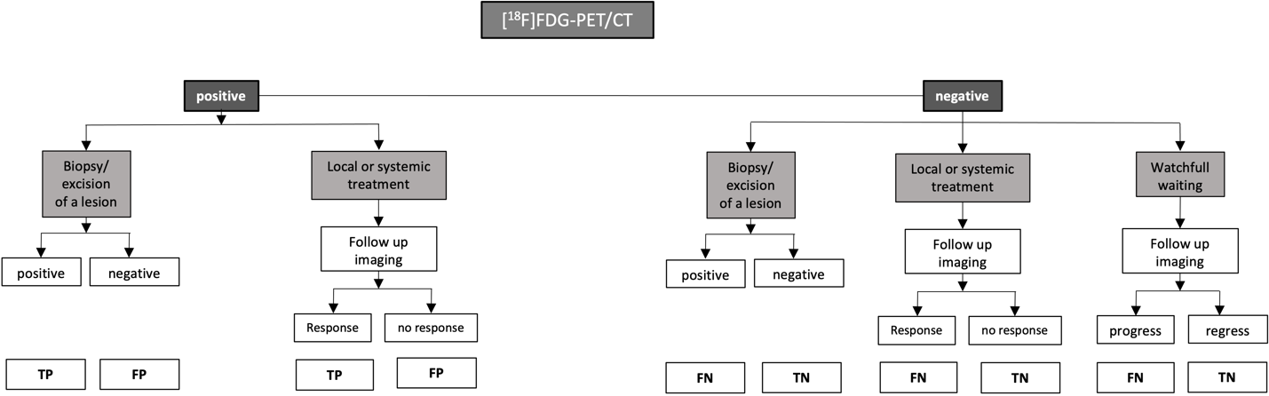
Figure 1: Flow chart to establish the composite reference standard (CRS) for each PET-positive mediastinal lymph node. TP=true positive, FP=false positive, TN=true negative and FN=false negative.

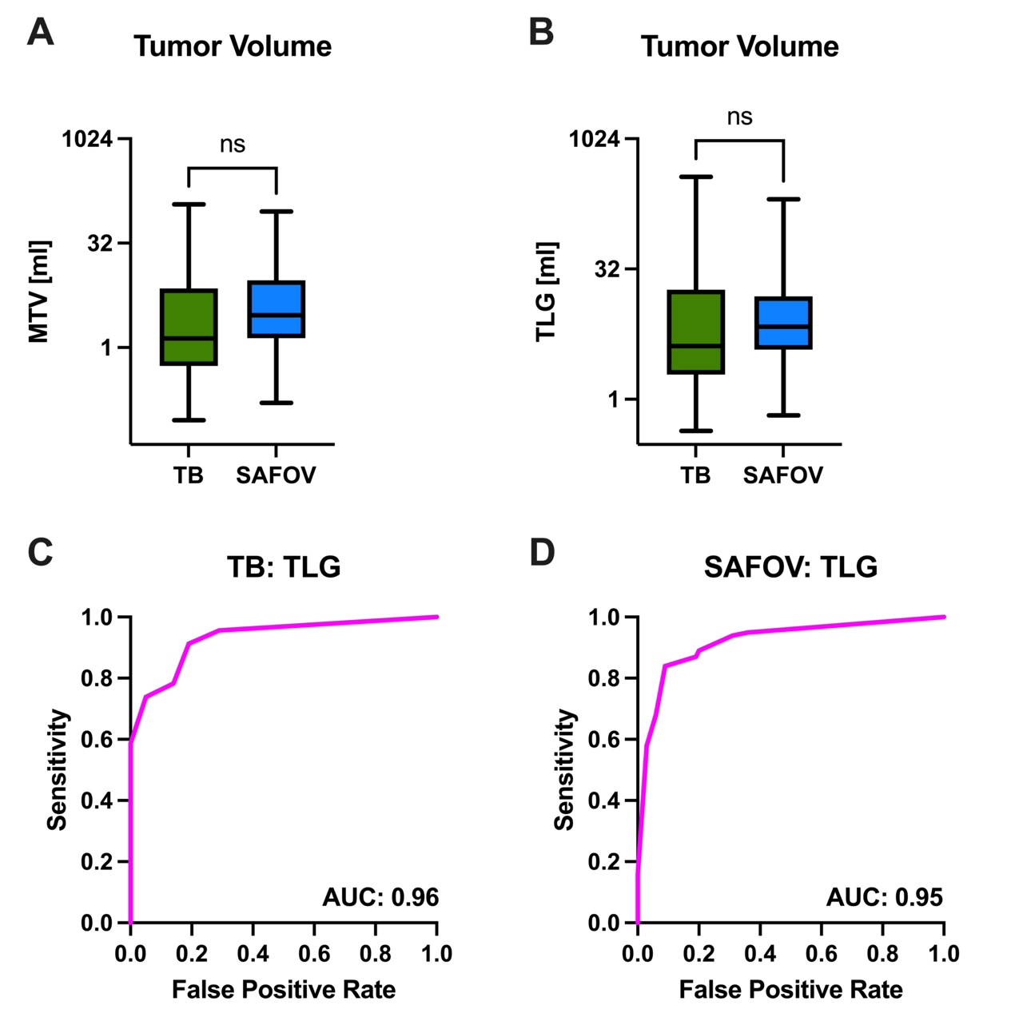
Figure 2: Displayed are metabolic tumor volumes (MTV, A) and total lesion glycolysis (TLG, B) on Total-Body (TB) and short-axial field-of-view (SAFOV) PET/CT. C and D show TLG receiver operator characteristics (ROC) for both scanners.

