Supplementary Materials
1. Image Acquisition
Supplementary table 1 - Image Acquisition Protocols
 | Institution | Equipment | PET protocol | CT protocol
Internal Dataset | Ruijin Hospital | Discovery STE (GE Healthcare, USA) | Reconstructed by ordered subset expectation maximization (OSEM) algorithm and the Gaussian filter with a full width at half maximum (FWHM) of 6 mm. Voxel size: 5.47×5.47×3.27 mm³. | 120 ~180 mA, 140 kV, slice thickness: 3.75 mm.
Internal Dataset | Ruijin Hospital | Discovery MI (GE Healthcare, USA) | Reconstructed using the block sequential regularized expectation maximization algorithm (Q.clear, GE Healthcare, USA) or OSEM algorithm. Voxel size: 2.73×2.7×2.79 mm³. | 120 to 180 mA, 120 kV, slice thickness: 3.75 mm.
Internal Dataset | Ruijin Hospital | Biograph Vision (Siemens, Germany) | Reconstructed by the 3D ordinary Poisson OSEM algorithm, involving 4 iterations and 5 subsets, with Time-Of-Flight (TOF) and all-pass filtering applied. Voxel size: 1.6×1.6×1.5 mm³. | 146 mA, 120 kV, slice thickness: 2 mm.
External Dataset | Ruijin Hospital | uEXPLORER (United Imaging, China) | OSEM algorithm utilized for reconstruction, with 2 iterations, 20 subsets. Voxel size: 3.125×3.125×2.886mm³. | 180mA, 120kV, slice thickness: 3mm.
External Dataset | Proton Center of Ruijin North Hospital | uMI 780 (United Imaging, China) | Reconstructed by OSEM with 2 iterations and 20 subsets, integrated with TOF and Point Spread Function (PSF). Gaussian FWHM is set to 2.0. Zoom factor by default, equal to 1.0. | 70~140 kV, 6~667 mA, slice thickness: 2 mm.
External Dataset | Shanghai Pulmonary Hospital | Biograph mCT (Siemens, Germany) | Reconstructed by OSEM with 2 iterations and 21subsets, integrated with TOF and PSF. Gaussian FWHM is set to 5.0. Zoom factor by default, equal to 1.0. Voxel size: 4.07×4.07×3.0mm³. | Quality ref: 210mAs,  120 kV,  slice thickness:3 mm
External Dataset | Lu'an People's Hospital of Anhui Province | uMI Vista (United Imaging, China) | Reconstructed by OSEM with 2 iterations and 20 subsets, 300ps Timing resolution，24cm Axial FOV，11cps/kBq sensitivity | 70~140 kV, 6~667 mA, slice thickness: 2 mm
External Dataset | The Affiliated Hospital of Nanjing University of Chinese Medicine | Biograph Vision (Siemens, Germany) | Reconstructed by the 3D ordinary Poisson OSEM algorithm with 3 iterations and 5 subsets, PSF modelling and using TOF information. Gaussian filtering applied. Voxel size: 1.65×1.65×1.65 mm3. | 121 mAs (CARE Dose4D) , 120 kV, slice thickness: 3 mm.
2. Lesion Segmentation
2.1 Preprocessing
  - PET/CT resampling
To align CT and PET images in the same spatial domain for subsequent analysis, we used nilearn's resample-to-img function, referencing PET images to match the CT voxel spacing and dimensions. We then applied SimpleITK to resample all PET/CT pairs to a consistent voxel spacing of (2.73, 2.73, 2.79).

  - Lung region extraction
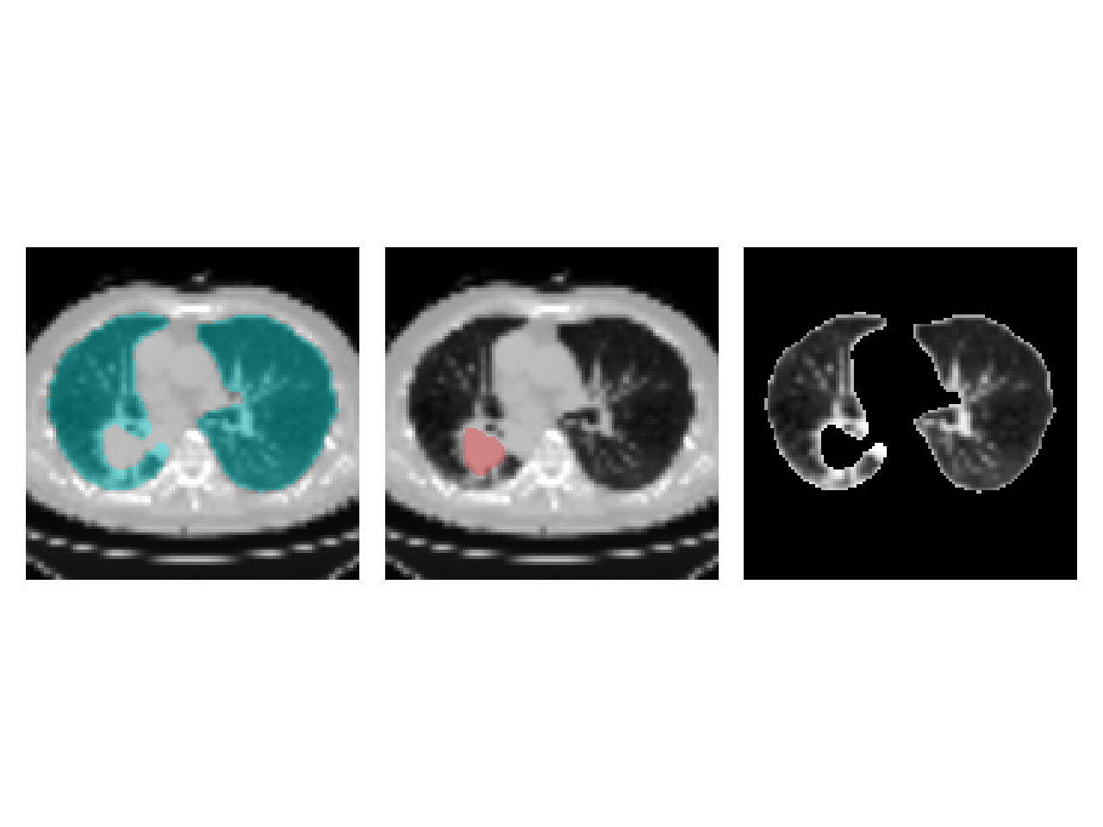
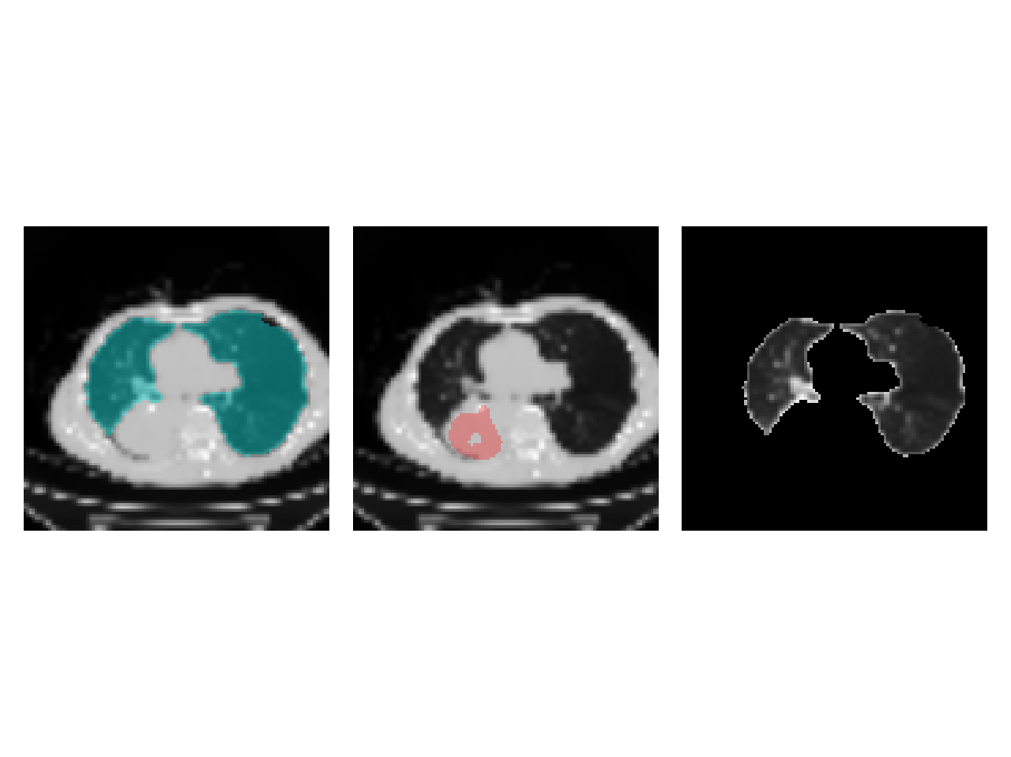
To extract lung region, we used the publicly available Lungmask model to perform inference on whole-body CT scans, generating lung masks. However, in our preliminary research, directly using the mask generated by Lungmask to extract the lung region from PET/CT images is not ideal and may result in missed lesions. The reason is that many of the highly metabolic lesions in the lungs are contiguous with the thoracic cage or mediastinum, particularly in cases of extensive pulmonary consolidation and central lung cancer, which reduce the lung cavity area and subsequently affect the accuracy of Lungmask in segmenting the lung region. As shown in Fig.1 (a)(b), consolidation lesions can cause Lungmask to miss these regions. Consequently, directly multiplying the lung masks with the PET/CT images to extract the lung region of interest could result in the lesions being masked out, as shown in Fig.1(c).
Fig.1 The illustration of function of Lungmask tool
(a1, a2) Mask of Lung region predicted by Lungmask.
(b1, b2) The ground truth of lung lesion.
(c1, c2) Result of multiplying the lung mask with CT images.
(a1)
(a2)
(b1)
(b2)
(c1)
(c2)
To address this issue, we opted to use a bounding box with dimensions of 128×128×128, centered on the centroid of the Lungmask, to extract the lung region from the PET/CT images. This method ensures that the entire lung region is captured, as it encompasses a larger area than the Lungmask itself, thereby reducing the likelihood of missing relevant lesions. By using this bounding box approach, we minimize the inaccuracies in lung region prediction that can occur due to consolidations.

  - CT contrast enhancement and normalization
For the CT images, we adjusted the Hounsfield Units (HU) to the range of -1000 to 500, thereby enhancing the visibility of the lung region. After this adjustment, we applied z-score normalization to standardize the CT data.

  - SUV standardization for PET images
Standardized Uptake Value is a commonly used quantitative metric for assessing the uptake of radiotracers by tissues or lesions. Normalizing to SUV allows PET images from different patients, different scanning devices, or different time points to be comparable. The formula is defined as follows:
$${SUV}_{bw}=\frac{C(t)}{\frac{injected dose}{Body Weight}}$$
Where $C(t)$ is the activity concentration in the tissue at time $t$, usually measured in kBq/mL or μCi/mL. Injected Dose is the total dose of the radiotracer administered to the patient, typically measured in MBq or mCi. Body Weight is the patient's body weight, typically measured in kilograms (kg).

2.2 Training strategy
In this study, we trained our model for 1000 epochs with a batch size of 2. We employed the One-Cycle learning rate scheduling strategy, with an initial learning rate set to 1e-2 and a half-cycle duration of 10% of the total training period. Stochastic Gradient Descent (SGD) was used as the optimization algorithm, with a momentum parameter set to 0.9. Additionally, we incorporated a weight decay regularization with a coefficient of 1e-4 to mitigate overfitting.

2.3 Architecture of Segmentation Network
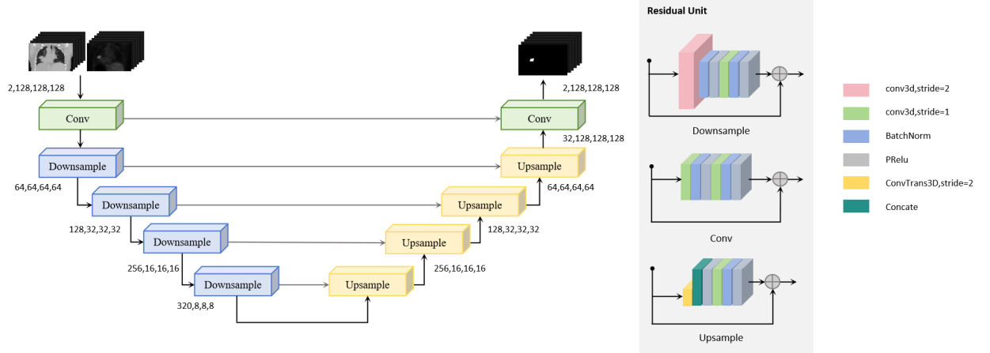
In the design of our segmentation network, we have built upon the Residual UNet architecture proposed in existing studies [1,2] and further extended it into a three-dimensional framework. The fundamental building blocks of the model are Residual Unit, which include three variants, as illustrated in Fig.3. In the encoder section, the number of output channels for each layer is 32, 64, 128, 256, and 320. The first layer's Residual Unit utilizes a 3D convolution with a stride of 1, while the subsequent layers employ a stride of 2. In the decoder section, the output feature map sizes at each layer are consistent with those of the corresponding layers in the encoder.
Fig.2 Overall architecture of Residual UNet and three variants of residual Unit.
To prevent the common "Dead ReLU" phenomenon, the activation function used in our network remains consistent with the original work, employing PReLU. This activation function introduces a learnable negative slope parameter, allowing the network to maintain gradient updates in the negative regions, thereby enhancing the model’s feature representation capability and robustness. Furthermore, we have incorporated Batch Normalization during network training to standardize the activation values within each batch, thereby accelerating the training process and significantly improving network stability. Through these improvements and optimizations, our model exhibits enhanced adaptability and accuracy in addressing the challenging task of three-dimensional medical image lesion segmentation.

2.4 Loss function
In the segmentation task, we optimized the model by employing a combined loss function that integrates Dice Loss and cross-entropy loss. The formula is defined as follows:
$$L_{DSC_CE}=L_{CE}+L_{DSC}$$
$$L_{CE}=-\frac{1}{N}\sum_{i}{\sum_{c=1}^{M}{y_{ic}\log{(p_{ic})}}}$$
$$L_{DSC}=1-\frac{2×\left|P×G\right|}{\left|P\right|+\left|G\right|}$$
Here, both and are set to 1. N denotes the total number of pixels in the image, C represents the number of classes.$y_{ic}$ is the true label of the i_{th} pixel for class c, while $p_{ic}$is the predicted probability that the ith pixel belongs to class c. represents the predicted probability map for each pixel, and G represents the ground truth segmentation. $L_{DSC}$measures the overlap between the predicted and true segments, effectively addressing class imbalance by focusing on the relative overlap between these regions. By combining these two losses, $L_{DSC_CE}$ enhances both the overlap and the pixel-wise accuracy, leading to improved performance in segmentation tasks.
In this study, we employed MONAI’s implementation of DiceCELoss to optimize segmentation performance [3]. Our configuration specifically involved the exclusion of background regions from the loss computation and the application of a sigmoid activation function.

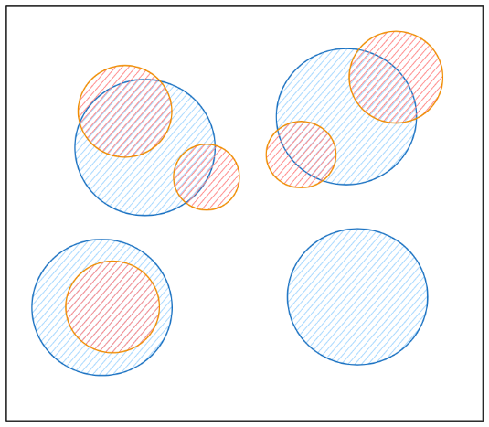
2.5 Count-wise performance evaluation
Fig.3 The illustration of an example of effect of multi-ROI annotation on detection metrics.
The code for calculating False Positive and False Negative volume is derived from the code provided in the official AutoPET2023 competition (https://github.com/lab-midas/autoPET/blob/master/val_script.py) [4], with additional logic added to count the number of True Positive (TP), False Positive (FP), False Negative (FN) lesions. TP lesions are defined as model’s predicted lesions that exhibit a non-zero overlap with ground truth, while FP lesions are predicted lesions with no overlap with ground truth. Conversely, FN lesions are defined as ground truth lesions that exhibit no overlap with the model's segmentation output. But in this scenario, the conventional formula “TP Lesions + FN Lesions = Total Lesions” does not apply, which may give rise to questions.
This discrepancy is visually demonstrated in Fig.3. The blue colouration represents the manually delineated ground truth, while the orange represents the model-delineated results. In this particular instance, the total number of ground truth lesions is 4 and the predicted number of lesions is 5. There are 5 TPs, as some ROIs are marked repeatedly, while there is 1 FN. However, this issue does not arise in the calculation of volume or the number of FP lesions, and the formula “Predicted lesion = FP Lesion + TP Lesion” applies.

3. Lesion Classification
  - Preprocessing
- Cropping lesion image patches
We used the trained segmentation model to perform inference on the test dataset, obtaining lesion mask images. To distinguish individual lesions, we applied connected component labeling, a fundamental image processing technique that identifies and labels distinct connected regions within a binary image. This process was implemented using the “skimage.measure.label” function from the scikit-image library, with a connectivity parameter of 3 to accurately group neighboring voxels belonging to the same lesion. Subsequently, each connected component was cropped using a 32×32×32 bounding box, thereby enabling precise single-lesion extraction.
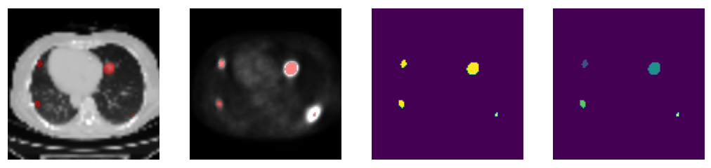
Fig.4 Connected Component Labeling Diagram.
(a)CT; (b)PET; (c)original mask; (d)Connected component labeling is applied to each ROI within the mask, assigning the same label value to all pixels within a single ROI, while ensuring different ROIs are assigned distinct label values.
（c）
（d）
（b）
（a）
- Generate MIP of PET and projection of Lesion
Maximum Intensity Projection (MIP) is a commonly used technique in medical imaging that projects the voxel with the highest intensity value along a specified axis onto a 2D plane. In this study, we implemented MIP by using NumPy's “max” function, which computes the maximum value along a specified axis of the 3D PET image. Specifically, we calculated the MIP by taking the maximum intensity along the axial direction of the PET image. This operation was also applied to individual lesion projections. After obtaining the MIP and lesion projections, we performed center cropping on these axial projections to standardize the cropped size to 160×128 pixels.

3.2 Training strategy
In this study, we trained our model for 1500 epochs with a batch size of 128. We employed the One-Cycle learning rate scheduling strategy, with an initial learning rate set to 1e-2 and a half-cycle duration of 5% of the total training period. Stochastic Gradient Descent (SGD) was used as the optimization algorithm, with a momentum parameter set to 0.9. Additionally, we incorporated a weight decay regularization with a coefficient of 1e-5 to mitigate overfitting.

3.3 Loss Function
In this part, we employed the cross-entropy loss function, which is widely used for its effectiveness in handling multi-class classification tasks.

3.4 Architecture of Classification Network
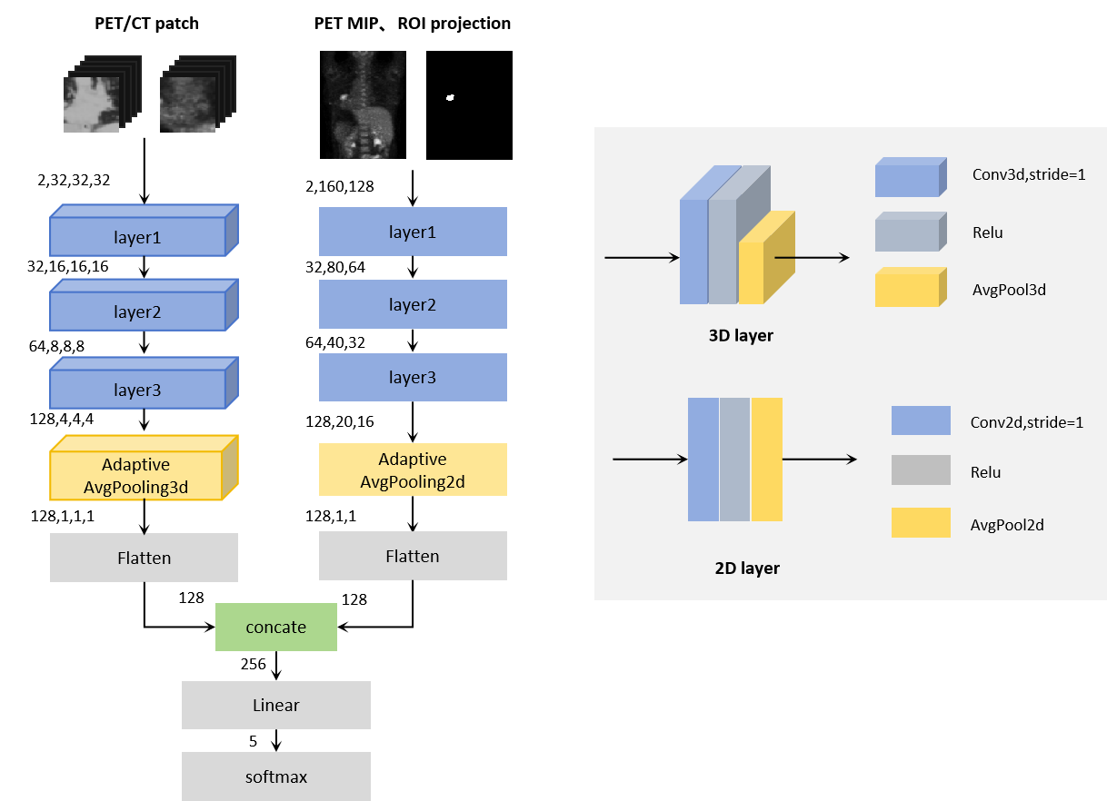
Our classification network is based on the improved structure proposed in an existing study [5], as illustrated in the Fig. 5. The model consists of two branches: the left branch is a 3D branch that takes PET/CT images as inputs, and the right branch is a 2D branch that processes MIP and lesion masks as input.
Fig.5 The architecture of classification network
(a) The overall architecture of the Classification Network including two branches.
(b) Basic building blocks used in the 2D and 3D branches.
(a)
(b)
3D Branch: This branch accepts a local PET/CT image patch centered on the lesion, with a size of (32,32,32), as input. By processing the 3D image patch, it extracts detailed information from the lesion's local region, including the distribution and variation of uptake values, as well as its density, enabling the model to learn fine-grained features effectively.
2D Branch: This branch takes as input MIP of the PET image in the coronal plane and the corresponding projection of the lesion mask in the same plane. The 2D coronal projections of the PET image and the lesion mask reveal the spatial position of the lesion in the global view, supporting a comprehensive analysis of the lesions’ overall characteristics and spatial relationships within the body.
As shown in Fig.5 (b), the basic building blocks of both branches are nearly identical, differing only in dimensionality (i.e., 2D or 3D structures). Each layer in both branches’ outputs 32, 64, and 128 channels respectively. Afterward, adaptive average pooling is applied to resize the feature maps to a fixed size (1×1 for 2D branch, 1×1×1 for 3D branch), and the resulting features are flattened. These features from different scales and dimensions are then concatenated to integrate them into a unified representation. Finally, the concatenated features are processed by a fully connected layer, followed by a SoftMax layer to output the probability distribution across different classes.
A key distinction between our network and the original network lies in the handling of PET/CT data. The original network crops the PET/CT images into patches of size 9×64×64 and treats the axial dimension as the channel dimension for 2D convolution. In contrast, our approach retains the full spatial dimensions, using 3D convolution to more effectively capture features within and around the lesion. Additionally, the original method processes PET and CT modalities separately using two structurally identical but independent networks, our approach employs a dual-channel network to process both modalities simultaneously, allowing for better fusion of information from both modalities. Another significant difference is in the handling of the lesion masks. The original method uses the coordinates of the axial projection of each mask as one of the network inputs to indicate the location of each lesion. In our approach, however, we directly use the axial projection of each mask as one of the inputs to the 2D branch. This design not only conveys location information but also introduces additional structural information about the lesion, such as lesion size and shape, thereby enhancing the network's capability to identify and characterize lesions with greater accuracy and richness of detail.

3.5 The attempt to incorporate clinical information
The clinical information and manifestations of the cases in the dataset were compiled by the researchers based on the medical history and examination indications collected by clinicians and nuclear medicine specialists prior to the scans. This included patient age, gender, and symptoms such as cough, sputum production, hemoptysis, pain, fever, weight loss, and incidental findings during physical exams or prior examinations, and then the quantified information alongside the images was put into the classification model for training.
However, the performance of the new model was found to be comparable to that of the original model based solely on PET/CT images. This may be due to the lack of specificity in some clinical manifestations. Additionally, symptoms and physical examination results, when quantified, are often represented using binary or ordinal scale outcomes. While these results may have good discriminative power in binary classification tasks, they might struggle to demonstrate significant differences among four groups in a multi-classification task. During the iterative process of deep learning, it is hypothesised that the weights of these features were reduced, resulting in the final optimal model still relying primarily on image features.

Supplementary table 2 - The comparison of classification efficiency between original model and modified model
Classification efficiency | Internal test set | External test set Ⅰ | External test set Ⅱ
Original Model
AUC | 88.4% | 80.7% | 66.6%
Accuracy | 67.7% (60.4~74.4%) | 56.9% (51.1~62.8%) | 41.5% (33.3~49.6%)
F1-Score | 55.8% (46.5~63.3%) | 40.5% (34.7~46.0%) | 36.5% (28.3~44.2%)
Precision | 57.7% (47.1~68.2%) | 44.0% (35.4~53.0%) | 44.1% (34.4~52.9%)
Recall | 56.6% (47.9~65.0%) | 42.7% (38.0~47.5%) | 38.3% (29.2~47.4%)
Modified Model
AUC | 87.0% | 78.8% | 71.1%
Accuracy | 65.2% (57.9~72.6%) | 54.7% (48.9~60.6%) | 45.2% (37.0~53.3%)
F1-Score | 56.0% (47.3~63.8%) | 42.7% (36.4~48.6%) | 40.5% (32.2~48.5%)
Precision | 57.0% (48.2~65.4%) | 46.3% (38.6~54.1%) | 43.6% (35.1~52.1%)
Recall | 58.7% (49.7~67.9%) | 42.9% (37.5~48.4%) | 43.9% (34.4~53.5%)

3.6 Additional information of the multifactorial case
In the main text, we have used a 73-year-old female patient with two concurrent cancers as a representative example to illustrate the practical value of the model. To save space and highlight the characteristics of the lung lesion, we did not include images of other lesions or follow-up scans in the main text. Here, we provide supplementary information to show the characteristics of the extrapulmonary lymphoma lesions and the changes in lesions of different types during follow-up, making the case information more complete.
The patient presented with palpable cervical lymphadenopathy, and a biopsy at an external hospital suggested lymphoma, with our hospital's pathological consultation considering follicular lymphoma. After two years of follow-up, the patient exhibited an increase in the size of lymph nodes. As shown in Fig.6, multiple enlarged lymph nodes with evidently increased or slightly increased metabolic activity were observed at baseline in the submandibular, cervical, axillary, hepato-gastric, retroperitoneal and iliac artery regions. In addition, a lobulated hypermetabolic nodule was seen in the anterior segment of the right upper lobe near the mediastinum. At this stage, it was difficult to determine directly whether the lung lesion was due to lymphoma infiltration.
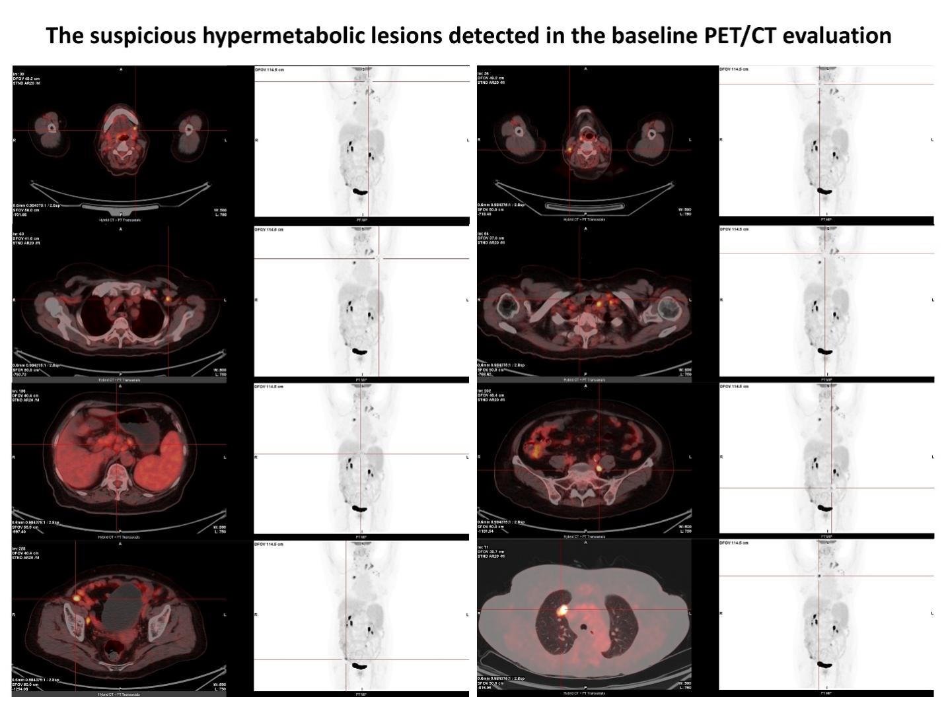
In the interim evaluation images shown in Fig.7, the lymph node lesions observed at baseline showed significant improvement in size, morphology and metabolic activity, while the lung lesion remained largely unchanged, suggesting that its nature may be different from that of the lymph node lesions.
Fig. 6 The screenshots of baseline evaluation
At the final assessment, shown in Fig.8, the lymph nodes observed at baseline remained in remission, consistent with the interim assessment. However, the lung lesion had slightly increased in size compared to the baseline and interim assessments, and there was increased metabolic activity in the ipsilateral hilar lymph node, indicating that it was likely to be a primary malignant lung lesion with metastases. Subsequent to treatment, this was confirmed as lung adenocarcinoma by biopsy.
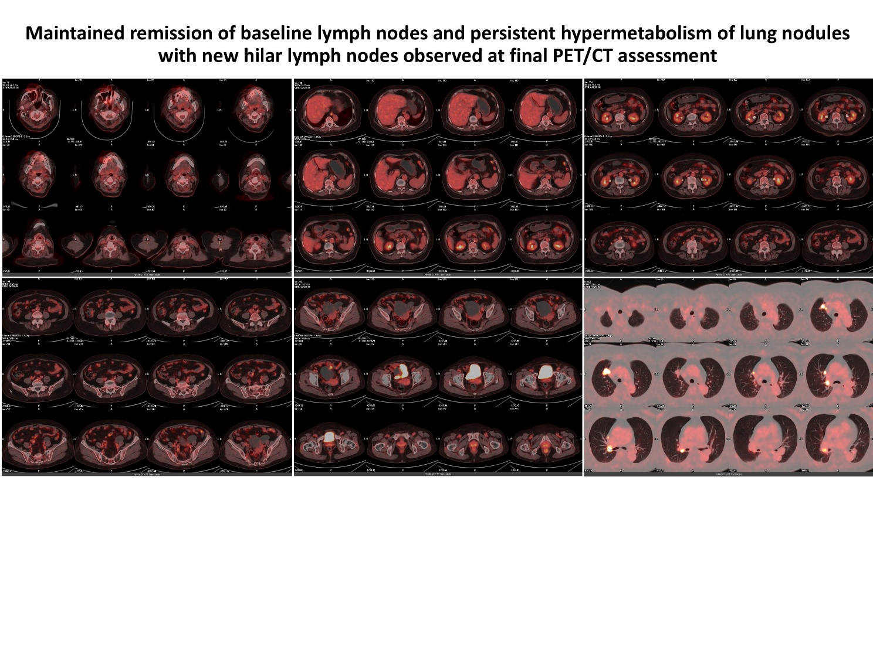
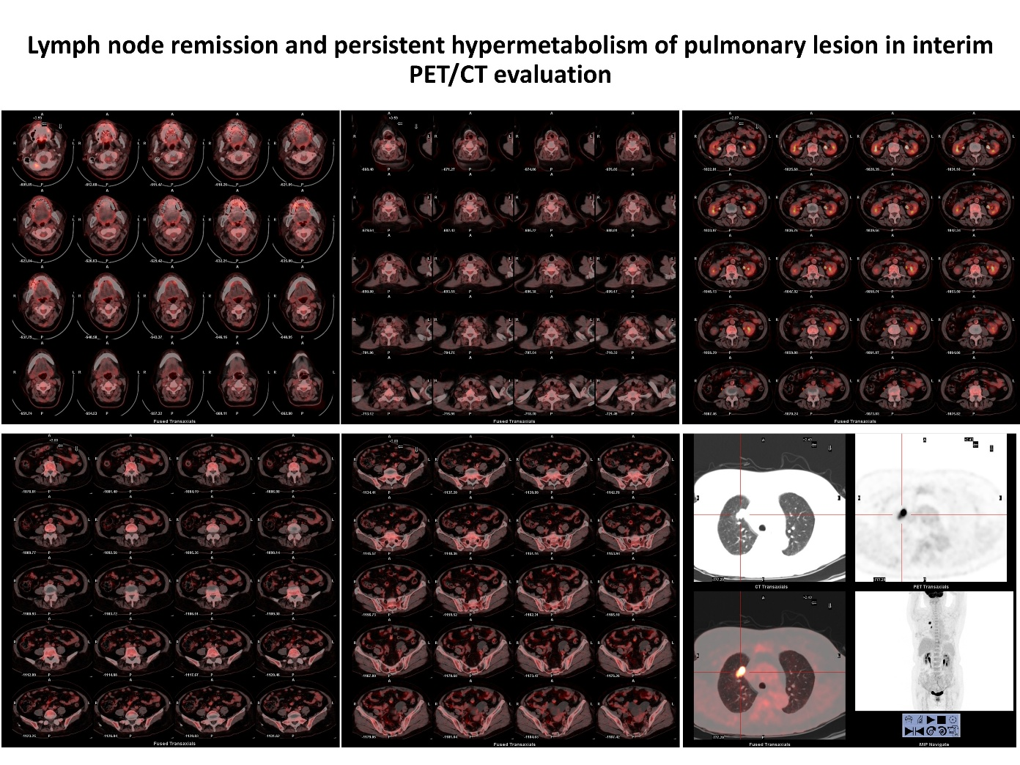
In this case, the interpretation of the lung lesion could affect whether the patient's Ann Arbor staging at baseline was stage III or stage IV. As mentioned in the main text, our model can infer the nature of the lung lesion based on its characteristics at baseline, without being subjectively influenced by the patient's history of lymphoma or other hypermetabolic lesions in the body. In similar cases of lymphoma, this model can effectively assist clinicians in making more accurate staging decisions.
Fig. 8 The screenshots of final assessment
Fig. 7 The screenshots of interim evaluation

4. Radiomics Model
4.1 Feature extraction
In the feature extraction process, the Python-based (v3.11.5) radiomics feature extraction toolkit PyRadiomics (v3.0.1) was utilised in conjunction with the medical image processing toolkit SimpleITK (v2.3.1), the data computation and input/output toolkit Numpy (v1.26.2), and the wavelet transform toolkit PyWavelet (v1.7.0). All of these toolkits are open-source [6]. The algorithms in PyRadiomics generally align with the recommendations of the Image Biomarker Standardization Initiative, although alternative equivalent algorithms were used for binning and grid alignment, which may introduce some differences in configurations C, D, and E due to gray-level discretization, resegmentation, and resampling [6, 7]. In this study, the default settings were primarily adopted, with a bin width of 25, a resample pixel spacing of 1×1×1, and normalization set to True. A total of 1465 features were extracted from each of the PET and CT images.

4.2 Feature selection
In our comparative experiments of radiomics, several feature selection methods were employed to retain the top 30 most significant features, as shown in the table below:
(1) Pearson Correlation Selection: This method removes features that exhibit high correlation with one another, thereby addressing multicollinearity issues.
(2) Variance Thresholding: This method filters out features with low variance, as they contribute little to the model's predictive power.
(3) F-test: This method selects features that demonstrate significant relationships with the target variable based on F-statistics and p-values.
(4) Random Forest Feature Importance: This method involves the training of a random forest classifier, with the aim of selecting features that have the highest importance scores.
The employment of these methodologies guarantees that the ultimate selected features are the most relevant for the designated task. Some of the above-mentioned example features were excluded in the final model construction after the process of feature selection, which can be interpreted as an indication of their more limited discriminative power or clinical relevance in lesion characterisation. Besides, the findings of this study also suggest that, in comparison to radiomics models that include or encapsulate these visual assessment features, deep learning models exhibit better performance and differential diagnostic capabilities. We hope this explanation addresses the reviewers' concerns and further clarifies our methodological choices.

Supplementary Table 3 - The top 30 most important features after selection
Features | Importance
ct_diagnostics_Image-interpolated_Minimum | 0.008737274135238617
pt_wavelet-HLL_glcm_SumAverage | 0.005711168802768457
pt_wavelet-HLL_gldm_HighGrayLevelEmphasis | 0.005141863048360074
ct_logarithm_firstorder_Minimum | 0.005082708293790112
pt_wavelet-HHL_glcm_ClusterShade | 0.004817416021186443
ct_diagnostics_Image-interpolated_Mean | 0.004747408969031728
ct_exponential_firstorder_Minimum | 0.004611587047112876
ct_diagnostics_Image-interpolated_Maximum | 0.004549184964816694
ct_squareroot_firstorder_Minimum | 0.004528256399179154
pt_wavelet-LLL_glcm_Imc2 | 0.004254879394176822
ct_wavelet-LHH_firstorder_TotalEnergy | 0.003981961130371655
pt_wavelet-HLL_glcm_MaximumProbability | 0.0038420028312253236
ct_wavelet-HLH_firstorder_Energy | 0.003841906158041677
ct_diagnostics_Mask-interpolated_Minimum | 0.0038023607217725396
ct_original_firstorder_Minimum | 0.0037391490499682485
pt_wavelet-HLH_glcm_SumAverage | 0.003722877370401147
pt_wavelet-HLL_gldm_LargeDependenceHighGrayLevelEmphasis | 0.003672964247045123
ct_square_firstorder_Minimum | 0.0036557791574202254
pt_wavelet-HLL_firstorder_Entropy | 0.0035812106009333335
pt_wavelet-HLL_glcm_JointAverage | 0.0035650436067655245
ct_square_firstorder_10Percentile | 0.0035229069193334693
pt_wavelet-HHL_glcm_SumAverage | 0.0033438186956337985
ct_logarithm_firstorder_Range | 0.0032764730028240385
ct_wavelet-HLH_firstorder_TotalEnergy | 0.0032357099838294014
ct_logarithm_firstorder_Maximum | 0.00319116190708441
ct_original_firstorder_Maximum | 0.003142804179886678
ct_squareroot_firstorder_Maximum | 0.003088043635816812
ct_exponential_firstorder_Maximum | 0.0030800506225211756
pt_wavelet-HLL_glcm_ClusterTendency | 0.0030252743461055844
ct_logarithm_firstorder_10Percentile | 0.0030115924168579887

Reference:
[1] Kerfoot E, Clough J, Oksuz I, Lee J, King AP, Schnabel JA. Left-Ventricle Quantification Using Residual U-Net. In: Pop M, Sermesant M, Zhao J, et al., eds. Statistical Atlases and Computational Models of the Heart. Atrial Segmentation and LV Quantification Challenges. Springer International Publishing; 2019:371-380. doi:10.1007/978-3-030-12029-0_40
[2] Milletari F, Navab N, Ahmadi SA. V-Net: Fully Convolutional Neural Networks for Volumetric Medical Image Segmentation. Published online June 15, 2016. doi:10.48550/arXiv.1606.04797
[3] Cardoso MJ, Li W, Brown R, et al. MONAI: An open-source framework for deep learning in healthcare. Published online November 4, 2022. doi:10.48550/arXiv.2211.02701
[4] Gatidis S, Kuestner T. A whole-body FDG-PET/CT dataset with manually annotated tumor lesions (FDG-PET-CT-Lesions) [Dataset]. The Cancer Imaging Archive, 2022. doi: 10.7937/gkr0-xv29
[5] Sibille L, Seifert R, Avramovic N, Vehren T, Spottiswoode B, Zuehlsdorff S, Schäfers M. ¹⁸F-FDG PET/CT Uptake Classification in Lymphoma and Lung Cancer by Using Deep Convolutional Neural Networks. Radiology. 2020 Feb;294(2):445-452. doi: 10.1148/radiol.2019191114. Epub 2019 Dec 10. PMID: 31821122.
[6] van Griethuysen JJ, Fedorov A, Parmar C, et al. Computational Radiomics System to Decode the Radiographic Phenotype. Cancer Res. 2017;77(21):e104-e107. doi:10.1158/0008-5472.CAN-17-0339
[7] Zwanenburg A, Vallières M, Abdalah MA, et al. The Image Biomarker Standardization Initiative: Standardized Quantitative Radiomics for High-Throughput Image-based Phenotyping. Radiology. 2020;295(2):328-338. doi:10.1148/radiol.2020191145

