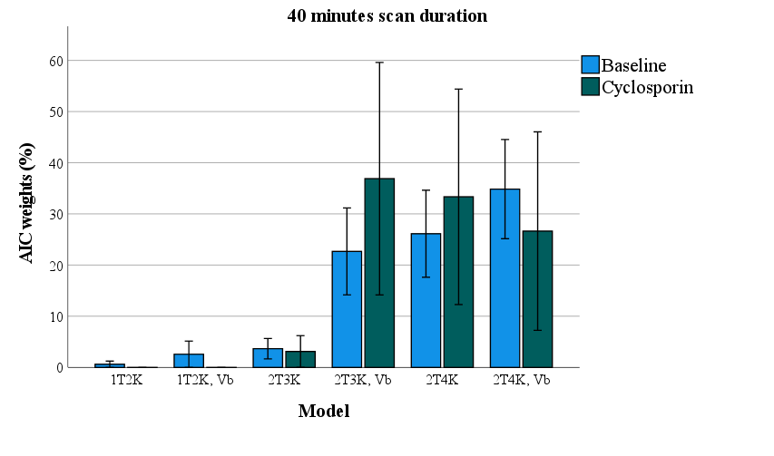
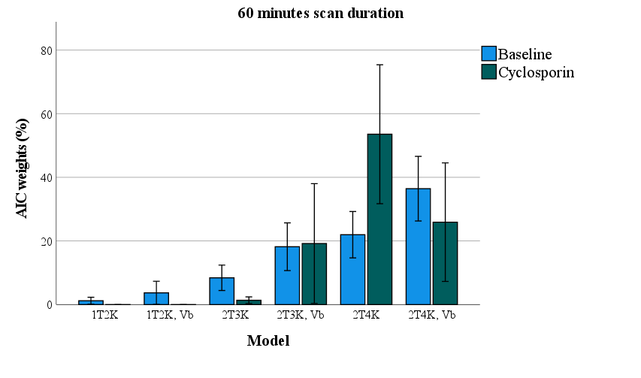
Supplementary data

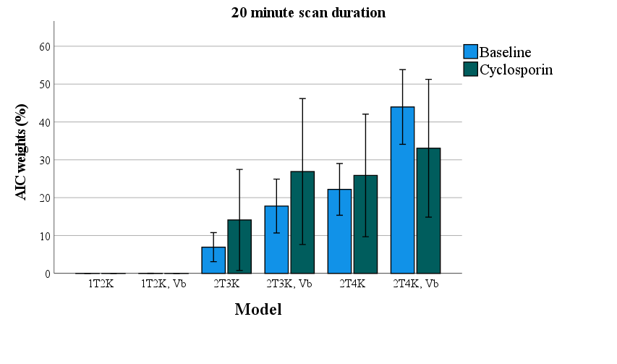

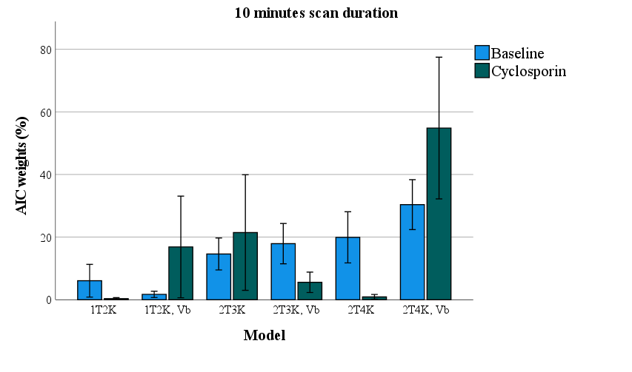
Supplementary data S1 – AIC values for 60, 0, 20 and 10 minutes of scan duation

Supplementary data S1 – AIC weighted values for 60, 40, 20, and 10 minutes of scan duration. 1T2K = 1 tissue compartment model, 2T3K – irreversible two-tissue compartment model, 2T4K = reversible two-tissue compartment model, Vb = fitted Vb parameter.

Supplementary data S2 – Mean and SD of time activity curves (TAC) for the whole brain grey matter region in SUV (g/mL) for baseline and cyclosporin scans.

Brain regions | K₁ (mL*cm⁻³*min⁻¹) |  |  | k₂ (min⁻¹) |  |  | k₃ (min⁻¹) |  |  | k₄ (min⁻¹)
 | Baseline | Cyclo-  sporin | % Difference | Baseline | Cyclo-  sporin | % Difference | Baseline | Cyclo-sporin | %Difference | Baseline | Cyclo-sporin | %  Difference
Amygdala | 0.16±0.04 | 0.15±0.03 | -8±38 | 0.16±0.09 | 0.16±0.05 | -0.7±73 | 0.19±0.08 | 0.18±0.06 | 7±48 | 0.04±0.01 | 0.02±0.01 | -52±21
Basal Ganglia | 0.25±0.06 | 0.20±0.04 | -17±33 | 0.24±0.11 | 0.12±0.025 | -47±48 | 0.21±0.10 | 0.16±0.05 | -5±53 | 0.05±0.01 | 0.03±0.01 | -41±18
Brainstem | 0.19±0.05 | 0.15±0.03 | -20±39 | 0.24±0.11 | 0.14±0.05 | -42±65 | 0.18±0.05 | 0.15±0.08 | -13±47 | 0.04±0.01 | 0.02±0.01 | -43±26
Caudate Nucleus | 0.24±0.08 | 0.19±0.03 | -22±33 | 0.29±0.18 | 0.11±0.02 | -60±36 | 0.24±0.13 | 0.14±0.05 | -25±39 | 0.05±0.01 | 0.03±0.01 | -39±19
Cerebellum | 0.25±0.06 | 0.20±0.05 | -20±36 | 0.23±0.10 | 0.11±0.05 | -50±67 | 0.20±0.07 | 0.13±0.04 | -25±45 | 0.05±0.01 | 0.03±0.01 | -37±28
Cingulate Gyrus | 0.27±0.07 | 0.23±0.05 | -15±36 | 0.22±0.10 | 0.13±0.04 | -37±68 | 0.21±0.06 | 0.16±0.03 | -14±34 | 0.05±0.02 | 0.03±0.01 | -36±10
Corpus Callosum | 0.08±0.03 | 0.08±0.02 | -5±50 | 0.15±0.08 | 0.18±0.07 | 16±91 | 0.11±0.04 | 0.14±0.04 | 46±40 | 0.03±0.01 | 0.02±0.01 | -9±29
Hippocampus | 0.20±0.06 | 0.16±0.03 | -21±40 | 0.23±0.13 | 0.13±0.06 | -40±88 | 0.18±0.05 | 0.14±0.07 | -13±46 | 0.04±0.01 | 0.02±0.01 | -48±27
Insula | 0.22±0.05 | 0.18±0.03 | -16±35 | 0.22±0.10 | 0.13±0.04 | -41±63 | 0.21±0.08 | 0.17±0.05 | -9±39 | 0.04±0.01 | 0.03±0.01 | -39±19
Nucleus Accumbens | 0.19±0.06 | 0.18±0.05 | -8±48 | 0.19±0.14 | 0.16±0.08 | -16±127 | 0.19±0.11 | 0.16±0.08 | 40±99 | 0.04±0.01 | 0.01±0.01 | -46±30
Occipital Cortex | 0.27±0.07 | 0.22±0.05 | -19±34 | 0.23±0.11 | 0.13±0.04 | -42±62 | 0.20±0.07 | 0.15±0.05 | -14±41 | 0.06±0.01 | 0.03±0.01 | -40±19
Orbitofrontal Cortex | 0.26±0.06 | 0.21±0.04 | -17±32 | 0.24±0.11 | 0.13±0.02 | -46±50 | 0.22±0.09 | 0.14±0.05 | -17±44 | 0.05±0.01 | 0.03±0.01 | -39±13
Pallidum | 0.18±0.07 | 0.15±0.02 | -15±35 | 0.27±0.24 | 0.20±0.11 | -27±53 | 0.18±0.08 | 0.16±0.04 | -1±38 | 0.03±0.01 | 0.02±0.01 | -42±24
Parietal Cortex | 0.25±0.05 | 0.21±0.05 | -15±32 | 0.21±0.09 | 0.13±0.03 | -35±50 | 0.20±0.06 | 0.17±0.04 | -9±33 | 0.05±0.01 | 0.03±0.01 | -37±13
Putamen | 0.27±0.07 | 0.23±0.04 | -15±34 | 0.24±0.11 | 0.14±0.03 | -40±50 | 0.23±0.08 | 0.17±0.06 | -18±35 | 0.05±0.01 | 0.02±0.01 | -39±20
Temporal Cortex | 0.23±0.06 | 0.18±0.04 | -20±36 | 0.24±0.12 | 0.14±0.04 | -42±65 | 0.21±0.06 | 0.15±0.04 | -22±36 | 0.04±0.01 | 0.02±0.01 | -41±21
Thalamus | 0.26±0.06 | 0.22±0.05 | -13±30 | 0.22±0.09 | 0.14±0.03 | -34±45 | 0.19±0.06 | 0.14±0.07 | -9±57 | 0.04±0.01 | 0.03±0.01 | -44±21
Whole Brain Grey Matter | 0.23±0.06 | 0.19±0.04 | -16±34 | 0.22±0.10 | 0.13±0.03 | -3±60 | 0.21±0.07 | 0.15±0.06 | -13±45 | 0.05±0.01 | 0.03±0.01 | -40±17
Whole Brain White Matter | 0.15±0.03 | 0.13±0.03 | -14±35 | 0.18±0.06 | 0.13±0.04 | -23±50 | 0.16±0.02 | 0.16±0.05 | 1±31 | 0.05±0.01 | 0.03±0.01 | -40±17
Pituitary gland | 0.56±0.15 | 0.45±0.11 | 19±29 | 0.13±0.16 | 0.11±0.05 | 15±66 | 0.14±0.17 | 0.09±0.06 | 39±64 | 0.16±0.22 | 0.03±0.01 | 82±95
Supplementary data S3 – Mean ± SD of regional microparameter outcomes for the baseline and cyclosporin scans.

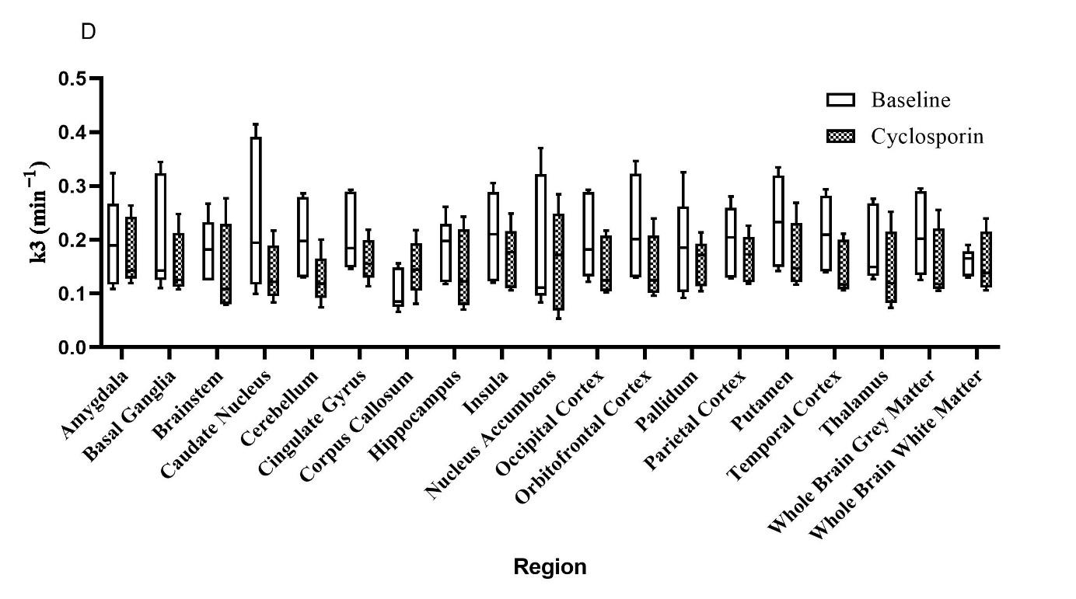
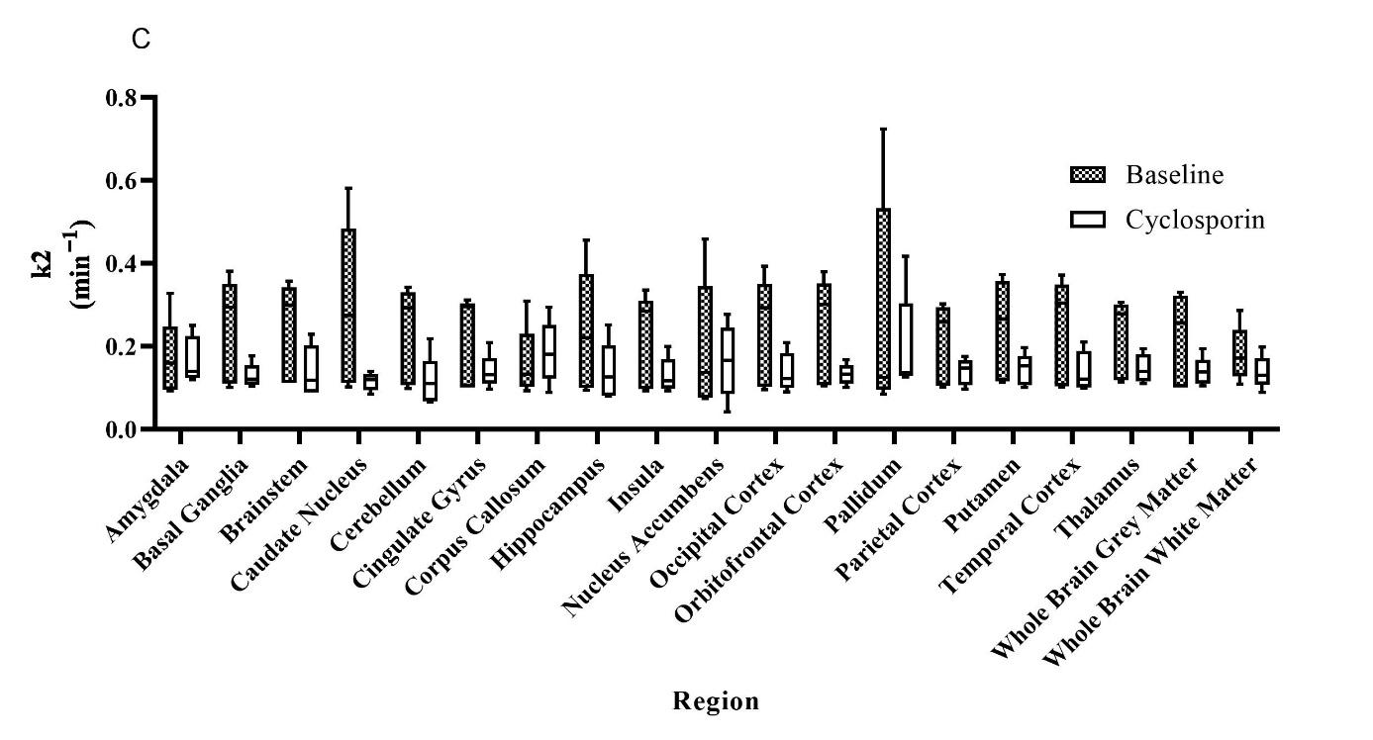

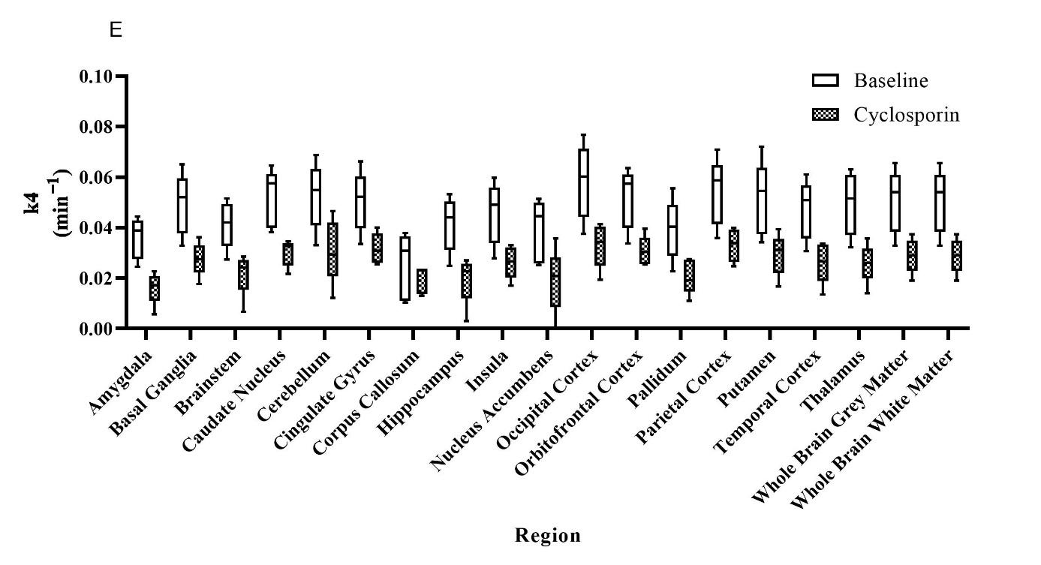
Supplementary data S4 – k₂, k₃, and k₄ values at baseline and cyclosporin scans.

Brain regions | V_{T} (mL*cm⁻³) |  | K₁ (mL*cm⁻³*min⁻¹) |  | k₂ (min⁻¹) |  | k₃ (min⁻¹) |  | k₄ (min⁻¹)
 | Baseline | Cyclosporin | Baseline | Cyclosporin | Baseline | Cyclosporin | Baseline | Cyclosporin | Baseline | Cyclosporin
Amygdala | 4.7 ± 2.0 | 10.6 ± 9.6 | 5.6 ± 3.5 | 5.1 ± 1.5 | 21.0 ± 7.0 | 19.2 ± 8.9 | 16.3 ± 4.7 | 13.3 ± 4.6 | 11.2 ± 4.4 | 16.4 ± 11.5
Basal Ganglia | 2.8 ± 1.7 | 3.2 ± 1.2 | 3.4 ± 2.0 | 2.5 ± 0.4 | 14.5 ± 7.7 | 9.2 ± 3.0 | 12.5 ± 5.6 | 7.6 ± 3.3 | 7.0 ± 3.1 | 7.5 ± 2.8
Brainstem | 3.0 ± 1.6 | 7.3 ± 8.8 | 4.2 ± 2.5 | 3.2 ± 0.8 | 15.3 ± 6.8 | 11.9 ± 3.7 | 12.7 ± 5.1 | 10.2 ± 4.0 | 7.5 ± 3.3 | 12.2 ± 10.2
Caudate Nucleus | 2.8 ± 1.3 | 4.7 ± 2.9 | 6.4 ± 4.6 | 2.8 ± 0.9 | 27.4 ± 13.2 | 13.8 ± 7.0 | 21.5 ± 8.2 | 14.5 ± 5.6 | 11.5 ± 6.3 | 10.6 ± 4.2
Cerebellum | 2.7 ± 1.8 | 5.2 ± 5.0 | 3.9 ± 2.5 | 2.4 ± 0.4 | 18.1 ± 10.3 | 9.9 ± 4.8 | 16.7 ± 12.9 | 12.0 ± 4.6 | 8.0 ± 4.2 | 11.5 ± 7.0
Cingulate Gyrus | 3.3 ± 2.0 | 2.6 ± 0.9 | 4.4 ± 2.7 | 3.1 ± 1.1 | 17.9 ± 9.9 | 12.7 ± 4.3 | 14.4 ± 6.0 | 10.7 ± 3.1 | 8.5 ± 3.7 | 6.8 ± 2.0
Corpus Callosum | 10.1 ± 11.1 | 6.3 ± 6.0 | 4.6 ± 2.1 | 4.5 ± 1.1 | 21.5 ± 13.5 | 15.1 ± 6.8 | 20.7 ± 10.6 | 12.8 ± 6.8 | 20.3 ± 14.0 | 11.0 ± 9.1
Hippocampus | 3.9 ± 2.3 | 16.8 ± 28.4 | 4.7 ± 2.9 | 3.8 ± 0.9 | 18.9 ± 8.1 | 14.8 ± 4.3 | 15.5 ± 5.4 | 12.8 ± 4.5 | 9.2 ± 4.1 | 23.3 ± 30.2
Insula | 3.2 ± 2.5 | 3.5 ± 1.3 | 3.3 ± 1.9 | 3.7 ± 1.1 | 13.2 ± 5.0 | 14.3 ± 2.1 | 11.3 ± 4.5 | 11.3 ± 3.7 | 8.4 ± 3.9 | 8.4 ± 2.3
Nucleus Accumbens | 16.0 ± 28.5 | 187219.6 ± 418619.0 | 7.3 ± 5.3 | 7.6 ± 2.1 | 31.4 ± 11.0 | 32.6 ± 14.4 | 34.2 ± 16.1 | 31.0 ± 20.9 | 34.6 ± 50.0 | 187238.7 ± 418643.6
Occipital Cortex | 3.2 ± 2.5 | 3.0 ± 1.7 | 4.8 ± 4.4 | 2.9 ± 1.2 | 19.4 ± 15.9 | 10.9 ± 4.5 | 15.4 ± 7.5 | 9.6 ± 5.0 | 9.1 ± 4.7 | 8.3 ± 2.9
Orbitofrontal Cortex | 2.9 ± 1.7 | 3.0 ± 1.4 | 3.7 ± 2.4 | 3.0 ± 0.4 | 15.8 ± 9.8 | 13.2 ± 6.5 | 15.1 ± 12.1 | 12.8 ± 6.2 | 7.3 ± 3.2 | 8.0 ± 3.1
Pallidum | 4.2 ± 1.9 | 4.6 ± 2.7 | 4.4 ± 3.0 | 3.4 ± 1.1 | 17.8 ± 10.6 | 9.5 ± 5.5 | 18.6 ± 13.7 | 7.7 ± 5.5 | 10.4 ± 5.0 | 9.1 ± 4.2
Parietal Cortex | 3.0 ± 2.0 | 3.3 ± 2.0 | 3.5 ± 2.2 | 3.0 ± 0.9 | 14.8 ± 7.7 | 12.7 ± 6.4 | 14.0 ± 7.2 | 10.7 ± 3.7 | 7.9 ± 4.2 | 7.6 ± 2.2
Putamen | 3.0 ± 1.7 | 3.2 ± 1.8 | 4.4 ± 2.3 | 2.7 ± 0.8 | 22.1 ± 10.0 | 9.7 ± 4.1 | 18.8 ± 11.3 | 8.2 ± 4.7 | 7.8 ± 3.5 | 7.8 ± 2.4
Temporal Cortex | 11.6 ± 12.7 | 24.7 ± 27.2 | 6.3 ± 3.1 | 6.5 ± 2.7 | 26.2 ± 7.1 | 20.4 ± 11.1 | 28.9 ± 12.1 | 18.6 ± 13.0 | 25.0 ± 21.4 | 33.1 ± 32.4
Thalamus | 2.9 ± 1.7 | 4.2 ± 3.1 | 4.0 ± 2.1 | 3.1 ± 0.8 | 19.4 ± 9.0 | 11.6 ± 3.6 | 16.5 ± 7.6 | 9.9 ± 4.8 | 7.8 ± 3.0 | 9.3 ± 4.1
Whole Brain Grey Matter | 3.1 ± 2.0 | 3.2 ± 1.5 | 3.9 ± 2.4 | 3.1 ± 0.7 | 15.8 ± 7.7 | 12.7 ± 3.6 | 13.9 ± 7.5 | 10.6 ± 3.8 | 7.9 ± 2.7 | 7.8 ± 2.3
Whole Brain White Matter | 4.0 ± 3.4 | 4.8 ± 2.3 | 7.0 ± 4.9 | 7.0 ± 2.8 | 20.6 ± 8.0 | 20.8 ± 9.0 | 17.3 ± 11.0 | 14.5 ± 6.3 | 14.6 ± 12.3 | 10.2 ± 3.3
Pituitary gland | 8.9 ± 5.2 | 23.0±23.6 | 8.6 ± 7.0 | 5.9 ± 3.1 | 86.3±97.9 | 23.7±14.1 | 708341.0±2124118 | 64.9±86.9 | 829.9±2405.0 | 79.2±123.5
Supplementary data S5 – Mean ± SD of percentage standard error (%SE) of V_{T} and microparameter outcomes for the baseline and cyclosporin scans.

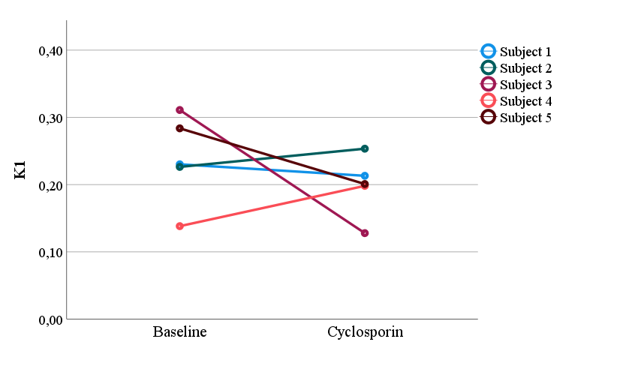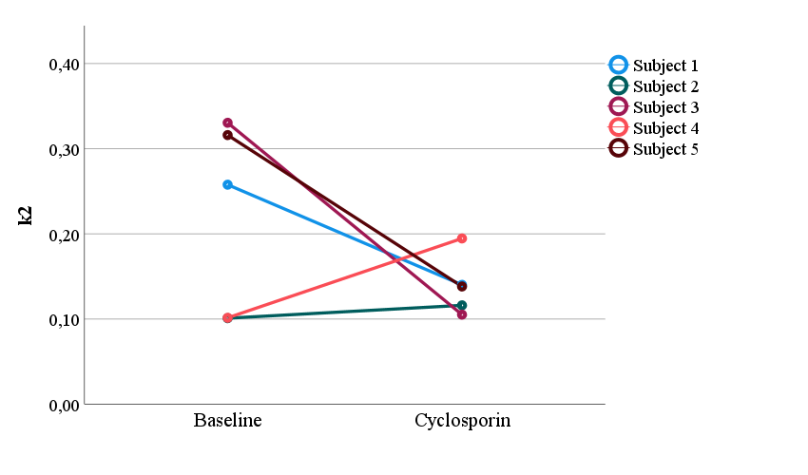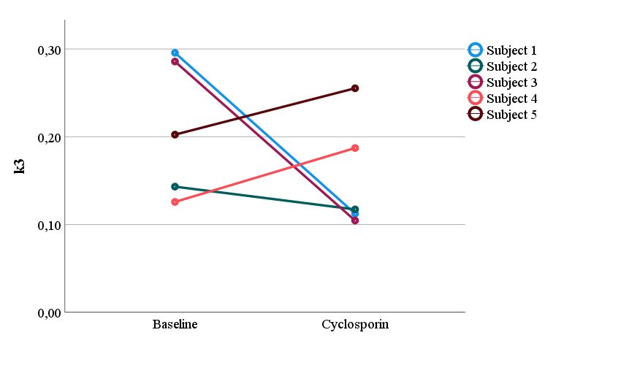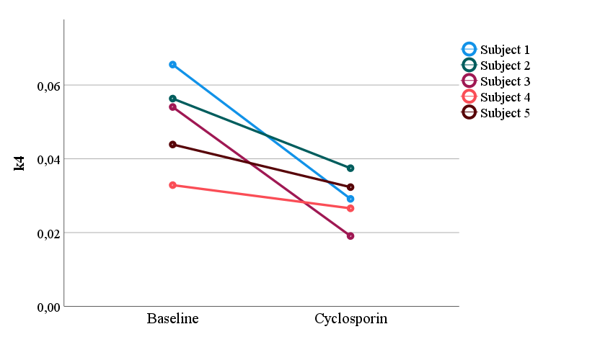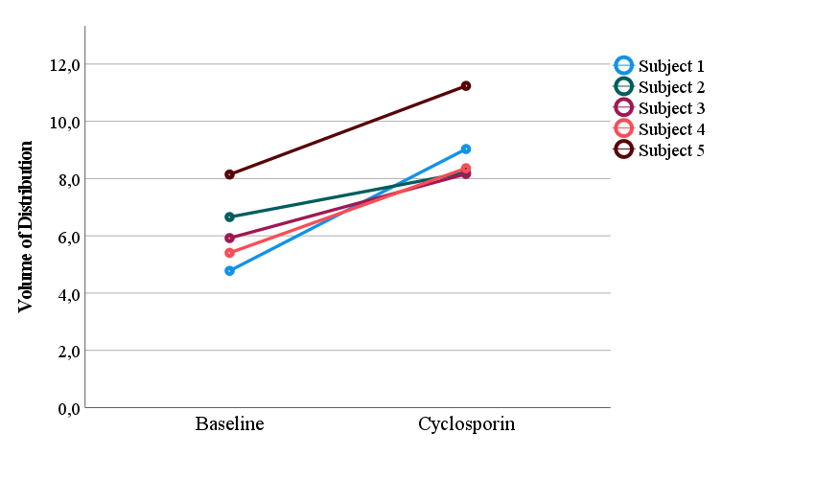
Supplementary data S5 – Plots of individual subjects before and after cyclosporin administration

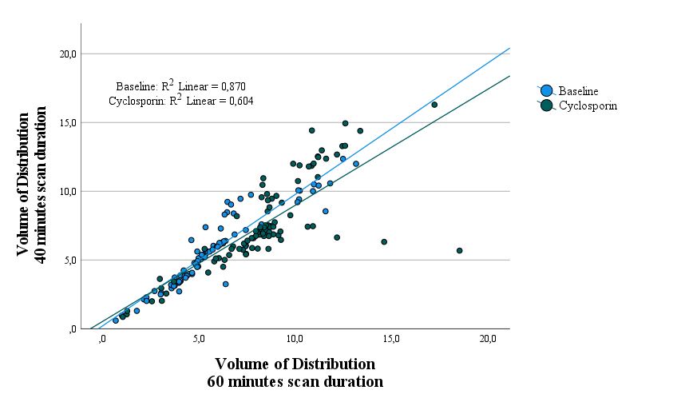

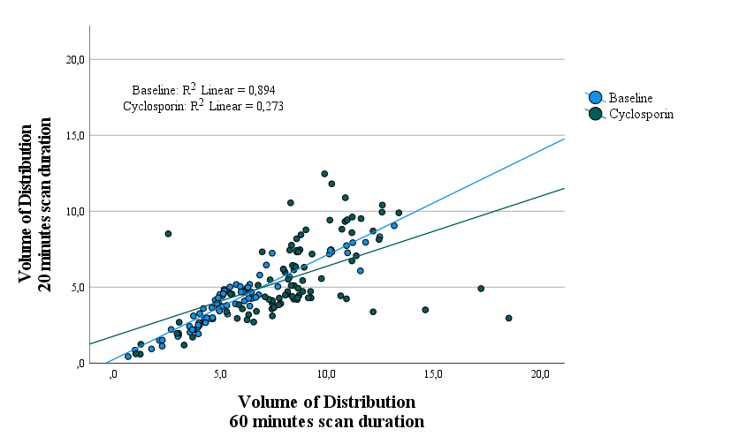

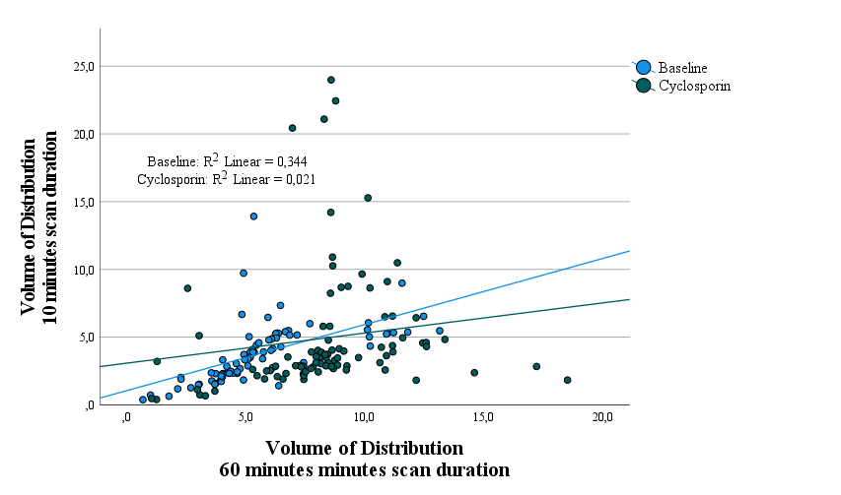
Supplementary data S3 – Scatter plots of V_{T} 40, 20, and 10 minutes of scan duration and the standard of 60 minutes scan duration

Supplementary data S6 – Correlation plots for 40, 20, and 10 minutes of scan duration outcome parameters (SUV and V_{T}).

Title:
Effect of cyclosporine on plasma binding of [¹⁸F]MC225.

Materials and equipment:
Cyclosporine A: Sandimmune for i.v. 50 mg/L
Gamma counter: Perkin Elmer (Revvity) 2480 gammacounter
Centrifuge: Mikro 20 Hettich centrifuge for eppendorfs

Methodology
Human plasma (450 μL) was treated with either 50 μL of Cyclosporine A (4 µmol/L, treatment group) or 50 μL of saline (control group) and incubated at 37 °C for 30 minutes (n=3, from 1 batch). Next, [¹⁸F]MC225 (100 kBq) was added to 500 μL of plasma and incubated at 37 °C for another 60 minutes. Plasma proteins were precipitated by adding 500 μL of acetonitrile, vortexing, and centrifuging at 4000 rpm for 10 minutes to separate the protein free supernatant from the plasma protein sediment. Radioactivity in both fractions was measured using a γ-counter. The ratio was calculated with the following formula:

$$=(\frac{Radioactivity supernatant}{weight of supernatant})/(\frac{Radioactivity sediment}{weight of sediment})$$

Results/ Conclusion
The protein free supernatant-to-sediment radioactivity ratio was 1.753 ± 0.173 for the cyclosporin treated group and 1.632 ± 0.050 for the control group. This indicates that there are no substantial differences between the two groups.

Supplementary data S7 – Additional experiment cyclosporin effect on plasma binding of [¹⁸F]MC225

