Supplementary File
Innate [¹⁸F]Fluorodeoxyglucose PET bone networks of lung cancer patients predict survival

Rucha Ronghe^{1†}, Teresa Crespo^{2†}, Catriona Wimberley^{3,4,5}, Karla Suchacki^{3,6}, and
Adriana A. S. Tavares^{3,4}*
†These authors contributed equally to this work.
¹ Edinburgh Medical School, University of Edinburgh, 49 Little France Crescent, Edinburgh, EH16 4SB, UK
² Edinburgh Medical School: Biomedical Sciences, University of Edinburgh, Old Medical School (Doorway 3), Teviot Place, Edinburgh, EH8 9AG, UK
³ British Heart Foundation-University of Edinburgh Centre for Cardiovascular Science, University of Edinburgh, 47 Little France Crescent, EH16 4TJ, Edinburgh, UK
⁴ Edinburgh Imaging, University of Edinburgh, EH16 4TJ, Edinburgh, UK
⁵ School of Physics and Astronomy, University of Edinburgh, EH9 3JW, Edinburgh, UK
⁶ SRUC, The Roslin Institute, Edinburgh, UK.

*Corresponding author:
Adriana A.S. Tavares
Centre for Cardiovascular Science, Queen's Medical Research Institute, 47 Little France Crescent, Edinburgh EH16 4TJ, UK
adriana.tavares@ed.ac.uk

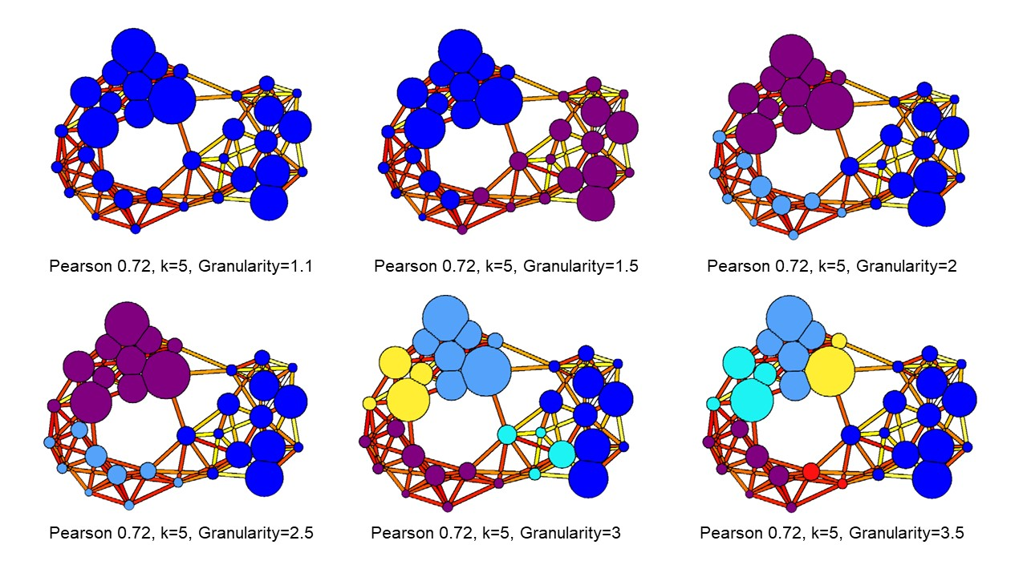
Supplementary Figure 1. Optimisation of single granularity parameter for networks derived from pre-treatment PET datasets.

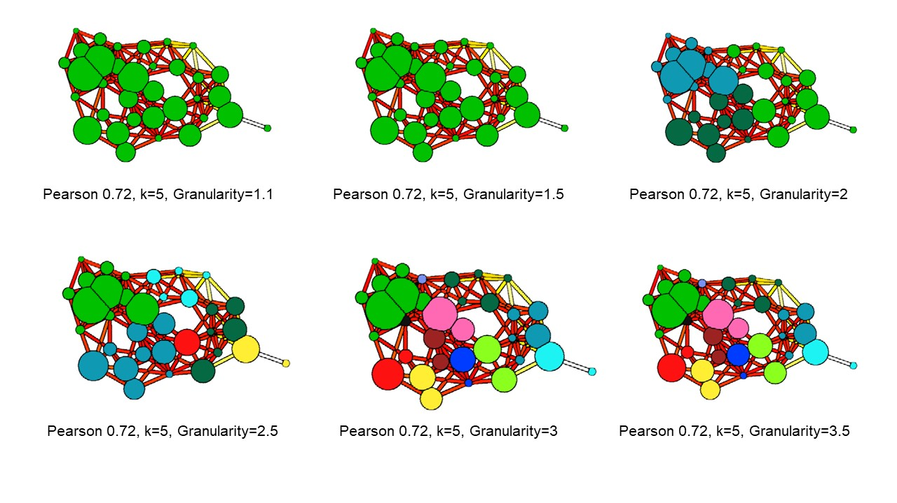
Supplementary Figure 2. Optimisation of single granularity parameter for networks derived from post-treatment PET datasets.

Supplementary Table 1. Multi-variate Cox analysis of lung SUV results from pre-treatment PET scans. Legend: CI=confidence interval.
Variable | Hazard ratios | 95% CI | p value
Age | 1.02 | 0.96 to 1.08 | 0.60
Sex (male reference) | 0.48 | 0.17 to 1.30 | 0.16
SUV (<5 reference) | 0.38 | 0.10 to 1.18 | 0.12
Chemotherapy (Cisplatin+Etoposide reference)
Carboplatin+Paclitaxel | 0.84 | 0.24 to 3.06 | 0.78
Carboplatin+Taxotere | 1.10 | 0.24 to 4.63 | 0.90
Cisplatin+Irinotecan | 0.48 | 0.10 to 1.91 | 0.31
Cisplatin+Navelbine | 2.66 | 0.25 to 23.63 | 0.38
Carboplatin+Navelbine | 2.63 | 0.12 to 24.37 | 0.44
Cisplatin+Paclitaxel | 0.52 | 0.03 to 3.21 | 0.55
Carboplatin+Etoposide | 3.63 | 0.18 to 26.42 | 0.26
Navelbine | 2.15 | 0.07 to 38.35 | 0.61

Supplementary Table 2. Multi-variate Cox analysis of bone network results from pre-treatment PET scans. Legend: CI=confidence interval. *p<0.05, ***p<0.001.
Variable | Hazard ratios | 95% CI | p value
Age | 0.98 | 0.92 to 1.04 | 0.56
Sex (male reference) | 0.29 | 0.09 to 0.87 | 0.03*
Cluster (reference to long-term survivors)
Short-term survivors cluster | 24.61 | 4.80 to 144.50 | 0.0002***
Mix-term survivors cluster | 6.72 | 1.51 to 34.29 | 0.02*
Chemotherapy (Cisplatin+Etoposide reference)
Carboplatin+Paclitaxel | 0.58 | 0.14 to 2.51 | 0.74
Carboplatin+Taxotere | 0.36 | 0.05 to 2.40 | 1.06
Cisplatin+Irinotecan | 0.15 | 0.02 to 1.12 | 1.80
Cisplatin+Navelbine | 1.05 | 0.10 to 9.21 | 0.05
Carboplatin+Navelbine | 0.62 | 0.03 to 6.27 | 0.37
Cisplatin+Paclitaxel | 0.14 | 0.005 to 1.59 | 1.45
Carboplatin+Etoposide | 0.42 | 0.02 to 4.36 | 0.67
Navelbine | 3.78 | 0.09 to 127.20 | 0.75

Supplementary Table 3. Multi-variate Cox analysis of lung SUV results from post-treatment PET scans. Legend: CI=confidence interval.
Variable | Hazard ratios | 95% CI | p value
Age | 0.99 | 0.93 to 1.06 | 0.89
Sex (male reference) | 0.63 | 0.19 to 1.97 | 0.43
SUV (<5 reference) | 1.72 | 0.42 to 7.20 | 0.44
Chemotherapy (Cisplatin+Etoposide reference)
Carboplatin+Paclitaxel | 1.43 | 0.40 to 5.89 | 0.59
Carboplatin+Taxotere | 1.45 | 0.26 to 7.45 | 0.65
Cisplatin+Irinotecan | 0.53 | 0.09 to 2.54 | 0.44
Cisplatin+Navelbine | 4.77 | 0.35 to 54.15 | 0.21
Carboplatin+Navelbine | 4.84 | 0.21 to 50.77 | 0.22
Cisplatin+Paclitaxel | 1.03 | 0.05 to 7.65 | 0.98
Carboplatin+Etoposide | 9.51 | 0.42 to 96.27 | 0.07
Navelbine | 3.51 | 0.07 to 116.00 | 0.49

Supplementary Table 4. Multi-variate Cox analysis of bone network results from post-treatment PET scans. Legend: CI=confidence interval.
Variable | Hazard ratios | 95% CI | p value
Age | 0.99 | 0.94 to 1.05 | 0.82
Sex (male reference) | 0.48 | 0.17 to 1.28 | 0.15
Cluster (reference to Mixed Cluster 2)
Mixed Cluster 1 | 2.12 | 0.64 to 7.27 | 0.22
Mixed Cluster 2 | 0.87 | 0.26 to 2.88 | 0.82
Chemotherapy (Cisplatin+Etoposide reference)
Carboplatin+Paclitaxel | 0.70 | 0.20 to 2.60 | 0.58
Carboplatin+Taxotere | 1.10 | 0.23 to 4.80 | 0.90
Cisplatin+Irinotecan | 0.27 | 0.04 to 1.40 | 0.13
Cisplatin+Navelbine | 4.97 | 0.46 to 46.17 | 0.16
Carboplatin+Navelbine | 3.76 | 0.17 to 37.00 | 0.29
Cisplatin+Paclitaxel | 0.75 | 0.04 to 5.11 | 0.80
Carboplatin+Etoposide | 2.04 | 0.09 to 18.54 | 0.57
Navelbine | 2.28 | 0.07 to 44.84 | 0.60

Supplementary Figure 3. Multi-variate Cox analysis for pre-treatment SUV results using threshold of 5 g/mL (a), network clusters (b), sex-adjusted SUV results (c), and sex-adjusted network analysis results (d). Cox regression models were censored as dead/alive with time variable being survival in days. Significant differences between cumulative survival analysis for different variables are presented as *p<0.05 and ***p<0.001. ns=non-significant.

Supplementary Figure 4. Multi-variate Cox analysis for post-treatment SUV results using threshold of 5 g/mL (a), network clusters (b), sex-adjusted SUV results (c), and sex-adjusted network analysis results (d). Cox regression models were censored as dead/alive with time variable being survival in days. Significant differences between cumulative survival analysis for different variables are presented as *p<0.05 and ***p<0.001. ns=non-significant.

