Supporting Information

Combination therapy of an ²¹¹At-labeled RGD peptide and immune checkpoint blockade to enhance antitumor efficacy

Hiroaki Echigoª, Masayuki Munekaneª, Takeshi Fuchigamiª, Kohshin Washiyama^{b}, Takashi Nakamuraª, Atsushi Furukawaª, Zhuoqing Chen^{c}, Kenji Mishiroª, Hiroshi Wakabayasi^{c}, Kazuhiro Takahashi^{b}, Seigo Kinuya^{c}, Kazuma Ogawa*^{, a}

ª Graduate School of Medical Sciences, Kanazawa University, Kakuma-machi, Kanazawa, Ishikawa 920-1192, Japan;
^{b} Advanced Clinical Research Center, Fukushima Global Medical Science Center, Fukushima Medical University, 1 Hikarigaoka, Fukushima, 960-1295, Japan;
^{c} Department of Nuclear Medicine, Kanazawa University Hospital, Kanazawa University, Takara-machi 13-1, Kanazawa, Ishikawa 920-8641, Japan;

*Corresponding Author
Institute for Frontier Science Initiative; Kanazawa University; Kakuma-machi, Kanazawa 920-1192; Japan.
Telephone: +81-76-234-4460; Fax: +81-76-234-4460
E-mail: kogawa@p.kanazawa-u.ac.jp

Table of contents
Preparation of Ga-DOTA-K([¹²⁵I]PBA)-c(RGDfK) ([¹²⁵I]2) S3
Figure S1 Cellular uptake experiments of [¹²⁵I]2 S3
Table S1 Biodistribution of [²¹¹At]1 and [¹²⁵I]2 in Colon-26 tumor-bearing BALB/c mice S4
Figure S2 Relative body weight of Colon-26 tumor-bearing BALB/c mice in therapeutic experiment S6
Table S2 Detailed relative tumor volume of Colon-26 tumor-bearing BALB/c mice in therapeutic experiment S7
Table S3 Detailed relative body weight of Colon-26 tumor-bearing BALB/c mice in therapeutic experiment S8
Table S4 Detailed relative tumor volume of Colon-26 tumor-bearing nu/nu mice in therapeutic experiment S9
Table S5 Detailed relative body weight of Colon-26 tumor-bearing nu/nu mice in therapeutic experiment S9
Figure S3 Flow cytometric analysis of Colon-26 tumors treated with [²¹¹At]1 + αPD-1 S10
Reference S11

Preparation of [¹²⁵I]2
[¹²⁵I]Sodium iodide (629 GBq/mg) was purchased from Revvity Japan (Yokohama, Japan). Ga-DOTA-K([¹²⁵I]IPBA)-c(RGDfK) ([¹²⁵I]2) were synthesized according to our previous report [1]. The radiochemical yield of [¹²⁵I]2 was 54%. After HPLC purification, the radiochemical purity was > 97%. HPLC purification completely separated the radiolabeled compounds from the precursor.

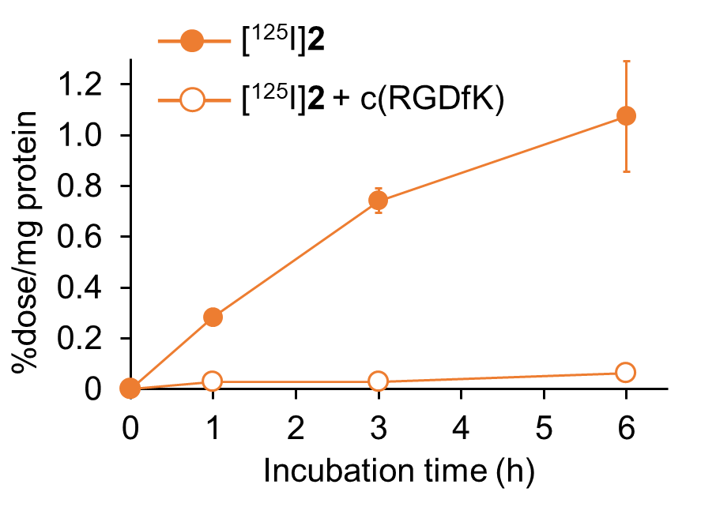
Figure S1. Cellular uptake experiments. Time-dependent accumulation of [¹²⁵I]2 in Colon-26 cells. Data were presented as mean ± SD for three samples.

Table S1. Biodistribution of radioactivity after intravenous injection of [²¹¹At]1 and [¹²⁵I]2 in Colon-26 tumor-bearing BALB/c mice.
Tissues | Times after injection
Tissues | 1 h | 4 h | 24 h
[²¹¹At]1
Blood | 26.71 (1.45) | 24.54 (1.49) | 16.47 (2.71)
Liver | 5.21 (0.53) | 4.39 (0.36) | 3.63 (0.51)
Kidney | 6.34 (0.56) | 7.51 (0.87) | 6.27 (1.22)
S. intestine | 3.78 (0.46) | 4.08 (0.60) | 2.10 (0.75)
L. intestine | 2.70 (0.31) | 4.75 (1.02) | 3.77 (2.34)
Spleen | 3.88 (0.54) | 3.80 (0.59) | 4.70 (1.32)
Pancreas | 2.70 (0.37) | 3.10 (0.29) | 2.55 (0.18)
Lung | 13.13 (2.84) | 14.21 (1.31) | 10.38 (1.54)
Heart | 7.08 (0.48) | 7.46 (0.95) | 5.34 (0.68)
Stomach‡ | 1.01 (0.14) | 0.88 (0.04) | 1.70 (0.22)
Bone | 2.41 (0.49) | 3.16 (0.16) | 2.61 (0.52)
Muscle | 1.84 (0.24) | 1.84 (0.11) | 1.34 (0.10)
Brain | 0.48 (0.07) | 0.47 (0.08) | 0.33 (0.08)
Neck‡ | 0.16 (0.02) | 0.09 (0.05) | 0.39 (0.12)
Tumor | 6.09 (0.31) | 7.12 (0.95) | 8.40 (0.60)
Urine‡ |  |  | 12.46 (3.08)
Feces‡ |  |  | 1.50 (0.58)
[¹²⁵I]2
Blood | 25.77 (1.50) ** | 21.84 (1.32) ** | 12.57 (2.36) **
Liver | 5.00 (0.48) * | 4.01 (0.28) ** | 2.81 (0.40) **
Kidney | 6.39 (0.50) | 7.25 (0.78) | 5.90 (1.16)
S. intestine | 3.50 (0.49) ** | 3.84 (0.59) ** | 1.91 (1.27)
L. intestine | 2.63 (0.30) | 4.83 (1.01) | 3.13 (1.56)
Spleen | 3.27 (0.54) * | 3.27 (0.48) * | 3.34 (0.97) *
Pancreas | 2.55 (0.35) * | 2.97 (0.73) | 1.91 (0.04) *
Lung | 12.45 (2.90) ** | 12.85 (1.21) ** | 7.46 (1.28) **
Heart | 6.90 (0.58) | 6.57 (0.78) ** | 3.91 (0.64) **
Stomach‡ | 0.72 (0.13) ** | 0.71 (0.06) * | 0.51 (0.07) *
Bone | 2.26 (0.42) | 2.55 (0.19) | 1.77 (0.18)
Muscle | 1.84 (0.17) | 1.67 (0.12) | 1.03 (0.10) **
Brain | 0.46 (0.07) | 0.41 (0.06) ** | 0.25 (0.06) *
Neck‡ | 0.15 (0.03) | 0.10 (0.02) | 0.09 (0.02) *
Tumor | 6.31 (0.50) | 6.94 (1.03) | 6.68 (0.40) *
Urine‡ |  |  | 25.39 (4.84) *
Feces‡ |  |  | 1.65 (0.69)
Expressed as % injected dose per gram.
Each value represents the mean (SD) for three or four animals.
‡ Expressed as % injected dose.
Significance was determined by paired t test.
*p < 0.05, **p < 0.01 vs [²¹¹At]1.

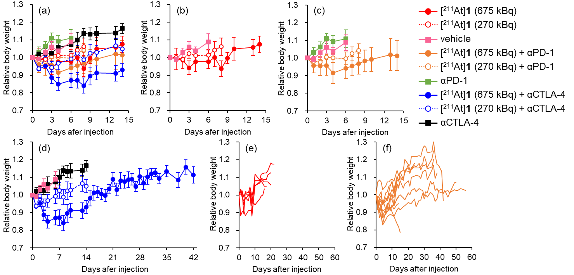
Figure S2. Therapeutic experiment in Colon-26 tumor-bearing BALB/c mice. Relative body weight in (a) all group, (b) [²¹¹At]1 or vehicle-treated group, (c) [²¹¹At]1 with or without αPD-1-treated group, (d) [²¹¹At]1 with or without αCTLA-4-treated group (mean ± SD), (e) individual relative body weight in [²¹¹At]1 (675 kBq) treated group, (f) individual relative body weight in [²¹¹At]1 (675 kBq) + αPD-1 treated group.

Table S2. Relative tumor volume of Colon-26 tumor-bearing BALB/c mice after administration of [²¹¹At]1 (270 or 675 kBq) with αPD-1 or αCTLA-4, [²¹¹At]1 (270 or 675 kBq), αPD-1, αCTLA-4, or vehicle. Data are expressed as relative value to initial tumor volume (mean ± SD).
Days after  injection | [²¹¹At]1  (675 kBq)  + αPD-1 | [²¹¹At]1  (675 kBq)  + αCTLA-4 | [²¹¹At]1  (675 kBq) | [²¹¹At]1  (270 kBq)  + αPD-1 | [²¹¹At]1  (270 kBq)  + αCTLA-4 | [²¹¹At]1  (270 kBq) | αPD-1 | αCTLA-4 | vehicle
0 | 1.00 (0.00) | 1.00 (0.00) | 1.00 (0.00) | 1.00 (0.00) | 1.00 (0.00) | 1.00 (0.00) | 1.00 (0.00) | 1.00 (0.00) | 1.00 (0.00)
1 | 1.23 (0.14) ª | 1.08 (0.14) ^{a, g} | 1.47 (0.30) ^{b, e} | 1.41 (0.18) ^{e} | 0.97 (0.07) ^{a, c} | 1.32 (0.18) ª | 1.44 (0.28) ^{b} | 1.05 (0.10) ª | 1.79 (0.06)
2 | 1.41 (0.24) ^{a, c} | 1.22 (0.24) ^{a, c} | 1.74 (0.21) ^{e} | 1.66 (0.32) ^{c, e} | 0.97 (0.15) ^{a, c, d} | 1.66 (0.29) ^{c} | 2.36 (0.70) ^{b} | 1.24 (0.14) ª | 2.28 (0.26)
3 | 1.65 (0.45) ^{a, c} | 1.11 (0.35) ^{a, c} | 2.07 (0.35) ^{a, c} | 1.85 (0.48) ^{a, c} | 1.14 (0.27) ^{a, c} | 2.20 (0.20) ª | 3.28 (1.26) ^{b} | 1.44 (0.27) ª | 3.52 (0.56)
4 | 1.77 (0.53) ^{a, c} | 0.97 (0.36) ^{a, c, d, f, g} | 2.20 (0.32) ^{a, c} | 2.31 (0.78) ^{a, c} | 1.29 (0.48) ^{a, c, d} | 2.63 (0.65) ^{a, b} | 4.10 (0.64) ^{b} | 1.51 (0.22) ª | 4.17 (0.84)
6 | 1.84 (0.50) ^{a, c, d, f} | 0.96 (0.33) ^{a, c, d, f} | 2.43 (0.52) ^{a, c} | 3.59 (0.70) ^{a, c, e} | 1.81 (1.15) ^{a, c, d} | 3.93 (0.86) ^{a, b} | 5.45 (0.99) ^{b} | 2.12 (0.70) ª | 5.68 (1.23)
Data are expressed as relative value to initial tumor volume mean (SD).
Significance was determined by one-way analysis of variance followed by Tukey-Kramer post hoc test.
ªp < 0.05 vs vehicle, ^{b}p < 0.05 vs αCTLA-4, ^{c}p < 0.05 vs αPD-1, ^{d}p < 0.05 vs [²¹¹At]1 (270 kBq), ^{e}p < 0.05 vs [²¹¹At]1 (270 kBq) + αCTLA-4, ^{f}p < 0.05 vs [²¹¹At]1 (270 kBq) + αPD-1, ^{g}p < 0.05 vs [²¹¹At]1 (675 kBq).

Table S3. Relative body weight of Colon-26 tumor-bearing BALB/c mice after administration of[²¹¹At]1 (270 or 675 kBq) with αPD-1 or αCTLA-4, [²¹¹At]1 (270 or 675 kBq), αPD-1, αCTLA-4, or vehicle. Data are expressed as relative value to initial tumor volume (mean ± SD).
Days after  injection | [²¹¹At]1  (675 kBq)  + αPD-1 | [²¹¹At]1  (675 kBq)  + αCTLA-4 | [²¹¹At]1  (675 kBq) | [²¹¹At]1  (270 kBq)  + αPD-1 | [²¹¹At]1  (270 kBq)  + αCTLA-4 | [²¹¹At]1  (270 kBq) | αPD-1 | αCTLA-4 | vehicle
0 | 1.00 (0.00) | 1.00 (0.00) | 1.00 (0.00) | 1.00 (0.00) | 1.00 (0.00) | 1.00 (0.00) | 1.00 (0.00) | 1.00 (0.00) | 1.00 (0.00)
1 | 0.96 (0.04) ^{b, c} | 0.93 (0.01) ^{b, c} | 0.99 (0.06) | 0.98 (0.02) | 1.00 (0.02) ^{b, c} | 1.00 (0.02) | 1.03 (0.03) | 1.02 (0.02) | 0.99 (0.01)
2 | 0.95 (0.06) ^{a, b, c} | 0.95 (0.02) ^{a, c} | 0.98 (0.05) | 0.98 (0.01) ^{c} | 0.99 (0.01) | 0.99 (0.01) | 1.06 (0.03) | 1.03 (0.02) | 1.03 (0.03)
3 | 0.96 (0.05) ^{a, b, c, h} | 0.89 (0.03) ^{a, b, c, d, f} | 0.94 (0.04) ^{a, b, c} | 1.00 (0.01) ^{c} | 1.02 (0.03) ^{a, b, c} | 1.02 (0.03) ^{c} | 1.11 (0.03) ^{b} | 1.03 (0.02) | 1.06 (0.03)
4 | 0.91 (0.06) ^{a, b, c, d} | 0.85 (0.04) ^{a, b, c, d, e, f, g} | 0.98 (0.05) ^{c} | 1.00 (0.03) | 1.01 (0.03) ^{c} | 1.01 (0.03) | 1.09 (0.03) | 1.06 (0.05) | 1.04 (0.02)
6 | 0.94 (0.06) ^{a, b, c} | 0.87 (0.04) ^{a, b, c, d, e, f, g} | 0.98 (0.04) ^{a, b, c} | 1.00 (0.04) ^{c} | 1.01 (0.03) ^{a, c} | 1.01 (0.03) | 1.11 (0.05) | 1.07 (0.04) | 1.09 (0.05)
Data are expressed as relative value to initial body weight mean (SD).
Significance was determined by one-way analysis of variance followed by Tukey-Kramer post hoc test.
ªp < 0.05 vs vehicle, ^{b}p < 0.05 vs αCTLA-4, ^{c}p < 0.05 vs αPD-1, ^{d}p < 0.05 vs [²¹¹At]1 (270 kBq), ^{e}p < 0.05 vs [²¹¹At]1 (270 kBq) + αCTLA-4, ^{f}p < 0.05 vs [²¹¹At]1 (270 kBq) + αPD-1, ^{g}p < 0.05 vs [²¹¹At]1 (675 kBq), ^{h}p < 0.05 vs [²¹¹At]1 (675 kBq) + αCTLA-4.

Table S4. Relative tumor volume of Colon-26 tumor-bearing BALB/c nu/nu mice after administration of [²¹¹At]1 (675 kBq) + αCTLA-4, [²¹¹At]1 (675 kBq), or vehicle. Data are expressed as relative value to initial tumor volume (mean ± SD).
Days after injection | [²¹¹At]1 (675 kBq)  +αCTLA-4 | [²¹¹At]1 675 kBq | Vehicle
0 | 1.00 (0.00) | 1.00 (0.00) | 1.00 (0.00)
1 | 1.48 (0.09) | 1.56 (0.07) | 1.43 (0.02)
2 | 2.05 (0.31) | 1.98 (0.14) | 1.95 (0.09)
3 | 2.23 (0.30) | 2.46 (0.32) | 2.40 (0.25)
4 | 2.67 (0.58) | 2.82 (0.35) | 3.10 (0.14)
6 | 3.98 (0.98) | 3.80 (0.48) | 4.74 (0.24)
7 | 4.71 (0.91) ª | 4.80 (0.54) ª | 6.61 (0.84)
Data are expressed as relative value to initial tumor volume mean (SD).
Significance was determined by one-way analysis of variance followed by Tukey-Kramer post hoc test.
ªp < 0.05 vs vehicle.

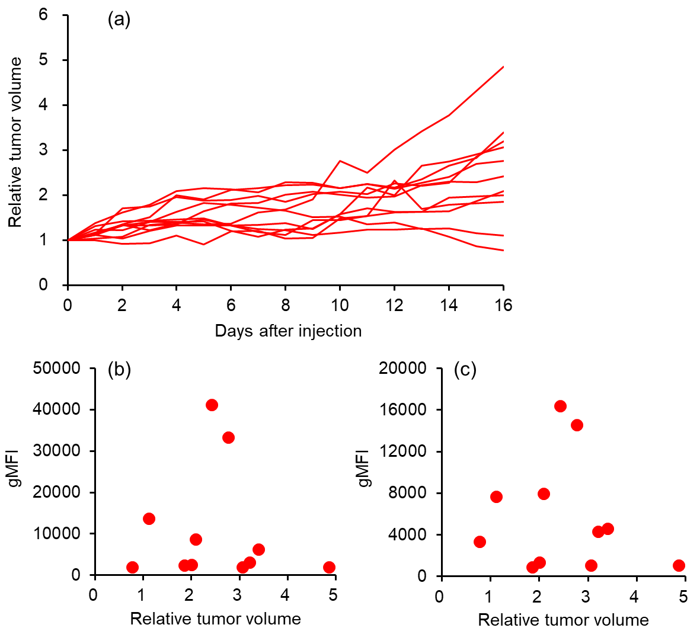
Figure S3. (a) Relative tumor volume of Colon-26 tumor-bearing BALB/c mice treated with [²¹¹At]1 (675 kBq) + αPD-1 used for flow cytometry. (b) Individual relative tumor volume and geometric mean fluorescence intensity (gMFI) of CD4⁺ T cells (CD4⁺CD45⁺ live cells). (c) Individual relative tumor volume and gMFI of CD8⁺ T cells (CD8a⁺CD45⁺ live cells). Flow cytometry was performed on day 16 after treatment, when the differences in therapeutic efficacy were observed.

Reference
1. Echigo H, Mishiro K, Munekane M, Fuchigami T, Washiyama K, Takahashi K, et al. Development of probes for radiotheranostics with albumin binding moiety to increase the therapeutic effects of astatine-211 (²¹¹At). Eur J Nucl Med Mol Imaging. 2024;51:412-21. doi:10.1007/s00259-023-06457-0.

