European Journal of Nuclear Medicine and Molecular Imaging

Aberrant Type 2 Dopamine and mu-Opioid Receptor Availability in Autism Spectrum Disorder

Abnormal opioid-dopamine interaction in autism

MD Tuomo Noppari¹⁻³, PhD Jouni Tuisku¹⁻², MD Lasse Lukkarinen¹⁻², Doc Pekka Tani³, Prof Nina Lindberg⁴, MSc Emma Saure⁵, Prof Hannu Lauerma⁶, Prof Jari Tiihonen⁷⁻⁹, Doc Jussi Hirvonen¹⁰, MD Semi Helin¹¹, Johan Rajander¹², Prof Juha Salmi¹³, Prof Lauri Nummenmaa^{1-2,14}

¹ Turku PET Centre, University of Turku, Finland, ²Turku University Hospital, Turku, Finland, ³Department of Psychiatry, Helsinki University Hospital, Finland, ⁴Department of Forensic Psychiatry, Helsinki University Hospital, Finland, ⁵Department of Psychology and Logopedics, Faculty of Medicine, University of Helsinki, Finland, ⁶Psychiatric Hospital for Prisoners, Health Care Services for Prisoners, Turku, Finland, ⁷Department of Clinical Neuroscience, Karolinska Institute and Center for Psychiatry Research, Stockholm, Sweden, ⁸Department of Forensic Psychiatry, University of Eastern Finland, Niuvanniemi Hospital, Kuopio, Finland, ⁹Neuroscience Center, University of Helsinki, Finland, ¹⁰Department of Radiology, Turku University Hospital, Finland, ¹¹Radiopharmaceutical Chemistry Laboratory, Turku PET Centre, University of Turku, Finland, ¹²Turku PET Centre, Acceletor Laboratory, Åbo Akademi University, Turku, Finland, ¹³Unit of Psychology, Faculty of Education and Psychology, University of Oulu, Finland, ¹⁴Department of Psychology, University of Turku, Finland.
Corresponding author: Tuomo Noppari, Department of Psychiatry, Helsinki University Hospital, PL 590, 00029 HUS, Helsinki, Finland, tuomo.noppari@hus.fi, ORCID 0009-0002-1757-082X

Supplementary figure S1.

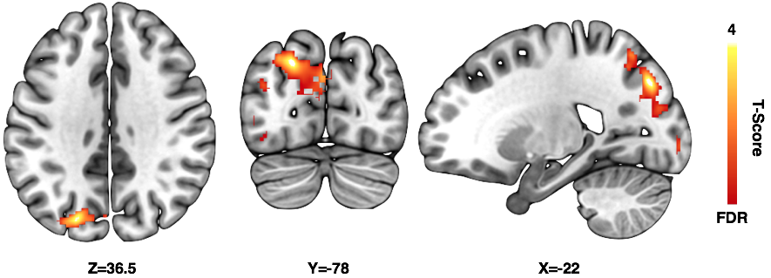
Figure S1. Higher [11C]carfentanil BP_{ND} in the left cuneus/precuneus of ASD participants compared to controls in the whole brain voxel-wise analysis. BA 7,18,19,39, Cluster size 2069 K_{E}, cluster defining threshold p< 0.05 (FDR-corrected), t = 1.68, Cohen´s d = 0.3.

