PICO Framework ( Eligibility Criteria )
Title
Therapeutic Outcomes of [225Ac]Ac-/[177Lu]Lu-PSMA Combination Therapy in Advanced Metastatic Castration-Resistant Prostate Cancer: A Systematic Review and Meta-Analysis
- P (Population): Adult Men with a diagnosis of metastatic castration-resistant prostate cancer
- I (Intervention): [225Ac]Ac-/[177Lu]Lu- PSMA combination therapy
- C (Comparator): [225Ac]Ac-PSMA monotherapy OR /[177Lu]Lu- PSMA monotherapy OR no comparator (single arm studies)
- O (Outcome): primary : PSA responses.

Secondary : treatment-related adverse events (AE), Overall survival(OS), progression-free survival(PFS)

Inclusion Criteria :
Adult men (aged >18 years) with a diagnosis of Metastatic Castration-Resistant Prostate Cancer.
Randomized clinical trials, prospective studies, and retrospective studies that established the efficacy and safety of [225Ac]Ac-/[177Lu]Lu- PSMA combination therapy.

Exclusion Criteria:
Basic science articles, non-human subjects, guidelines, case reports, editorials, replies, commentary, reviews, non- English language articles, non-prostate cancer articles, and metastatic castrate sensitive prostate cancer articles to be excluded.

Funnel Plots for Assessment of Publication Bias in Prostate-Specific Antigen (PSA) Response

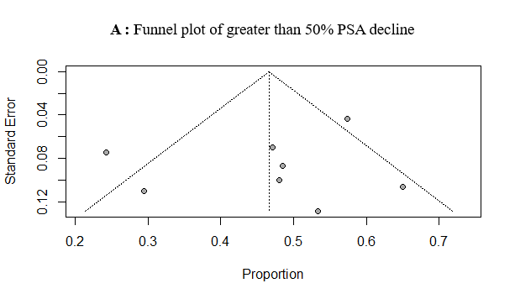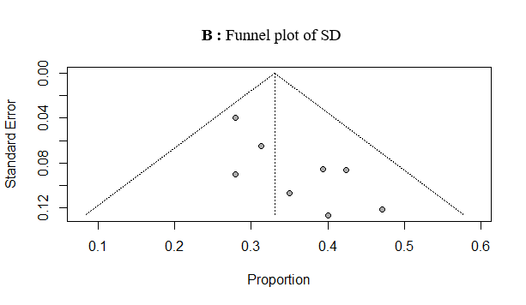
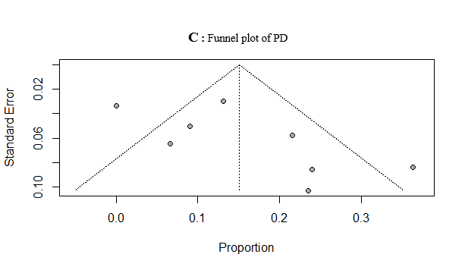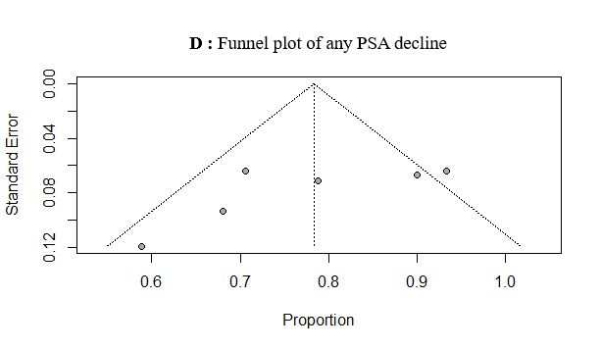

Figure S1. Funnel plots for Assessment of Publication Bias. (A) PSA50 response, (B) stable disease (SD), (C) progressive disease (PD), and (D) any PSA decline.

Assessment of publication bias
Funnel plots and Egger’s linear regression tests were used to explore potential small-study effects. For PSA50, the funnel plot did not indicate clear asymmetry, and Egger’s test was non-significant (t = –0.81, df = 6, p = 0.45). For SD, the funnel plot suggested asymmetry, which was confirmed by Egger’s test (t = 3.12, df = 6, p = 0.02). For PD, visual inspection showed no clear asymmetry, and Egger’s test was not significant (t = 1.94, df = 6, p = 0.10). For any PSA decline, both visual inspection and Egger’s test were negative (t = –0.24, df = 5, p = 0.82). Overall, these findings suggest potential publication bias in SD, but not in the other outcomes.

