Supplementary information
Supplementary Table 1: Acquisition and reconstruction parameters for ¹²⁴I and [¹⁸F]FDG PET/CT imaging. [¹⁸F]FDG PET/CT acquisition and reconstruction were compliant with EARL ¹⁸F standards 1. Scan parameters are the same for both isotopes unless otherwise specified.
Parameter | Values
Scanner | Vereos (Philips Healthcare) | Omni Legend 32 (GE Healthcare)
Sensitivity (cps/kBq) | 5.2 [1] | 47.6 [2]
Acquisition duration  per bed position  [¹⁸F]FDG  [¹²⁴I]NaI | 3 min.  4 min. | 1 min.  4 min.
Energy window | 449.7-613.2 keV | 435-580 keV
Reconstruction  Method  Iterations  Subsets  Smoothing | OSEM  5  15  5.5 mm FWHM Gaussian | VPDH  4  12  7.0 mm FWHM Gaussian
Corrections applied | attenuation, decay, scatter, randoms | attenuation, decay, scatter, randoms
Low-dose CT  Exposure time  Pitch  Collimation  Tube voltage  Tube current | 0.6 s  0.83  0.625 mm  120 kV  variable, 20-80 mA | 0.5 s  0.98  0.625 mm  120 kV  variable, 20-80 mA
OSEM: ordered-subsets expectation-maximization; VPDH: Vue Point HD; FWHW: full width at half maximum
Supplementary Table 2: Acquisition parameters for ¹²⁴I whole body counting.
Parameter | Value
Scanner | Discovery 670 Pro (GE Healthcare)
Collimator | None
Detector configuration | L-mode, start angle 279°
Acquisition duration | 1 min (anterior) + 1 min (posterior)
Energy window | 390-650 keV
Matrix | 256x256
Zoom | 1.0
Distance detector-patient | 2 m

Supplementary Table 3: Tumor characteristics and details regarding prior ¹³¹I therapy per patient
 | 1 | 2 | 3 | 4 | 5 | 6 | 7 | 8 | 9
Tumor histology | oncocytic | oncocytic | oncocytic | oncocytic | oncocytic | oncocytic | papillary | papillary | papillary
Time from initial diagnosis to RAI-R disease | 2 years | 12 years | 4 years | 4 months | 1 year | 2 months | 2.5 years | 6 years | 3 years
Number of prior ¹³¹I therapy cycles | 4 | 2 | 3 | 1 | 2 | 1 | 5 | 5 | 4
Uptake on last ¹³¹I post-therapy scan? | yes | mixed | mixed | no | no | mixed | mixed | yes | mixed

Supplementary Table 4: Change from baseline in dosimetric results of the target lesions per subgroup (estimated for ¹³¹I based on ¹²⁴I data)
Parameter | Median change (IQR)
 | wk0-6 |  | wk0-12
 | Oncocytic | Papillary | Oncocytic | Papillary
No. of patients | 5 | 2 | 6 | 2
No. of target lesions | 12 | 5 | 15 | 5
Absorbed dose | 27%  (-47-146%) | 130%  (89-301%) | 113%  (18-212%) | 71%  (12-212%)
Uptake at 24h p.i. | -50%  (-75-20%) | 21%  (-39%-461%) | -1%  (-74-110%) | 22%  (-86-380%)
Residence time | -52%  (-77- -26%) | 40%  (21-182%) | -29%  (-74-12%) | 10%  (-37-33%)
IQR: interquartile range, p.i.: post-ingestion

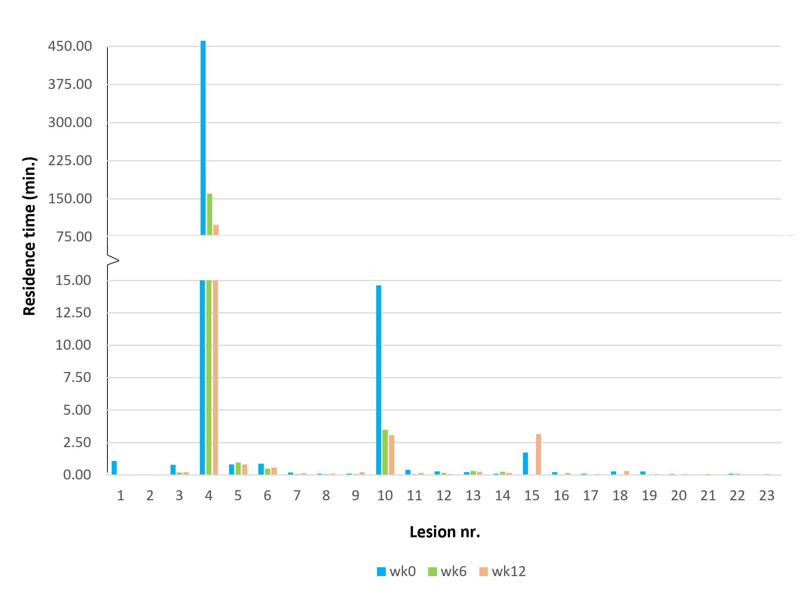
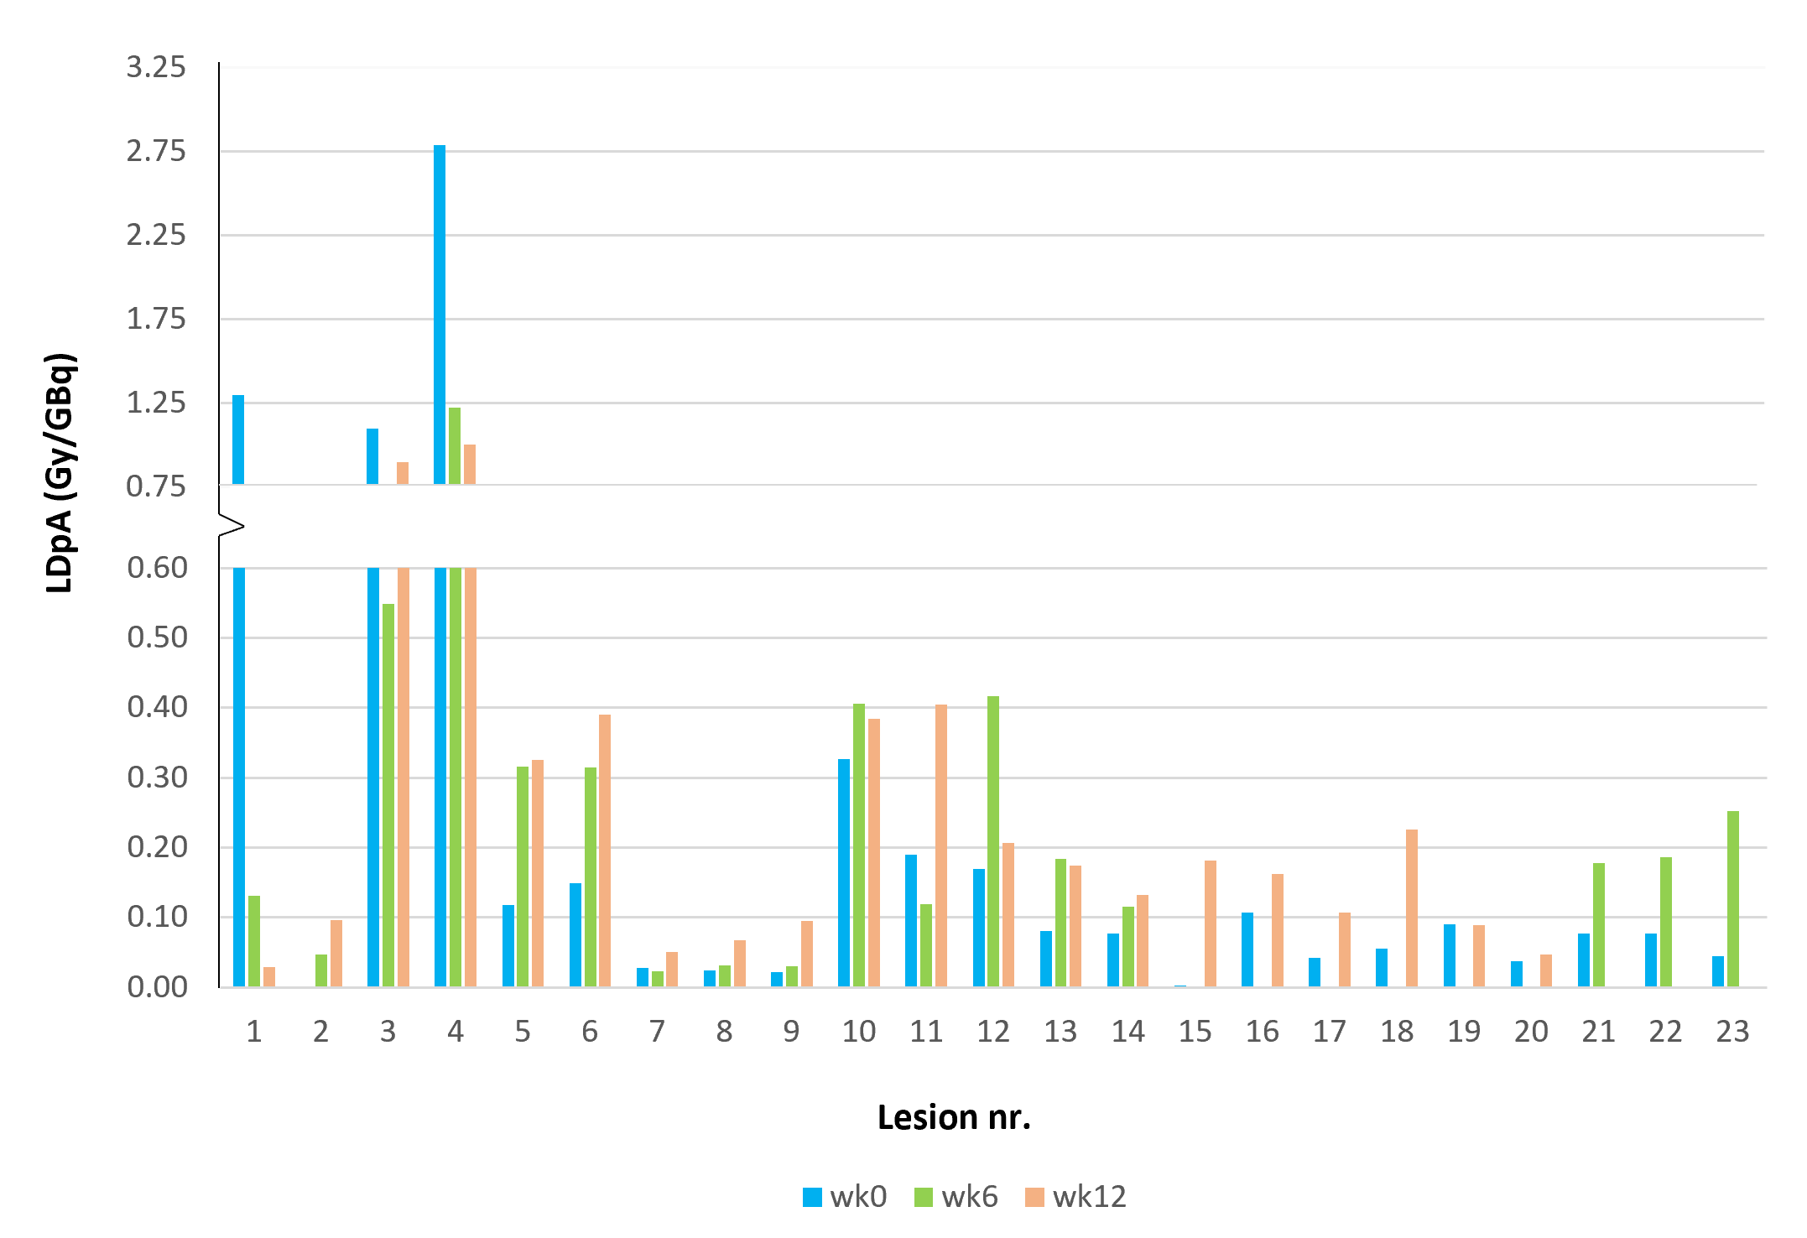
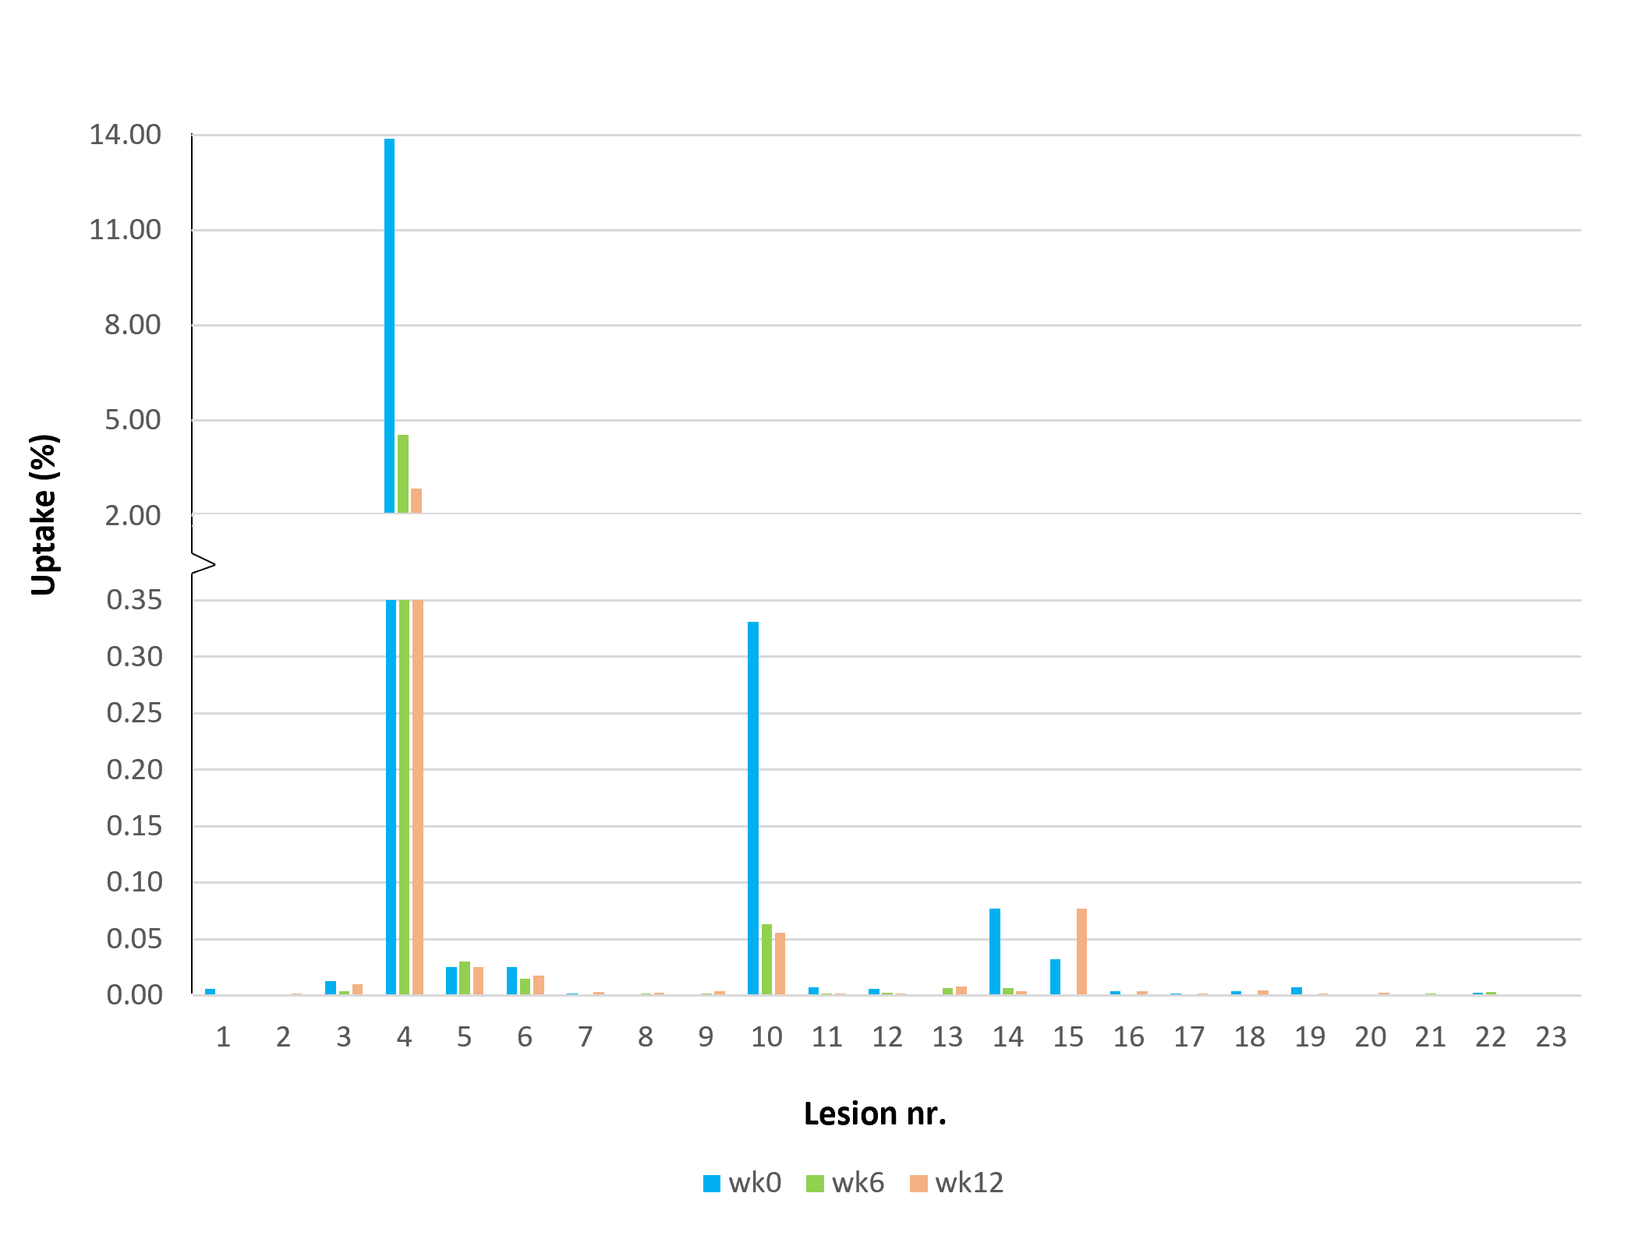
Supplementary Figure 1: Lesion dose per administered activity (LdpA) per target lesion in time (estimated for ¹³¹I based on ¹²⁴I data).
Supplementary Figure 2: Residence time per target lesion in time (estimated for ¹³¹I based on ¹²⁴I data).

Supplementary Figure 3: Uptake (%) at 24 hours post-ingestion per target lesion in time (estimated for ¹³¹I based on ¹²⁴I data).

References
1. Rausch, I., et al., Performance Evaluation of the Vereos PET/CT System According to the NEMA NU2-2012 Standard. J Nucl Med, 2019. 60(4): p. 561-567.
2. Kennedy, J.A., et al., An extended bore length solid-state digital-BGO PET/CT system: design, preliminary experience, and performance characteristics. Eur J Nucl Med Mol Imaging, 2024. 51(4): p. 954-964.

