Supplementary Materials

Supplementary Text 1. Detailed neuropsychological tests
Neuropsychological testing was performed using the Seoul Neuropsychological Screening Battery (SNSB)-II¹. This battery contains assessments of attention (forward and backward Digit Span Test [DST]), language function (Korean-Boston Naming Test [K-BNT]), praxis (Ideomotor, Buccofacial), the four symptoms testing of Gerstmann syndrome (Writing, Finger naming, Right-left orientation and calculation), visuospatial function (Rey Complex Figure Test [RCFT]-copy), verbal memory (Seoul Verbal Learning Test-Elderly’s version[SVLT-E] immediate, 20-min delayed recall and recognition), visual memory ([RCFT] immediate, 20-min delayed recall and recognition), and frontal/executive functions (semantic and phonemic Controlled Oral Word Association Test [COWAT]; Korean-Color Word Stroop Test[K-CWST]; Korean-Trail Making Test-Elderly’s version [K-TMT-E])².

References
- Kang Y, Jahng S, Na DL. In: Seoul Neuropsychological Screening Battery, 2nd Edition (SNSB-II). Seoul: Human Brain Research & Consulting Co., 2012.
- Ahn HJ, Chin J, Park A, et al. Seoul Neuropsychological Screening Battery-dementia version (SNSB-D): a useful tool for assessing and monitoring cognitive impairments in dementia patients. J Korean Med Sci 2010;25:1071-1076.

Supplementary Text 2. MRI acquisition parameters
The imaging protocol included a high-resolution three-dimensional T1-weighted MPRAGE sequence with the following settings: repetition time (TR) of 1810 ms, echo time (TE) of 2.91 ms, a flip angle of 9°, bandwidth of 340 Hz per pixel, matrix dimensions of 250 × 250, and a field of view (FOV) of 250 mm. The number of excitations (NEX) was 1, with a total scan duration of approximately 3 minutes and 37 seconds. The resulting voxel resolution was 0.5 × 0.5 × 1.0 mm³.
Fluid attenuated inversion recovery (FLAIR) imaging was performed using TR = 9000 ms, TE = 122 ms, flip angle = 150°, bandwidth = 287 Hz/pixel, matrix size = 256 × 224, FOV = 256 mm, and NEX = 1. Each scan lasted approximately 2 minutes and 44 seconds, with a voxel size of 0.5 × 0.5 × 2.0 mm³.
3D susceptibility weighted imaging (SWI) was conducted with TR = 40 ms and dual echo times of 13.70 ms and 30.50 ms. The flip angle was 15°, bandwidth was 120 Hz/pixel, matrix = 230 × 202, FOV = 230 mm, and NEX = 1. The scan duration was about 1 minute and 49 seconds, with voxel dimensions of 0.8 × 0.8 × 2.0 mm³.
3D T2-weighted images were acquired using TR = 3200 ms and TE = 355 ms, with a bandwidth of 651 Hz/pixel. The matrix size was 256 × 232, FOV = 256 mm, and NEX = 1. This sequence lasted approximately 2 minutes and 41 seconds and had a voxel size of 0.5 × 0.5 × 1.0 mm³.

Supplementary Text 3. Assessment of WMHV, microbleeds and lacune
Assessment of WMHV
We used FLAIR images to quantify WMH volume through fully automated segmentation of WMH, as described previously.²² The method is consisted of five stages, (A) initial preprocessing; (B) WMH candidate region mask; (C) WMH segmentation; (D) T1 intensity substitution; and (E) local quantification of segmented WMH.²²

Assessment of Microbleeds and Lacunes
All structural imaging markers of CSVD were rated in accordance with consensus guidelines. Lacunes were identified and counted in accordance with 2013 STRIVE guideline (STandards for ReportIng Vascular changes on nEuroimaging).²³ Lacunes were defined as lesions of ≥3 mm and ≤15 mm in diameter with low signal on T1-MPRAGE images, high signal on T2-weighted images, and low signal with a perilesional halo on 72 axial sections of FLAIR images. Microbleeds were defined as small lesions of ≤10 mm in diameter, using criteria proposed by Greenberg et al.,³ lobar CMBs were defined as homogenous and round lesions with low signal (≤ 10 mm in diameter) on SWI images and high signal on phase images, with location in exclusively lobar (cortex, gray-white matter junction, subcortical white matter) areas.

References
- Jeon S, Yoon U, Park JS, et al. Fully automated pipeline for quantification and localization of white matter hyperintensity in brain magnetic resonance image. International Journal of Imaging Systems and Technology 2011;21:193-200.
- Wardlaw JM, Smith EE, Biessels GJ, et al. Neuroimaging standards for research into small vessel disease and its contribution to ageing and neurodegeneration. The Lancet Neurology 2013;12:822-838.
- Greenberg SM, Nandigam RK, Delgado P, et al. Microbleeds versus macrobleeds: evidence for distinct entities. Stroke 2009;40:2382-2386.

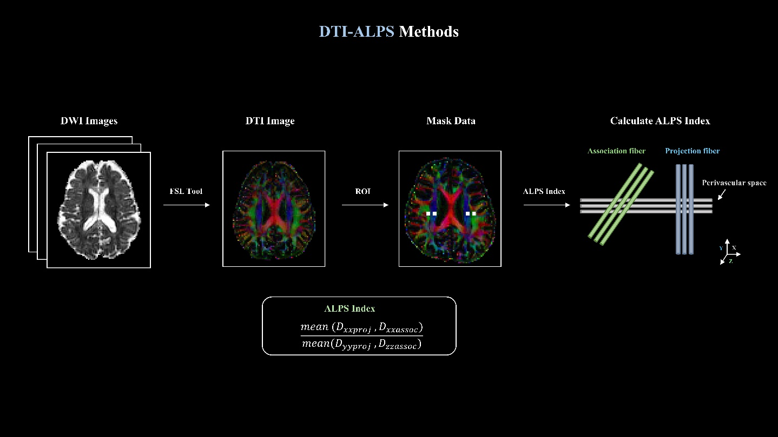

Supplementary Figure 1. This figure illustrates the process of calculating the DTI-ALPS index.
Footnotes. Diffusion-weighted imaging (DWI) images are converted to diffusion tensor imaging (DTI) images using the FSL Tool, followed by generating mask data for the region of interest (ROI). The ALPS index is subsequently calculated by analyzing association and projection fibers along the perivascular space.

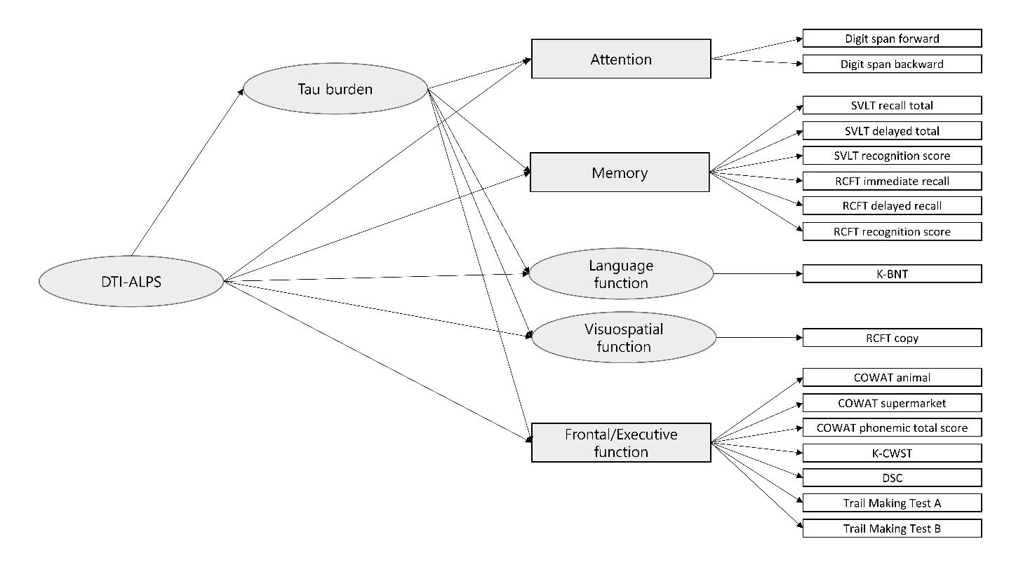
Supplementary Figure 2. Structural model of Partial Least Squares Structural Equation Modelling for mediation analysis estimating indirect effects of DTI-ALPS index on specific domains of cognitive function mediated tau burden
Abbreviation. DTI-ALPS, Diffusion tensor image analysis along the perivascular space; SVLT, Seoul verbal learning test; RCFT, Rey-Osterrieth complex figure test; K-BNT, Korean version of the Boston naming test; COWAT, Controlled oral word association test; K-CWST, Korean-color word stroop test; DSC, Digit symbol coding.
Footnotes. Squares indicate observed variables while ellipses represent latent variables/constructs. All analyses were adjusted for APOE e4 carrier and cortical FLUTE SUVR.

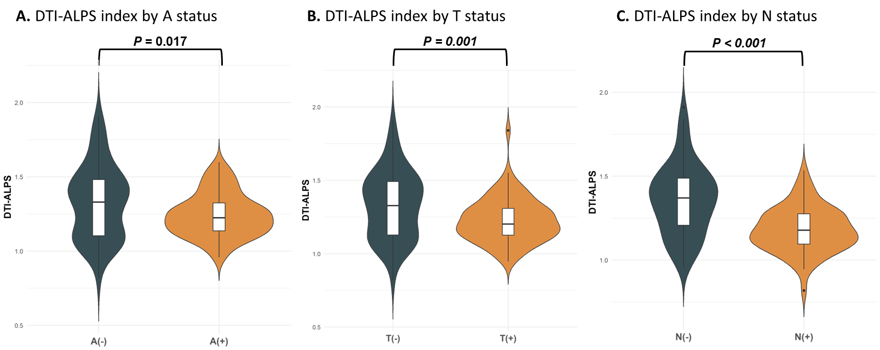

Supplementary Figure 3. DTI-ALPS indexes by biological stages among individuals excluding other dementia
Footnotes. Comparing ALPS indexes in different biological groups, covariates include age, sex, educational years, APOE e4 carrier, and baseline diagnoses (A-C). Amyloid positivity was defined based on a standardized visual rating protocol on ¹⁸F-flutemetamol (FLUTE) PET (A). Tau positivity was defined as a temporal meta-ROI SUVR ≥ 1.35 on ¹⁸F-MK6240 PET (B). Neurodegeneration positivity was defined as a Hippocampal volume/Intracranial Volume *1000 < 2.150 (C).

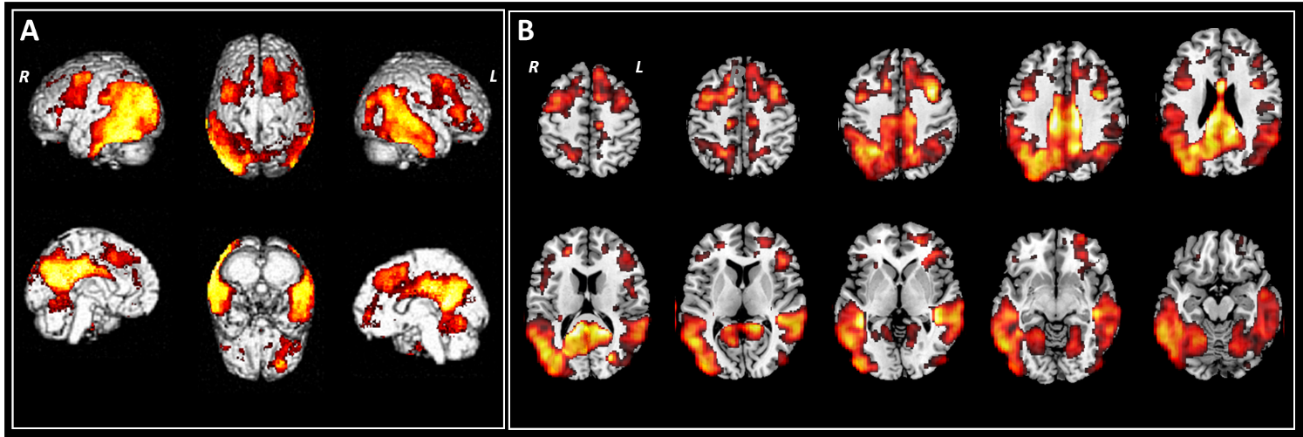

Supplementary Figure 4. Voxel-wise associations between DTI-ALPS index and ¹⁸F-MK6240 PET retention in the subjects excluding other dementia
Footnotes. 3D surface maps (a) and 2D axial slices (b) illustrate brain regions where a lower DTI-ALPS index is significantly associated with increased ¹⁸F-MK6240 SUVR, indicating greater tau burden. The statistical maps are thresholded at uncorrected p < 0.001 (t = 3.15, cluster size = 0) and adjusted for age, sex, years of education, and APOE e4 carrier. Participants with other types of dementia were excluded from this analysis.

Supplementary table 1. Cognitive function test results of the study subjects
Characteristics | CN (n=39) |  | MCI (n=54) |  | ADD (n=38) |  | Other dementia (n=13) |  | p-value
Attention, mean (SD)
Digit span forward | 0.02 | (0.82)^{c,d} | -0.13 | (0.93) | -0.61 | (0.89)ª | -0.84 | (1.42)ª | 0.003
Digit span backward | 0.12 | (0.85)^{c} | -0.16 | (0.95)^{c} | -0.86 | (1.07)^{a,b} | -0.61 | (1.36) | <0.001
Language function, mean (SD)
K-BNT | 0.19 | (0.94)^{c,d} | -0.46 | (1.10)^{c,d} | -1.99 | (1.60)^{a,b} | -2.06 | (2.11)^{a,b} | <0.001
Visuospatial, mean (SD)
RCFT copy | 0.39 | (0.51)^{c,d} | -0.52 | (0.98)^{c,d} | -3.16 | (4.29)^{a,b} | -3.27 | (4.92)^{a,b} | <0.001
Memory, mean (SD)
SVLT recall total | 0.22 | (0.93)^{b,c,d} | -0.95 | (0.95)^{a,c,d} | -2.08 | (1.08)^{a,b} | -2.05 | (0.79)^{a,b} | <0.001
SVLT delayed recall | 0.34 | (0.96)^{b,c,d} | -1.66 | (1.05)^{a,c,d} | -2.48 | (0.74)^{a,b} | -2.48 | (0.57)^{a,b} | <0.001
SVLT recognition score | 0.40 | (0.87)^{b,c,d} | -1.10 | (1.57)^{a,c,d} | -2.74 | (1.75)^{a,b} | -2.88 | (1.62)^{a,b} | <0.001
RCFT immediate recall | 0.29 | (0.77)^{b,c,d} | -1.13 | (0.83)^{a,c,d} | -1.91 | (0.65)^{a,b} | -1.78 | (0.91)^{a,b} | <0.001
RCFT delayed recall | 0.24 | (0.69)^{b,c,d} | -1.31 | (0.83)^{a,c,d} | -2.14 | (0.60)^{a,b} | -2.10 | (0.81)^{a,b} | <0.001
RCFT recognition score | 0.16 | (0.75)^{b,c,d} | -0.92 | (1.13)^{a,c,d} | -1.88 | (1.32)^{a,b} | -2.28 | (1.04)^{a,b} | <0.001
Frontal/executive function, mean (SD)
COWAT animal | -0.09 | (1.04)^{b,c,d} | -0.89 | (0.83)^{a,c,d} | -1.75 | (0.80)^{a,b} | -1.79 | (0.95)^{a,b} | <0.001
COWAT supermarket | 0.07 | (0.90)^{b,c,d} | -0.74 | (0.84)^{a,c,d} | -1.48 | (0.92)^{a,b} | -1.85 | (0.55)^{a,b} | <0.001
COWAT phonemic total score | 0.20 | (1.12)^{b,c,d} | -0.56 | (0.84)^{a,d} | -0.92 | (1.13)ª | -1.51 | (0.60)^{a,b} | <0.001
K-CWST | 0.38 | (0.81)^{b,c,d} | -0.62 | (0.91)^{a,c,d} | -1.86 | (1.21)^{a,b} | -1.65 | (1.27)^{a,b} | <0.001
DSC | 0.83 | (1.04)^{b,c,d} | -0.25 | (1.01)^{a,c,d} | -1.69 | (1.40)^{a,b} | -1.32 | (1.22)^{a,b} | <0.001
Trail Making Test A | 0.57 | (0.54)^{d} | -0.25 | (1.93)^{d} | -2.34 | (5.54) | -6.40 | (19.49)^{a,b} | 0.005
Trail Making Test B | 0.30 | (0.91)^{c,d} | -0.70 | (1.56)^{c,d} | -5.13 | (5.14)^{a,b} | -6.82 | (9.76)^{a,b} | <0.001
Abbreviation. CN, Cognitive normal; MCI, Mild cognitive impairment; ADD, Alzheimer’s disease dementia; SD, Standard deviation; SNSB, Seoul neuropsychological screening battery; K-BNT, Korean version of the Boston naming test; RCFT, Rey complex figure test; SVLT, Seoul verbal learning test; COWAT, Controlled oral word association test; DSC, Digit symbol coding; K-CWST, Korean-color word stroop test.
Footnotes. Data were presented as means (standard deviation [SD]). All SNSB variables were converted to z-scores standardized for age, sex, and years of education. P-values were from one-way analysis of variance for continuous variables.
Different superscript letters in a column indicate statistically significant difference between groups (using ANOVA and Tukey test, p <0.05).
ªVersus cognitive normal individuals
^{b}Versus Alzheimer’s disease
^{c}Versus Mild cognitive impairment
^{d}Versus other dementia

Supplementary table 2. Effects of tau burden on specific domains of cognitive function via tau burden
Mediator | Paths |  | Path coefficient | SE | t value | P-value | Decision
Global MK6240 | Direct effect
SUVR |  | DTI-ALPS → Global MK6240 | -0.19 | 0.06 | 3.33 | 0.001
 |  | DTI-ALPS → Attention | 0.10 | 0.10 | 1.02 | 0.307
 |  | DTI-ALPS → Frontal/executive functions | 0.27 | 0.09 | 2.93 | 0.003
 |  | DTI-ALPS → Language function | 0.22 | 0.08 | 2.63 | 0.009
 |  | DTI-ALPS → Memory | 0.29 | 0.07 | 4.08 | <0.001
 |  | DTI-ALPS → Visuospatial | 0.18 | 0.08 | 2.30 | 0.021
 |  | Global MK6240 → Attention | -0.36 | 0.09 | 4.13 | <0.001
 |  | Global MK6240 → Frontal/executive functions | -0.50 | 0.09 | 5.40 | <0.001
 |  | Global MK6240 → Language function | -0.40 | 0.09 | 4.35 | <0.001
 |  | Global MK6240 → Memory | -0.28 | 0.06 | 4.45 | <0.001
 |  | Global MK6240 → Visuospatial | -0.68 | 0.11 | 6.16 | <0.001
 | Indirect effect
 |  | DTI-ALPS → Global MK6240 → Attention | 0.07 | 0.03 | 2.33 | 0.020 | Rejected
 |  | DTI-ALPS → Global MK6240 → Frontal/executive functions | 0.09 | 0.03 | 2.77 | 0.006 | Accepted
 |  | DTI-ALPS → Global MK6240 → Language function | 0.08 | 0.03 | 2.47 | 0.013 | Accepted
 |  | DTI-ALPS → Global MK6240 → Memory | 0.05 | 0.02 | 2.84 | 0.005 | Accepted
 |  | DTI-ALPS → Global MK6240 → Visuospatial | 0.13 | 0.05 | 2.85 | 0.004 | Accepted
Braak 1/2 | Direct effect
 |  | DTI-ALPS → Braak 1/2 | -0.17 | 0.08 | 2.17 | 0.030
 |  | DTI-ALPS → Attention | 0.08 | 0.10 | 0.80 | 0.425
 |  | DTI-ALPS → Frontal/executive functions | 0.26 | 0.09 | 2.96 | 0.003
 |  | DTI-ALPS → Language function | 0.21 | 0.08 | 2.52 | 0.012
 |  | DTI-ALPS → Memory | 0.30 | 0.07 | 4.20 | <0.001
 |  | DTI-ALPS → Visuospatial | 0.13 | 0.08 | 1.77 | 0.076
 |  | Braak 1/2 → Attention | -0.06 | 0.13 | 0.52 | 0.606
 |  | Braak 1/2 → Frontal/executive functions | -0.12 | 0.12 | 1.00 | 0.315
 |  | Braak 1/2 → Language function | -0.22 | 0.12 | 1.91 | 0.056
 |  | Braak 1/2 → Memory | -0.41 | 0.09 | 4.54 | <0.001
 |  | Braak 1/2 → Visuospatial | -0.02 | 0.09 | 0.27 | 0.789
 | Indirect effect
 |  | DTI-ALPS → Braak 1/2 → Attention | 0.01 | 0.03 | 0.44 | 0.661 | Rejected
 |  | DTI-ALPS → Braak 1/2 → Frontal/executive functions | 0.02 | 0.03 | 0.81 | 0.418 | Rejected
 |  | DTI-ALPS → Braak 1/2 → Language function | 0.04 | 0.03 | 1.29 | 0.196 | Rejected
 |  | DTI-ALPS → Braak 1/2 → Memory | 0.07 | 0.04 | 1.85 | 0.065 | Rejected
 |  | DTI-ALPS → Braak 1/2 → Visuospatial | 0.01 | 0.02 | 0.24 | 0.812 | Rejected
Braak 3/4 | Direct effect
 |  | DTI-ALPS → Braak 3/4 | -0.20 | 0.07 | 2.96 | 0.003
 |  | DTI-ALPS → Attention | 0.10 | 0.10 | 1.04 | 0.297
 |  | DTI-ALPS → Frontal/executive functions | 0.28 | 0.09 | 3.04 | 0.002
 |  | DTI-ALPS → Language function | 0.24 | 0.09 | 2.80 | 0.005
 |  | DTI-ALPS → Memory | 0.30 | 0.07 | 4.24 | <0.001
 |  | DTI-ALPS → Visuospatial | 0.17 | 0.08 | 2.17 | 0.030
 |  | Braak 3/4 → Attention | -0.32 | 0.11 | 2.89 | 0.004
 |  | Braak 3/4 → Frontal/executive functions | -0.45 | 0.10 | 4.52 | <0.001
 |  | Braak 3/4 → Language function | -0.53 | 0.10 | 5.17 | <0.001
 |  | Braak 3/4 → Memory | -0.41 | 0.08 | 5.31 | <0.001
 |  | Braak 3/4 → Visuospatial | -0.45 | 0.12 | 3.74 | <0.001
 | Indirect effect
 |  | DTI-ALPS → Braak 3/4 → Attention | 0.06 | 0.03 | 1.86 | 0.063 | Rejected
 |  | DTI-ALPS → Braak 3/4 → Frontal/executive functions | 0.09 | 0.04 | 2.31 | 0.021 | Accepted
 |  | DTI-ALPS → Braak 3/4 → Language function | 0.11 | 0.05 | 2.36 | 0.019 | Accepted
 |  | DTI-ALPS → Braak 3/4 → Memory | 0.08 | 0.03 | 2.56 | 0.011 | Accepted
 |  | DTI-ALPS → Braak 3/4 → Visuospatial | 0.09 | 0.04 | 2.18 | 0.029 | Accepted
Braak 5/6 | Direct effect
 |  | DTI-ALPS → Braak 5/6 | -0.17 | 0.06 | 2.78 | 0.006
 |  | DTI-ALPS → Attention | 0.10 | 0.10 | 1.02 | 0.308
 |  | DTI-ALPS → Frontal/executive functions | 0.27 | 0.09 | 2.93 | 0.003
 |  | DTI-ALPS → Language function | 0.22 | 0.08 | 2.64 | 0.008
 |  | DTI-ALPS → Memory | 0.29 | 0.07 | 4.11 | <0.001
 |  | DTI-ALPS → Visuospatial | 0.19 | 0.08 | 2.29 | 0.022
 |  | Braak 5/6 → Attention | -0.34 | 0.10 | 3.34 | 0.001
 |  | Braak 5/6 → Frontal/executive functions | -0.47 | 0.10 | 4.51 | <0.001
 |  | Braak 5/6 → Language function | -0.39 | 0.10 | 3.84 | <0.001
 |  | Braak 5/6 → Memory | -0.29 | 0.07 | 4.08 | <0.001
 |  | Braak 5/6 → Visuospatial | -0.65 | 0.12 | 5.40 | <0.001
 | Indirect effect
 |  | DTI-ALPS → Braak 5/6 → Attention | 0.06 | 0.03 | 1.89 | 0.058 | Rejected
 |  | DTI-ALPS → Braak 5/6 → Frontal/executive functions | 0.08 | 0.04 | 2.19 | 0.029 | Accepted
 |  | DTI-ALPS → Braak 5/6 → Language function | 0.07 | 0.03 | 2.05 | 0.040 | Accepted
 |  | DTI-ALPS → Braak 5/6 → Memory | 0.05 | 0.02 | 2.25 | 0.024 | Accepted
 |  | DTI-ALPS → Braak 5/6 → Visuospatial | 0.11 | 0.05 | 2.33 | 0.020 | Accepted
Temporal | Direct effect
meta-ROI |  | DTI-ALPS → Temporal meta-ROI | -0.21 | 0.06 | 3.33 | 0.001
 |  | DTI-ALPS → Attention | 0.11 | 0.10 | 1.06 | 0.290
 |  | DTI-ALPS → Frontal/executive functions | 0.28 | 0.09 | 3.02 | 0.003
 |  | DTI-ALPS → Language function | 0.24 | 0.09 | 2.77 | 0.006
 |  | DTI-ALPS → Memory | 0.30 | 0.07 | 4.17 | <0.001
 |  | DTI-ALPS → Visuospatial | 0.17 | 0.08 | 2.20 | 0.028
 |  | Temporal meta-ROI → Attention | -0.36 | 0.09 | 3.88 | <0.001
 |  | Temporal meta-ROI → Frontal/executive functions | -0.48 | 0.08 | 5.80 | <0.001
 |  | Temporal meta-ROI → Language function | -0.54 | 0.10 | 5.57 | <0.001
 |  | Temporal meta-ROI → Memory | -0.35 | 0.07 | 5.24 | <0.001
 |  | Temporal meta-ROI → Visuospatial | -0.48 | 0.11 | 4.33 | <0.001
 | Indirect effect
 |  | DTI-ALPS → Temporal meta-ROI → Attention | 0.08 | 0.03 | 2.30 | 0.021 | Rejected
 |  | DTI-ALPS → Temporal meta-ROI → Frontal/executive functions | 0.10 | 0.04 | 2.79 | 0.005 | Accepted
 |  | DTI-ALPS → Temporal meta-ROI → Language function | 0.11 | 0.04 | 2.66 | 0.008 | Accepted
 |  | DTI-ALPS → Temporal meta-ROI → Memory | 0.07 | 0.03 | 2.91 | 0.004 | Accepted
 |  | DTI-ALPS → Temporal meta-ROI → Visuospatial | 0.10 | 0.04 | 2.50 | 0.013 | Accepted
Abbreviations. SE, standard error; DTI-ALPS, Diffusion tensor image analysis along the perivascular space; SUVR, Standardized uptake value ratio.
Footnotes. Coefficients and standard errors were estimated from partial least squares structural equation modeling with bootstrap re-sampling (5,000 iterations). Attention was evaluated using the digit span forward and digit span backward. Language function was assessed using the Korean-Boston Naming Test, while visuospatial function was evaluated using the Rey Complex Figure Test (RCFT) copy. Memory was assessed using the Seoul Verbal Learning Test (SVLT) recall, SVLT delayed recall, SVLT recognition score, RCFT immediate recall, RCFT delayed recall, and RCFT recognition score. Frontal/executive functions were assessed using the Controlled Oral Word Association Test (COWAT) phonemic total score, supermarket, animal, Korean-Color Word Stroop Test, Digit Symbol Coding, Trail making test A and B.
All models were adjusted for APOE e4 carrier (positive, negative) and cortical FLUTE SUVR. Braak1/2, Braak3/4, were Braak5/6 log-transformed.

Supplementary table 3. PLS-SEM model evaluation indicators (validity and reliability)
Model (A): DTI-ALPS → Global MK6240 → specific domains of cognitive function
Latent variable | Indicators | Convergent validity |  |  | Internal consistency reliability
Latent variable | Indicators | Outer loadings | Indicator reliability | AVE | Cronbach's Alpha | Composite Reliability (rho_A)
Attention | Digit span forward | 0.86 | 0.74 | 0.81 | 0.77 | 0.84
Attention | Digit span backward | 0.93 | 0.86 | 0.81 | 0.77 | 0.84
Memory | SVLT recall total | 0.85 | 0.72 | 0.76 | 0.94 | 0.94
Memory | SVLT delayed recall | 0.93 | 0.86 | 0.76 | 0.94 | 0.94
Memory | SVLT recognition score | 0.84 | 0.71 | 0.76 | 0.94 | 0.94
Memory | RCFT immediate recall | 0.88 | 0.77 | 0.76 | 0.94 | 0.94
Memory | RCFT delayed recall | 0.92 | 0.85 | 0.76 | 0.94 | 0.94
Memory | RCFT recognition score | 0.80 | 0.64 | 0.76 | 0.94 | 0.94
Frontal/Executive functions | COWAT animal | 0.76 | 0.58 | 0.61 | 0.89 | 0.92
Frontal/Executive functions | COWAT supermarket | 0.80 | 0.64 | 0.61 | 0.89 | 0.92
Frontal/Executive functions | COWAT phonemic total score | 0.73 | 0.53 | 0.61 | 0.89 | 0.92
Frontal/Executive functions | K-CWST | 0.86 | 0.74 | 0.61 | 0.89 | 0.92
Frontal/Executive functions | DSC | 0.88 | 0.77 | 0.61 | 0.89 | 0.92
Frontal/Executive functions | Trail Making Test A | 0.57 | 0.32 | 0.61 | 0.89 | 0.92
Frontal/Executive functions | Trail Making Test B | 0.83 | 0.69 | 0.61 | 0.89 | 0.92
Model (B): DTI-ALPS → Braak 1/2 → specific domains of cognitive function
Latent variable | Indicators | Convergent validity |  |  | Internal consistency reliability
Latent variable | Indicators | Outer loadings | Indicator reliability | AVE | Cronbach's Alpha | Composite Reliability (rho_A)
Attention | Digit span forward | 0.88 | 0.77 | 0.81 | 0.77 | 0.79
Attention | Digit span backward | 0.92 | 0.85 | 0.81 | 0.77 | 0.79
Memory | SVLT recall total | 0.84 | 0.71 | 0.76 | 0.94 | 0.94
Memory | SVLT delayed recall | 0.93 | 0.87 | 0.76 | 0.94 | 0.94
Memory | SVLT recognition score | 0.84 | 0.70 | 0.76 | 0.94 | 0.94
Memory | RCFT immediate recall | 0.88 | 0.78 | 0.76 | 0.94 | 0.94
Memory | RCFT delayed recall | 0.93 | 0.86 | 0.76 | 0.94 | 0.94
Memory | RCFT recognition score | 0.80 | 0.64 | 0.76 | 0.94 | 0.94
Frontal/Executive functions | COWAT animal | 0.77 | 0.59 | 0.61 | 0.89 | 0.91
Frontal/Executive functions | COWAT supermarket | 0.80 | 0.65 | 0.61 | 0.89 | 0.91
Frontal/Executive functions | COWAT phonemic total score | 0.74 | 0.54 | 0.61 | 0.89 | 0.91
Frontal/Executive functions | K-CWST | 0.86 | 0.73 | 0.61 | 0.89 | 0.91
Frontal/Executive functions | DSC | 0.88 | 0.78 | 0.61 | 0.89 | 0.91
Frontal/Executive functions | Trail Making Test A | 0.57 | 0.32 | 0.61 | 0.89 | 0.91
Frontal/Executive functions | Trail Making Test B | 0.82 | 0.68 | 0.61 | 0.89 | 0.91
Model (C): DTI-ALPS → Braak 3/4 → specific domains of cognitive function
Latent variable | Indicators | Convergent validity |  |  | Internal consistency reliability
Latent variable | Indicators | Outer loadings | Indicator reliability | AVE | Cronbach's Alpha | Composite Reliability (rho_A)
Attention | Digit span forward | 0.84 | 0.71 | 0.81 | 0.77 | 0.93
Attention | Digit span backward | 0.95 | 0.90 | 0.81 | 0.77 | 0.93
Memory | SVLT recall total | 0.85 | 0.71 | 0.76 | 0.94 | 0.94
Memory | SVLT delayed recall | 0.93 | 0.87 | 0.76 | 0.94 | 0.94
Memory | SVLT recognition score | 0.84 | 0.71 | 0.76 | 0.94 | 0.94
Memory | RCFT immediate recall | 0.88 | 0.77 | 0.76 | 0.94 | 0.94
Memory | RCFT delayed recall | 0.92 | 0.85 | 0.76 | 0.94 | 0.94
Memory | RCFT recognition score | 0.80 | 0.64 | 0.76 | 0.94 | 0.94
Frontal/Executive functions | COWAT animal | 0.80 | 0.64 | 0.61 | 0.89 | 0.93
Frontal/Executive functions | COWAT supermarket | 0.81 | 0.66 | 0.61 | 0.89 | 0.93
Frontal/Executive functions | COWAT phonemic total score | 0.73 | 0.54 | 0.61 | 0.89 | 0.93
Frontal/Executive functions | K-CWST | 0.88 | 0.77 | 0.61 | 0.89 | 0.93
Frontal/Executive functions | DSC | 0.89 | 0.78 | 0.61 | 0.89 | 0.93
Frontal/Executive functions | Trail Making Test A | 0.50 | 0.25 | 0.61 | 0.89 | 0.93
Frontal/Executive functions | Trail Making Test B | 0.79 | 0.62 | 0.61 | 0.89 | 0.93
Model (D): DTI-ALPS → Braak 5/6 → specific domains of cognitive function
Latent variable | Indicators | Convergent validity |  |  | Internal consistency reliability
Latent variable | Indicators | Outer loadings | Indicator reliability | AVE | Cronbach’s Alpha | Composite Reliability (rho_A)
Attention | Digit span forward | 0.87 | 0.75 | 0.81 | 0.77 | 0.83
Attention | Digit span backward | 0.93 | 0.87 | 0.81 | 0.77 | 0.83
Memory | SVLT recall total | 0.85 | 0.72 | 0.76 | 0.94 | 0.94
Memory | SVLT delayed recall | 0.93 | 0.87 | 0.76 | 0.94 | 0.94
Memory | SVLT recognition score | 0.84 | 0.71 | 0.76 | 0.94 | 0.94
Memory | RCFT immediate recall | 0.88 | 0.78 | 0.76 | 0.94 | 0.94
Memory | RCFT delayed recall | 0.92 | 0.85 | 0.76 | 0.94 | 0.94
Memory | RCFT recognition score | 0.80 | 0.63 | 0.76 | 0.94 | 0.94
Frontal/Executive functions | COWAT animal | 0.76 | 0.58 | 0.61 | 0.89 | 0.92
Frontal/Executive functions | COWAT supermarket | 0.79 | 0.63 | 0.61 | 0.89 | 0.92
Frontal/Executive functions | COWAT phonemic total score | 0.73 | 0.53 | 0.61 | 0.89 | 0.92
Frontal/Executive functions | K-CWST | 0.86 | 0.73 | 0.61 | 0.89 | 0.92
Frontal/Executive functions | DSC | 0.88 | 0.78 | 0.61 | 0.89 | 0.92
Frontal/Executive functions | Trail Making Test A | 0.58 | 0.33 | 0.61 | 0.89 | 0.92
Frontal/Executive functions | Trail Making Test B | 0.83 | 0.69 | 0.61 | 0.89 | 0.92
Model (E): DTI-ALPS → Temporal meta-ROI → specific domains of cognitive function
Latent variable | Indicators | Convergent validity |  |  | Internal consistency reliability
Latent variable | Indicators | Outer loadings | Indicator reliability | AVE | Cronbach's Alpha | Composite Reliability (rho_A)
Attention | Digit span forward | 0.87 | 0.76 | 0.81 | 0.77 | 0.81
Attention | Digit span backward | 0.93 | 0.86 | 0.81 | 0.77 | 0.81
Memory | SVLT recall total | 0.85 | 0.72 | 0.76 | 0.94 | 0.91
Memory | SVLT delayed recall | 0.93 | 0.86 | 0.76 | 0.94 | 0.91
Memory | SVLT recognition score | 0.84 | 0.71 | 0.76 | 0.94 | 0.91
Memory | RCFT immediate recall | 0.88 | 0.77 | 0.76 | 0.94 | 0.91
Memory | RCFT delayed recall | 0.92 | 0.85 | 0.76 | 0.94 | 0.91
Memory | RCFT recognition score | 0.80 | 0.64 | 0.76 | 0.94 | 0.91
Frontal/Executive functions | COWAT animal | 0.77 | 0.59 | 0.61 | 0.89 | 0.94
Frontal/Executive functions | COWAT supermarket | 0.80 | 0.64 | 0.61 | 0.89 | 0.94
Frontal/Executive functions | COWAT phonemic total score | 0.73 | 0.53 | 0.61 | 0.89 | 0.94
Frontal/Executive functions | K-CWST | 0.86 | 0.74 | 0.61 | 0.89 | 0.94
Frontal/Executive functions | DSC | 0.88 | 0.77 | 0.61 | 0.89 | 0.94
Frontal/Executive functions | Trail Making Test A | 0.56 | 0.31 | 0.61 | 0.89 | 0.94
Frontal/Executive functions | Trail Making Test B | 0.82 | 0.67 | 0.61 | 0.89 | 0.94
Abbreviation. AVE, Average Variance Extracted; RCFT, Rey complex figure test; SVLT, Seoul verbal learning test; COWAT, Controlled oral word association test; DSC, Digit symbol coding; K-CWST, Korean-color word stroop test.
Footnotes. Of five domains of SNSB tests, attention, frontal/executive function, and memory were reflective measurements models. Cronbach’s alpha ≥ 0.70 and Composite Reliability (rho_A) ≥ 0.70 indicate good combined reliability of the reflective measurement model. Outer loadings ≥ 0.70 indicated good validity of the outer model. AVE ≥ 0.50 indicated good convergent validity of the reflective measurement model.

