Supplemental material

⁶⁸Ga-FAPI-PET/CT in extra-cervical CUP: Head-to-Head Comparison of ⁶⁸Ga-FAPI-46 with ¹⁸F-FDG in 13 patients
Anna-Maria Spektor¹, Sergio Armando Zapata Bonilla², Philipp Mildenberger³, Anton Kilburg⁴, Daniela Driess¹, Erik Winter⁵, Michael Kloth⁶, Mathias Schreckenberger¹, Tobias Bäuerle⁴, Thomas Kindler^{2,7,8,9}, Uwe Haberkorn^{10,11,12}, Maria Pouyiourou^{13,14}, Alwin Krämer^{13,14}, Tilmann Bochtler^{13,15}, Manuel Röhrich¹

Affiliations:
- Department of Nuclear Medicine, University Medical Center, Johannes Gutenberg University Mainz, Mainz, Germany.
- University Cancer Center, University Medical Center, Johannes Gutenberg University Mainz, Mainz, Germany.
- Institute of Medical Biometry, Epidemiology and Informatics, Johannes Gutenberg University Mainz, Mainz, Germany.
- Department of Diagnostic and Interventional Radiology, University Medical Center, Johannes Gutenberg-University Mainz, Mainz, Germany.
- Department of Nuclear Medicine, University Hospital Heidelberg, Heidelberg, Germany.
- Department of Pathology, University Medical Center, Johannes Gutenberg-University Mainz, Mainz, Germany.
- 3rd Medical Department, University Medical Center, Johannes Gutenberg University Mainz, Mainz, Germany.
- TRON-Translational Oncology, University Medical Center, Johannes Gutenberg University Mainz, Mainz, Germany.
- German Cancer Consortium (DKTK), partner site Frankfurt/Mainz, a partnership between DKFZ and University Medical Center Mainz, Mainz, Germany.
- Department of Nuclear Medicine, University Hospital Heidelberg, Heidelberg, Germany.
- Translational Lung Research Center Heidelberg (TLRC), Member of the German Center for Lung Research DZL, Heidelberg, Germany.
- Clinical Cooperation Unit Nuclear Medicine, German Cancer Research Center (DKFZ), Heidelberg, Germany.
- Clinical Cooperation Unit Molecular Hematology/Oncology, German Cancer Research Center (DKFZ) and Department of Internal Medicine V, University of Heidelberg, Heidelberg, Germany
- Department of Internal Medicine V, University of Heidelberg, Heidelberg, Germany.
- Department of Medical Oncology, Heidelberg University Hospital, Medical Faculty Heidelberg, Heidelberg, Germany.

Corresponding author:
Sergio Armando Zapata Bonilla
Langenbeckstr. 1
55131 Mainz, Germany
Telephone: +49 06131 17 5717
Email: Sergio.ZapataBonilla@unimedizin-mainz.de

Supplemental Table 1: Comprehensive IHC and molecular profiling
Patient | Histology | Key IHC Markers† | NGS Performed | Key Mutations‡ | Targeted Therapy received prior PET/CT
1 | Urothelial | CK7+,p40+,PAX8+ | Yes | BRAF-V600E  PIK3Ca E542L | no
2 | Adenocarcinoma | CK7+, Desmi -, Thyreoglobulin-, CD10+, Ca125+, CK20-, GATA3-, Vimentin-, ER-, PR-, TTF1-, Ca19-9-, CDX2-, PD-L1 (IPS 3%, CPS 3, TPS 0%) | Yes | No actionable mutations | Ipilimumab/ Nivolumab
3 | Squamous | CK 5/6+, CK7-, p16- | No |  | no
4 | Squamous | p63+,p40-/+,p16-,PD-L1 5% HPV-DNA-; TMB 47 | Yes | No actionable mutations | Pembrolizumab
5 | Adenocarcinoma | CK7+, CK20-, ER-, PR-, Her2neu 1+, GATA3+, CK19+, CDX2-, TTF1-, Thyreoglobulin-, WT1-, Chromogranin-, Mammaglobin-, AE1/3+ | No |  | Pembrolizumab
6 | Squamous | CK7+,CK20+/-, GATA3+, TTF1-, ER-, PR-, PAX8-, p63+ | No |  | no
7 | Adenocarcinoma | AE1/3+, TTF1+, Napsin+, GATA3-, p40-, CD56-, PD-L1 TPS 0% IC 0 CPS 0 | Yes | KRAS-G12V, STK11 mut, KEAP1mut | no
8 | Squamous | AE 1/3+, PIT1-, TPIT-, GATA3-, p63+, CK5/6+, CK7-, CK20-, TG-, Napsin- | No |  | no
9 | Adenocarcinoma | CK7+, CK20-, PAX8 weak, CDX2-, ER- | No | CHEK2mut, HRD-Score high (51) | no
10 | Squamous | CK7+, CK5/14(+), p63+, CK5/6-, Chromogranin A-, HMB45-m TTF1- | No |  | Pembrolizumab
11 | Adenocarcinoma | CK7+, GATA3+, HMB45-, Melan A, SOX10-, CD117-, ER-, Mammaglobin-, PSMA-, PAP-, PSA-, Adipophilin-, TTF-1-, p40-, DOG1-, NTRK-, Her2/neu 1+, p16 -, PD-L1 TPS 0%, CPS 5, IC 5% | Yes | BRCA1 c.4183C>T/p.Q1395*  BRCA2 (V) c.1597A>G/p.T533A  PTEN c.243del/p.F81Lfs*18  TP53 c.783-1G>T/p.X261_splice | no
12 | Adenocarcinoma | CK7+, CK20-, SATB2-, TTF-1-, NapsinA-, Calretin-, WT1- | Yes | STK11-R297K | no
13 | Sarcomatoid | AE1/3+, BEP4-, S100-, CD45-, CK7+, SMARCA4+, TTF1-, Snaptophysin-, CK20-, CDX2-, Ca19-9-, Calretin -, AR-, PD-L1: TPS:95%, CPS:100, IC:2%, TAP:100% | Yes | No actionable mutations | No
Abbreviations: †PD-L1 and p16 status were reported in selected cases only and were included in the IHC profile where available.
‡ “No actionable mutations” includes mutations detected without therapeutic relevance

Supplemental Table 2: Ratio FAPI/FDG for all metastatic sites

Variable | Ratio | 95%-CI | p-value | p-value_adj
SUVmax | 1.053 | (0.78 - 1.442) | 0.3710 | 0.429
SUVmean | 0.976 | (0.714 - 1.366) | 0.4290 | 0.429
TBRmax | 1.541 | (1.052 - 2.254) | 0.0120 | 0.072
TBRmean | 1.443 | (0.985 - 2.121) | 0.0310 | 0.093
TTRmax | 1.347 | (0.648 - 2.863) | 0.2215 | 0.354
TTRmean | 1.297 | (0.648 - 2.669) | 0.2360 | 0.354
SUVmax/mean: maximum/mean standardized uptake values; TBR: tumor-to-background ratio; TTR: tumor-to-tissue ratio; CI: Confidence interval; p-value: unadjusted p-value; p-value_adj: p-values adjusted using the Bonferroni-Holm method

Supplemental table 3: ¹⁸F-FDG- and ⁶⁸Ga-FAPI-46-uptake in treated and untreated patients
Patients (n) | Lesions  (n) | ¹⁸F-FDG-PET/CT |  |  | ⁶⁸Ga-FAPI-46-PET/CT
Patients (n) | Lesions  (n) | SUVmax/  mean ±SD | TBRmax/  mean ±SD | TTBmax/  mean ±SD | SUVmax/  mean ±SD | TBRmax/  mean±SD | TTBmax/  mean±SD
Treatment-naïve (3) | 8* | 6.11±4.97/  3.89±3.53 | 5.29±4.79/  3.40±3.38 | 10.86±7.51/  6.77±5.39 | 8.59±9.32/  3.49±3.53 | 8.41±9.30/  3.41±3.81 | 10.46±9.62/  4.61±5.07
Treated  (6) | 13** | 6.18±4.21/  4.13±2.47 | 2.93±1.78/ 1.97±1.09 | 5.43±5.52/  3.56±3.55 | 6.61±4.33/  4.51±2.78 | 5.60±3.89/  3.76±2.31 | 11.17±11.60/  7.51±7.73
Abbreviations: n: number; PET/CT: positron emission tomography with computed tomography; ¹⁸F-FDG: ¹⁸Fluor-fluorodeoxyglucose; ⁶⁸Ga-FAPI: ⁶⁸Gallium-fibroblast activation protein inhibitor; SUVmax/mean: maximum/mean standardized uptake values; TBR: tumor-to-background ratio; TTR: tumor-to-tissue ratio; SD: standard deviation.
* 5 x lymph nodes, 1 x bone, 2 x lungs.
**4 x lymph nodes, 3 x bones, 3 x liver, 1 x spleen, 1 x pleura, 1 x peritoneal carcinomatosis bordering the edge of the liver.

Supplemental Table 4: Ratio FAPI/FDG for 9 lymph node metastases
Variable | Ratio | 95%-CI | p-value | p-value_adj
SUVmax | 1.027 | (0.516 - 2.02) | 0.4635 | 0.4635
SUVmean | 1.066 | (0.622 - 1.832) | 0.4315 | 0.4635
TBRmax | 1.253 | (0.589 - 2.707) | 0.3090 | 0.4635
TBRmean | 1.302 | (0.678 - 2.458) | 0.2245 | 0.4635
TTRmax | 0.690 | (0.255 - 1.864) | 0.2365 | 0.4635
TTRmean | 0.714 | (0.312 - 1.614) | 0.2265 | 0.4635
SUVmax/mean: maximum/mean standardized uptake values; TBR: tumor-to-background ratio; TTR: tumor-to-tissue ratio; CI: Confidence interval; p-value: unadjusted p-value; p-value_adj: p-values adjusted using the Bonferroni-Holm method

Supplemental Table 5: Ratio FAPI/FDG for 12 metastatic sites other than lymph nodes
Variable | Ratio | 95%-CI | p-value | p-value_adj
SUVmax | 0.993 | (0.625 – 1.565) | 0.4730 | 0.4730
SUVmean | 0.761 | (0.437 - 1.363) | 0.2135 | 0.3750
TBRmax | 1.564 | (1.016 - 2.456) | 0.0295 | 0.0885
TBRmean | 1.166 | (0.583 - 2.179) | 0.3330 | 0.3996
TTRmax | 2.075 | (1.046 – 4.12) | 0.0205 | 0.0885
TTRmean | 1.489 | (0.554 – 3.97) | 0.2500 | 0.3750
SUVmax/mean: maximum/mean standardized uptake values; TBR: tumor-to-background ratio; TTR: tumor-to-tissue ratio; CI: Confidence interval; p-value: unadjusted p-value; p-value_adj: p-values adjusted using the Bonferroni-Holm method

Supplemental Table 6: SUV, TBR and TTR of metastatic sites
Metastatic sites (n) | ¹⁸F-FDG-PET/CT |  |  | ⁶⁸Ga-FAPI-46-PET/CT
Metastatic sites (n) | SUVmax/  mean (±SD) | TBRmax/  mean (±SD) | TTRmax/  mean (±SD) | SUVmax/  mean (±SD) | TBRmax/  mean (±SD) | TTRmax/  mean (±SD)
Lymph nodes (9) | 6.05±2.95/ 3.97±1.99 | 4.23±2.05/ 2.77±1.27 | 8.90±4.85/ 5.90±3.37 | 7.04±5.51/  4.50±3.26 | 6.32±6.06/  3.90±3.39 | 8.18±8.47/ 4.99±4.87
Other than LN (12) | 6.23±5.36/  4.09±3.42 | 3.53±4.16/  2.32±2.87 | 6.46±7.91/  3.95±5.17 | 7.60±7.44/  3.84±2.99 | 6.93±6.94/  3.41±2.58 | 12.94±11.96/  7.46±8.08
Bone (4) | 7.50±6.06/ 5.26±4.21 | 5.44±6.93/ 3.81±4.82 | 8.17±12.25/ 5.67±8.54 | 11.81±10.30/ 4.64±3.38 | 10.39±9.55/ 3.79±1.65 | 19.65±14.85/  10.78±12.10
Liver (3) + peritoneum* (1) | 7.02±7.32/ 4.63±4.12 | 2.84±2.58/ 1.88±1.42 | 2.38±2.32/ 1.58±1.29 | 4.74±3.07/ 3.12±1.75 | 6.38±6.36/ 4.07±3.67 | 6.95±5.09/ 4.53±2.87
Lung (2) + pleura (1) | 4.73±2.77/ 2.50±1.78 | 2.65±1.06/ 1.36±0.68 | 11.39±4.56/ 5.82±2.86 | 6.88±8.55/ 4.01±4.97 | 4.34±5.06/ 2.47±2.99 | 14.94±14.50/  8.51±8.71
Spleen (1) | 2.50/2.02 | 1.28/1.03 | 1.10/0.89 | 4.41/3.03 | 3.09/2.12 | 4.09/2.81
Abbreviations: n: number of lesions; LN: lymph nodes; PET/CT: positron emission tomography with computed tomography; ¹⁸F-FDG: ¹⁸Fluor-fluorodeoxyglucose; ⁶⁸Ga-FAPI: ⁶⁸Gallium-fibroblast activation protein inhibitor; SUVmax/mean: maximum/mean standardized uptake values; TBR: tumor-to-background ratio; TTR: tumor-to-tissue ratio; SD: standard deviation.
*: peritoneal carcinomatosis bordered the edge of the liver

Supplemental figure 1
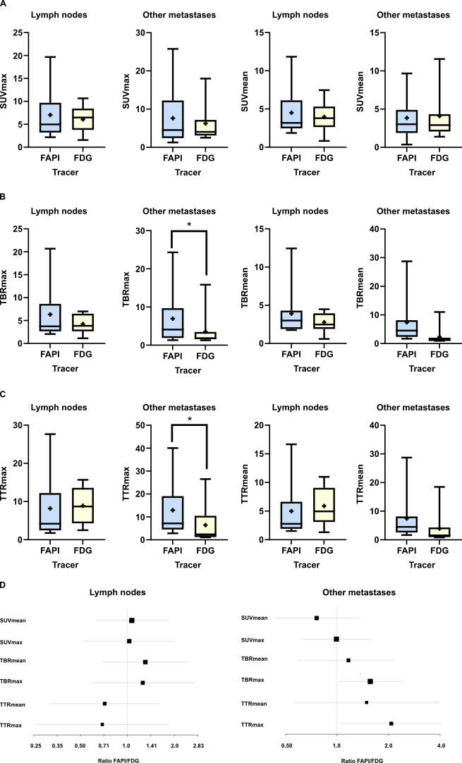
Box-Whisker-Plot of A maximum and mean standardized uptake values (SUVmax/mean), B tumor-to-background ratios (TBRmax/mean) and C tumor-to-tissue ratios (TTRmax/mean) of 9 lymph node metastases and 12 other metastatic lesions (4 bone, 3 liver, 1 peritoneal carcinomatosis bordering the liver dome, 2 lung, 1 pleura carcinomatosis, 1 splen) of 9 patients with extra-cervical CUP who were examined with positron emission tomography combined with computed tomography (PET/CT) with ⁶⁸Gallium-labelled fibroblast activation protein inhibitor (⁶⁸Ga-FAPI) and ¹⁸Fluor-labelled fluorodeoxyglucose (¹⁸F-FDG). Significant differences (*) were observed for TBRmax and TTRmax in metastatic lesions other than lymph nodes. The box represents the interquartile range, the whiskers indicate the lower and upper quartiles, the horizontal line within the box indicates the median and the “+” shows the mean. D Geometric mean ratios of quantitative ⁶⁸Ga-FAPI-PET-parameters and ¹⁸F-FDG-PET-parameters of lymph node metastases and other metastases.

Supplemental figure 2
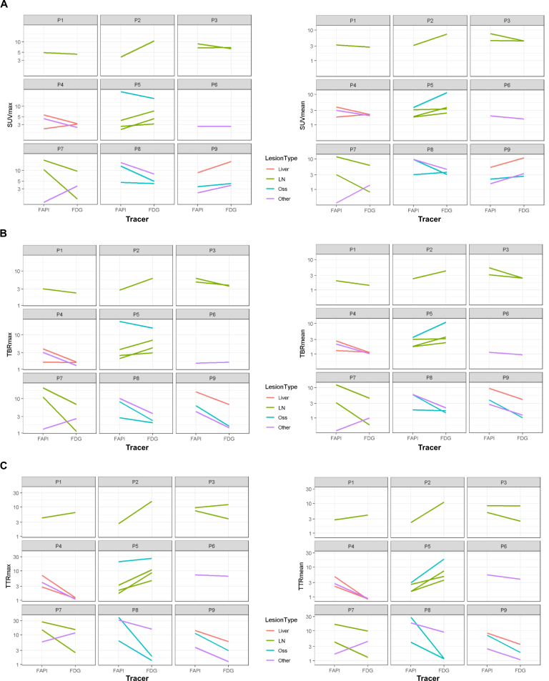
A Standardized uptake values (SUVmax/mean) B tumor-to-background ratio (TBRmax/mean) and C tumor-to-tissue ratio (TTRmax/mean) of metastatic lesions (liver and peritoneal carcinomatosis bordering the liver dome (liver, red), lymph nodes (LN, green), bones (Oss, blue), lung, pleural carcinomatosis, spleen (other, purple) across nine patients (P1-P9). Each line represents the two measurements for one lesion, ⁶⁸Ga-FAPI (left) and ¹⁸F-FDG (right). An upward slope indicates higher tracer uptake for ¹⁸F-FDG compared to ⁶⁸Ga-FAPI, while a downward slope indicates higher uptake for ⁶⁸Ga-FAPI compared to ¹⁸F-FDG.

