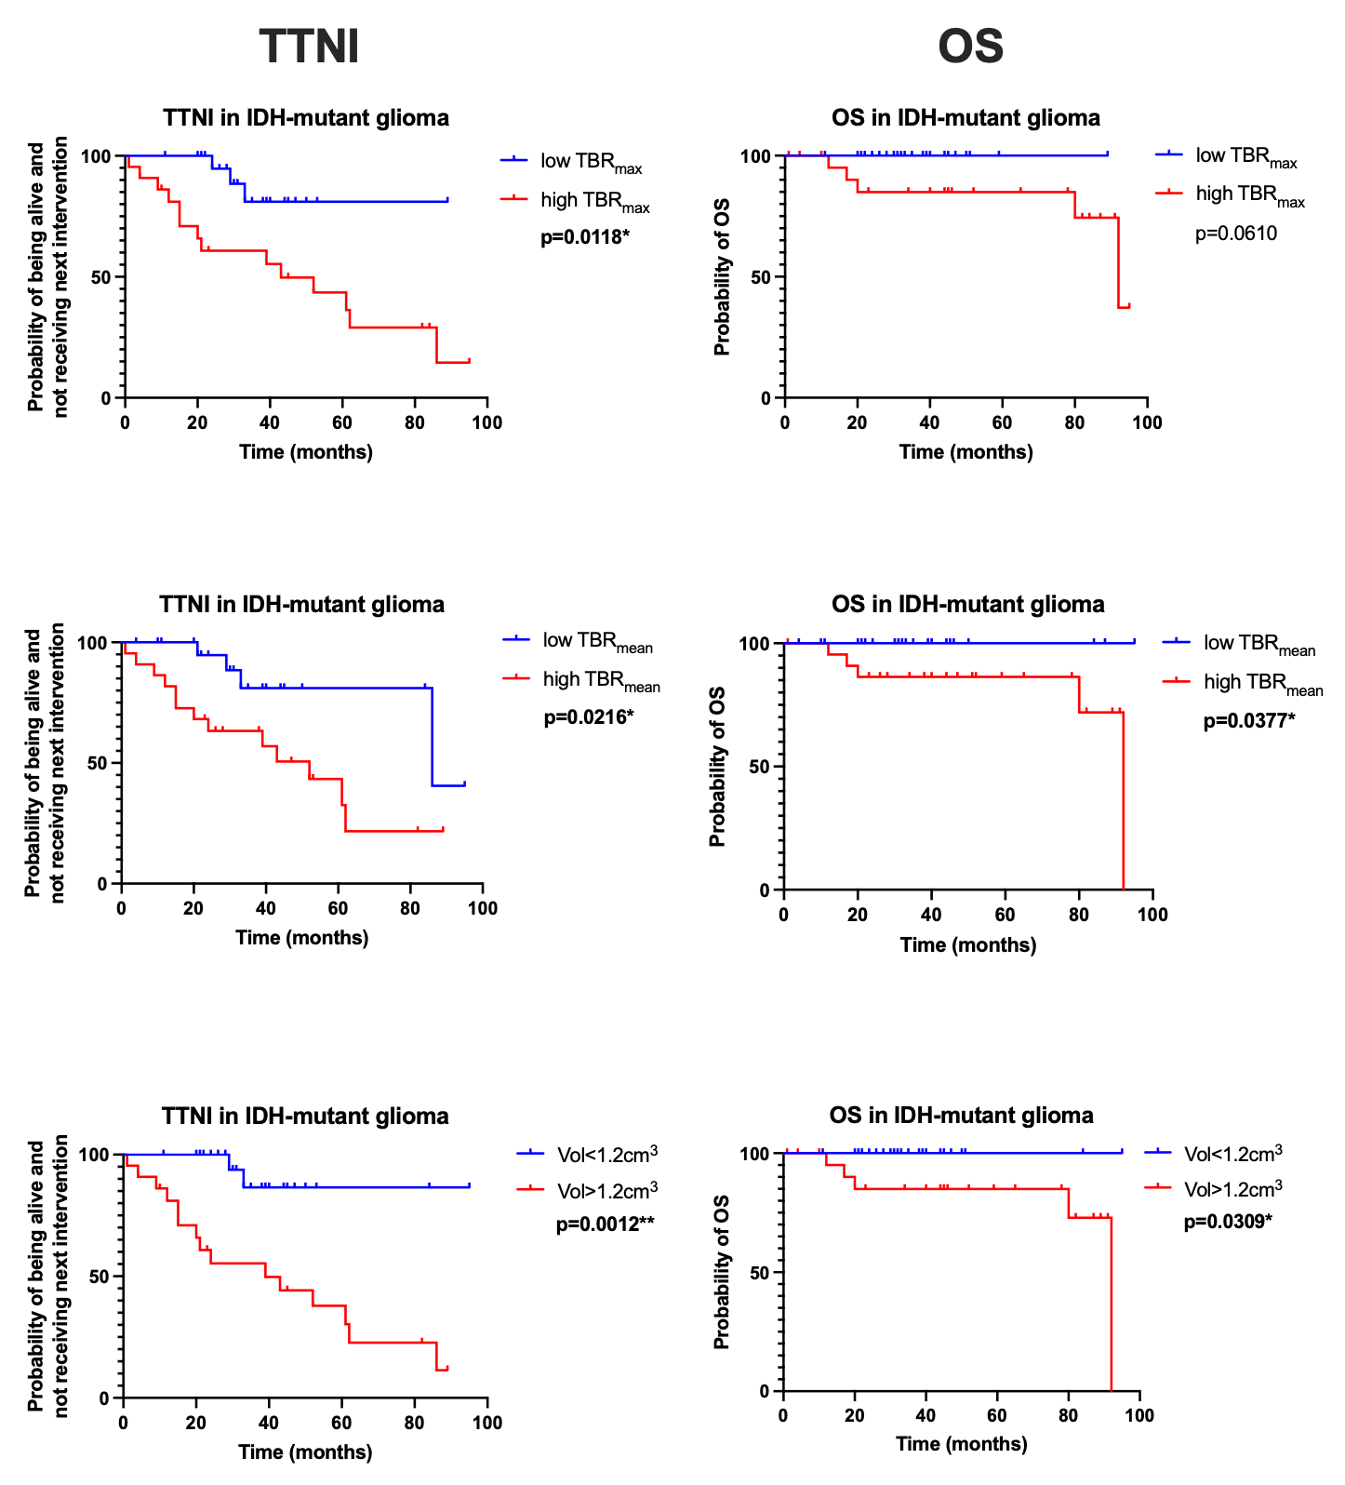
Supplemental Figure 1 Kaplan-Meier estimation of TTNI and OS based on additional TSPO-PET parameters (n=46): Stratification for TBR_{max}, TBR_{mean}, and PET-positive volume are illustrated. We identified significant associations between low vs. high TBR_{mean} with TTNI (p=0.0216), and OS (p=0.0377), as well as for TBR_{max} and TTNI (p=0.0118). Based on the TSPO-PET-positive volume, TTNI and OS were significantly different (p=0.0012, p=0.0309, Fig. 4).

