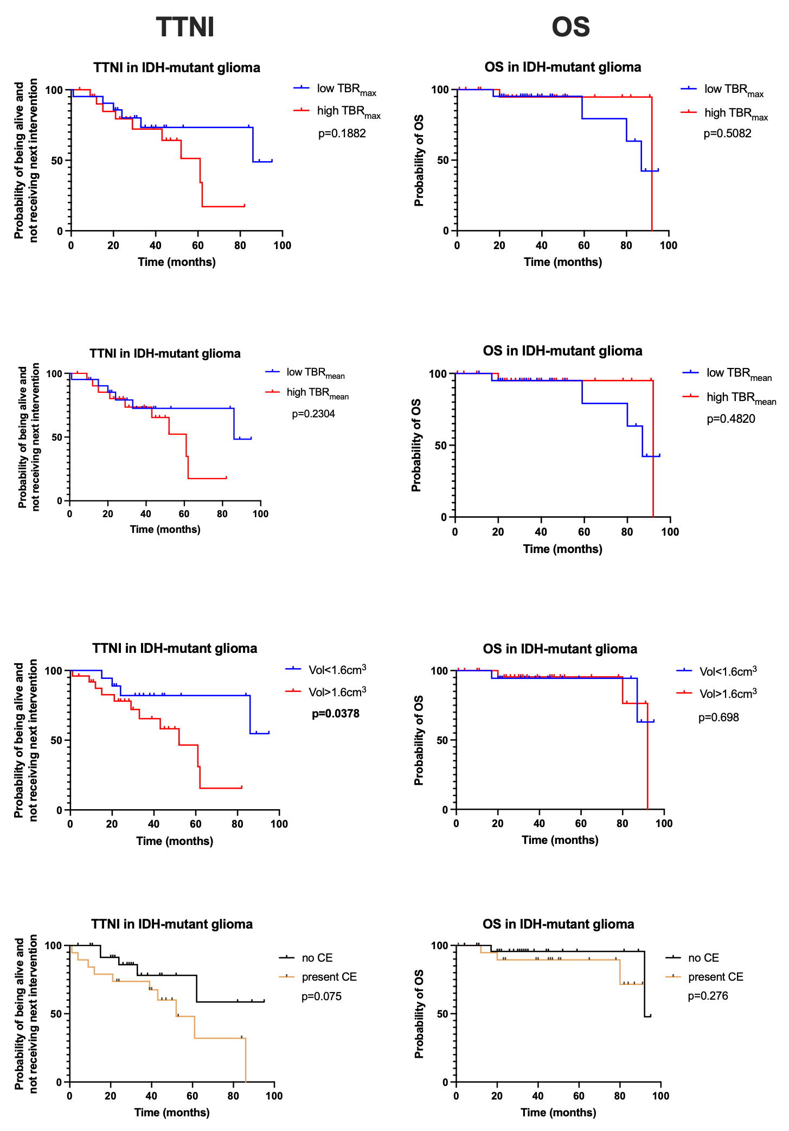
Supplemental Figure 2 Kaplan-Meier estimation of PFS, TTNI and OS in 44 patients, stratified for SUV_{max}, TBR_{max}, TBR_{mean}, and FET-PET-positive volume. Presence of CE on MRI is also illustrated. For FET-PET, only PET-positive volume correlated with TTNI (p=0.0378), whereas other parameters (TBR_{mean}, TBR_{max}) and contrast enhancement on MRI showed no significant associations.

