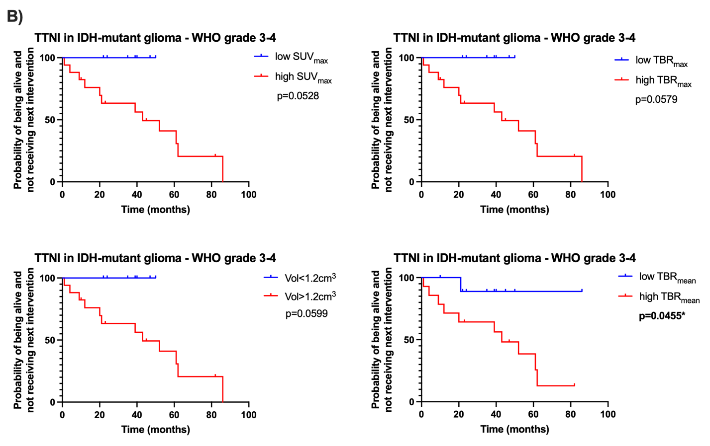
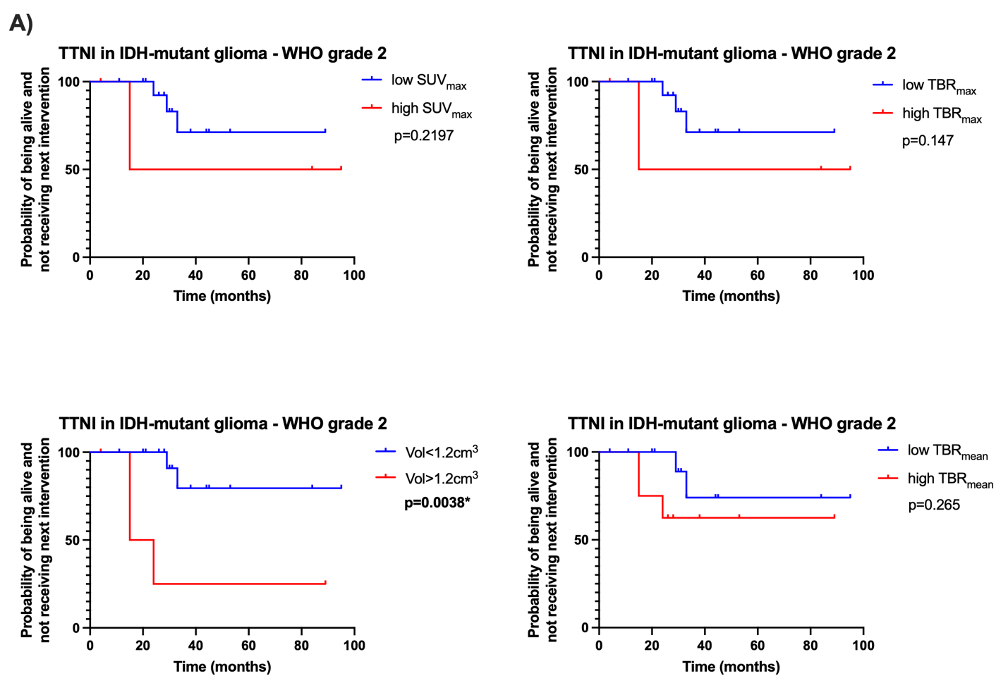
Supplemental figure 3 Kaplan-Meier analysis of TTNI according to [¹⁸F]GE180-PET parameters in WHO grade 2 (n=22) and WHO grade 3-4 IDH-mutant glioma (n=24)
A) In WHO grade 2, higher [¹⁸F]GE180-PET-positive volume was significantly associated with shorter TTNI (p=0.0038), whereas tracer uptake intensity was not significant. B) In WHO grade 3-4, higher TBR_{mean} on [¹⁸F]GE180-PET was significantly associated with shorter TTNI (p=0.0455).

