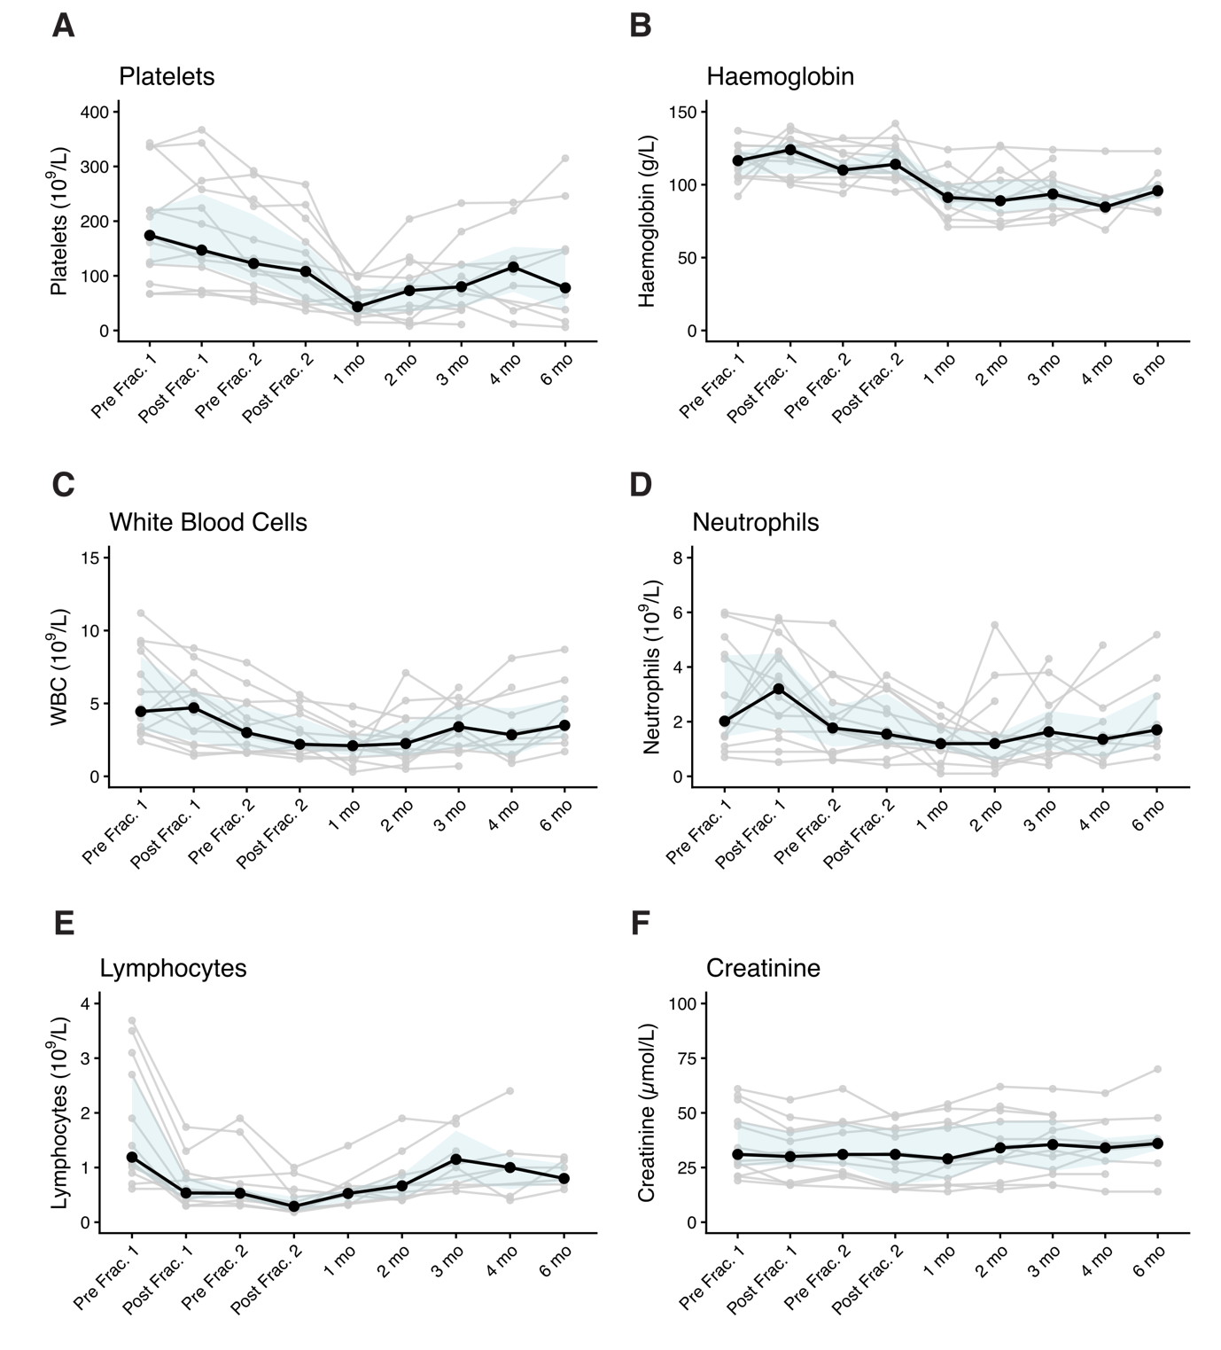
Supplementary Figure 2. Longitudinal trajectories of blood parameters during and after ¹⁷⁷Lu-DOTATATE treatment. Absolute measurements are shown for (A) platelets, (B) haemoglobin, (C) while blood count, (D) neutrophils, (E) lymphocytes and (F) creatinine. Each grey line represents an individual patient trajectory. The black line represents the median, with the blue ribbon indicating IQR.

