Supplementary Fig. S1 Changes in topological parameters of the global network, N-N network, S-S network and N-S network.
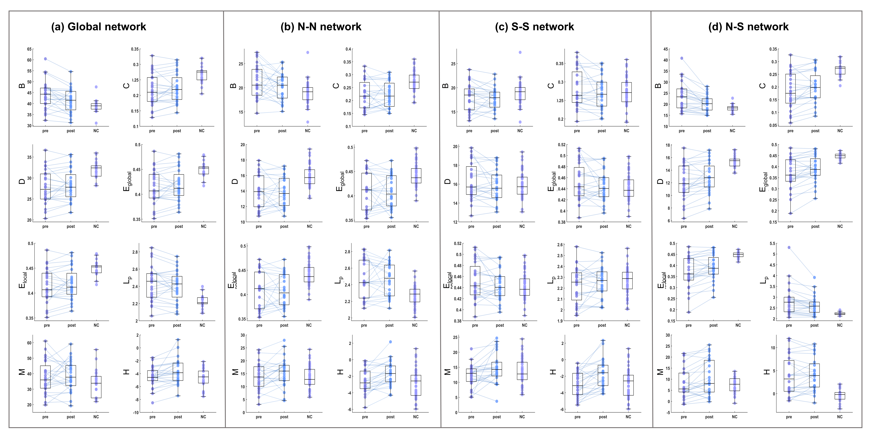

Supplementary Fig. S2 Schematic diagram of network change trends.
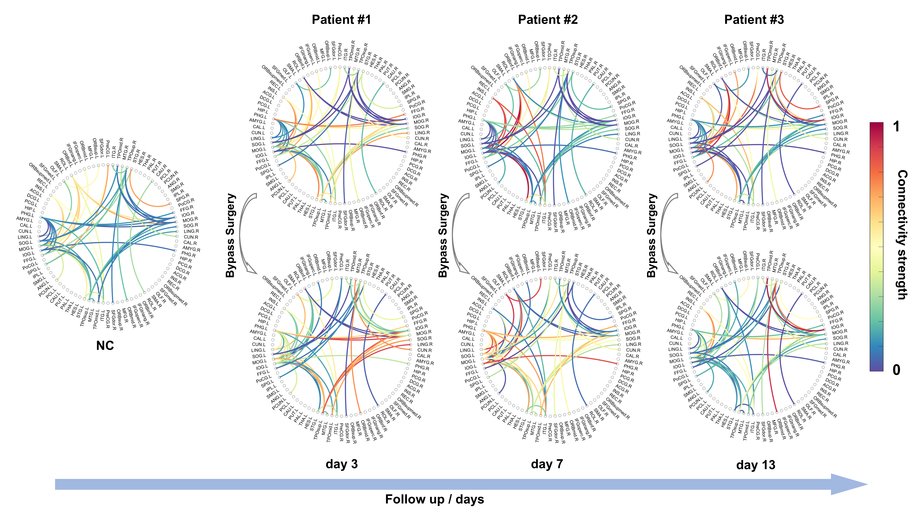

Supplementary Fig. S3 Correlations between MCES and clinical scales.
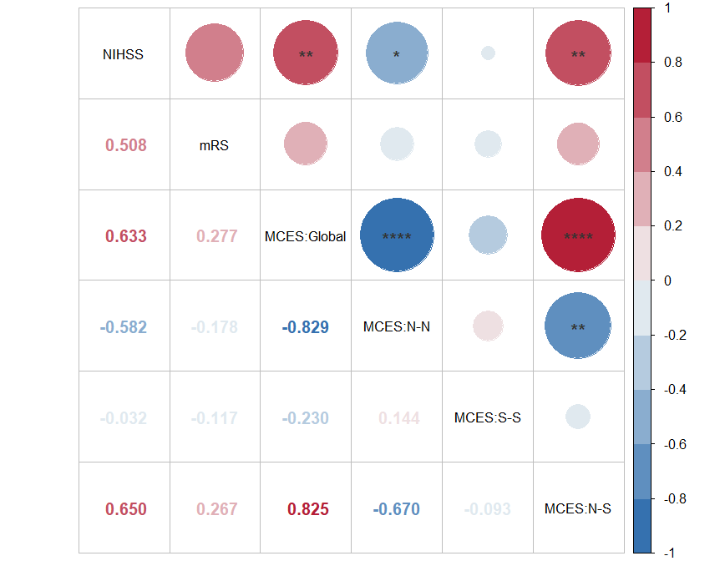

Supplementary Table S1. Bootstrap optimism-corrected discrimination performance of MCES.
 | NC(Global) | NC(L-R) | pre-ICVD(N-N)
 | vs | vs | vs
 | pre-ICVD(Global) | pre-ICVD(N-S) | pre-ICVD(S-S)
Apparent AUC | 0.922 | 0.973 | 0.864
Bootstrap AUC, mean (95% CI) | 0.963(0.883~1.000) | 0.985(0.834~1.000) | 0.904(0.817~0.981)
Mean optimism (95% CI) | 0.096(-0.000~0.225) | 0.083(-0.006~0.194) | 0.078(-0.021~0.185)
Optimism-corrected AUC | 0.826 | 0.891 | 0.786

Supplementary Table S2. Bootstrap-estimated discrimination performance and Hedge’s g effect sizes of individual topological metrics between NC group and preoperative ICVD group

NC (Global) vs preoperative ICVD (Global)
Metrics | Apparent AUC | Bootstrap AUC, mean (95% CI) | Mean Hedges’ g (95% CI)
Asymmetry index | 0.765 | 0.764(0.613~0.894) | 0.977(0.518~1.459)
Betweenness | 0.799 | 0.797(0.662~0.909) | 1.208(0.672~1.847)
Clustering coefficient | 0.81 | 0.809(0.679~0.918) | 1.257(0.737~1.888)
Degree | 0.82 | 0.818(0.685~0.926) | 1.267(0.762~1.860)
Global efficiency | 0.82 | 0.818(0.685~0.926) | 1.267(0.762~1.860)
Local efficiency | 0.82 | 0.818(0.685~0.926) | 1.238(0.791~1.759)
Shortest path length | 0.605 | 0.612(0.505~0.765) | 0.373(0.017~0.943)
Modularity | 0.509 | 0.572(0.503~0.696) | 0.234(0.009~0.661)
Hierarchical coefficient | 0.765 | 0.764(0.613~0.894) | 0.977(0.518~1.459)

NC(L-R) vs preoperative ICVD (N-S)
Metrics | Apparent AUC | Bootstrap AUC, mean (95% CI) | Mean Hedges’ g (95% CI)
Betweenness | 0.767 | 0.765(0.620~0.888) | 0.961(0.628~1.337)
Clustering coefficient | 0.835 | 0.833(0.711~0.936) | 1.438(0.919~2.074)
Degree | 0.839 | 0.837(0.717~0.937) | 1.423(0.933~2.029)
Global efficiency | 0.873 | 0.872(0.759~0.965) | 1.378(0.972~1.870)
Local efficiency | 0.873 | 0.872(0.759~0.965) | 1.378(0.972~1.870)
Shortest path length | 0.873 | 0.872(0.759~0.965) | 1.111(0.834~1.444)
Modularity | 0.558 | 0.584(0.503~0.731) | 0.210(0.008~0.588)
Hierarchical coefficient | 0.827 | 0.827(0.702~0.937) | 1.245(0.813~1.779)

NC(L-L/R-R) vs preoperative ICVD (N-N)
Metrics | Apparent AUC | Bootstrap AUC, mean (95% CI) | Mean Hedges’ g (95% CI)
Betweenness | 0.745 | 0.746(0.618~0.863) | 0.928(0.401~1.495)
Clustering coefficient | 0.796 | 0.797(0.672~0.909) | 1.251(0.713~1.898)
Degree | 0.800 | 0.801(0.674~0.915) | 1.288(0.757~1.924)
Global efficiency | 0.794 | 0.795(0.664~0.911) | 1.239(0.728~1.843)
Local efficiency | 0.794 | 0.795(0.664~0.911) | 1.237(0.726~1.841)
Shortest path length | 0.794 | 0.795(0.664~0.911) | 1.276(0.775~1.863)
Modularity | 0.584 | 0.593(0.504~0.722) | 0.290(0.012~0.768)
Hierarchical coefficient | 0.509 | 0.558(0.502~0.663) | 0.197(0.009~0.558)

NC(L-L/R-R) vs preoperative ICVD (S-S)
Metrics | Apparent AUC | Bootstrap AUC, mean (95% CI) | Mean Hedges’ g (95% CI)
Betweenness | 0.638 | 0.638(0.510~0.771) | 0.419(0.027~0.911)
Clustering coefficient | 0.555 | 0.575(0.503~0.699) | 0.283(0.011~0.749)
Degree | 0.566 | 0.581(0.503~0.713) | 0.286(0.012~0.761)
Global efficiency | 0.591 | 0.598(0.505~0.733) | 0.352(0.015~0.861)
Local efficiency | 0.592 | 0.599(0.505~0.734) | 0.352(0.015~0.862)
Shortest path length | 0.591 | 0.598(0.505~0.733) | 0.317(0.015~0.824)
Modularity | 0.577 | 0.588(0.505~0.713) | 0.336(0.019~0.797)
Hierarchical coefficient | 0.538 | 0.565(0.502~0.683) | 0.239(0.009~0.659)

Supplementary Table S3. Bootstrap-estimated discrimination performance and Hedge’s g effect sizes of individual topological metrics between preoperative ICVD (N-N) and preoperative ICVD (S-S) network.
Metrics | Apparent AUC | Bootstrap AUC, mean (95% CI) | Mean Hedges’ g (95% CI)
Betweenness | 0.796 | 0.796(0.674~0.901) | 1.199(0.674~1.785)
Clustering coefficient | 0.820 | 0.820(0.706~0.917) | 1.305(0.763~1.922)
Degree | 0.817 | 0.817(0.701~0.914) | 1.319(0.784~1.941)
Global efficiency | 0.819 | 0.819(0.702~0.915) | 1.328(0.794~1.957)
Local efficiency | 0.819 | 0.819(0.702~0.915) | 1.327(0.794~1.955)
Shortest path length | 0.819 | 0.819(0.702~0.915) | 1.325(0.790~1.949)
Modularity | 0.662 | 0.663(0.524~0.796) | 0.557(0.083~1.103)
Hierarchical coefficient | 0.572 | 0.584(0.504~0.715) | 0.247(0.011~0.701)

Supplementary Table S4. Bootstrap-estimated discrimination performance and Hedge’s g effect sizes of individual topological metrics between preoperative ICVD and postoperative ICVD group.

Preoperative ICVD (Global) vs Postoperative ICVD (Global)
Metrics | Apparent AUC | Bootstrap AUC, mean (95% CI) | Mean Hedges’g (95% CI)
Betweenness | 0.598 | 0.609(0.516~0.707) | 0.382(0.108~0.705)
Clustering coefficient | 0.519 | 0.536(0.501~0.603) | 0.110(0.005~0.318)
Degree | 0.508 | 0.535(0.501~0.604) | 0.105(0.004~0.309)
Global efficiency | 0.524 | 0.539(0.501~0.608) | 0.118(0.005~0.323)
Local efficiency | 0.524 | 0.539(0.501~0.608) | 0.118(0.005~0.323)
Shortest path length | 0.524 | 0.539(0.501~0.608) | 0.124(0.006~0.335)
Modularity | 0.524 | 0.553(0.501~0.651) | 0.175(0.008~0.491)
Hierarchical coefficient | 0.664 | 0.675(0.590~0.773) | 0.615(0.368~0.950)

Preoperative ICVD (N-N) vs Postoperative ICVD (N-N)
Metrics | Apparent AUC | Bootstrap AUC, mean (95% CI) | Mean Hedges’g (95% CI)
Betweenness | 0.551 | 0.577(0.503~0.700) | 0.275(0.012~0.721)
Clustering coefficient | 0.517 | 0.554(0.503~0.653) | 0.162(0.006~0.468)
Degree | 0.524 | 0.553(0.501~0.649) | 0.159(0.006~0.464)
Global efficiency | 0.535 | 0.561(0.503~0.667) | 0.164(0.006~0.470)
Local efficiency | 0.540 | 0.564(0.503~0.669) | 0.164(0.006~0.471)
Shortest path length | 0.535 | 0.561(0.503~0.667) | 0.168(0.006~0.485)
Modularity | 0.596 | 0.599(0.508~0.711) | 0.347(0.043~0.710)
Hierarchical coefficient | 0.671 | 0.679(0.590~0.773) | 0.697(0.419~1.029)

Preoperative ICVD (S-S) vs Postoperative ICVD (S-S)
Metrics | Apparent AUC | Bootstrap AUC, mean (95% CI) | Mean Hedges’g (95% CI)
Betweenness | 0.503 | 0.539(0.501~0.608) | 0.132(0.005~0.367)
Clustering coefficient | 0.574 | 0.578(0.506~0.673) | 0.264(0.024~0.577)
Degree | 0.576 | 0.582(0.506~0.678) | 0.264(0.023~0.583)
Global efficiency | 0.562 | 0.569(0.503~0.671) | 0.227(0.009~0.556)
Local efficiency | 0.565 | 0.570(0.503~0.671) | 0.227(0.010~0.555)
Shortest path length | 0.562 | 0.569(0.503~0.671) | 0.207(0.009~0.529)
Modularity | 0.635 | 0.640(0.528~0.753) | 0.576(0.163~1.023)
Hierarchical coefficient | 0.735 | 0.742(0.669~0.819) | 0.887(0.602~1.221)

Preoperative ICVD (N-S) vs Postoperative ICVD (N-S)
Metrics | Apparent AUC | Bootstrap AUC, mean (95% CI) | Mean Hedges’g (95% CI)
Betweenness | 0.628 | 0.639(0.551~0.730) | 0.609(0.364~0.901)
Clustering coefficient | 0.565 | 0.575(0.506~0.660) | 0.179(0.013~0.400)
Degree | 0.562 | 0.573(0.508~0.651) | 0.202(0.019~0.426)
Global efficiency | 0.578 | 0.589(0.518~0.667) | 0.293(0.109~0.512)
Local efficiency | 0.578 | 0.589(0.518~0.667) | 0.293(0.109~0.512)
Shortest path length | 0.578 | 0.589(0.518~0.667) | 0.329(0.146~0.533)
Modularity | 0.569 | 0.579(0.506~0.669) | 0.317(0.095~0.585)
Hierarchical coefficient | 0.58 | 0.586(0.508~0.687) | 0.166(0.010~0.402)

Supplementary Table S5. Correspondence Table of Full Names and Abbreviations for Brain Regions
Index | Regions | Abbreviation
1 | Precental gyrus | PreCG.L
2 | Precental gyrus | PreCG.R
3 | Superior frontal gyrus, dorsolateral | SFGdor.L
4 | Superior frontal gyrus, dorsolateral | SFGdor.R
5 | Superior frontal gyrus, orbital part | ORBsup.L
6 | Superior frontal gyrus, orbital part | ORBsup.R
7 | Middle frontal gyrus | MFG.L
8 | Middle frontal gyrus | MFG.R
9 | Middle frontal gyrus, orbital part | ORBmid.L
10 | Middle frontal gyrus, orbital part | ORBmid.R
11 | Inferior frontal gyrus, opercular part | IFGoperc.L
12 | Inferior frontal gyrus, opercular part | IFGoperc.R
13 | Inferior frontal gyrus, triangular part | IFGtriang.L
14 | Inferior frontal gyrus, triangular part | IFGtriang.R
15 | Inferior frontal gyrus, orbital part | ORBinf.L
16 | Inferior frontal gyrus, orbital part | ORBinf.R
17 | Rolandic operculum | ROL.L
18 | Rolandic operculum | ROL.R
19 | Supplementary motor area | SMA.L
20 | Supplementary motor area | SMA.R
21 | Olfactory cortex | OLF.L
22 | Olfactory cortex | OLF.R
23 | Superior frontal gyrus, medial | SFGmed.L
24 | Superior frontal gyrus, medial | SFGmed.R
25 | Superior frontal gyrus, medial orbital | ORBsupmed.L
26 | Superior frontal gyrus, medial orbital | ORBsupmed.R
27 | Gyrus rectus | REC.L
28 | Gyrus rectus | REC.R
29 | Insula | INS.L
30 | Insula | INS.R
31 | Anterior cingulate and paracingulate gyri | ACG.L
32 | Anterior cingulate and paracingulate gyri | ACG.R
33 | Median cingulate and paracingulate gyri | DCG.L
34 | Median cingulate and paracingulate gyri | DCG.R
35 | Posterior cingulate gyrus | PCG.L
36 | Posterior cingulate gyrus | PCG.R
37 | Hippocampus | HIP.L
38 | Hippocampus | HIP.R
39 | Parahippocampal gyrus | PHG.L
40 | Parahippocampal gyrus | PHG.R
41 | Amygdala | AMYG.L
42 | Amygdala | AMYG.R
43 | Calcarine fissure and surrounding cortex | CAL.L
44 | Calcarine fissure and surrounding cortex | CAL.R
45 | Cuneus | CUN.L
46 | Cuneus | CUN.R
47 | Lingual gyrus | LING.L
48 | Lingual gyrus | LING.R
49 | Superior occipital gyrus | SOG.L
50 | Superior occipital gyrus | SOG.R
51 | Middle occipital gyrus | MOG.L
52 | Middle occipital gyrus | MOG.R
53 | Inferior occipital gyrus | IOG.L
54 | Inferior occipital gyrus | IOG.R
55 | Fusiform gyrus | FFG.L
56 | Fusiform gyrus | FFG.R
57 | Postcentral gyrus | PoCG.L
58 | Postcentral gyrus | PoCG.R
59 | Superior parietal gyrus | SPG.L
60 | Superior parietal gyrus | SPG.R
61 | Inferior parietal, but supramarginal and angular gyri | IPL.L
62 | Inferior parietal, but supramarginal and angular gyri | IPL.R
63 | Supramarginal gyrus | SMG.L
64 | Supramarginal gyrus | SMG.R
65 | Angular gyrus | ANG.L
66 | Angular gyrus | ANG.R
67 | Precuneus | PCUN.L
68 | Precuneus | PCUN.R
69 | Paracentral lobule | PCL.L
70 | Paracentral lobule | PCL.R
71 | Caudate nucleus | CAU.L
72 | Caudate nucleus | CAU.R
73 | Lenticular nucleus, putamen | PUT.L
74 | Lenticular nucleus, putamen | PUT.R
75 | Lenticular nucleus, pallidum | PAL.L
76 | Lenticular nucleus, pallidum | PAL.R
77 | Thalamus | THA.L
78 | Thalamus | THA.R
79 | Heschl gyrus | HES.L
80 | Heschl gyrus | HES.R
81 | Superior temporal gyrus | STG.L
82 | Superior temporal gyrus | STG.R
83 | Temporal pole: superior temporal gyrus | TPOsup.L
84 | Temporal pole: superior temporal gyrus | TPOsup.R
85 | Middle temporal gyrus | MTG.L
86 | Middle temporal gyrus | MTG.R
87 | Temporal pole: middle temporal gyrus | TPOmid.L
88 | Temporal pole: middle temporal gyrus | TPOmid.R
89 | Inferior temporal gyrus | ITG.L
90 | Inferior temporal gyrus | ITG.R

