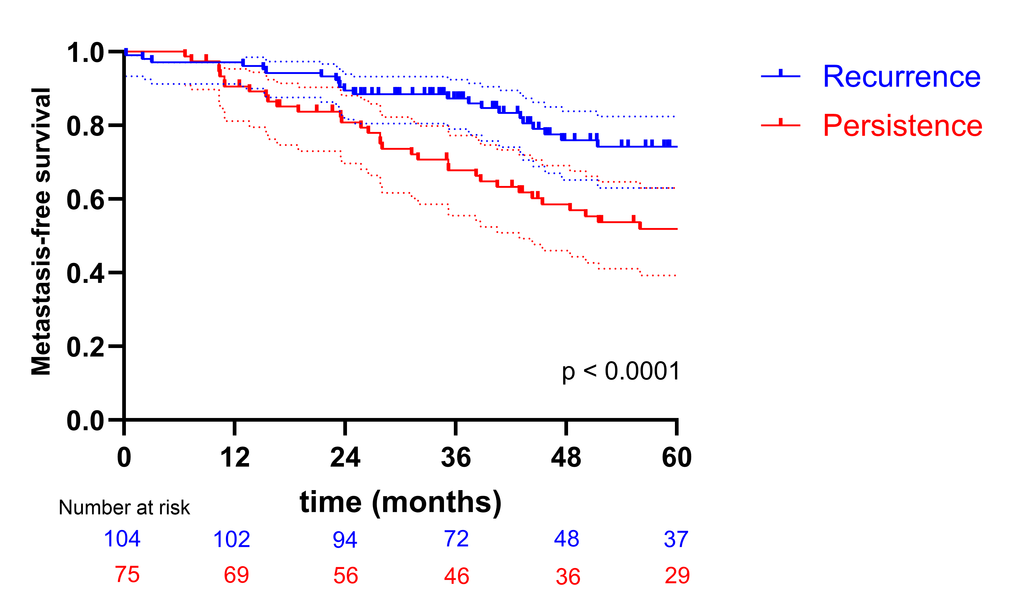
Supplementary Figure 1 Metastasis-free survival in patients with true biochemical recurrence versus PSA persistence after radical prostatectomy. Kaplan–Meier curves showing metastasis-free survival in patients with true biochemical recurrence and PSA persistence. Dotted lines indicate 95% confidence intervals. Survival distributions were compared using the log-rank test. The numbers of MFS events were 28 in patients with true biochemical recurrence and 48 in patients with PSA persistence.

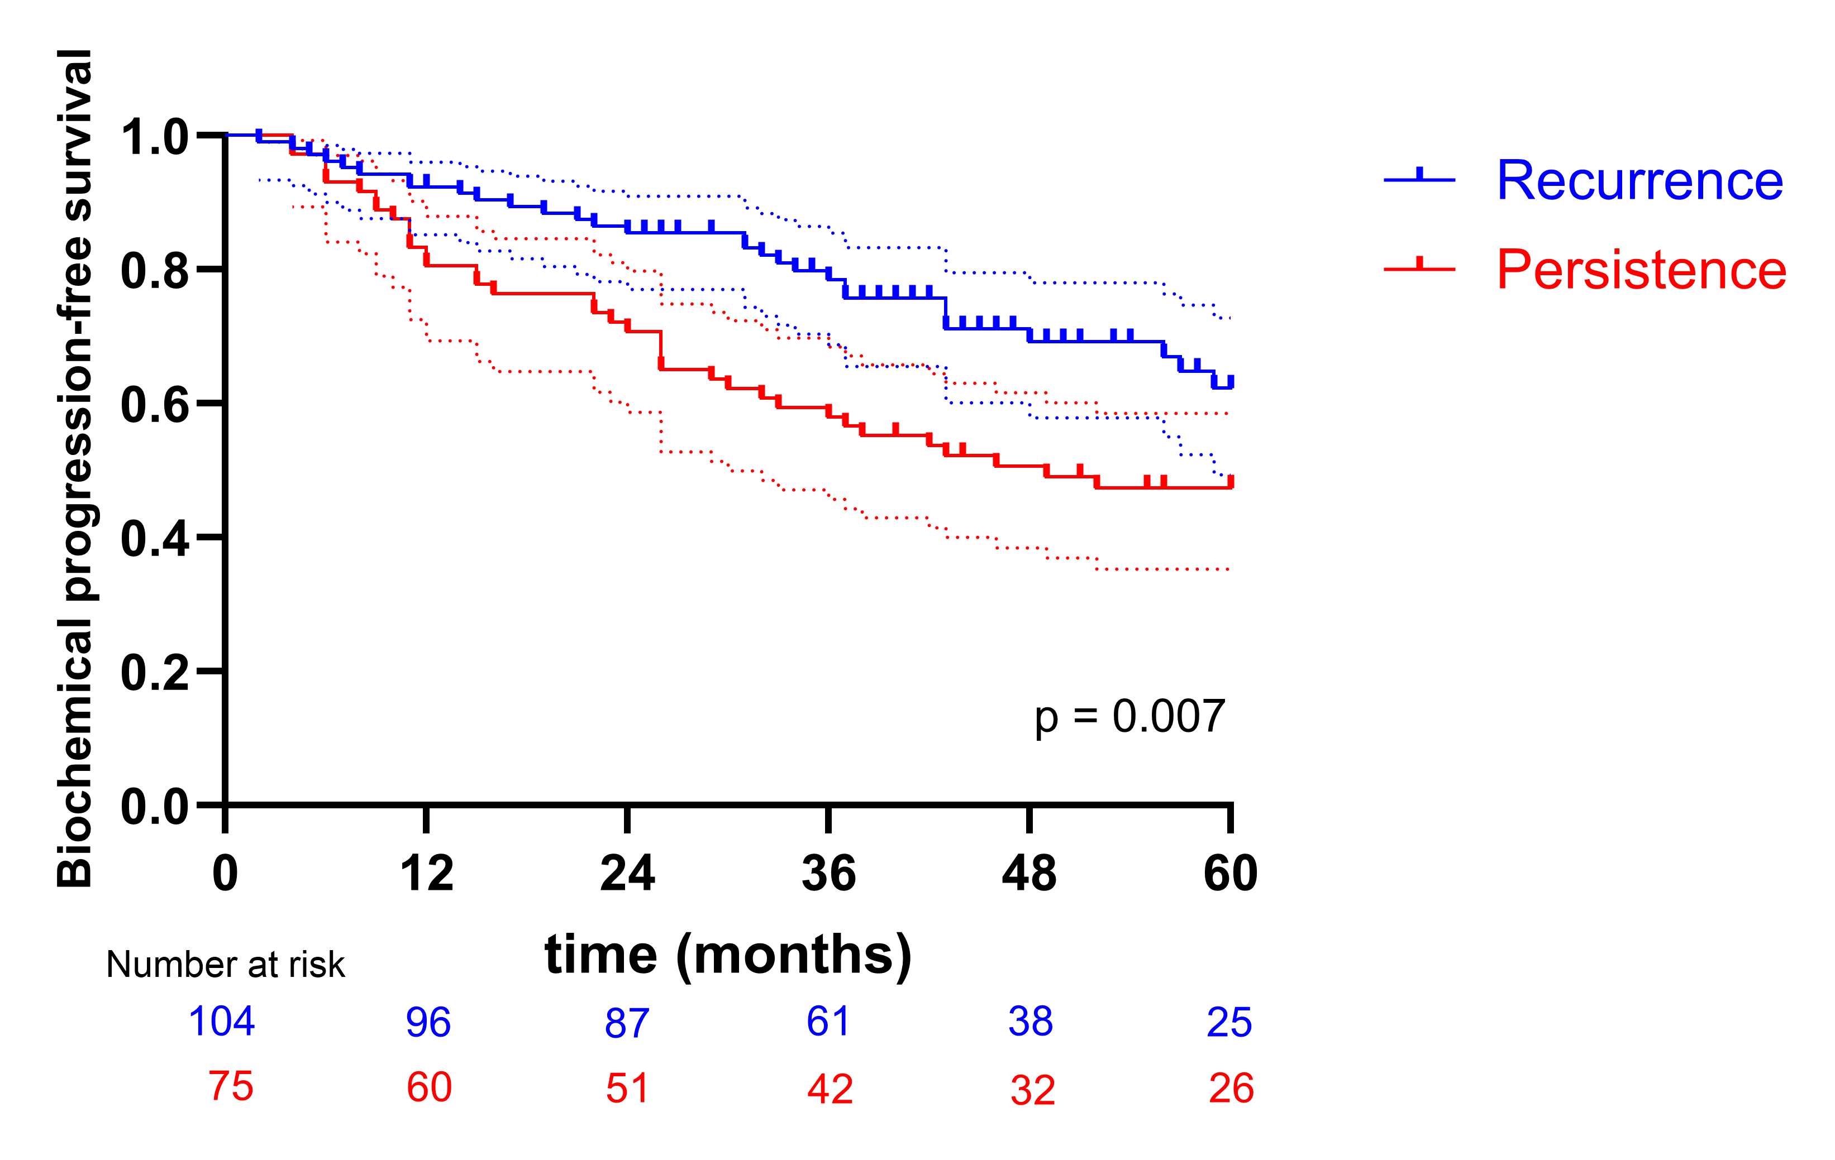
Supplementary Figure 2 Biochemical progression-free survival in patients with true biochemical recurrence versus PSA persistence after radical prostatectomy. Kaplan–Meier curves showing biochemical progression-free survival in patients with true biochemical recurrence and PSA persistence. Dotted lines indicate 95% confidence intervals. Survival distributions were compared using the log-rank test. Thirty-two patients with true biochemical recurrence and 41 patients with PSA persistence experienced biochemical progression.

