Supplementary material

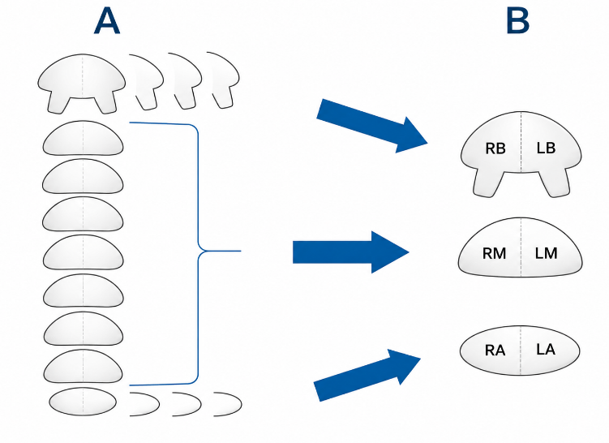
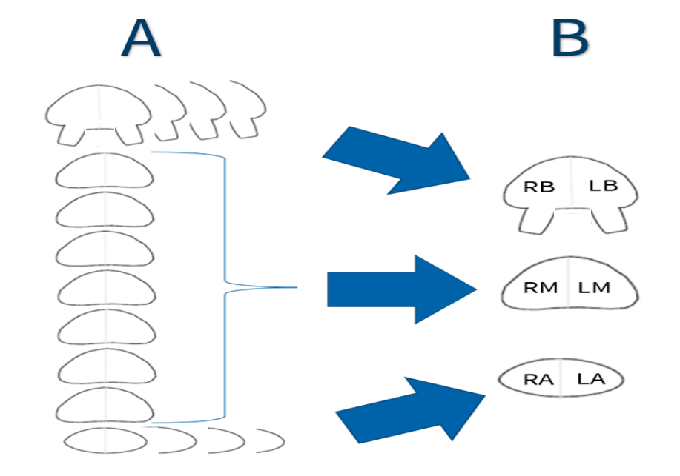

Figure S1. A prostate pathology segmentation worksheet (A) was used to register tumour foci on each histological slice to the corresponding anatomical region. To ensure standardised reporting, a six-segment model of the prostate gland (B) was applied. All findings were mapped to six regions: right base (RB), left base (LB), right mid-gland (RM), left mid-gland (LM), right apex (RA), and left apex (LA). The presence of carcinoma on any single slice rendered the corresponding region positive, with localisation recorded as right or left.

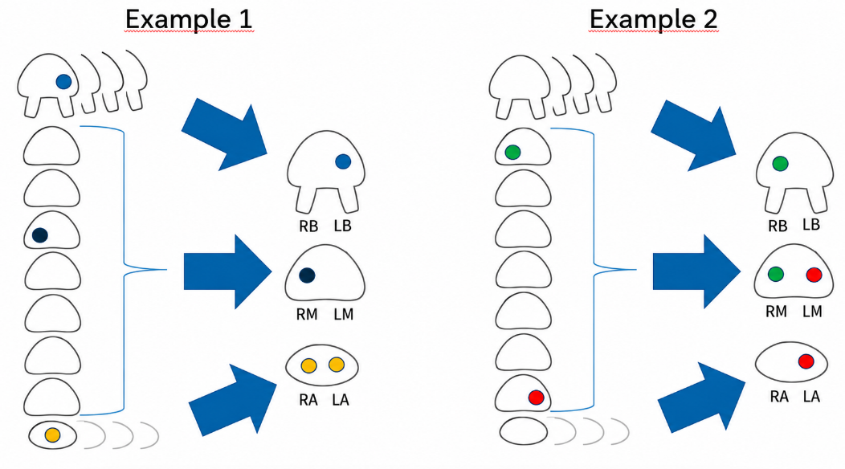

Figure S2. Schematic illustrating the neighbouring approach used to translate prostate imaging segmentation worksheets into sextant regions across all three modalities. Example 1 shows three tumour foci—left base (blue), right mid-gland (black), and apical (orange)—translated to left base, right mid-gland, and bilateral apex positivity. Example 2 shows foci in the cranial right mid-gland (green) and caudal left mid-gland (red), corresponding to right mid-gland/right base and left mid-gland/left apex involvement, respectively.

Left apex
Prevalence = 0.7200 | Sensitivity (95% CI) | Specificity (95% CI) | AUC (95% CI) | Accuracy (95% CI) | PPV (95% CI) | NPV (95% CI)
F-PSMA PET/CT | 66.7 (51.2, 82.1) | 71.4 (47.7, 95.2) | 69.0 (54.9, 83.2) | 68.0 (55.0, 81.0) | 85.7 (75.1, 96.3) | 45.5 (31.3, 59.6)
Ga-PSMA PET/CT | 61.1 (45.1, 77.1) | 71.4 (47.7, 95.2) | 66.3 (52.0, 80.6) | 64.0 (50.7, 77.3) | 84.6 (73.3, 96.0) | 41.7 (28.8, 54.5)
mpMRI | 50.0 (32.6, 67.4) | 69.2 (44.1, 94.4) | 59.6 (44.3, 74.9) | 55.4 (41.0, 69.7) | 80.7 (66.8, 94.5) | 35.0 (23.6, 46.4)
Left basal
Prevalence = 0.5400 | Sensitivity (95% CI) | Specificity (95% CI) | AUC (95% CI) | Accuracy (95% CI) | PPV (95% CI) | NPV (95% CI)
F-PSMA PET/CT | 59.3 (40.7, 77.9) | 69.6 (50.7, 88.4) | 64.4 (51.2, 77.7) | 64.0 (50.7, 77.3) | 69.6 (54.9, 84.3) | 59.3 (46.4, 72.1)
Ga-PSMA PET/CT | 44.4 (25.6, 63.3) | 60.9 (40.9, 80.9) | 52.7 (38.9, 66.4) | 52.0 (38.3, 65.7) | 57.1 (40.9, 73.4) | 48.3 (36.5, 60.1)
mpMRI | 8.3 (-2.8, 19.4) | 90.5 (77.9, 103.1) | 49.4 (41.0, 57.8) | 46.1 (37.8, 54.5) | 50.7 (3.8, 97.6) | 45.7 (41.1, 50.3)
Left mid
Prevalence = 0.8400 | Sensitivity (95% CI) | Specificity (95% CI) | AUC (95% CI) | Accuracy (95% CI) | PPV (95% CI) | NPV (95% CI)
F-PSMA PET/CT | 76.2 (63.3, 89.1) | 50.0 (15.2, 84.8) | 63.1 (44.5, 81.6) | 72.0 (59.8, 84.2) | 88.9 (81.8, 96.0) | 28.6 (10.6, 46.6)
Ga-PSMA PET/CT | 85.7 (75.1, 96.3) | 50.0 (15.2, 84.8) | 67.9 (49.7, 86.0) | 80.0 (69.5, 90.5) | 90.0 (83.6, 96.4) | 40.0 (15.6, 64.4)
mpMRI | 63.2 (47.8, 78.5) | 71.4 (37.8, 105.0) | 67.3 (48.8, 85.8) | 64.5 (50.5, 78.5) | 92.1 (83.3, 100.8) | 27.0 (14.6, 39.4)
Right apex
Prevalence = 0.7000 | Sensitivity (95% CI) | Specificity (95% CI) | AUC (95% CI) | Accuracy (95% CI) | PPV (95% CI) | NPV (95% CI)
F-PSMA PET/CT | 65.7 (49.9, 81.5) | 66.7 (42.7, 90.6) | 66.2 (51.9, 80.5) | 66.0 (52.8, 79.2) | 82.1 (71.0, 93.3) | 45.5 (31.0, 59.9)
Ga-PSMA PET/CT | 45.7 (29.2, 62.3) | 73.3 (50.9, 95.8) | 59.5 (45.6, 73.5) | 54.0 (40.6, 67.4) | 80.0 (65.3, 94.7) | 36.7 (26.6, 46.7)
mpMRI | 45.2 (27.6, 62.7) | 85.7 (67.3, 104.1) | 65.4 (52.7, 78.2) | 57.3 (43.8, 70.8) | 88.1 (73.9, 102.2) | 40.1 (30.8, 49.4)
Right basal
Prevalence = 0.5000 | Sensitivity (95% CI) | Specificity (95% CI) | AUC (95% CI) | Accuracy (95% CI) | PPV (95% CI) | NPV (95% CI)
F-PSMA PET/CT | 60.0 (40.7, 79.3) | 68.0 (49.7, 86.3) | 64.0 (50.7, 77.3) | 64.0 (50.7, 77.3) | 65.2 (50.3, 80.1) | 63.0 (50.1, 75.8)
Ga-PSMA PET/CT | 64.0 (45.1, 82.9) | 80.0 (64.3, 95.7) | 72.0 (59.7, 84.3) | 72.0 (59.7, 84.3) | 76.2 (60.9, 91.4) | 69.0 (57.0, 81.0)
mpMRI | 38.1 (17.3, 58.9) | 95.8 (87.8, 103.9) | 67.0 (55.8, 78.1) | 67.0 (55.8, 78.1) | 90.1 (72.4, 107.9) | 60.8 (52.5, 69.0)
Right mid
Prevalence = 0.8000 | Sensitivity (95% CI) | Specificity (95% CI) | AUC (95% CI) | Accuracy (95% CI) | PPV (95% CI) | NPV (95% CI)
F-PSMA PET/CT | 82.5 (70.7, 94.3) | 50.0 (18.9, 81.1) | 66.3 (49.6, 82.9) | 76.0 (64.7, 87.3) | 86.8 (79.5, 94.1) | 41.7 (19.4, 64.0)
Ga-PSMA PET/CT | 85.0 (73.9, 96.1) | 40.0 (9.5, 70.5) | 62.5 (46.3, 78.7) | 76.0 (65.2, 86.8) | 85.0 (78.3, 91.7) | 40.0 (14.5, 65.5)
mpMRI | 68.6 (53.1, 84.0) | 90.0 (71.3, 108.7) | 79.3 (67.2, 91.4) | 72.9 (60.0, 85.8) | 96.5 (90.1, 102.9) | 41.7 (28.8, 54.7)
Table S1. Diagnostic accuracy parameters for each index test were calculated per region, with whole-mount histopathology as the reference standard for intraprostatic tumour detection, treating each region as an independent unit.
CI = confidence interval; AUC = area under ROC curve; PPV = positive predictive value; NPV = negative predictive value.

Table S2. Estimates of diagnostic accuracy parameters for each index test for the detection of clinically significant prostate cancer were obtained from region-based analyses using mixed-effects regression models to account for repeated measurements within patients, with all ISUP grade group 2 lesions considered positive.
Index test | Sensitivity  (95% CI) | Specificity  (95% CI) | AUC  (95% CI) | Accuracy (95% CI) | PPV  (95% CI) | NPV  (95% CI)
[¹⁸F]F-PSMA-1007 N=300 | 67.9 (60.0, 75.9) | 71.8 (58.7, 84.8) | 69.8 (62.6, 77.1) | 68.8 (62.3, 75.4) | 88.7 (84.1, 93.4) | 40.7 (33.6, 47.7)
[⁶⁸Ga]Ga-PSMA-11 N=300 | 63.6 (56.2, 71.0) | 68.9 (55.3, 82.5) | 66.2 (59.2, 73.3) | 64.8 (59.0, 70.7) | 87.0 (82.1, 91.8) | 36.7 (30.9, 42.5)
mpMRI  N=270 | 47.8 (40.8, 54.8) | 93.6 (85.2, 101.9) | 70.7 (64.8, 76.6) | 58.5 (52.5, 64.6) | 96.0 (91.0, 101.1) | 35.4 (31.5, 39.4)
N = total number; CI = confidence interval; AUC = area under ROC curve; PPV = positive predictive value; NPV = negative predictive value

Table S3. Pairwise comparison of sensitivity and specificity of [¹⁸F]F-PSMA PET/CT, [⁶⁸Ga]Ga-PSMA PET/CT, and mpMRI for detection of intraprostatic tumour using a region-based mixed-effects regression model accounting for repeated measurements within patients, with all ISUP grade group 2 lesions considered positive.
Comparison (Differences) | Difference in sensitivity (95% CI), P | Difference in specificity (95% CI), P
[¹⁸F]F-PSMA-1007 vs [⁶⁸Ga]Ga-PSMA-11 | 0.043 (-0.012, 0.099), 0.12 | 0.029 (-0.158, 0.215), 0.76
[¹⁸F]F-PSMA-1007 PET/CT vs mpMRI | 0.201 (0.106, 0.297), < 0.001 | -0.218 (-0.362, -0.075), 0.003
[⁶⁸Ga]Ga-PSMA-11 PET/CT vs mpMRI | 0.158 (0.073, 0.243), < 0.001 | -0.247 (-0.393, -0.101), < 0.001
CI = confidence interval; P = probability value

