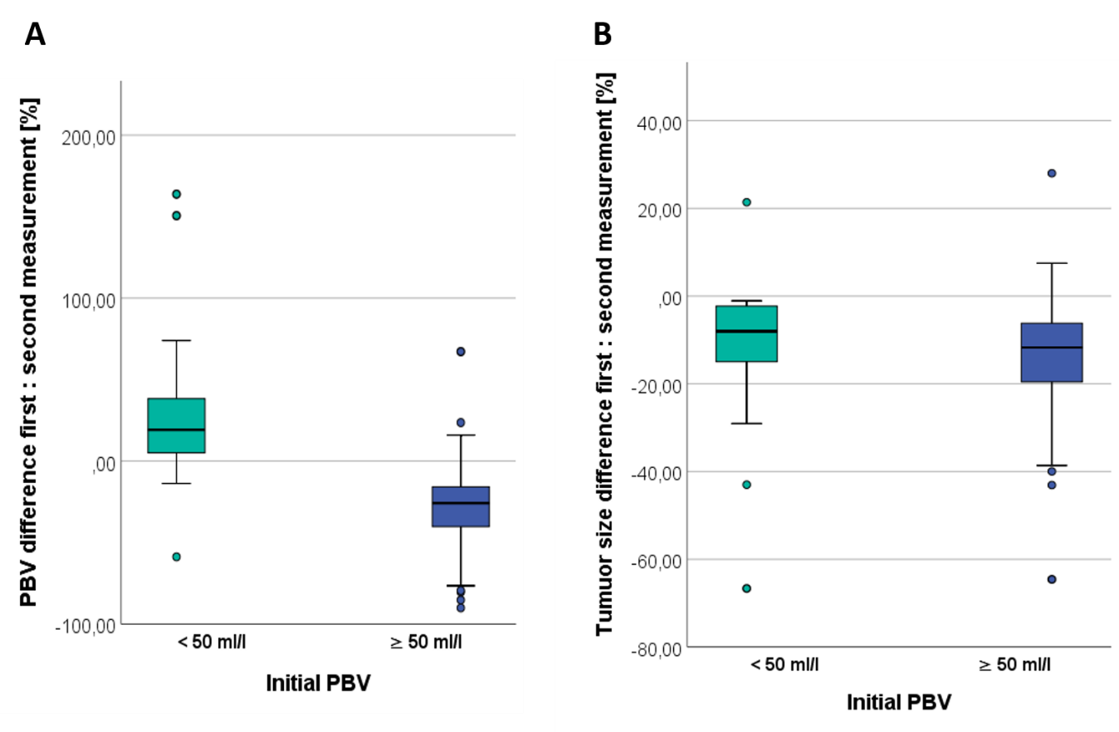
Supplement Figure 1: Boxplot (A) PBV differences first to second measurement [%] (B) tumour size difference first to second measurement [%].

