Supplementary information to:

Cancer Immunology, Immunotherapy (submitted in 2022) – Lukas Häselbarth et al.

Supplementary Table 1: Antibodies for flow cytometry.
Antibody | Fluorochrome | Clone | Isotype | Manufacturer
CD3 | APC | UCHT1 | Mouse IgG1, κ | Biolegend
CD4 | FITC | RPA-T4 | Mouse IgG1, κ | Biolegend
CD4 | APC/Cy7 | OKT-4 | Mouse IgG2b, κ | Biolegend
CD8 | APC/Cy7 | HIT8a | Mouse IgG1, κ | Biolegend
CD8 | PE/Cy7 | SK1 | Mouse IgG1, κ | Biolegend
CD25 | PE/Cy7 | BC96 | Mouse IgG1, κ | Biolegend
CD28 | PerCP/Cy5.5 | CD28.2 | Mouse IgG1, κ | Biolegend
CD36 | PE | 5-271 | Mouse IgG2a,κ | Biolegend
CD69 | PerCP/Cy5.5 | FN50 | Mouse IgG1, k | Biolegend
CD98 | PE/Vio770 | REA387 | Recombinant Human IgG1 | Miltenyi Biotec
CD137 | PE/Cy7 | 4B4-1 | Mouse IgG1, k | Biolegend
PD-1 | PE | EH12.2H7 | Mouse IgG1, κ | Biolegend
Glut-1 | AF488 | 202915 | Mouse IgG2b | R&D Systems

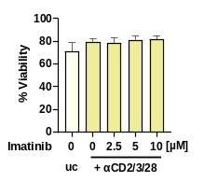
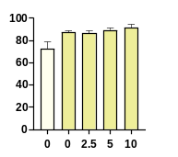
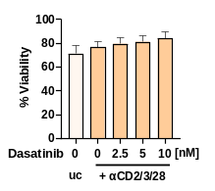
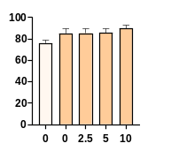
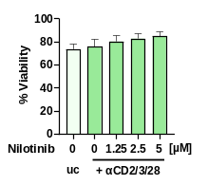
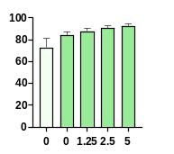
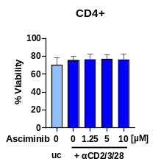
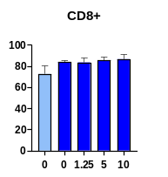

Supplementary Figure 1: Therapeutical TKI-concentrations are subtoxic for T cells. Human T cells were treated with the TKIs asciminib (blue), imatinib (yellow), dasatinib (orange) or nilotinib (green), stimulated with/without αCD2/3/28-beads for 72h and stained with antibodies against CD4/CD8 and 7-AAD/Annexin V. Cell viability was measured by flow cytometry (n=5 different donors).

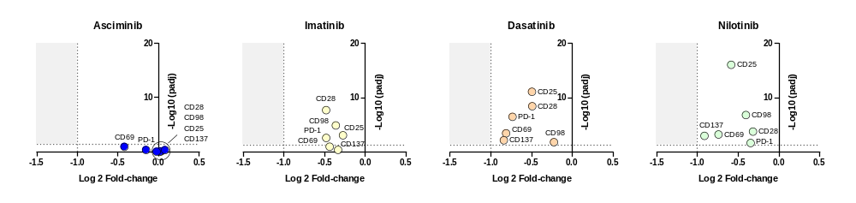
Supplementary Figure 2: TKI-induced changes in CD28, CD98, PD-1, CD25, CD69, and CD137 gene expression. Human T cells were treated with 5 µM asciminib (blue), 5 µM imatinib (yellow), 5 nM dasatinib (orange) or 2.5 µM nilotinib (green) and stimulated with αCD2/3/28-beads for 72h. RNA was isolated and gene expression analyzed by RNA-sequencing. padj = adjusted p-value (n=3 different donors).

Supplementary Figure 3: Imatinib, dasatinib, and nilotinib inhibit T cell proliferation. Human T cells were treated with the TKIs imatinib (yellow), dasatinib (orange) or nilotinib (green) and stimulated with/without αCD2/3/28-beads for 72h. (a) Proliferation. VPD450-staining and measurement by FACs (n=5). (b) Cytokine secretion. Supernatants were analyzed for IFNγ, IL-2, IL-6 and IL-17A by ELISA. Measurements were normalized to the respective TKI-untreated controls (= 0% cytokine secretion, n=5-6 different donors). uc = unstimulated control (no bead addition), *** p < 0.001, ** p < 0.01, * p < 0.05.

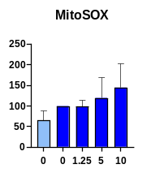
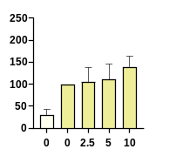
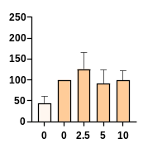
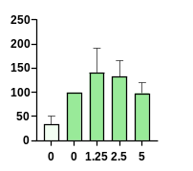
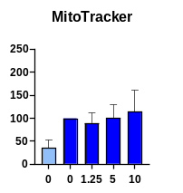
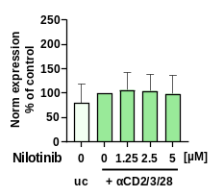
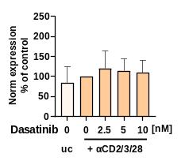
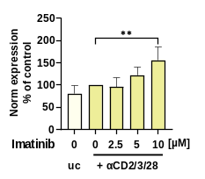
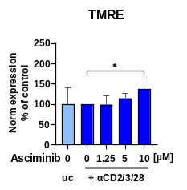
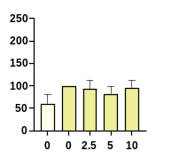
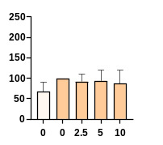
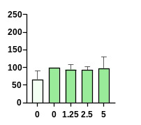
Supplementary Figure 3: Effects of TKIs on mitochondrial functions. Human T cells were treated with the TKIs asciminib (blue), imatinib (yellow), dasatinib (orange) or nilotinib (green), stimulated with/without αCD2/3/28-beads for 72h and stained with TMRE (membrane potential), MitoTrackerTM Green FM (biomass) or MitoSOXTM Red Mitochondrial Superoxide Indicator (superoxid generation). Expression (MdFI) of parameters were analyzed via flow cytometry (n=5-8 different donors). Measurements were normalized to the respective TKI-untreated controls. Norm = normalized, uc = unstimulated control (no bead addition), **p < 0.01, * p < 0.05.

