Fig S1
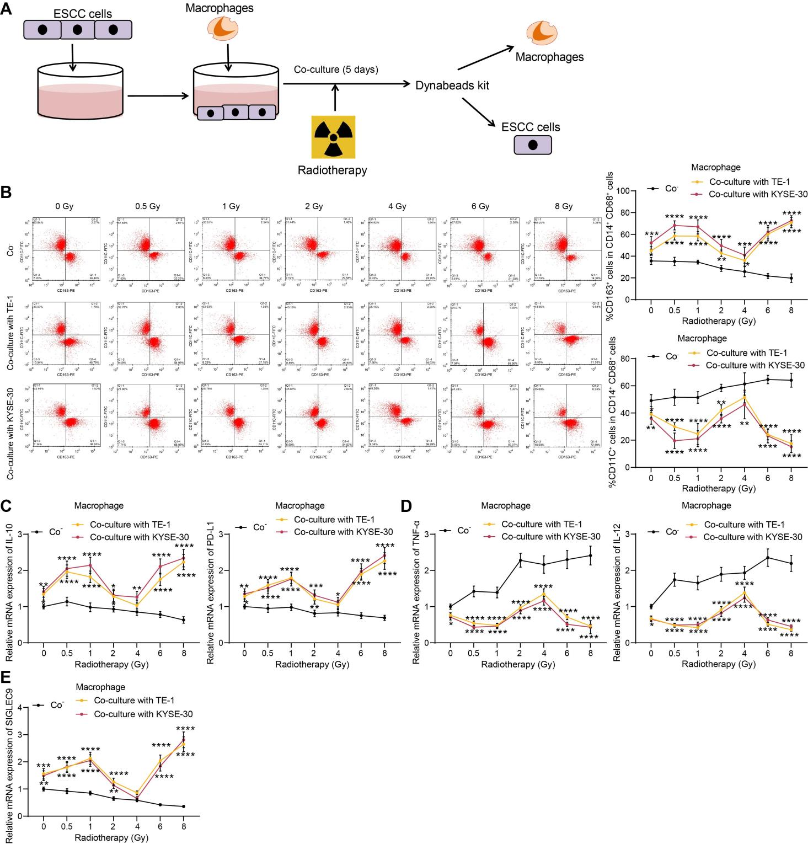
Fig S1 Radiotherapy induces phenotype change of TAMs. A, a sketch map for the co-culture system of macrophages and ESCCs; B, phenotype change of macrophages analyzed by flow cytometry; C-D, expression of M2 phenotype markers IL-10 and PD-L1 (C) and M1 phenotype markers TNF-α and IL-12 (D) in macrophages analyzed by qPCR analysis; E, expression of SIGLEC9 in macrophages determined by qPCR analysis. Differences of the normally distributed data between groups were analyzed by two-way ANOVA (B-E). *p < 0.05, **p < 0.01, ***p < 0.001, ****p < 0.0001.
Fig S2
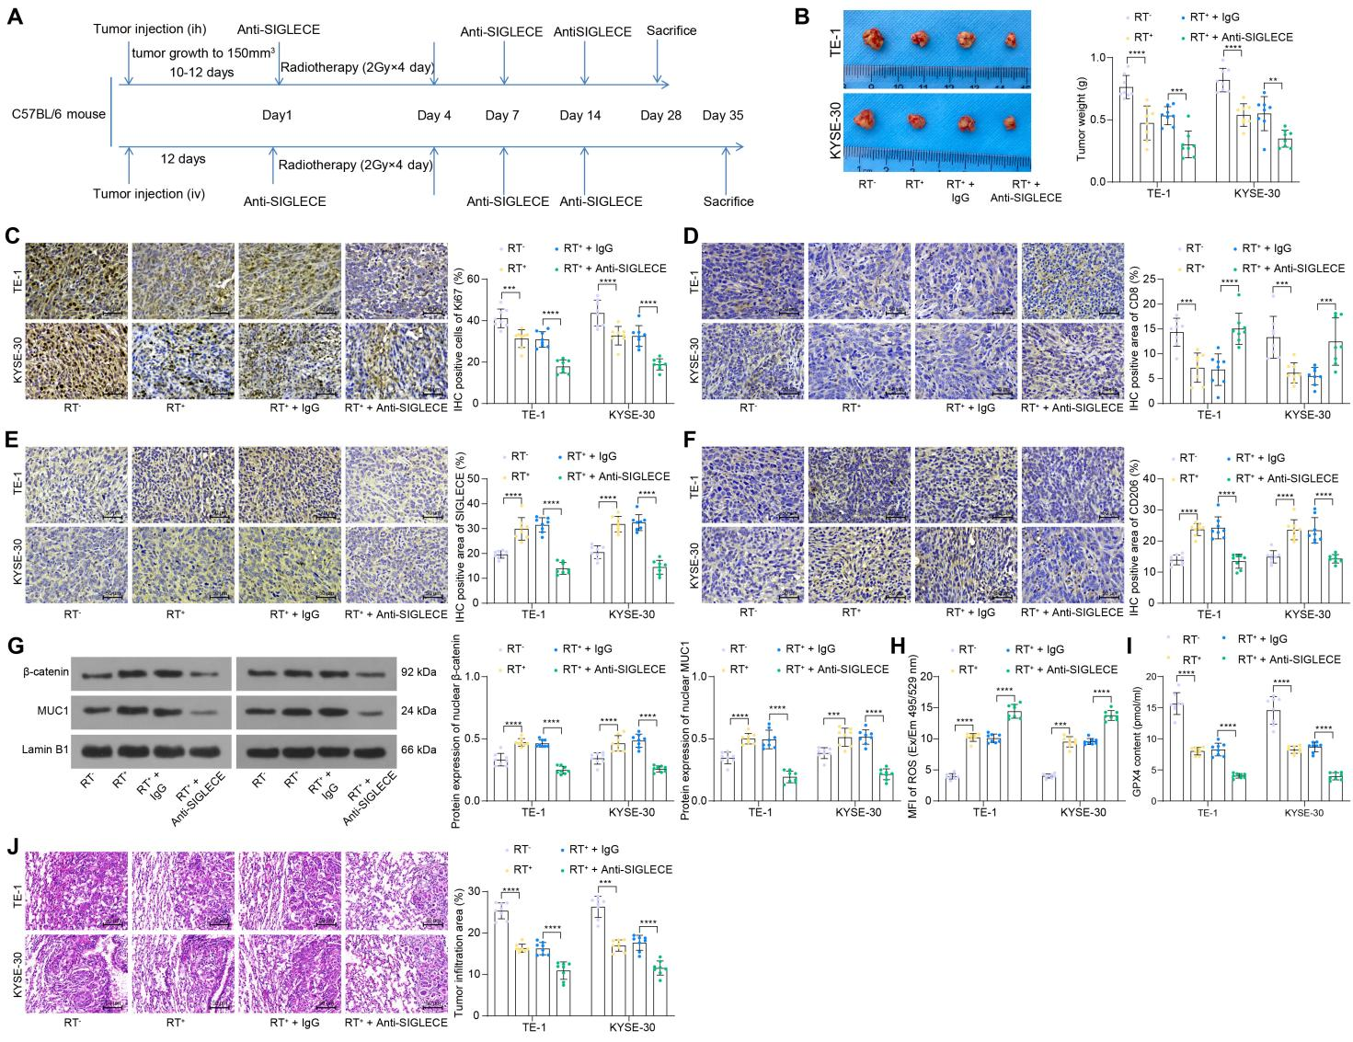
Fig S2 Suppression of SIGLEC9-mediated TAM re-education inhibits nuclear translocation of MUC1-β-catenin in ESCC cells to reduce radioresistance. A, a sketch map for the animal treatment; B, representative images of the subcutaneous xenograft tumors; C-F, expression of Ki67, CD8, SIGLECE, and CD206 in tumor tissues analyzed by IHC; G, protein levels of MUC1 and β-catenin in the nuclei of tumor cells analyzed by WB analysis; H-I, ROS and GPX4 levels in tumor cells analyzed by ELISA kits; J, tumor infiltration in mouse lung tissues upon tail vein injection of cancer cells analyzed by HE staining. Differences of the normally distributed data between groups were analyzed by two-way ANOVA (B-J). Significance of difference was analyzed by Tukey’s multiple comparisons test (B-J). **p < 0.01, ***p < 0.001, ****p < 0.0001.

Fig S3
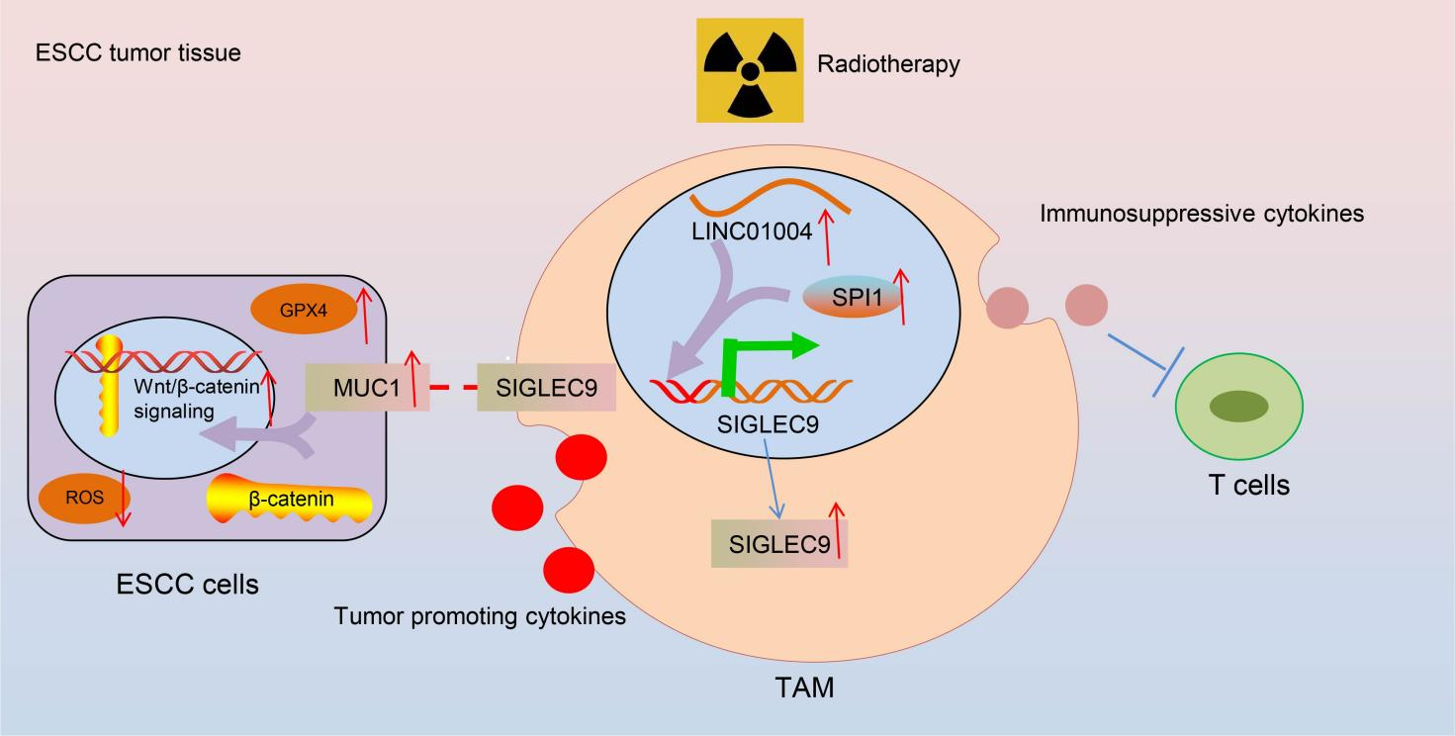
Fig S3 Graphical abstract. Under high doses of radiotherapy, the LINC01044-SPI1 axis mediates transcriptional activation of SIGLEC9 in TAMs, which induces M2 reprogramming of macrophages and suppresses proliferation of active T cell to form an immunosuppressive TME. SIGLEC9 interacts with MUC1 expressed on ESCC cells to induce M2 TAM polarization and radioresistance, and this interaction promotes nuclear translocation of β-catenin to protect ESCC cells from radiotherapy-induced ferroptosis.

