Supporting Information
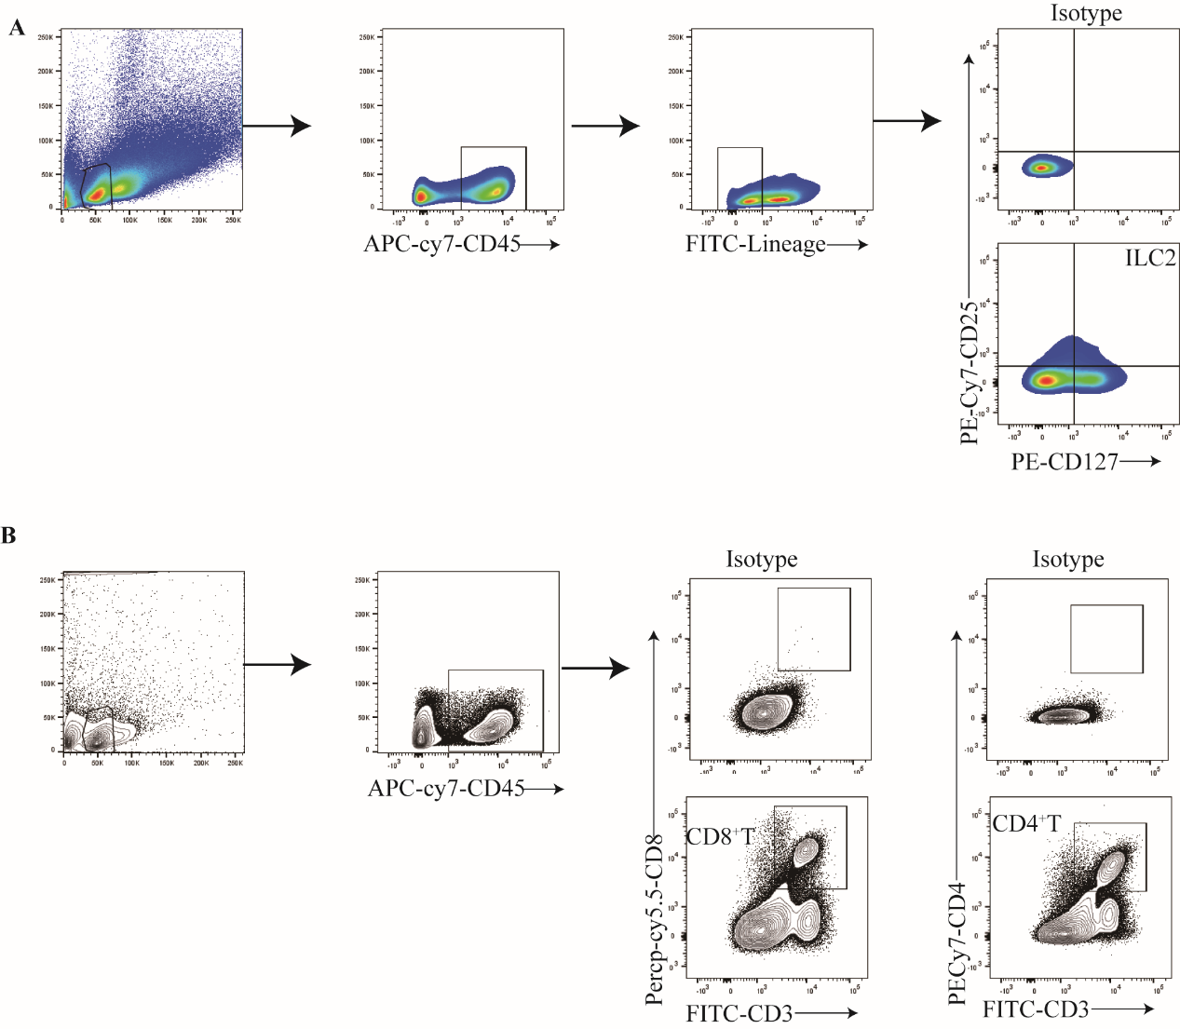 Supplementary Fig. 1 Gating strategy. A, Gating and phenotype of ILC2s. B, Gating and phenotype of CD4⁺T cell and CD8⁺T cell.

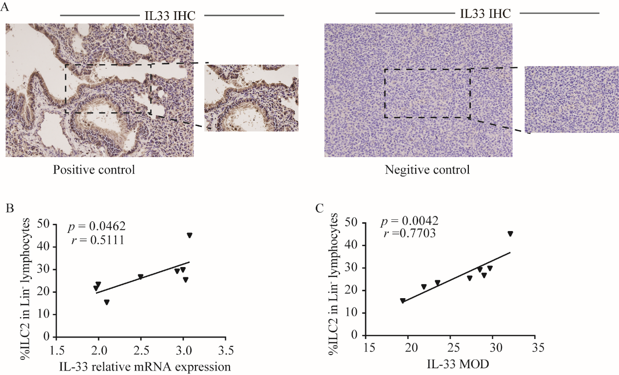

Supplementary Fig. 2 A, Positive and negative control of IL-33 expression in tissues. Correlations between the levels of IL-33 mRNA expression (B) and IL-33 MOD (C) with the percentage of ILC2s in tumor tissues from lung adenocarcinoma tumor-bearing mice.

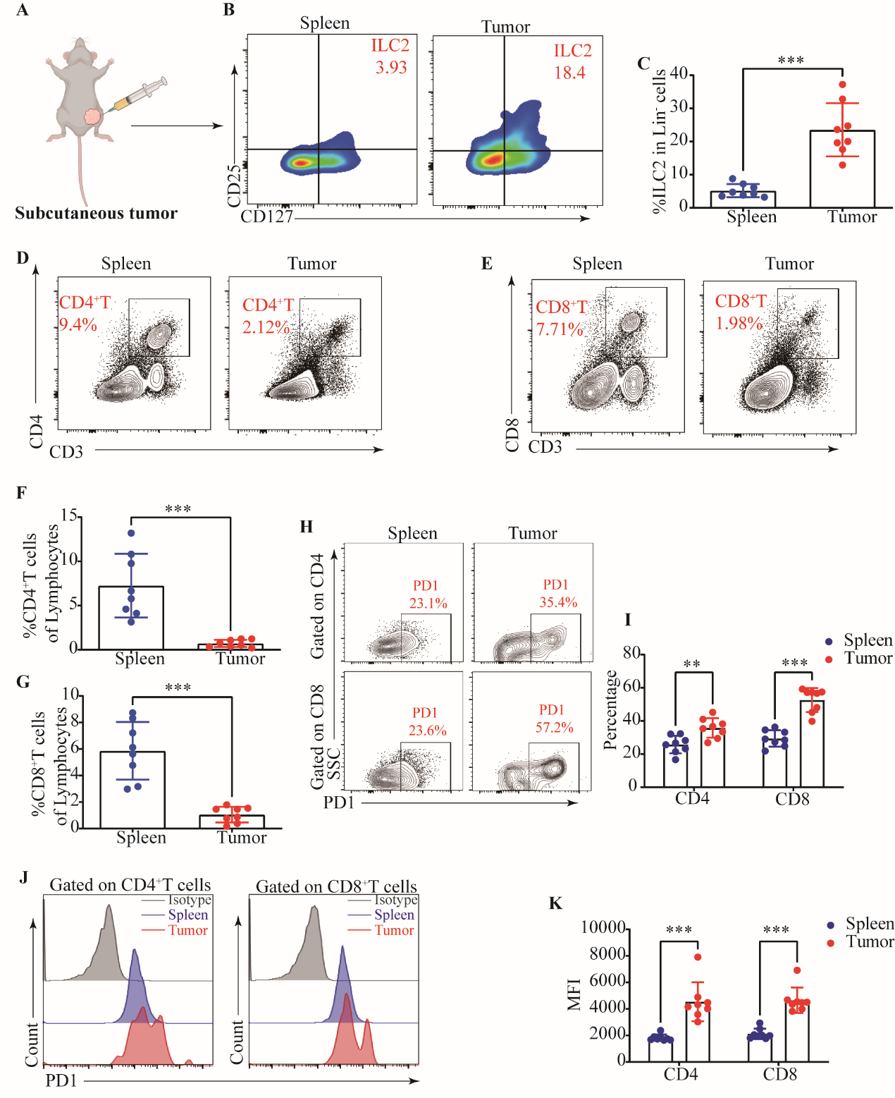
Supplementary Fig. 3 ILC2s infiltrating in tumor tissues in subcutaneous LUAD tumor. A, Subcutaneous LUAD tumor model. Gating (B) and frequency (C) of ILC2s in subcutaneous LUAD tumor-bearing mouse. Gating and phenotype of CD4⁺T cell (D), and CD8⁺T cell (E) in spleen and tumor tissue. Frequency of CD4⁺T cell (F), and CD8⁺T cell (G) in spleen and tumor tissue. Gating (H) and frequency (I) of PD1 in CD4⁺T cell and CD8⁺T cell in spleen and tumor tissue. Staining (J) and MFI (K) of PD-1 in CD4⁺T cell and CD8⁺T in spleen and tumor tissue. Data were pooled from ≥2 independent experiments with n = 8/group; n and data points denote individual mice analyzed separately. P values were determined by unpaired t test (C, F, G), two-way analysis with multiple comparisons (I, K). ***P < 0.001, **P < 0.01.

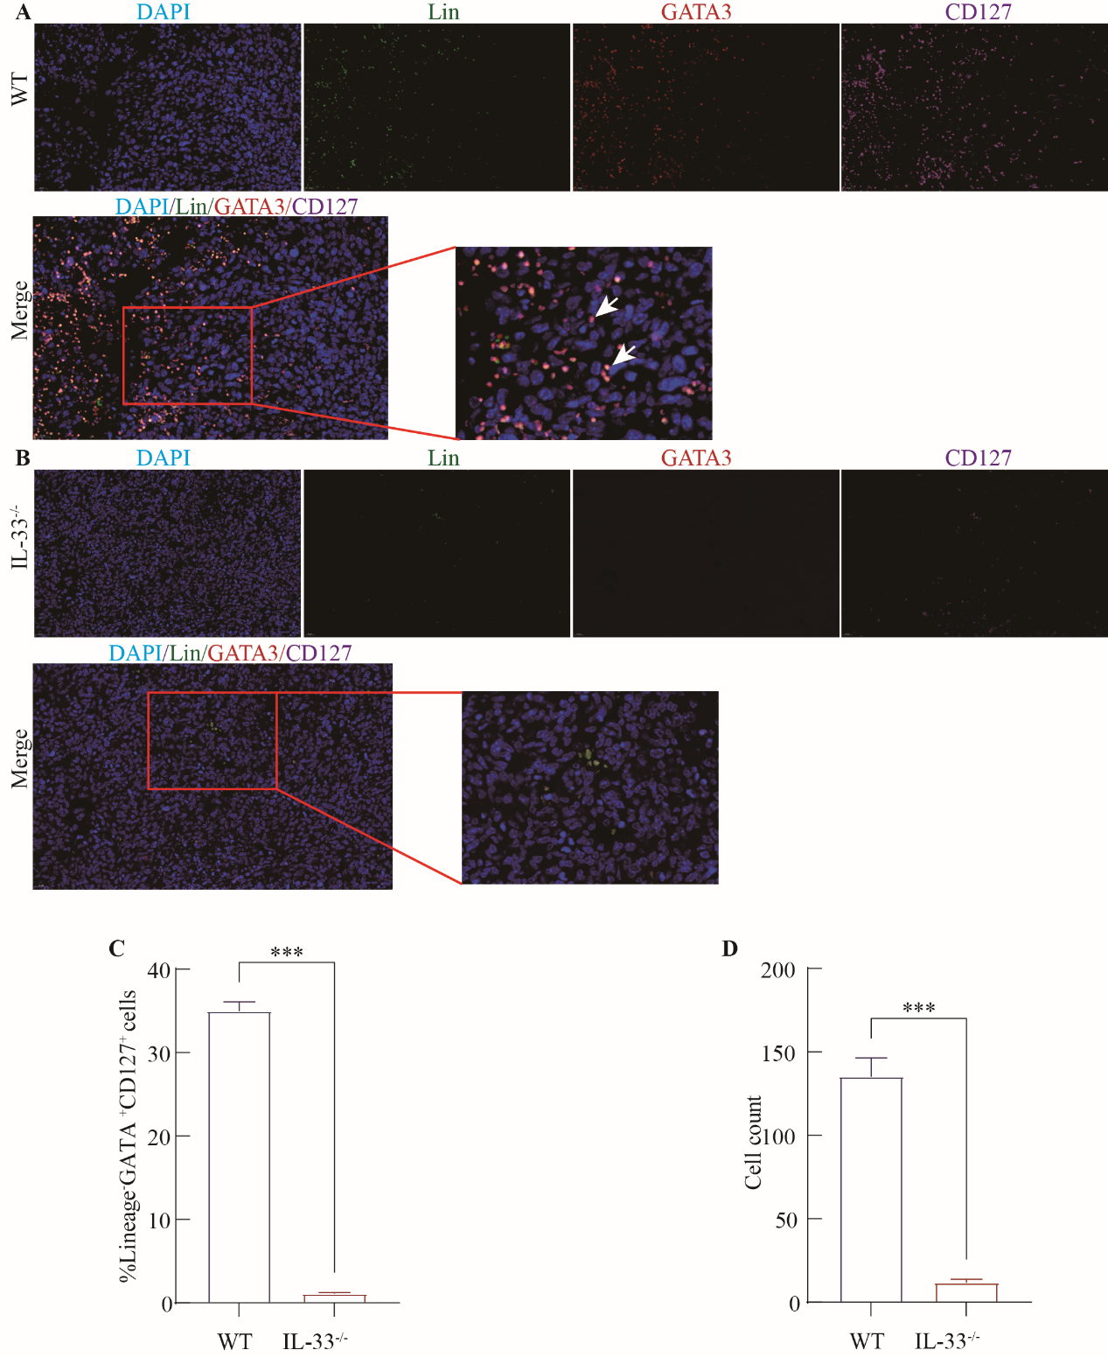

Supplementary Fig. 4 Murine tumor-derived ILC2s were detected by immunofluorescence. A, Murine tumor-derived ILC2s in tumor tissue of WT mice. B, Murine tumor-derived ILC2s in tumor tissue of IL-33^{-/-} mice. C, ILC2s frequency in tumor tissue of WT and IL-33^{-/-}mice. D, ILC2s cell number in tumor tissue of WT and IL-33^{-/-}mice. Data were pooled from ≥2 independent experiments; n = 5/group. P values were determined by unpaired t test. ***P < 0.001.

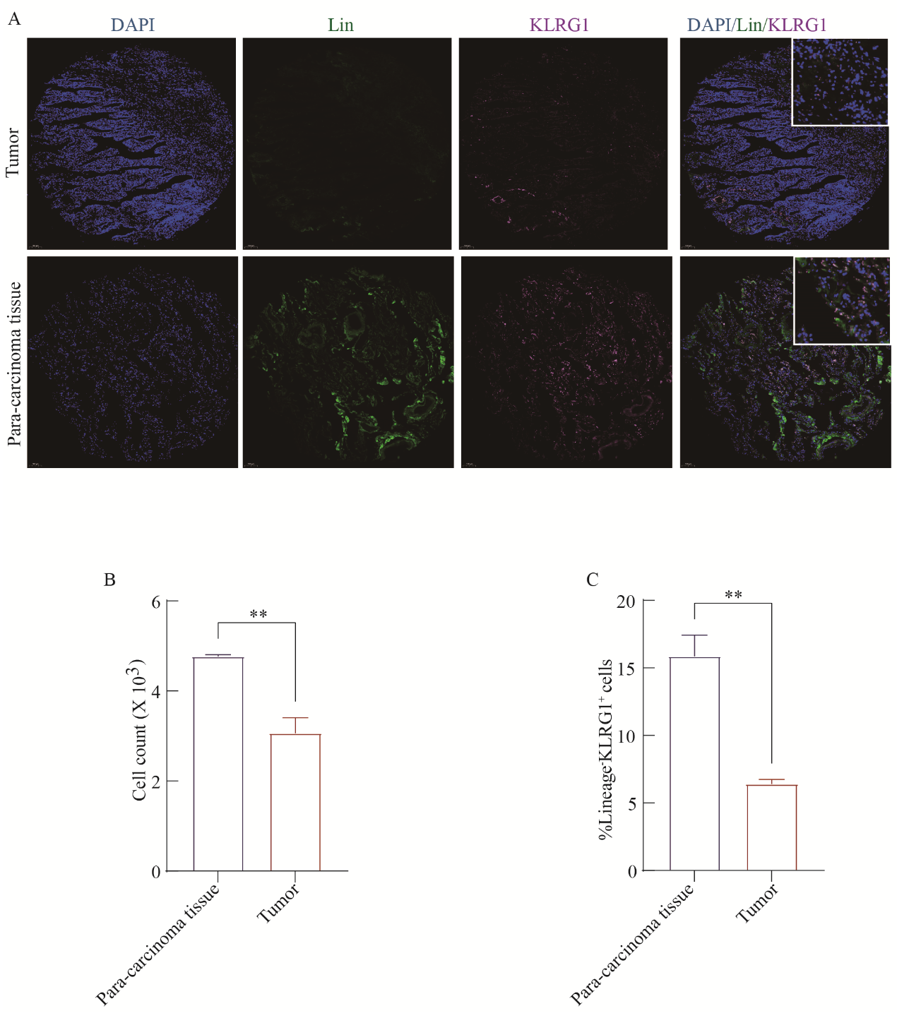 Supplementary Fig. 5 Human Lin⁻KLRG1⁺ cell was detected by IF. A, Human Lin⁻KLRG1⁺ cell in tumor tissue and Para-carcinoma tissue. B, Lineage⁻KLRG1⁺ cell count in tumor tissue and Para-carcinoma tissue. C, Lineage⁻KLRG1⁺ cell frequency in tumor tissue and Para-carcinoma tissue. Data were pooled from 3 independent experiments; P values were determined by unpaired t test. **P < 0.01.

Supplementary Fig. 6 The tumor growth curves of tumor-bearing mice post of different treatments.

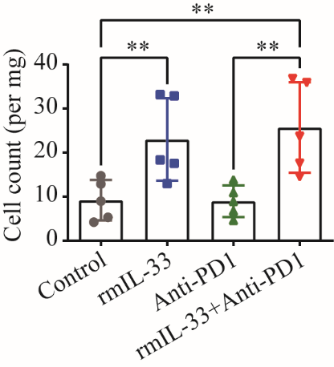
Supplementary Fig. 7 Numbers of ILC2s in tumor tissues from tumor-bearing mice post of different treatments.

